State Purchase Contracts Registration Guide

Background

A new state purchase contract (SPC) confidential information system has been developed to ensure the government has the appropriate level of security and control with regards to the management of information within the confidential section.
Your existing user account to access SPC confidential information is no longer active. As such, you will be required to follow the process below to gain access to the new confidential information system.

Next steps
- Set up a new user account to access the new SPC Confidential Information System.

First time user (login)

STEP 1: REGISTRATER FOR DTF.APPS PORTAL AND ACCESS TO THE NEW SPC CONFIDENTIAL INFORMATION SYSTEM
- Go to http://apps.dtf.vic.gov.au/apps_state_purchase_contracts/
- Click on the “Register menu”, fill in the form to create a new APPS.DTF Account.

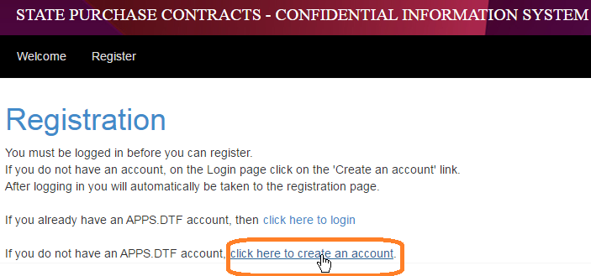
- Once the registration form is completed, an email with a verification link will be emailed to you.

- Click on the email verification link to activate your user account and reset your temporary password.

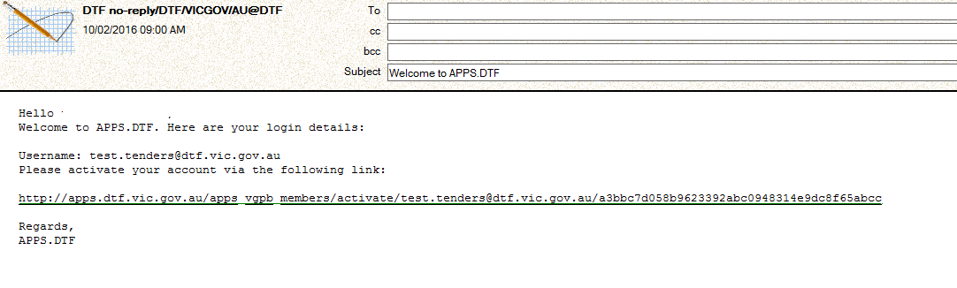

- Once completed, click on the APPS.DTF Login link.

- Once logged in successfully on the New State Purchase Contracts Information System, click on “Register link” and fill in the SPC confidential information registration form and press the submit button.

Registered user

STEP 2: REQUEST ACCESS TO SPC’S SELECTED CONFIDENTIAL INFORMATION
- Go to http://apps.dtf.vic.gov.au/apps_state_purchase_contracts/ to access the new confidential information system for selected SPC’s.

- Click on the “All Contracts” menu, and select the contracts you wish to request access.
- Click on the “My Contracts” menu, to view and manage the status of your requests.

- The Category Manager will receive your request and approve your eligibility.

Technical support

For system technical support, contact:
Liliana Sousa
Senior Application Support Analyst
Phone: 9651 1672
Email: liliana.sousa@dtf.vic.gov.au

