Victorian Government Purchasing Board

Annual Report 2014–2015
Achieving excellence in government procurement

Victorian Government Purchasing Board Annual Report 2014–15
Victorian Government Purchasing Board
Telephone: +61 3 9651 1699
Email: vgpb@dtf.vic.gov.au
Authorised by the Victorian Government
1 Treasury Place Melbourne Victoria 3002
Printed by On Demand, Port Melbourne
Printed on 100 per cent recycled paper

© State of Victoria (Victorian Government Purchasing Board) 2015
You are free to re-use this work under a Creative Commons Attribution 4.0 licence, provided you credit the State of Victoria (Victorian Government Purchasing Board) as author, indicate if changes were made and comply with the other licence terms. The licence does not apply to any images, photographs or branding, including Government logos.
Copyright queries may be directed to IPpolicy@dtf.vic.gov.au
ISSN 1444-4097
Published September 2015
Designed by Cordial Creative
This document is available in PDF and Word format at www.procurement.vic.gov.au.
Contents
As required by section 54M of the Financial Management Act 1994, this annual report describes the work and activities of the Victorian Government Purchasing Board from 1 July 2014 to 30 June 2015. This report has information about purchasing activity carried out by the seven Victorian Government departments and Victoria Police.

The year in review 6
Chair’s report 6
Key strategic priorities in 2014–15 7
Changes to the annual report in 2014–15 12
Key strategic priorities in 2015–16 13
About the VGPB 15
Vision and mission 15
Directives 15
Functions and powers 16
Scope of VGPB policies 16
Compliance with VGPB policies 17
Reporting relationship 18
VGPB members 18
VGPB annual assessment 20
Procurement spend 21
Overview of procurement spend 21
One-off supply contracts 22
Aggregated purchasing arrangements 24
Critical incident procurement 29
Procurement complexity and VGPB oversight 30
Procurement complexity in 2014–15 30
Procurement activity subject to VGPB oversight 33
Compliance with VGPB procurement policies 34
Complaints 36
Departmental procurement activities 38
Links and glossary 46
Procurement websites 46
Glossary 47
Acronyms and abbreviations 52
Tables and figures

Tables
Table 1: VGPB projects and initiatives completed in 2014–15 7
Table 2: Departmental transition dates and progress reports submitted 8
Table 3: Audit program schedule from 2016 to 2018 9
Table 4: VGPB guidelines produced in 2014–15 11
Table 5: Machinery of government changes in 2014–15 12
Table 6: Victorian Government public service bodies bound by VGPB policies as at 30 June 2015 17
Table 7: VGPB members as at 30 June 2015 18
Table 8: Total number and value of one-off supply, SEPC and SPC approvals in 2014–15 compared with 2013–14 21
Table 9: Number and value of one-off supply, SEPC and SPC approvals by goods and services in 2014–15 22
Table 10: Number and value of one-off supply approvals by department and by goods and services in 2014–15 22
Table 11: Number and estimated potential value of SEPC approvals by department and by goods and services in 2014–15 24
Table 12: Breakdown of SEPCs approved in 2014–15 26
Table 13: Number and estimated potential value of pre-qualification arrangements approved in 2014–15 28
Table 14: Breakdown of SPCs approved in 2014–15 28
Table 15: Description of complexity quadrants 30
Table 16: Number of one-off supply, SEPC and SPC approvals by complexity quadrant in 2014–15 31
Table 17: Complexity quadrants by department 32
Table 18: Number and estimated value of procurement activities subject to VGPB oversight in 2014–15 33
Table 19: Compliance with VGPB supply policies in 2014–15 34
Table 20: Complaints related to procurement activity in 2014–15 36

Figures
Figure 1: Performance measures to assess the benefits of procurement reform 10
Figure 2: VGPB 2015–16 Strategy overview 14
Figure 3: VGPB reporting relationship 18
Figure 4: Number of one-off supply approvals by department and by goods and services in 2014–15 22
Figure 5: Value of one-off supply approvals by department and by goods and services in 2014–15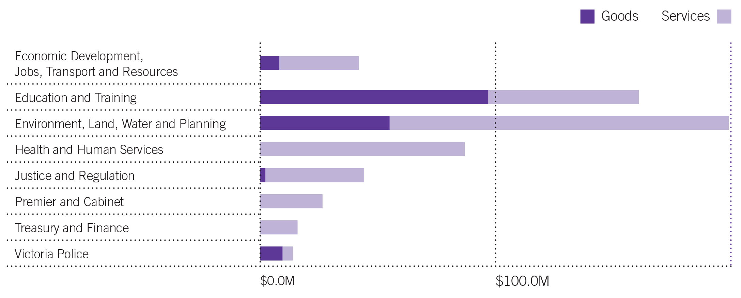 23
Figure 6: Number of SEPC approvals by department and by goods and services in 2014–15 25
Figure 7: Value of SEPC approvals by department and by goods and services in 2014–15 25
Figure 8: Number of procurement approvals by complexity quadrant in 2014–15 31
Figure 9: Value of procurement approvals by complexity quadrant in 2014–15 32

The year in review

Chair’s report
In 2014–15 the Victorian Government Purchasing Board (VGPB) successfully supported the transition of the remaining departments to its new supply policy framework. All departments and Victoria Police now take a complexity and risk-based approach to their procurement projects with the aim of delivering the best procurement process and outcomes for government.
This is a major milestone for the VGPB. Now that all departments and specified entities are working under the same supply policies, we can start assessing the benefits of the reform and continue to look for ways to improve the procurement framework.
As the VGPB develops its strategic oversight role and as departments strengthen their procurement capabilities, the VGPB will continue to work with departments to help the Government mature its procurement environment.
The VGPB also completed several projects this year, delivering on our strategic priorities to broaden VGPB influence across government and working with stakeholders to begin measuring the benefits of the procurement reform. Projects included implementing an audit program for the next three years, developing performances measures, launching a new procurement website and reviewing the suite of VGPB supply policies in response to the Government’s election commitments and broader operational feedback.
On behalf of the VGPB, I would like to express my appreciation to the Minister for Finance, Robin Scott MP, for his support of the VGPB. The VGPB looks forward to continuing to meet with the Minister to discuss the supply policy review and how best to reflect the Government’s procurement election commitments.
I would like to thank all VGPB members for their ongoing support in what has been a busy year, and particularly for their work in ensuring the successful transition of all departments.
The VGPB has again been supported wonderfully well by our Secretariat in the Department of Treasury and Finance. Their commitment to detail and the quality of their analysis across a breadth of initiatives has made our decision making much easier. Thanks also to the many departmental and entity officials who implemented procurement reform in their organisations. The VGPB appreciates the feedback from chief procurement officers throughout the year at forums and consultations focused on improving supply policies and measuring the benefits of reform.
It is with optimism and enthusiasm that we look to the future. We will continue to focus on building our partnerships with other government entities, collaborating with them to build their organisational capability and cultures and helping to embed VGPB policies so that procurement can deliver the best outcomes with the best value for money for the people of Victoria.
(Dr) Lynne Williams
Chair, Victorian Government Purchasing Board

Key strategic priorities in 2014–15
The VGPB continued to work with departments to progress its strategic priorities in 2014–15 with a significant focus on embedding the procurement reform and assessing its benefits.
Strategic priorities are focused on improving procurement outcomes for government and are aligned with the VGPB’s vision and mission. The priorities are set to ensure all procurement activity follows four procurement directives of value for money, scalability, probity and transparency.
The VGPB completed several projects to deliver on its strategic priorities for the year, as summarised in Table 1.
Table 1: VGPB projects and initiatives completed in 2014–15
Project | Result | Status
Strategic priority 1: Embedding procurement reform
Transition to the new procurement framework | Successfully supported the transition of all mandated departments and entities to its new VGPB supply policy framework by January 2015. | Completed
Strategic priority 2: Measuring the benefits of procurement reform
Performance measures | Developed six standardised performance measures to evaluate the benefits of the procurement reform by quantifying the extent to which departments:  - achieve savings, efficiencies and better service delivery;  - increase market engagement; and  - improve capability development. | Completed (performance measures effective in 2015–16)
Audit program | Launched a comprehensive multi-year audit program to ensure compliance with supply policies. | Completed  (audits begin in 2016)
Strategic priority 3: Broadening the VGPB’s influence
Accreditation to operate under VGPB policy | Worked with entities to bring their goods and services expenditure under the scope of VGPB supply policies. VicRoads was granted accreditation from 1 July 2015. Public Transport Victoria’s accreditation is in progress. | On track
New procurement website | Launched a concise, easy-to-navigate website to reinforce key messaging on the procurement reform and offer procurement information including guides and helpful links for buyers and suppliers. | Completed
Strategic priority 4: Understanding the market
New market guidelines | Worked on three guidelines to improve supplier engagement and identify and manage supply markets. One guideline was published in 2014–15 and two are due for publication in 2015–16. | On track
Other projects
Supply policy review | Began a review of VGPB supply policies in response to the Government’s election commitments and broader operational feedback. | On track

Strategic priority 1: Embedding procurement reform
By the end of 2014 the VGPB had completed the second and final stage of its transition review process. This involved evaluating and facilitating improvements to the remaining departments’ transition plans, including their procurement strategies and activity plans.
As part of the review process, the VGPB met with senior departmental executives including chief procurement officers to confirm that the requisite procurement governance arrangements were in place to comply with the supply policies.
The departments that presented their transition plans to the VGPB in 2014–15 were:
- Justice and Regulation;
- Economic Development, Jobs, Transport and Resources; and
- Environment, Land, Water and Planning.
The VGPB is currently working with other government entities to assist them to become accredited to procure goods and services under the VGPB’s supply policy framework. Both VicRoads and Public Transport Victoria (PTV) have been working with the VGPB to gain accreditation to the supply policies (see Strategic priority 4: Broadening the VGPB’s influence under Key strategic priorities in 2015–16).
Post transition, the VGPB’s role has shifted from approving procurements based on set dollar values to a strategic oversight function. In this new role, the VGPB continues to regularly review the performance of departments while maintaining oversight of procurement activity plans and specific strategic procurement activity (see Procurement activity subject to VGPB oversight later in this report).
As part of the oversight process, the VGPB reviews documentation at key stages of the procurement process and provides advice to accountable officers and chief procurement officers to ensure compliance with policy and the four procurement directives of value for money, scalability, probity and transparency.
Table 2 shows an overview of transition dates and progress reports submitted to the VGPB in 2014–15.
Table 2: Departmental transition dates and progress reports submitted
Departments | Transition date | Notes
Treasury and Finance (DTF) | 1 July 2013 | DTF submitted two progress reports to the VGPB in 2014–15.
Victoria Police | 1 Dec 2013 | Victoria Police submitted two progress reports to the VGPB in 2014–15.
Premier and Cabinet (DPC) | 1 Jan 2014 | DPC submitted two progress reports to the VGPB in 2014–15.
Education and Training (DET) | 1 July 2014 | DET submitted two progress reports to the VGPB in 2014–15.
Health and Human Services (DHHS) | 1 July 2014 | DHHS submitted two progress reports to the VGPB in 2014–15.
Justice and Regulation (DJR) | 1 Oct 2014 | DJR submitted a progress report to the VGPB in March 2015.
Economic Development, Jobs, Transport and Resources (DEDJTR) | 1 Jan 2015 | DEDJTR submitted a progress report to the VGPB in March 2015.
Environment, Land, Water and Planning (DELWP) | 1 Jan 2015 | DELWP submitted a progress report to the VGPB in March 2015.
Entities | Transition date | Notes
VicRoads | 1 July 2015 | VicRoads successfully gained accreditation to the VGPB supply policies.
Public Transport Victoria (PTV) | TBC | PTV is scheduled to submit its procurement plan and strategy in August 2015.
Note: The structure of some departments altered substantially in 2014–15 due to machinery of government changes. For more information refer to Changes to the annual report in 2014–15.

Strategic priority 2: Measuring the benefits of procurement reform
Now that transition to the procurement reform supply policies is complete for all in-scope entities, the VGPB will continue to fulfil its key legislative role of monitoring compliance with the VGPB supply policies as outlined in the Financial Management Act 1994 (the FMA).
The VGPB annual reporting framework is a key component in this. Under the framework, the Chair of each department’s internal procurement unit must attest that the department complies with the VGPB’s supply policies and provide associated evidence of specific initiatives and activities.
In 2014–15 the VGPB launched a comprehensive multi-year audit program to ensure compliance with the supply policies. The aim of the audit program is to minimise risks and improve processes to drive better procurement outcomes.
The audit program will be rolled out over three years from 2016 to 2018, in order of departments’ and entities’ transition. Audit results will be published in subsequent VGPB annual reports.
The audit program schedule is listed in Table 3.
Table 3: Audit program schedule from 2016 to 2018
Year | Department
2016 | - Treasury and Finance  - Victoria Police  - Premier and Cabinet  - Education and Training
2017 | - Health and Human Services  - Justice and Regulation  - Economic Development, Jobs, Transport and Resources
2018 | - Environment, Land, Water and Planning  - VicRoads
Once this first audit cycle is complete, the VGPB proposes to restart the schedule from the beginning. The schedule will be adjusted and updated subject to new entities being brought under the scope of VGPB supply policies.
To complement the audit program, the VGPB developed six standardised performance measures to achieve a consistent, quantifiable approach to measuring reform benefits (see Figure 1). The performance measures were developed in consultation with departments and finalised in June 2015.
The performance measures will be implemented as part of the VGPB’s annual reporting framework for 2015–16. A focus in 2015–16 will be to work with departments and specified entities to further review and refine the KPIs and targets.
Figure 1: Performance measures to assess the benefits of procurement reform
- Value created as a consequence of department procurement activity
- Proportion of the number of transactions at or below $2 000 through a P-Card or equivalent
- Increase in procurement capability
- Cost of department’s procurement resources as a percentage of total contract spend
- Supplier satisfaction assessment
- Planned procurement activity as a percentage of actual procurement activity

Strategic priority 3: Broadening the VGPB’s influence
In late 2013 the Victorian Government amended the FMA granting greater flexibility to change the scope of government entities required under legislation to comply with VGPB policies. This enabled the VGPB to work with entities to bring their goods and services expenditure under the scope of VGPB supply policies.
In 2014 the VGPB began working with VicRoads and PTV to bring these government entities within its framework.
VicRoads submitted an accreditation plan including its procurement strategy and procurement activity plan for VGPB review in April 2015. The VGPB was pleased to grant VicRoads accreditation to the supply policies effective from 1 July 2015.
VicRoads was the first entity under the amended FMA to undertake accreditation. This model will be used as the basis for other entities’ accreditation as the VGPB broadens its scope.
The VGPB also worked with PTV to bring its goods and services procurement under the scope of VGPB supply policies. PTV is currently undertaking preparatory work to gain accreditation and is expected to present its accreditation plan for review early in the 2015–16 financial year.
The VGPB is committed to promoting procurement reform across government by regularly engaging with its stakeholders. Throughout the year, the VGPB continued to build its relationship with Health Purchasing Victoria (HPV), a statutory body responsible for supply chain improvements including procurement of goods and services across the health sector. Victorian public hospitals and health services are mandated by the State Government to use HPV contracts. HPV has implemented a policy framework modelled on the VGPB supply policies. The VGPB and HPV meet regularly to share information to encourage improvements in procurement outcomes and capability development.
In April 2015 the VGPB Chair spoke at the World Bank delegation knowledge exchange program. The World Bank delegation consisted of the heads of procurement from nine South-East Asian countries. It focused on policy, process capability development, sustainable procurement and construction. The VGPB Chair shared lessons learned and the benefits achieved to date from the Victorian Government procurement reform.
The VGPB continued to engage with the business community to increase procurement opportunities for small and medium enterprises (SMEs) through different initiatives. For example, the VGPB’s new supply policy framework is communicated through Small Business Victoria’s Winning Government Business seminars.
In addition, the VGPB launched a new website that offers departmental buyers and industry suppliers an easily accessible online resource. The website features supply policy information and good practice guides for buyers along with handy links to government business seminars and upcoming procurement opportunities for suppliers.
Building on positive outcomes from its engagements in 2014–15, the VGPB will continue to engage regularly with key stakeholders across the Victorian Government and interstate jurisdictions. The VGPB recognises the importance of consulting with these stakeholders to promote its procurement reform agenda and to learn from the experience of these entities.

Strategic priority 4: Understanding the market
In 2014–15 the VGPB worked on three guidelines to enhance procurement capability across departments (see Table 4). The guidelines aim to improve government engagement with suppliers and how departments identify and manage supply markets. They provide good practice advice on taking a strategic approach to procurement.
Table 4: VGPB guidelines produced in 2014–15
Guide | Description | Published
Guide to supplier feedback | How to enhance existing tender debriefing and contract management communications, enabling suppliers to provide more general feedback on the government’s engagement with the market. | July 2014
Guide to category management | How to identify categories, create a strategic category plan and manage each category to deliver the best value-for-money outcomes. | Scheduled for late 2015
Guide to supply chain management | How to manage goods and services throughout the procurement lifecycle, with a holistic approach to planning and monitoring the supply chain to identify risks and opportunities. | Scheduled for early 2016

Changes to the annual report in 2014–15
This annual report marks the first year that all departments reported under the VGPB’s new supply policy framework.
The new reporting framework improves transparency by assessing departmental performance against the new policy objectives and providing a single, consistent approach across the government procurement portfolio.
In December 2014 the Victorian Government announced machinery of government changes affecting the naming and structure of several departments. Nine departments were streamlined into seven, and previous departmental and portfolio responsibilities shifted (see Table 5).
The change in departmental structure saw a substantial change in the procurement landscape. The seven departments reported on all procurement during the financial year based on their procurement profile at 30 June 2015.
Table 5: Machinery of government changes in 2014–15
Departments | Machinery of government changes
Economic Development, Jobs, Transport and Resources | Renamed (formerly Department of State Development, Business and Innovation) with additional responsibilities from the former Department of Environment and Primary Industries (DEPI), and transport from the former Department of Transport, Planning and Local Infrastructure (DTPLI)
Education and Training | Renamed (formerly Department of Education and Early Childhood Development) with no change in responsibilities
Environment, Land, Water and Planning | Renamed (formerly DEPI) retaining some responsibilities from DEPI and planning and local infrastructure from the former DTPLI
Health and Human Services | Combination of Department of Health and Department of Human Services
Justice and Regulation | Renamed (formerly Department of Justice) with amended responsibilities
Premier and Cabinet | Retained with amended responsibilities
Treasury and Finance | Retained with amended responsibilities

Key strategic priorities in 2015–16
As the VGPB and departments and specified entities continue to evolve into their new roles post transition – both independently and jointly – the VGPB will focus on measuring the benefits of the reform and strengthening working relationships with departments and entities to build procurement capability and broaden scope where appropriate. The VGPB will also continue to review its supply policies to ensure that they reflect the Government’s policies.
The four strategic priorities identified for 2015–16 are underpinned by strategic oversight and will continue to support the VGPB’s vision, mission, directives and policies. Figure 2 provides a high level overview of the VGPB’s Strategy.

Strategic priority 1: Enhancing the VGPB supply policies to reflect the Government’s election commitments
In 2014–15 the VGPB began reviewing its supply policies to see how well they reflected the Government’s election commitments as well as broader operational issues identified now that all major entities have transitioned.
The VGPB is providing advice to the Government on the supply policy review. The review is anticipated to be finalised in early 2015–16 before beginning any gazettal process. The VGPB consulted widely across government as part of the review process to facilitate the implementation of any proposed options for change.

Strategic priority 2: Measuring the benefits of procurement reform
The VGPB will continue to implement its audit program to ensure compliance with supply policies. Departmental compliance will achieve greater procurement efficiencies and drive greater value-for-money outcomes. The first rounds of audits will begin in early 2016.
The VGPB will implement six standard key performance indicators across the seven departments, Victoria Police, VicRoads and other entities as they come under the scope of the VGPB. These measures are designed to quantify the benefits of the procurement reform and provide a baseline against which to set further targets for the two and three year marks. Next year’s VGPB annual report will feature the baseline results from year one.

Strategic priority 3: Improving procurement capability across government
In 2015–16 the VGPB will continue to focus on improving procurement capability across government following the transition of all departments to the new supply policy framework. The VGPB will use initiatives such as a gap analysis to identify opportunities to improve capability and continuously assess capability improvement initiatives where required.
In addition, the VGPB will continue to develop guidelines to assist departments and entities to better understand the market to complement a more sophisticated approach to procurement.

Strategic priority 4: Broadening the VGPB’s influence
The VGPB is committed to improving procurement processes and outcomes by bringing more entities under the scope of VGPB policies and engaging with key stakeholders across government.
The VGPB will continue to work with PTV to bring its procurement of goods and services under the scope of the VGPB.
As in previous years, the VGPB will continue to engage with stakeholders across government to build on the reform agenda. Departmental chief procurement officers meet regularly to share their experiences and challenges with implementing the procurement reform. Understanding stakeholder needs and their experiences with implementing the reform will enable the VGPB to continuously improve and tailor the accreditation program as part of the reform agenda.
Figure 2: VGPB 2015–16 Strategy overview
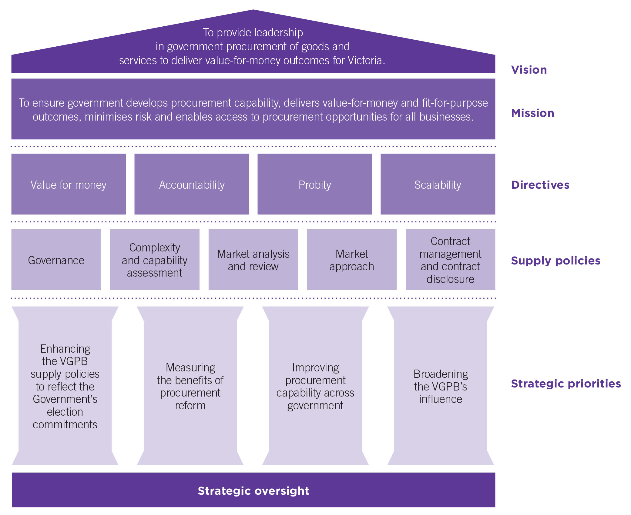

About the VGPB
The Victorian Government Purchasing Board (VGPB) was established under the Financial Management Act 1994 (the FMA). The VGPB meets no less than six times a year to develop and approve policies, provide strategic oversight of major departmental procurements and discuss procurement policy and practice.

Vision and mission
The VGPB’s vision is to provide leadership in government procurement of goods and services to deliver value-for-money outcomes for Victoria.
The VGPB’s mission is to ensure government:
- develops procurement capability;
- delivers value-for-money and fit-for-purpose outcomes;
- minimises risk; and
- enables access to procurement opportunities for all businesses.

Directives
The VGPB’s supply policies cover end-to-end procurement activity from identifying needs, planning and market research through to contract management. Each policy is supported by good practice guides, tools and templates to ensure consistency across government.
When applying the policies, departments must ensure that all procurement activity meets the following directives:
- Value for money: A balanced judgement of a range of financial and non-financial factors, taking into account the mix of quality, cost and resources; fitness for purpose; total cost of ownership; and risk.
- Accountability: The accountable officer has the flexibility to conduct procurement activities using appropriate capability to provide value-for-money outcomes.
- Probity: High standards of behaviour and actions in the conduct of procurement processes. Equity, confidentiality, avoiding conflicts of interest, and consumer/supplier confidence in the integrity of government procurement processes.
- Scalability: The relationship between the complexity of a procurement project and the capability of the organisation to conduct it to achieve a good procurement outcome.

Functions and powers
The VGPB has the following functions as defined by section 54B of the FMA:
- in relation to the supply of goods and services to departments and specified entities and the management and disposal of goods by departments and specified entities—
    - to develop, implement and review policies and practices; and
    - to provide advice, staff training and consultancy services;
- to monitor compliance by departments and specified entities with supply policies and Ministerial directions and to report irregularities to the relevant Minister and the Minister;
- to foster improvements in the use and application of purchasing systems and electronic trading;
- to establish and maintain a comprehensive data base of purchasing data of departments and specified entities and supply markets for access by departments and specified entities;
- any other functions conferred on the Board by this Part.
The VGPB has the following powers under section 54C of the FMA:
- The Board has all the powers necessary to perform its functions.
- Without limiting subsection (1), the Board may—
  - enter into contracts or arrangements on its own behalf, on behalf of the State or on behalf of departments or specified entities;
  - call and award tenders and advertise;
  - consider and approve requisitions for the purchase of goods and services by departments or specified entities;
  - require accountable officers to audit compliance by departments and specified entities with supply policies and Ministerial directions and provide audit reports to the Board;
  - require accountable officers to provide information and data relating to the supply of goods and services and the management and disposal of goods;
  - exercise any other powers conferred on the Board by this Act or the regulations.
An accountable officer must provide to the Board on request—
  - audit reports referred to in subsection (2)(d);
  - information and data referred to in subsection (2)(e).

Scope of VGPB policies
The VGPB’s policies apply to the following public service bodies:
- government departments and specified entities;
- administrative offices; and
- the Victorian Public Sector Commission.
Under section 54AA of the FMA, the Governor in Council may declare by Order that VGPB policy also applies to an entity or a class of entities. VicRoads was granted VGPB accreditation effective 1 July 2015 and the process has started for the Governor in Council to declare that VicRoads is specified as an entity under the scope of the VGPB. Public Transport Victoria has begun its accreditation process with the VGPB.
Table 6 lists the public service bodies bound by VGPB policies as at 30 June 2015.
Administrative offices and the Victorian Public Sector Commission do not report directly to the VGPB, but operate through their portfolio departments. Victoria Police sits in the Department of Justice and Regulation portfolio but reports to the VGPB directly for reasons of oversight.
Table 6: Victorian Government public service bodies bound by VGPB policies as at 30 June 2015
 | Public service body
Departments | Economic Development, Jobs, Transport and Resources
Departments | Education and Training
Departments | Environment, Land, Water and Planning
Departments | Health and Human Services
Departments | Justice and Regulation
Departments | Premier and Cabinet
Departments | Treasury and Finance
Offices | Commission for Children and Young People
Offices | Essential Services Commission
Offices | Game Management Authority
Offices | Independent Broad-Based Anti-Corruption Commission
Offices | Office of Public Prosecutions
Offices | Office of the Chief Commissioner of Police (Victoria Police)
Offices | Office of the Commissioner for Environmental Sustainability
Offices | Office of the Fire Services Levy Monitor
Offices | Office of the Freedom of Information Commissioner
Offices | Office of the Legal Services Commissioner
Offices | Office of the Ombudsman
Offices | Office of the Privacy Commissioner
Offices | Office of the Road Safety Camera Commissioner
Offices | Office of the Victorian Inspectorate
Offices | Taxi Services Commission
Offices | Victorian Auditor-General's Office
Offices | Victorian Commission for Gambling and Liquor Regulation
Offices | Victorian Electoral Commission
Offices | Victorian Equal Opportunity and Human Rights Commission
Other | Victorian Public Sector Commission

Compliance with VGPB policies
Section 54L of the FMA requires all accountable officers and other members of staff of departments and specified entities to comply with VGPB procurement policies when acquiring goods and services.
Departments must report to the VGPB at least once every six months with a revised procurement activity plan and an update on their progress in delivering improvements in procurement capability, governance and procurement outcomes among other things.
When reviewing procurement activity plans, the VGPB identifies specific procurements for ongoing oversight. These procurements are considered by the VGPB to be of strategic importance to the State and are subject to the VGPB’s ongoing review at key stages of the procurement process. The VGPB provides recommendations for departments to action based on the outcomes of its review.
Departments also complete an annual supply report (ASR) at the end of each financial year for the VGPB. The ASR summarises departmental procurement activity during the year and is signed off by the Chair of the internal procurement unit, who is responsible for governing departmental procurement process.

Reporting relationship
The VGPB reports to the Minister for Finance. The Department of Treasury and Finance (DTF) provides secretariat and other support to the VGPB and has a direct reporting line to the Minister for Finance on procurement and contracting issues. Figure 1 illustrates this relationship.
Figure 3: VGPB reporting relationship
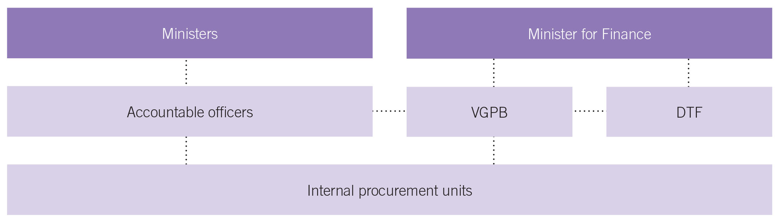
Under section 54M of the FMA, the VGPB must give the Minister for Finance a report of its work and activities for the year ending on 30 June that year. The Minister for Finance tables the VGPB’s annual report in Parliament.

VGPB members
The Board consists of a chairperson and not less than six other members. Board members are selected based on experience and expertise in procurement-related matters. They can be internal or external to government.
At 30 June 2015 the VGPB had seven members including the Chair. Five members were external appointees and two appointees were from the Victorian Government (see Table 7).
The VGPB meets every two months with an additional strategic planning day held in March each year. The Board held an extraordinary meeting in September 2014 to help departments transition to the new procurement framework.
The VGPB had two member appointments that concluded during the year:
- Roger Cotton on 31 July 2014; and
- Professor Nilss Olekalns on 30 September 2014.
Table 7: VGPB members as at 30 June 2015
Title | Name | Background and experience | Meetings attended | Appointed
Chair | Dr Lynne Williams | Dr Williams worked in the state and federal public sectors for over 30 years, and held several senior executive roles specialising in economic policy, primarily in central agencies. Dr Williams has a number of other board positions including on the Victorian Legal Services Board, the Victorian Building Authority, the Essential Services Commission of South Australia, and the Faculty of Business and Economics at the University of Melbourne. | 5 out of 6 | 4 October 2011
External appointees | Neil Lucas | Mr Lucas has extensive experience in governance, strategic and operational management across the public sector, including Chief Executive Officer to the City of Berwick and Administrator of Christmas Island and Cocos (Keeling Islands). Mr Lucas also served as a member of the Victorian Parliament from 1996 to 2002. | 5 out of 6 | 4 October 2011
External appointees | Craig Rooney | Mr Rooney has over 25 years of procurement experience in the public, private and consulting environments. Mr Rooney is currently Regional Manager of Porter Davis Homes and has held a number of senior procurement management positions at CSR Sugar, Madison Cross Corporate Advisory and Coles Myer. Mr Rooney is a Member of the Chartered Institute of Purchasing and Supply Australia. | 4 out of 6 | 1 October 2012
External appointees | Randall Straw | Mr Straw was Deputy Secretary, Innovation and Technology/Industry and Trade at the former Department of Business and Innovation. He has an extensive background in technology innovation, policy, planning and implementation with Victorian public sector agencies. Mr Straw is currently Chair of CenITex and Chair of the Department of Economic Development, Jobs, Transport and Resource's Investment Committee. He was awarded the Public Service Medal in 2012. | 6 out of 6 | 1 October 2009
External appointees | Russell Yardley | Mr Yardley is a successful entrepreneur and business owner. Mr Yardley has strong governance skills and is an experienced board member. His career has focused on innovation, ideas strategy, business and planning in the ICT industry in particular. | 6 out of 6 | 1 July 2014
Government appointees | Marisa De Cicco | Ms De Cicco is the Deputy Secretary, Criminal Justice Division at the Department of Justice and Regulation. She has experience in policy advice and development, formulation of strategy and legislation, procurement and contracting. | 5 out of 6 | 1 October 2003
Government appointees | Julie Freeman | Ms Freeman is an Assistant Victorian Government Solicitor, Head of Commercial, Property and Technology Branch at the Victorian Government Solicitor’s Office. Ms Freeman has extensive experience in public sector procurement projects, corporate governance, policy development, legislative interpretation and industry regulation and reform. | 5 out of 6 | 1 July 2014

VGPB annual assessment
As part of its commitment to continuous improvement, the VGPB assesses its performance over the previous year.
The assessment in 2014–15 showed that the VGPB continues to fulfil its legislative functions. The VGPB prioritised the transition of all departments to the new supply policies, working through the change in government. The VGPB also reviewed its supply policies two years after their launch.
The appointment of new VGPB members further strengthened the procurement expertise required to support departments under the supply policy framework. Members agreed that relationships in the Board were productive and effective.
Members also noted the importance of continuing to clarify the VGPB’s role under the supply policy framework to its stakeholders, and to focus on how supply policies might be improved further to achieve the best outcomes for Victorians.

Procurement spend

This section provides an overview of procurement approvals valued at greater than $100 000 in the 2014–15 financial year for:
- one-off supply; and
- aggregated purchasing arrangements including:
  - sole entity purchase contracts (SEPCs); and
  - state purchase contracts (SPCs).
This section also includes purchases made under the critical incident procurement policy.
One-off supply and SEPC approvals relate to approval of the procurement, that is, to enter into a contractual arrangement with the selected supplier or suppliers. SPC approvals relate to approval of the business case.
Actual expenditure occurs later and may occur over a number of financial years depending on the nature of the contract.
All figures in the tables and text in the annual report have been rounded. Discrepancies in tables between totals and sums of components reflect this rounding.
For ease of reporting, any reference to ‘departments’ in this annual report includes Victoria Police (where relevant).

Overview of procurement spend
In 2014–15 departments reported 673 procurement approvals valued at $1 621.9 million as shown in Table 8. This compares with 607 procurement approvals valued at $943.5 million reported in 2013–14.
Table 8: Total number and value of one-off supply, SEPC and SPC approvals in 2014–15 compared with 2013–14
 | 2014–15 |  | 2013–14
 | Number | Value |  | Number | Value
One-off supplies | 630 | $692.3M |  | 573 | $735.5M
SEPCs | 37 | $270.9M |  | 29 | $93.2M
SPCs | 6 | $658.6M |  | 5 | $114.8M
Totals | 673 | $1 621.9M |  | 607 | $943.5M
The total value of procurement approvals increased by $678.3 million in 2014–15. This is due to one high value SPC (the legal services panel valued at $525.0 million) and one high value SEPC valued at $164.0 million. Both of these contracts are based on estimated values that are set to run over multiple years (six years and four months including options and five years respectively). The SPC also represents demand aggregated across all departments and specified entities.

Table 9 shows an overview of procurement spend by goods and services. Overall, 12 per cent of procurement approvals were for goods and 88 per cent for services.
Table 9: Number and value of one-off supply, SEPC and SPC approvals by goods and services in 2014–15
 | One-off supplies |  | SEPCs |  | SPCs |  | Totals
 | Number | Value | Number | Value | Number | Value | Number | Value
Goods | 60 | $174.8M | 18 | $42.1M | .. | .. | 78 | $216.9M
Services | 570 | $517.6M | 19 | $228.8M | 6 | $658.6M | 595 | $1 405.0M
Totals | 630 | $692.3M | 37 | $270.9M | 6 | $658.6M | 673 | $1 621.9M

One-off supply contracts
One-off supply refers to a single purchase of a specific quantity of goods or services which has been subject to a discrete quotation or tender process.
In 2014–15 departments reported 630 one-off supply procurement approvals valued at $692.3 million. Ten per cent of one-off supply approvals were for procurement of goods and 90 per cent for services.
This compares to 573 one-off supply approvals in 2013–14 valued at $735.5 million.
Table 10 and Figures 4 and 5 show the number and value of one-off supply approvals by department and by goods and services.
Table 10: Number and value of one-off supply approvals by department and by goods and services in 2014–15
Department | Goods |  | Services
Department | Number | Value | Number | Value
Economic Development, Jobs, Transport and Resources | 16 | $8.1M | 75 | $33.9M
Education and Training | 19 | $96.9M | 174 | $64.0M
Environment, Land, Water and Planning | 11 | $55.5M | 82 | $144.1M
Health and Human Services | .. | .. | 109 | $86.9M
Justice and Regulation | 4 | $4.3M | 51 | $141.8M
Premier and Cabinet | 2 | $0.4M | 52 | $26.5M
Treasury and Finance | .. | .. | 21 | $15.9M
Victoria Police | 8 | $9.5M | 6 | $4.4M
Totals | 60 | $174.8M | 570 | $517.6M
Figure 4: Number of one-off supply approvals by department and by goods and services in 2014–15
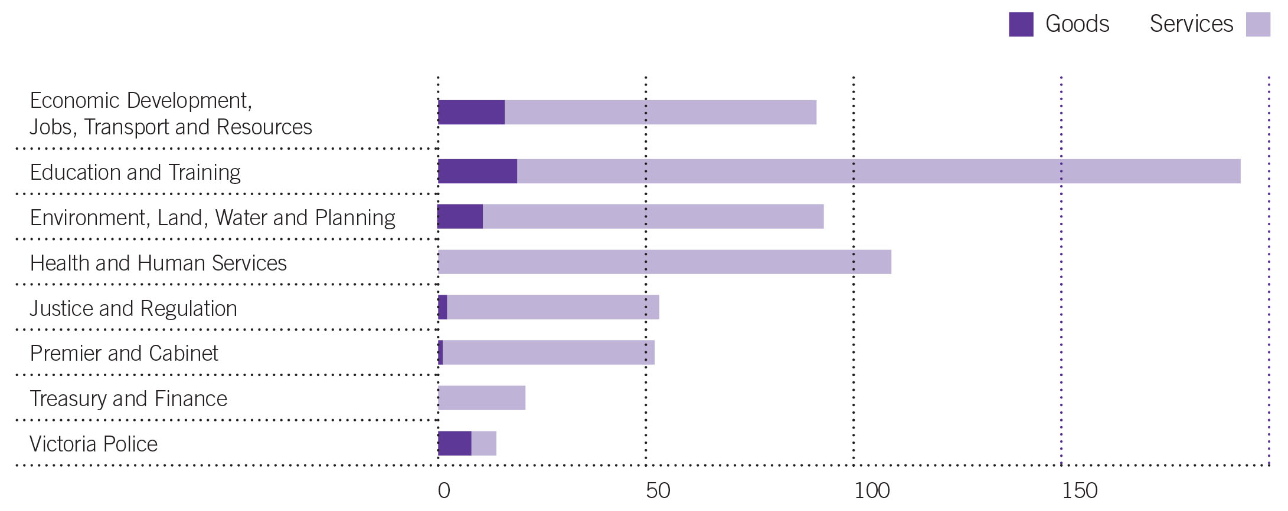
Figure 5: Value of one-off supply approvals by department and by goods and services in 2014–15

Aggregated purchasing arrangements
Aggregated purchasing arrangements (also known as standing offer agreements) are established when a sole or multiple departments have a specific requirement for frequently purchased goods and services. By grouping together demand (aggregating demand) for commonly purchased goods and services, departments can harness greater economies of scale when negotiating with potential suppliers.
These arrangements take the form of SPCs or SEPCs. SPCs incorporate a number of organisations, whereas SEPCs usually apply to a single organisation.
Aggregated purchasing arrangements can be established and managed in a number of ways – sole or multiple suppliers, open or closed panels, register, pre-qualification or a more formal contractual arrangement. They can involve arrangements with one or more suppliers for a set period (usually three to five years), incorporate a schedule of rates and performance levels, and usually require no obligation on the State to purchase a particular quantity of the goods or services.
All government departments and agencies can access SPCs as long as they commit to the rules of use. SEPCs are mandatory for the department establishing the procurement arrangement.
These long-term agreements have benefits to government such as:
- using the aggregated purchasing power of departments to negotiate lower prices and better service; and
- reducing the administrative burden for end users in preparing specifications, requesting quotations and tenders, and evaluating offers for similar purchases.
The values in the tables are estimates. Expenditure occurs later and over a number of years as detailed in the contract term and options columns. Total estimated value includes the initial contract term as well as any options.

Sole entity purchase contracts
In 2014–15 departments reported 37 SEPC approvals valued at $270.9 million. Only four departments reported SEPCs during the year (see Table 11).
Of these, 49 per cent were for goods and 51 per cent for services although the overall value of goods was much lower (16 per cent of total SEPC approval value) than the value of services (84 per cent of total SEPC approval value).
This compares to 29 SEPCs approvals in 2013–14 valued at $93.2 million of which 45 per cent were for goods and 55 per cent for services.
Table 11: Number and estimated potential value of SEPC approvals by department and by goods and services in 2014–15
Department | Goods |  | Services
Department | Number | Value | Number | Value
Education and Training | 1 | $4.5M | .. | ..
Environment, Land, Water and Planning | 3 | $12.0M | 2 | $29.5M
Health and Human Services | 1 | $6.6M | 5 | $8.5M
Victoria Police | 13 | $19.1M | 12 | $190.9M
Totals | 18 | $42.1M | 19 | $228.8M
Figures 6 and 7 provide an overview of number and value of SEPCs by department and by goods and services and Table 12 provides a breakdown of all SEPCs approved in 2014–15.
Figure 6: Number of SEPC approvals by department and by goods and services in 2014–15
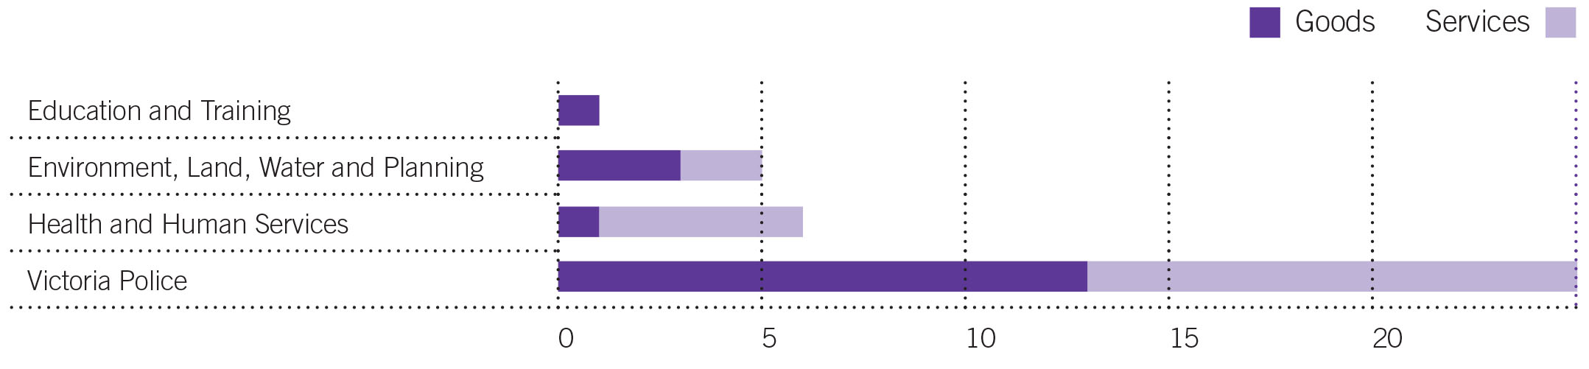
Figure 7: Value of SEPC approvals by department and by goods and services in 2014–15
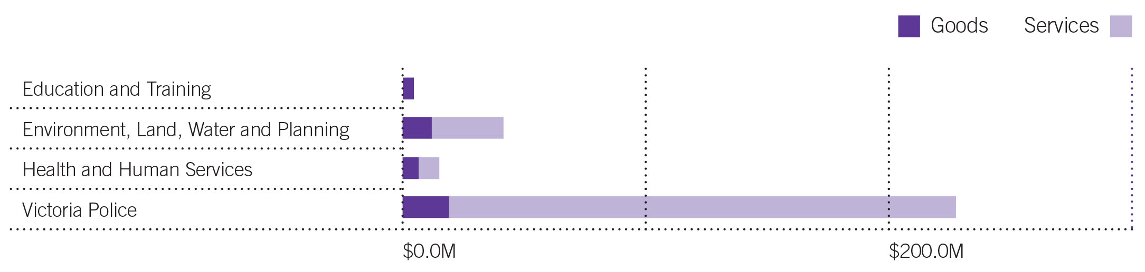

Table 12: Breakdown of SEPCs approved in 2014–15
Department | Total no. | Title/description | Total estimated value | Contract term (yrs) | Options (yrs) | Complexity assessment outcome | Market approach method | Type of arrangement | No. of suppliers
Education and Training | 1 | Secure print panel | $4.5M | 3 | 2 | Leveraged | Open market EOI then select tender | Closed | 8
Environment, Land, Water and Planning | 5 | Vehicle mounted emergency fire blankets | $1.0M | 3 | 2x1 | Strategic | Quotation – sole supplier | Closed | 1
Environment, Land, Water and Planning | 5 | Safety and wellbeing panel | $4.5M | 3 | 2x1 | n/a [1] | Open tender | Closed | 18
Environment, Land, Water and Planning | 5 | Drummed and bulk specialist fuels | $5.0M | 2.5 | 2x1 | n/a [1] | Open tender | Closed | 3
Environment, Land, Water and Planning | 5 | Drummed and bulk aviation fuels | $6.0M | 3 | 2x1 | n/a [1] | Open tender | Closed | 5
Environment, Land, Water and Planning | 5 | Aviation services panel | $25.0M | 4 | – | n/a [1] | Open tender | Open | 38
Health and Human Services | 6 | Review officer panel – grievance investigations | $0.4M | 2 | 1 | Strategic | Open tender | Closed | 8
Health and Human Services | 6 | Fire safety induction program | $0.5M | 3 | 2 | Transactional | Open tender | Closed | 1
Health and Human Services | 6 | Video relay interpreting service (Auslan) | $0.5M | 3 | – | Leveraged | Open tender | Closed | 1
Health and Human Services | 6 | Employee assistance program | $2.6M | 3 | 2 | Leveraged | Open tender | Closed | 1
Health and Human Services | 6 | Pathology services | $4.4M | 3 | 2 | Transactional | Open tender | Closed | 1
Health and Human Services | 6 | Diphtheria, tetanus, pertussis vaccine | $6.6M | 3 | 1 | Transactional | Open tender | Closed | 1
Victoria Police | 25 | Prisoner meals at Wangaratta police complex | $0.1M | 0.8 | – | Transactional | Quotation | Closed | 1
Victoria Police | 25 | Maintenance and support services for visual audio recorded evidence (VARE) interview equipment | $0.2M | 2 | 2 | Transactional | Open tender | Closed | 1
Victoria Police | 25 | Tamper evident audit bags | $0.3M | 3 | 2 | Transactional | Quotation | Closed | 1
Victoria Police | 25 | Binders, folders and covers | $0.3M | 3 | 2 | Transactional | Quotation | Closed | 1
Victoria Police | 25 | Mainframe software | $0.3M | 2 | – | Focused | Quotation – sole supplier | Closed | 1
Victoria Police | 25 | Fingerprint consumables | $0.4M | 3 | 2 | Transactional | Quotation | Closed | 1
Victoria Police | 25 | Adobe social software | $0.4M | 3 | – | Transactional | Quotation | Closed | 1
Victoria Police | 25 | Nitrile gloves | $0.4M | 3 | 2 | Transactional | Open tender | Closed | 1
Victoria Police | 25 | Psychological testing tool | $0.5M | 2.8 | 3 | Transactional | Quotation | Closed | 1
Victoria Police | 25 | Food supplies – non-alcoholic beverages, confectionery and milk products | $0.7M | 3 | 2 | Transactional | Quotation | Closed | 4
Victoria Police | 25 | High visibility vests and raincoats | $0.7M | 3 | 2 | Transactional | Open tender | Closed | 1
Victoria Police | 25 | Adobe licensing for Windows 7 | $0.7M | 3 | – | Transactional | Quotation | Closed | 1
Victoria Police | 25 | Facilitation of the senior managers’ leadership development program | $0.7M | 3 | 1 | Transactional | Open tender | Closed | 1
Victoria Police | 25 | Made to measure uniform incorporating cloth | $0.7M | 3 | 2 | Transactional | Open tender | Closed | 4
Victoria Police | 25 | Secure waste collection and disposal | $1.2M | 3 | 2 | Leveraged | Select tender | Closed | 1
Victoria Police | 25 | Light cartage (parcel delivery) services | $1.7M | 3 | 2 | Transactional | Open tender | Closed | 1
Victoria Police | 25 | Microsoft Premier support | $2.0M | 3 | – | Transactional | Quotation | Closed | 3
Victoria Police | 25 | Replacing moving mobile and stationary radars | $2.3M | 1.6 | – | Focused | Quotation | Closed | 2
Victoria Police | 25 | Telecommunication network technical support services (voice/data), project management and LAN maintenance | $2.8M | 2.25 | 2 | Transactional | Open tender | Closed | 1
Victoria Police | 25 | National survey of community satisfaction with policing | $3.4M | 3 | 2 | Leveraged | Open tender | Closed | 1
Victoria Police | 25 | Food supplies to Victoria Police | $5.3M | 3 | 2 | Leveraged | Open tender | Closed | 8
Victoria Police | 25 | Integrated operational equipment vests | $6.6M | 2 | 1 | Focused | Quotation | Closed | 1
Victoria Police | 25 | Employment suitability tests for recruit applicants | $6.9M | 3 | 3 | Leveraged | Open tender | Closed | 1
Victoria Police | 25 | Internal audit services | $7.3M | 2 | 2 | Transactional | Open tender | Closed | 1
Victoria Police | 25 | Information technology services | $164.0M | 5 | – | Strategic | Open tender | Closed | 1
Total | 37 |  | $270.9M
[1] These SEPCs were approved before transition and did not require a complexity assessment.
EOI = Expression of interest

Pre-qualification arrangements
Pre-qualification is a type of aggregated purchasing arrangement. It can reduce the cycle time of the procurement process by evaluating potential bidders against a list of criteria before tenders are invited to ensure that only bidders that meet defined standards are eligible to bid.
In 2014–15 there were three pre-qualification arrangements reported valued at $2.3 million as listed in Table 13.
Table 13: Number and estimated potential value of pre-qualification arrangements approved in 2014–15
Department | Total number | Title/  description | Total estimated value | Contract term (yrs) | Options (yrs) | Complexity assessment outcome | Market approach method | Type of arrangement | No. of suppliers
Premier and Cabinet | 3 | Career advisory register | $0.3M | 3 | – | Transactional | EOI | Closed | 30
Premier and Cabinet | 3 | Federalism and public sector reform | $1.0M | 3 | 2x1 | Transactional | EOI | Closed | 16
Premier and Cabinet | 3 | Victorian Leadership Development Centre executive coaching panel [1] | $1.0M | 3 | 2x1 | Strategic | Open tender | Closed | 21
Totals | 3 |  | $2.3M
EOI = Expression of interest
[1] Open to all departments to access.

State purchase contracts
SPCs are primarily established and managed by the Department of Treasury and Finance (DTF). DTF may grant lead agency status to another organisation if it meets certain criteria as outlined in the relevant VGPB supply policy. Responsibility for whole of government ICT SPCs was moved to the Department of Premier and Cabinet under machinery of government changes in 2014–15.
In 2014–15 departments reported six SPCs with an estimated total value of $658.6 million. This compares with five SPCs with an estimated total value of $114.8 million reported in 2013–14.
Table 14 provides a breakdown of all SPCs approved in 2014–15.
Table 14: Breakdown of SPCs approved in 2014–15
Department | Total number | Title/  description | Total estimated value | Contract term (yrs) | Options (yrs) | Complexity assessment outcome | Market approach method | Type of arrangement | No. of suppliers
Justice and Regulation | 1 | Legal services panel | $525.0M | 3.3 | 3 | Strategic | Open tender | Closed | 0 [1]
Premier and Cabinet | 3 | Cloud web services | $2.0M | 1 | – | Leveraged | Sole supplier | Closed | 1
Premier and Cabinet | 3 | Multi-function devices and printing | $40.0M | 3 | – | Leveraged | Open tender | Closed | 3
Premier and Cabinet | 3 | Oracle systems and support | $72.0M | 3 | 1 | Strategic | Sole supplier | Closed | 1
Treasury and Finance | 2 | Fleet disposal | $2.1M | 3 | – | Transactional | Open tender | Closed | 1
Treasury and Finance | 2 | Document mail exchange | $17.5M | 3 | 2x1 | Transactional | Direct negotiation | Closed | 1
Totals | 6 |  | $658.6M
[1] Contracts not yet awarded.

Critical incident procurement
The market approach policy establishes an alternative procurement process to operate during a critical incident and any subsequent relief effort. The processes under this policy aim to accommodate urgent procurement needs while ensuring that the procurement process adopted is reasonable and conducted with appropriate consideration of good practice procurement principles.
There were no critical incident procurements reported in 2014–15. This compares with four critical incident procurements valued at $0.08 million in 2013–14.

Procurement complexity and VGPB oversight
Procurement complexity relates to the level of intricacy and scope of issues involved in procuring a good or service. It is measured by considering the internal and external influences on a procurement activity such as risk, total cost of ownership and market dynamics.
When buying goods and services, departments complete a complexity assessment and use the results to guide the sourcing strategy and how to manage risks and contractual arrangements.
During its regular review of departments’ procurement activity plans, the VGPB identifies procurements for oversight that it considers to be of strategic importance to the State. Departments can also nominate specific procurements for VGPB oversight.
There are four complexity quadrants as described in Table 15.
Table 15: Description of complexity quadrants
 | Quadrant | Description
1 | Transactional | Low value and low risk transactions where approved suppliers (e.g. SPCs) are not available.
2 | Leveraged | Frequently used goods/services in a competitive marketplace that are procured by an individual organisation or whole of government, where the organisation has the ability to drive value.
3 | Focused | Procured goods/services where a limited number of suppliers are available or where novel commercial arrangements are in place. May include whole of government contracts.
4 | Strategic | Goods/services in a competitive market that are high value, where business criticality is high, and/or where the good/service is of State significance. May include whole of government contracts.

Procurement complexity in 2014–15
Table 16 shows the complexity assessment results for the one-off supply, SEPC and SPC approvals reported by departments in 2014–15.
Under the current VGPB supply policy framework, departments complete a complexity assessment at the start of every procurement process unless purchasing from an established SEPC or SPC. Departments that transitioned part-way through 2014–15 did not carry out complexity assessments while operating under the former framework. As a result, the total number and value in Table 16 does not match the total one-off supply, SEPC and SPC approvals reported under Procurement spend.

Table 16: Number of one-off supply, SEPC and SPC approvals by complexity quadrant in 2014–15
Type of complexity | Number | Value | Average value
Transactional | 149 | $109.6M | $0.7M
Leveraged | 208 | $240.1M | $1.2M
Focused | 112 | $62.4M | $0.6M
Strategic | 107 | $954.3M | $8.9M[1]
Totals | 576 | $1 366.5M | $2.4M
[1] The strategic quadrant includes two high value SPCs (see Table 14). Without these two SPCs the average contract value for strategic procurement approvals would be considerably lower at $3.3 million.

Number of procurement approvals by complexity quadrant
Most procurements approvals were assessed as leveraged (36 per cent). Approximately one quarter (26 per cent) were assessed as transactional and both focused and strategic came in at 19 per cent (see Figure 8).
Figure 8: Number of procurement approvals by complexity quadrant in 2014–15

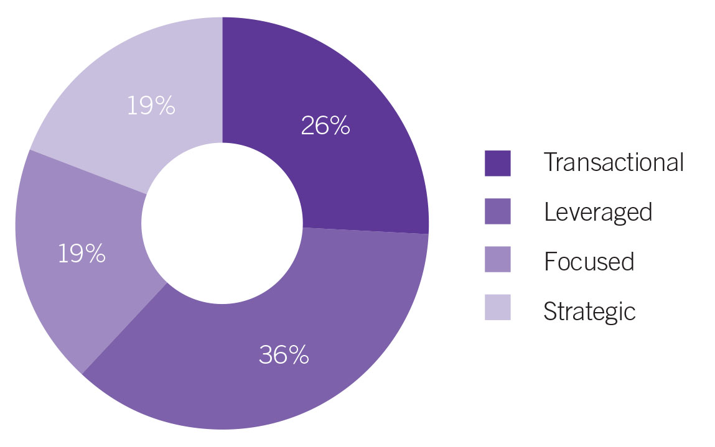

Value of procurement approvals by complexity quadrant
The strategic quadrant had the highest total value with 70 per cent of the value of all procurement approvals (see Figure 9). This quadrant also had the highest average contract value at $8.9 million. This could be expected given that the strategic quadrant includes high value goods and services. However, this quadrant also includes the legal services SPC valued at $525.0 million over six years and four months (including a three-year option) which is equivalent to 55 per cent of the total strategic quadrant value.
The leveraged quadrant was the next highest in value with 18 per cent of the total value and an average contract value of $1.2 million.
The focused quadrant had the lowest total value of procurement process approvals (5 per cent) with the lowest average contract value ($0.6 million). This too would be expected given that the focused quadrant is for procurements where a limited number of suppliers are available or where novel commercial arrangements are in place.
Figure 9: Value of procurement approvals by complexity quadrant in 2014–15
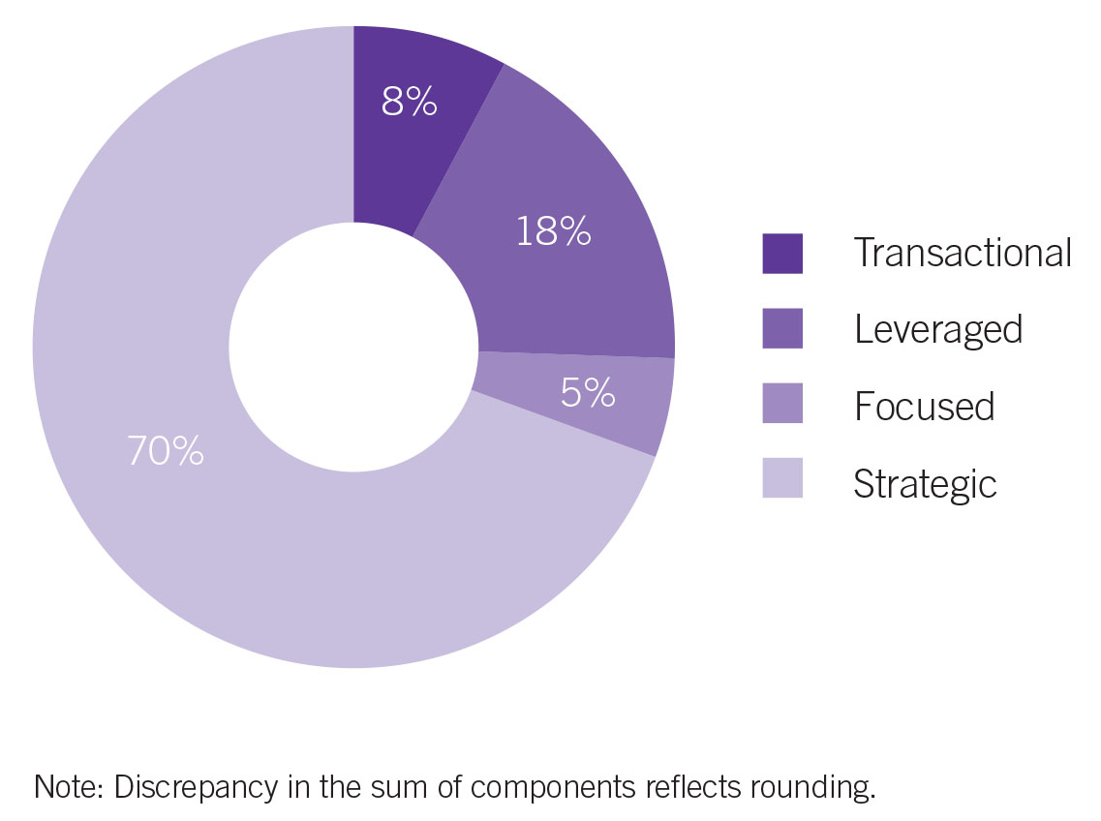

Note: Discrepancy in the sum of components reflects rounding.

Complexity quadrants by department
Table 17 shows a breakdown of complexity quadrants by department giving some insight into the procurement profile of each department.
Table 17: Complexity quadrants by department
Department | Transactional | Leveraged | Focused | Strategic | Totals
Economic Development, Jobs, Transport and Resources | 4 | 17 | 50 | 3 | 74
Education and Training | 3 | 170 | 21 | .. | 194
Environment, Land, Water and Planning | 11 | 2 | 3 | 2 | 18
Health and Human Services | 9 | 9 | .. | 97 | 115
Justice and Regulation | 25 | 3 | 25 | 3 | 56
Premier and Cabinet | 54 | 2 | .. | 1 | 57
Treasury and Finance | 18 | .. | 5 | .. | 23
Victoria Police | 25 | 5 | 8 | 1 | 39
Totals | 149 | 208 | 112 | 107 | 576

Procurement activity subject to VGPB oversight
The VGPB reviews specific procurement activities for process and probity oversight. Procurement oversight projects typically run across multiple years.
The VGPB actively managed nine oversight projects during 2014–15. The VGPB commenced oversight of five of these projects in 2014–15 as shown in Table 18. The other four were referred to the VGPB in the previous financial year and are listed in the VGPB Annual Report 2013–14.
Table 18: Number and estimated value of procurement activities subject to VGPB oversight in 2014–15
Department | Total number | Total estimated value | Title/description | Goods/ service | Complexity assessment outcome | Proposed market approach strategy
Education and Training (DET) | 1 | $150.0M | DET managed services – replacing payroll and human resource management services | Service | Leveraged | EOI followed by request for proposal
Health and Human Services | 2 | ≥$50.0M | Personal Alert Victoria – remote monitoring of vulnerable Victorians | Service | Strategic | TBC
Health and Human Services | 2 | ≥$50.0M | Records management and storage services for hard copy public records held and managed by the department | Service | Leveraged | Open tender
Justice and Regulation | 1 | $525.0M | Legal services panel SPC | Service | Strategic | Open tender
Victoria Police | 1 | $5.8M | Intelligence management systems | Goods | Strategic | Quotation
Totals | 5 | $780.8M
EOI = Expression of interest

Compliance with VGPB procurement policies
Section 54L of the Financial Management Act 1994 requires all accountable officers and other members of staff of departments and specified entities to comply with VGPB procurement policies when acquiring goods and services.
Departments must report to the VGPB at least once every six months with a revised procurement activity plan and an update on their progress in delivering improvements in procurement capability, governance and procurement outcomes among other things.
Departments also list actions taken to ensure compliance with applying VGPB policies in their annual supply report (ASR). The ASR is a report provided by each department to the VGPB at the end of each financial year. It summarises departments’ procurement activity during the financial year and is signed by the Chair of the department’s internal procurement unit (IPU).
Table 19 provides a synopsis of the actions taken by departments to comply with VGPB policies in 2014–15.
Table 19: Compliance with VGPB supply policies in 2014–15
Department | Actions taken
Economic Development, Jobs, Transport and Resources (DEDJTR) | - Refreshed intranet content to improve user engagement and ease of use.  - Formed community of practice with procurement ‘champions’ across DEDJTR to raise awareness and understanding of the new policies to ensure compliance with VGPB policies.  - Established procurement governance committee (DEDJTR’s IPU). The committee provided oversight of all strategic and high value procurement from 1 January 2015 (DEDJTR’s transition date).
Education and Training (DET) | - Established procurement governance committee (DET’s IPU), chief procurement officer (CPO) and procurement category managers. The committee meets monthly to discuss procurement cases, policy and governance issues. The terms of reference are reviewed annually.  - Carried out an annual procurement capability assessment and will prepare an updated capability development plan.  - Carried out an annual complexity assessment.  - Supported DET staff to determine appropriate market approach through DET’s procurement system, training and procurement staff.  - Enabled procurement system to identify all required contracts ≥ $100 000 to ensure these are published and disclosed in accordance with policy and to remind staff to complete post contract evaluation reports.
Environment, Land, Water and Planning (DELWP) | - Prior to transition on 1 January 2015, the accredited purchasing unit committee continued to review all procurements valued at greater than $100 000. From 1 January 2015 onwards the CPO reviewed all procurements greater than $150 000.  - The procurement governance team (DELWP’s IPU) reported to the CPO on transactional information and contract register data, and processed breaches of VGPB policy.  - Engaged an external supplier to review procurement documentation to ensure suitability to transition to the new procurement framework.
Health and Human Services (DHHS) | - Implemented new supply policies in the former departments of Health and Human Services from 1 July 2014 (Department of Health and Human Services commenced 1 January 2015).  - Communicated reform via all available mechanisms in DHHS including updating hub sites, holding meetings for departmental staff and publishing news releases.  - Enhanced the capability of the central procurement team through training and support, including a two-day category management workshop.  - Strengthened the procurement system interfaces between DHHS staff and the procurement teams by enhancing the 'procurement job management systems' and contracts reporting systems, and by introducing a buyer's guide to help staff work out the appropriate procurement process for goods and services.  - Attended external forums such as VGPB workshops to confirm policy interpretation and implementation.  - Supported procurement activities via DHHS’s procurement governance framework with a review of procurement activity plans.
Justice and Regulation (DJR) | - The procurement approval board (DJR’s IPU) reviewed and approved all procurements valued at $100 000 or more.  - Conducted an annual spend analysis to identify and target areas of concern. This includes areas of DJR with procurements valued at less than $100 000 and spend not assessed by the procurement approval board.  - Introduced a comprehensive procurement and contract management framework that guides practitioners through sourcing activities of all complexities to ensure compliance.  - Analysed data from the mandatory contract management system to identify engagements that have not been submitted to the procurement approval board for oversight.
Premier and Cabinet (DPC) | - Developed a procurement policy with mandatory steps for carrying out procurement in DPC.  - Restructured the procurement governance committee (DPC’s IPU) to reflect machinery of government and staffing changes in DPC.  - Strengthened awareness of delegate certification in conjunction with DPC Finance.  - Introduced weighted selection criteria to promote transparent and accountable procurement outcomes.  - Reported relevant DPC contracts on Tenders VIC on a fortnightly basis.  - Strengthened delegate awareness of procurement approvals (initiation and outcome documents) when committing expenditure.
Treasury and Finance (DTF) | - Regularly communicated VGPB policy requirements to DTF staff via the intranet and weekly eNews.  - Provided training, tools and support to new procurers including shadowing.  - Provided regular procurement reporting and auditing. The procurement resource unit (PRU) provided quarterly and six-monthly reports to the IPU on DTF’s procurement activities, as well as holding monthly IPU meetings. DTF’s procurement activities are audited as part of the DTF Internal Audit Plan and results tabled with the VGPB.  - Required all procurement activities greater than $10 000 to be registered and reviewed by the PRU.  - Conducted an annual capability assessment to ensure appropriate levels of capability in DTF.
Victoria Police | - Conducted a series of compliance audits including an audit of supplier arrangements and any possible conflicts of interest.  - Reviewed the spend profile quarterly to detect compliance risks.  - Reviewed and refined the toolkits and templates that guide users through a compliant procurement process.  - Completed a Chartered Institute of Purchasing and Supply audit achieving corporate certification in June 2015.

Compliance under the former VGPB policies
There were three breaches reported to the VGPB from departments still operating under the former VGPB supply policies in 2014.
The three breaches were valued at $0.6 million and were reported by the former departments of Justice (one breach) and Environment and Primary Industries (two breaches).
The VGPB noted:
- factors leading to the non-compliance;
- actions taken to rectify the breach; and
- processes implemented to prevent a recurrence of factors that lead to the non-compliance in the first instance.

Complaints
Departments are required to develop a complaints management system that sets out the process and procedures for addressing complaints by suppliers. Chief procurement officers (CPOs) are responsible for their department’s complaints management process.
The VGPB defines a complaint as an issue or concern expressed by a supplier in relation to the process and probity applied by an organisation when carrying out a procurement activity.
In 2014–15 departments reported six complaints related to procurement activity as shown in Table 20. This compares to three complaints reported in 2013–14.
Table 20: Complaints related to procurement activity in 2014–15
Department | Number | Nature of complaint | Actions taken | Status
Economic Development, Jobs, Transport and Resources (DEDJTR) | 1 | Allegations of unfair tender evaluation methodology and process giving rise to a poor value-for-money outcome. | The procurement governance committee and CPO are reviewing the procurement process. DEDJTR has engaged an external probity auditor to further inform the process. The complainant will be formally advised at the conclusion of the process. | Still under investigation
Environment, Land, Water and Planning (DELWP) | 2 | Unsuccessful tenderer complained about conduct of the tender process alleging scoring influenced by possible conflict of interest. | DELWP re-examined the conduct of the tender and found the conflict had been declared and managed. Some processes could have been improved and recommendations were made for future tenders. These processes did not affect scoring of tender. Tenderer advised of review findings and that no further action would be taken by DELWP. | Matter resolved
Environment, Land, Water and Planning (DELWP) | 2 | Unsuccessful tenderer complained about conduct of tender process alleging conflict of interest with former supplier involvement in process. | Review of conduct of tender commenced. | Still under investigation
Justice and Regulation | 1 | Unsuccessful tenderer lodged a complaint on the grounds of probity. | Review of conduct of tender commenced. | Still under investigation
Victoria Police | 2 | Unsuccessful tenderer concerned that the tender evaluation process did not reflect the risks involved. | The CPO investigated the procurement process, including a review of the evaluation process, report and supplier debriefs. The CPO met with the complainant and consulted the evaluation team.  This process identified the cause of the concern to be incorrect and based on an untested assumption by the tenderer about the nature of services required. The outcome identified an improvement opportunity to expand the use of tender briefing sessions to ensure the scope of services is fully understood. The findings and recommendations were confirmed in writing to the complainant. | Matter resolved
Victoria Police | 2 | Concern that a contract was awarded without an open market test. | The CPO reviewed the procurement process and found the cause of the complaint to be a misunderstanding about the broad nature of the services required and the contract cost.  The review validated the market analysis that informed the approach. It found that the complainant could not deliver the full range of services required and the concern about value was based on incorrect information that did not take into account the special rates available to government through aggregated demand and further discounts achieved through negotiation. The outcome was communicated to the complainant in writing with no further action required. | Matter resolved
Total | 6

Departmental procurement activities
This section provides information about the strategic projects and initiatives carried out by internal procurement units (IPUs) in relation to the procurement of goods and services. It may include, but is not limited to, actions and initiatives relating to:
- supporting SME/local business participation in government procurement opportunities;
- supplier engagement initiatives;
- market briefings of procurement directions;
- procurement marketing;
- procurement process efficiencies implemented/planned;
- systems development and application;
- innovation;
- capability development; and
- awards/recognition attained.
IPUs and their secretariats ensure compliance with VGPB supply policies, keeping departmental policies, tools and templates aligned and up to date. They provide advice, assistance and expertise to support departmental staff in their procurement activities.
Chief procurement officers (CPOs) are involved in the consultation process for changes to procurement policies and have responsibility for their department’s complaints management process.
Departmental representatives may provide strategic advice or participate in reference groups and tender evaluation panels to provide input on whole of government purchasing arrangements.
IPUs are also responsible for assessing the procurement capability of the organisation and preparing a capability development plan on an annual basis. They also identify major procurement categories and report annually to the accountable officer on the organisation’s procurement activities.

Summary of IPU activities in 2014–15
In 2014–15 departments continued to focus on activities related to procurement reform. Departments also began to assess their performance against the performance measures listed in their procurement strategies. In 2015–16 they will assess their performance against a set of predefined KPIs established by the VGPB.
The CPO and IPU Chair listed under each department is the person in the role at 30 June 2015.

Department of Economic Development, Jobs, Transport and Resources
IPU Chair | Tony Aitkenhead, Acting Chief Information Officer, Technology Services
CPO | Darren Bloomfield, Chief Procurement Officer, Procurement Governance Unit
Transition date | 1 January 2015
In 2014–15 the Department of State Development, Business and Innovation became the Department of Economic Development, Jobs, Transport and Resources (DEDJTR) under machinery of government changes. DEDJTR also took on responsibilities from the former Department of Environment and Primary Industries and transport from the former Department of Transport, Planning and Local Infrastructure.
The VGPB agreed that DEDJTR could operate under its new supply policy framework from its start date of 1 January 2015.

Other activities in 2014–15 included:
- reviewing the department’s professional and technical services panel in preparation for a refresh of the panel in the future;
- investigating reporting and compliance systems to determine a possible product suite; and
- refreshing intranet content to improve layout and content as per user feedback.

Activities planned for 2015–16 include:
- developing a suite of departmental procurement policies, procedures, tools and templates aligned with the new supply policy framework to allow the IPU to track compliance and measure improved procurement outcomes;
- integrating existing procurement and contract management systems (CMS) and databases to rationalise the number of systems currently in use and improve monitoring and compliance; and
- procuring and rolling out new CMS and e-procurement systems to improve compliance and KPI reporting.

Department of Education and Training
IPU Chair | Jim Miles, Deputy Secretary, Infrastructure and Finance Services Group
CPO | Janet Thompson, Executive Director, Procurement Division
Transition date | 1 July 2014
In 2014–15 the Department of Education and Early Childhood Development (DEECD) became the Department of Education and Training (DET) under machinery of government changes.
The former DEECD was approved by the VGPB for transition on 1 July 2014. The department established a new procurement and governance operating model including the procurement governance committee (DET’s IPU), CPO and procurement category managers.
The new governance structure was designed to build the profile of procurement across DET and ensure sufficient oversight to meet the requirements of the VGPB’s new supply policy framework.
DET continued to invest in building procurement capability, identifying requirements for the procurement team and departmental staff and offering training scaled to the requirements of departmental procurement activity.

Other activities in 2014–15 included:
- establishing category specialists to partner with business areas and advise, lead and support their procurement activity as required;
- delivering basic procurement training to all department staff and engaging a supplier to provide Certificate IV in Government (Procurement and Contracting) for procurement staff; and
- identifying areas for improvement in DET’s procurement system, processes and documentation.

Activities planned for 2015–16 include:
- reviewing DET’s procurement strategy to ensure it aligns with VGPB supply policies;
- updating the procurement capability development plan;
- carrying out an annual assessment of the effectiveness of the procurement governance committee against its terms of reference to see what areas are working well and identify any opportunities for improvements;
- continuing to deliver basic procurement training for department staff; and
- delivering the Certificate IV in Government (Procurement and Contracting) to procurement staff.

Department of Environment, Land, Water and Planning
IPU Chair | Kathryn Anderson, Deputy Secretary, Corporate Services
CPO | Anthony Connelly, Executive Director, Business Operations
Transition date | 1 January 2015
In 2014–15 the Department of Environment and Primary Industries (DEPI) became the Department of Environment, Land, Water and Planning (DELWP) under machinery of government changes. DELWP also took on some responsibilities from the former Department of Transport, Planning and Local Infrastructure.
The VGPB agreed that DELWP could operate under its new supply policy framework from its start date of 1 January 2015.
The department developed a new procurement strategy to incorporate the new functions transferred to DELWP. Some of the activities planned for 2014–15 were delayed until 2015–16 due to the additional work required by machinery of government changes.

Other activities in 2014–15 included:
- implementing a new contract management system – the system has been developed and user testing completed;
- developing ICT and staffing services category management strategies to identify savings and efficiencies as part of DELWP’s category management framework;
- updating the procurement templates and guidance on the DELWP intranet procurement pages;
- reviewing the DELWP vendor base to strengthen the department’s reputation with suppliers with a focus on SMEs and regionally based local suppliers;
- implementing a procurement complaints framework so that stakeholders can lodge complaints on the DELWP website related to the conduct of DELWP procurement processes; and
- launching an online complexity assessment tool to help staff classify their procurements into one of the four complexity quadrants.

Activities planned for 2015–16 include:
- setting up the structure to resource the central procurement governance team;
- promoting support and awareness of Aboriginal businesses;
- increasing capability by reviewing existing contract management and procurement training and providing new courses as needed to DELWP staff; and
- implementing category management strategies for ICT resourcing and staffing services.

Department of Health and Human Services
IPU Chair | Kerrie Parker, Executive Director, NDIS Strategic Review
CPO | Genine Wallinga, Director, Procurement and Contract Management
Transition date | 1 July 2014
From 1 January 2015 the Department of Health (DoH) and the Department of Human Services (DHS) were merged under machinery of government changes to form the Department of Health and Human Services (DHHS). DoH and DHS already operated with a joint IPU (formerly the accredited purchasing unit) so the procurement profile of the new department remained the same.
The former DoH and DHS transitioned on 1 July 2014 so activities in 2014–15 focused on implementing the procurement transition plan approved by the VGPB in 2013–14.
DHHS implemented a number of change management activities such as updating procurement information on the intranet and communicating with staff about the changes. The department also analysed its procurement data from 2013–14 for category planning and completed 189 procurement plans in accordance with new VGPB policies.

Other activities in 2014–15 included:
- implementing three out of five procurement capability development projects started in 2013–14 to address gaps identified in contract management, category management and performance management; and
- implementing a range of internal and external training programs across the department under DHHS’s Finance and Procurement Training Matrix. Training sessions are targeted at staff carrying out specific functions who attend nominated training as designated in the matrix. DHHS saw high levels of attendance in 2014–15 with 322 financial delegates attending training; 460 staff attending a range of courses (up to one day each) and over 1 200 staff attending a range of seminars and workshops conducted in both metropolitan and rural offices.

Activities planned for 2015–16 include:
- implementing the remaining two procurement capability development projects in the areas of metrics and reporting, and benchmarking;
- working on several large-scale state purchase contracts that are due for re-tendering in 2015–16; and
- continuing to implement training programs under the department’s Finance and Procurement Training Matrix.

Department of Justice and Regulation
IPU Chair | Gail Moody, Deputy Secretary, Corporate Governance and Infrastructure
CPO | Philip Chalkley, Chief Procurement Officer, Office of the Chief Procurement Officer
Transition date | 1 October 2014
The Department of Justice became the Department of Justice and Regulation (DJR) under machinery of government changes.
After successfully transitioning in October 2014, DJR delivered a comprehensive communications program to let staff know about the changes to procurement process.
DJR continues to provide procurement and contract management training and has trained more than 700 departmental staff to date.

Other activities in 2014–15 included:
- establishing a procurement business engagement team to offer specialist advice to business units that may not have procurement expertise;
- implementing a contract management system (ContraX) in September 2014 to consolidate all departmental contracts. The Office of the Chief Procurement Officer (OCPO) will use ContraX data to identify efficiencies across the department;
- launching the OCPO website in September 2014 giving the department a single source for procurement documents, policies and processes; and
- creating a procurement community of practice for practitioners from across the department to share knowledge and lessons learned.

Activities planned for 2015–16 include:
- introducing an eSourcing tool to streamline the procurement process and standardise the approach to market;
- developing a series of online learning modules that will give participants a procurement qualification from DJR’s Procurement Academy; and
- launching eCatalogues to streamline the buying process using existing technology.

Department of Premier and Cabinet
IPU Chair | Matthew Vincent, Executive Director, People Culture and Operations Group
CPO | David Butler, Director, Corporate Operations Branch
Transition date | 1 January 2014
The Department of Premier and Cabinet (DPC) continued to operate under the new supply policy framework.
In 2014–15 DPC organised its first annual planning event for the CPO and other executives to ensure that DPC's procurement strategy is aligned with DPC's broader organisational strategy and is endorsed by senior management.

Other activities in 2014–15 included:
- improving procurement capability through training and communications;
- enhancing procurement tools and templates to allow users to access self-service options; and
- developing DPC’s monitoring process to give better oversight of procurement practice and outcomes.

Activities planned for 2015–16 include:
- reviewing current procurement reporting process to enable better analysis of spend and compliance in DPC;
- reviewing contract management practices to improve contract management capability and compliance with DPC’s contract management policy; and
- reviewing and updating procurement information on DPC’s intranet.

Department of Treasury and Finance
IPU Chair | Joe Bonnici, Chief Financial Officer, Department of Treasury and Finance and Premier and Cabinet
CPO | Jane Olsen, Chief Procurement Officer
Transition date | 1 July 2013
The Department of Treasury and Finance (DTF) continued to operate under the new supply policy framework, working on numerous projects to deliver against its governance KPIs.
DTF worked on building capability to ensure staff understand their role in the procurement lifecycle and can use the appropriate systems and processes.
The department is taking a more proactive approach to procurement planning to ensure that the market is aware of upcoming opportunities via the published procurement activity plan.
The department also reassessed its processes and systems to improve planning practices across DTF and ensure that corrective action is being taken where needed.

Other activities in 2014–15 included:
- self-evaluating the performance of the IPU through a survey twice a year with most results in the high or very high range;
- providing workshops on probity and conflict of interest for staff involved in strategic procurement and one-to-one training sessions for staff that are new to procurement or required to take on more complex procurements;
- maintaining a capability register to identify staff with appropriate procurement skills and experience who can support others;
- implementing a new policy and process for confidential/sensitive and high value/high risk procurements. These now require a higher level of approval than other procurements;
- implementing a supplier engagement framework for procurements assessed as leveraged or transactional to better understand suppliers and ensure high levels of competition and contestability;
- analysing spend data from the past five years and developed a methodology to understand procurement costs and identify ways to improve the efficiency of DTF procurement; and
- improving data collection and providing regular and timely procurement reports.

Activities planned for 2015–16 include:
- evaluating and benchmarking DTF’s procurement governance performance and processes and systems against other departments and developing improvement plans if appropriate;
- continuing to review and modify capability action plans as needed;
- sharing information generated from DTF’s supplier engagement framework across departments for existing contracts;
- implementing the methodology developed in 2014–15 to understand DTF’s procurement costs, evaluate costs against benchmarks and improve understanding of end-to-end costs; and
- improving DTF’s systems-based procurement capability to generate enhanced performance reporting.

Victoria Police
IPU Chair | Andrew Loader, Director of Corporate Strategy, Chair of the Police  Procurement Board
CPO | Jo Hoffman, Director Procurement / Chief Procurement Officer
Transition date | 1 December 2013
In 2014–15 Victoria Police continued to operate under the new supply policy framework, reviewing and revising its procurement strategy and developing procurement plans for each region and department. The organisation developed new category plans with better market analysis and a more strategic approach to managing category spend and supporting the business strategy.
Victoria Police reviewed its implementation of the new framework to ensure that all components were in place and fully aligned with VGPB policies. The review also identified opportunities for continuous improvement.
Victoria Police worked on embedding category management in its procurement practices and built capability by implementing initiatives from the capability building plan developed in 2013–14 to address gaps identified in its capability assessment.
The organisation also continued to look for savings through its commercial arrangements to reduce costs, achieving $6 million in bankable savings from new contract savings initiatives during the year.

Other activities in 2014–15 included:
- providing category management training for all central procurement staff and members of the Police Procurement Board (Victoria Police’s IPU);
- achieving corporate certification from the Chartered Institute of Purchasing and Supply after a comprehensive audit process;
- recruiting procurement and governance experts to fill procurement vacancies;
- reassessing the complexity of existing contracts and the capability of contract managers to identify gaps, training needs and potential changes to contract management arrangements;
- updating the spend profile and analysis to build a more accurate picture of total procurement activity and identify opportunities; and
- establishing a full suite of category procurement plans to maximise the benefits of aggregating demand and improve engagement with all stakeholders including internal business units and suppliers.

Activities planned for 2015–16 include:
- improving commercial acumen and controls through recruitment, staff development, expanding the suite of standard contract templates and enhancing the commercial skills of financial delegates;
- expanding the procurement governance model to cover a broader range of commercial transactions including construction and contract establishment;
- minimising fraud or corruption through procurement or commercial transactions by improving the conflict of interest policy, establishing a conflict of interest register and developing reporting requirements for when family members are employed or engaged through contracts;
- using more project management tools and techniques in sourcing to ensure procurement activities are completed in required timeframes and provide stakeholders with advance notice of key tasks and timing to improve resource planning; and
- establishing a three-year sourcing pipeline to broaden the focus of the procurement planning cycle and improve end-to-end planning.

Links and glossary

Procurement websites

Procurement Victoria
A one-stop portal for advice on procurement of goods and services for government and businesses in Victoria. The portal contains VGPB policies, guidelines, tools and templates, and links to other procurement-related websites.
www.procurement.vic.gov.au

Tenders VIC
All tenders advertised and major contracts awarded by Victorian Government departments including listings of past tenders and contracts.
www.tenders.vic.gov.au

Australasian Procurement and Construction Council
The peak council of departments responsible for procurement, construction and asset management policy for the Australian state and territory governments. Papua New Guinea is an associate member.
www.apcc.gov.au

Training.gov.au
The National Register on Vocational Education and Training (VET) in Australia.
www.training.gov.au

Victorian Registration and Qualifications Authority
The statutory authority responsible for ensuring that employers of apprentices and trainees and providers of education and training (including course and qualification owners) meet quality standards, and that information is readily available to support informed choice in education and training.
www.vrqa.vic.gov.au

Glossary

Accountable officer: the head of any given department, or, for a public body, the chief executive officer (or comparable title) of that body.
Accreditation: Accreditation is the process undertaken by a government entity to be assessed for compliance with the procurement reform framework and subsequently brought within VGPB scope. Government entities can either self nominate for accreditation or can be nominated by the Minister for Finance through legislative powers.
Administrative office: an office specified in section 16(1) of the Public Administration Act 2004.
Aggregated demand or aggregation: a generic term whereby demand for identical or similar categories is grouped together to leverage benefits from greater economies of scale when negotiating with potential suppliers.*
Annual supply report: a report to the VGPB from departments providing information and data relating to the purchase of goods and services during one financial year.
Audit: Audits are typically part of a control process to validate that key activities are being or have been undertaken and to identify weaknesses or opportunities for improvement.*
Best practice: seeking to identify and apply the best processes to achieve better value-for-money outcomes.
Breach: a case of non-compliance with VGPB policies. Under the VGPB’s former supply policies, where a breach involves a financial commitment above $150 000, the accountable officer is to report the breach to the VGPB immediately.
Business case (procurement): the information needed to enable a manager to decide whether to support a proposed project before significant resources are committed to its development. The core of the business case is an assessment of the costs and benefits of proceeding with a project.
Capability: competence, capability and capacity are often used interchangeably to describe an individual’s or organisation’s ability to perform tasks or activities effectively. VGPB policy defines procurement capability as matching the person(s), resources, systems and processes to the requirements of a procurement activity.
Capability assessment: an assessment of the level of procurement capability in an organisation.
Capability development plan: a summary of the organisation’s capability assessment and plans to increase capability where required.
Category: a grouping of related goods or services based on similar characteristics. For example, packaging as a category may include a variety of different goods and materials, all of which share a common purpose. A category may be further divided into subcategories based on physical characteristics such as plastic packaging or cardboard packaging.*
Category management: at the organisational level, category management covers better management of areas of spend that include similar goods and services, and involves analysis of and interaction with the appropriate market sectors. It also forms the basis for organising the procurement team to manage the end-to-end procurement process for a specific range of goods or services.
Chartered Institute of Purchasing and Supply (CIPS): CIPS exists to promote and develop high standards of professional skill, ability and integrity among all those engaged in purchasing and supply chain management. CIPS assists individuals, organisations and the profession as a whole.
Chief procurement officer (CPO): provides strategic expert advice and oversight of the procurement function to drive and ensure value-for-money outcomes in the organisation. The CPO is responsible for developing and monitoring a number of strategic procurement activities. The CPO can be a role or a position as defined in the VGPB’s new governance policy.
Complexity: the level of intricacy and scope of issues involved in procuring a good or service, as defined in the VGPB’s complexity and capability assessment policy.
Complexity assessment: an assessment of the level of intricacy and scope of issues involved in procuring a good or service which considers a broad range of factors including risk, total cost of ownership and market dynamics.
Conflict of interest: a conflict between public duties and private interests. Conflicts of interest can be actual, perceived or potential. The Victorian Public Sector Commission provides resources to help public sector officials, organisations and directors of public entities protect the public interest by identifying and managing conflicts of interest appropriately. For more information, visit www.vpsc.vic.gov.au.
(Source: definition as outlined by the Victorian Public Sector Commission website)
Contract: an agreement between two or more authorised persons on behalf of their organisations to perform or not perform a specific act that is enforceable in law. A contract may be verbal, written or inferred by conduct.
Contract management: all activities at the start, during and after the contract period to ensure that all contractual obligations are fulfilled.
Critical incident: A critical incident is an emergency, crisis or disaster under which an organisation may adopt streamlined and flexible procurement processes to facilitate an immediate response.
Debrief: the process of advising unsuccessful respondents, on a no commitment basis, of where improvements in their bid would make them more competitive in future.
Department: a body existing by virtue of an order made under the Public Administration Act 2004.
Entity: any government or semi-government organisation not defined under the Public Administration Act 2004, i.e. not a department or administrative body. Also referred to as non-Crown bodies, public bodies and outer budget agencies.
e-procurement: involves the online conduct of business-to-business procurement processes using web-based applications.*
Expression of interest (EOI): used to identify suppliers interested in, and capable of, delivering the required goods or services. Potential suppliers are asked to provide information on their capability and capacity to do the work. It is usually the first stage of a multistage tender process.
Financial delegate: a person authorised by the Minister to make general or specified decisions constrained only by the instrument of financial delegation. Specifically, financial delegates commit and incur expenditure, and sign contracts.
Financial delegation: a power handed down to a second party to act on their own behalf, but not including power to further delegate. The second party is responsible for actions arising from their use of such power.
Internal procurement unit (IPU): a body in each department responsible for ensuring that procurement activity complies with VGPB policy. The IPU assesses the procurement capability of the organisation and prepares a capability development plan on an annual basis. It also identifies major procurement categories and reports annually to the accountable officer on the organisation’s procurement activities.
Machinery of government: the allocation of functions and responsibilities between departments and ministers. In Victoria, these matters are the sole responsibility of the Premier.
One-off supply: a purchase of a specific quantity of goods or services which has been subject to a discrete quotation or tender process.
Open tender: the process of publicly inviting tenders usually through the release of a request for tender (RFT) to the open market.
Pre-qualification: assessing a business’ eligibility to supply based on specific criteria for a particular category of goods or services.
Probity: uprightness, honesty, proper and ethical conduct and propriety in dealings. It is often also used in government in a general sense to mean good process.
Procurement: all the business processes associated with purchasing, spanning the whole cycle from identifying needs to the end of a service contract or the end of the useful life and subsequent disposal of an asset. It also includes the organisational and governance frameworks that underpin the procurement function. Procurement does not include store management and logistics that are part of the wider subject of supply chain management.
Procurement activity plan: details planned procurement activity for at least the next 12 to 18 month period and must be reviewed at least annually to keep the market informed of changes or developments. A high level summary plan must be published on the organisation’s website to improve transparency for suppliers.
Procurement process: the step-by-step process for the planning, establishment and contract management of small and large acquisitions.
Procurement strategy: an overview of an organisation’s procurement profile. It includes a procurement activity plan, a contract management planning strategy, a supplier engagement plan and a capability development plan.
Purchasing Card (P-Card): any type of purchasing card used in the Victorian public sector, i.e. general government purchasing card, corporate card, credit card, purchasing card facility. It is a payment mechanism that can provide benefits in the form of efficient procurement and reduced administration costs.
Quotation/quote: an offer to supply goods and/or services, usually in response to a request for quotation (RFQ). Often used interchangeably with proposal, tender, bid and offer.
Request for quotation (RFQ): a written process of inviting offers to supply goods and/or services involving simple documentation and a limited number of potential suppliers.
Request for tender (RFT): a request for offer against a set of clearly defined and specified requirements. Tenderers are advised of all requirements involved including the conditions of tendering and proposed contract conditions.
Risk management: risks can occur at various stages in the procurement process and should be focused on both the operational consequences of non-performance and the risks to business delivery if a procurement activity does not achieve the desired value-for-money outcomes. Risks to the procurement activity should be continually monitored and managed, and new risks identified throughout the procurement cycle.
Scalability: adapting the procurement function to the needs of the organisation ensuring that sufficient capability (people, systems and processes) are in place within the organisation to handle the complexity level of all procurement activity. Scalability is also about simplifying procurement processes and not running an overly onerous process for low value, low risk purchases.
Select tender: a two-stage approach to the open market involving a registration/expression of interest, followed by a request for tender to a shortlist of registrants who satisfy an assessment of their capability and capacity.
Small to medium enterprises (SMEs): firms with less than 200 full-time equivalent employees and/or less than $10 million turnover (Australian Bureau of Statistics). Note that the Victorian Government uses the employment numbers to define small, medium and large enterprises. Less than 20 is defined as small, 20–199 is defined as medium and 200 plus is defined as large.
Sole entity purchase contract (SEPC): a procurement arrangement established when a sole department has a specific requirement for frequently purchased goods and services. SEPCs are mandatory contracts for the department establishing the procurement arrangement.
Sole supplier: sole supplier contract arrangements are established following a specific requirement for frequently purchased goods and or services, and where value for money can best be achieved by engaging with one party. The arrangement also works as they are seen as market leaders and guarantee strong services levels complemented with competitive pricing.
Standing offer agreement (SOA): an agreement for commonly used goods and services that provides more effective and efficient procurement. It covers a set period of time and usually requires no obligation on the State to purchase a particular quantity of the goods or services from the supplier. It includes SPCs and SEPCs.
State purchase contract (SPC): a mandatory standing offer agreement for departments for the purchase of goods and services. The purpose of SPCs is to pursue whole of government contracts to achieve the best value-for-money outcomes, and make best use of the State’s aggregated purchasing power.
Supply policies: policies created by the VGPB to govern procurement of goods and services by all Victorian Government departments and specified entities.
Tender: a document in the form of an offer to supply goods and/or services, usually submitted in response to a public or selective invitation such as an RFT.
Tenderer: a party submitting a tender in response to an RFT.
Tenders VIC: the website provided by the Department of Treasury and Finance for advertising all government tenders.
Value for money (VFM): involves a balanced judgement of financial and non-financial factors. Typical factors include fitness for purpose, quality, whole-of-life costs, risk, environmental and sustainability issues, as well as price.
Victorian Government Purchasing Board (VGPB): the independent government entity that develops, implements and reviews procurement policies and practices; monitors compliance and reports irregularities; and fosters improvements in the use and application of purchasing systems. The VGPB provides leadership in government procurement of goods and services to deliver value-for-money outcomes for Victoria.
World Bank: The World Bank is like a cooperative made up of 188 member countries. It is a unique partnership that aims to reduce poverty and support development. It provides financial and technical assistance to developing countries around the world.
* Source: Adapted from Paul Rogers (2012), The Glossary, Chartered Institute of Purchasing and Supply, <www.cips.org/Knowledge/procurement-glossary/>

Acronyms and abbreviations

CPO Chief procurement officer
DEDJTR Department of Economic Development, Jobs, Transport and Resources
DET Department of Education and Training
DELWP Department of Environment, Land, Water and Planning
DHHS Department of Health and Human Services
DJR Department of Justice and Regulation
DPC Department of Premier and Cabinet
DTF Department of Treasury and Finance
EOI Expression of interest
HPV Health Purchasing Victoria
IPU Internal procurement unit
PTV Public Transport Victoria
RFQ Request for quotation
RFT Request for tender
SEPC Sole entity purchase contract
SPC State purchase contract
SME Small and medium enterprises
VGPB Victorian Government Purchasing Board

This annual report is printed on Ecostar. Ecostar is made Carbon Neutral Revive Laser Digital 115–140 gsmand is 100 per cent recycled and FSC® Recycled Certified.
No bleaching occurs in the recycling process and Revive Laser DigitalEcostar is manufactured in a process chlorine free environment by an ISO 14001 certified mill.

