VGPB Annual Report

2015–16

Victorian Government Purchasing Board
Achieving excellence in government procurement

Victorian Government Purchasing Board Annual Report 2015–16
Victorian Government Purchasing Board
Telephone: +61 3 9651 1699
Email: vgpb@dtf.vic.gov.au
Authorised by the Victorian Government
1 Treasury Place Melbourne Victoria 3002
Printed by Doculink, Port Melbourne
Printed on 100 per cent recycled paper

© State of Victoria (Victorian Government Purchasing Board) 2016
You are free to re-use this work under a Creative Commons Attribution 4.0 licence, provided you credit the State of Victoria (Victorian Government Purchasing Board) as author, indicate if changes were made and comply with the other licence terms. The licence does not apply to any images, photographs or branding, including government logos.
Copyright queries may be directed to IPpolicy@dtf.vic.gov.au
ISSN 1444-4097
Published October 2016
Designed by Cordial Creative
This document is available in PDF and Word format at www.procurement.vic.gov.au.
Contents
As required by section 54M of the Financial Management Act 1994, this annual report describes the work and activities of the Victorian Government Purchasing Board from 1 July 2015 to 30 June 2016. This report has information about purchasing activity carried out by the seven Victorian Government departments, Victoria Police and VicRoads.

Message from the Chair 6
Year in review 7
Strategic priorities in 2015–16 7
Changes to the annual report in 2015–16 14
Strategic priorities for 2016–21 14
About the VGPB 17
Vision and mission 17
Directives 17
Functions and powers 18
Scope of VGPB policies 19
Compliance with VGPB policies 21
VGPB members 22
Procurement spend 26
Overview of procurement spend 26
One-off supply contracts 27
Aggregated purchasing arrangements 31
Critical incident procurement 38
Procurement complexity and VGPB oversight 39
Procurement complexity 39
Procurement activity subject to VGPB oversight 43
Compliance with VGPB procurement policies 44
Actions taken to ensure compliance 44
Audits 48
Complaints 48
Procurement profiles and performance by organisation 48
Department of Economic Development, Jobs, Transport and Resources 48
Department of Education and Training 48
Department of Environment, Land, Water and Planning 48
Department of Health and Human Services 48
Department of Justice and Regulation 48
Department of Premier and Cabinet 48
Department of Treasury and Finance 48
VicRoads 48
Victoria Police 48
Links and glossary 48
Procurement websites 48
Glossary 48
Acronyms and abbreviations 48
Tables and figures

Tables
Table 1: VGPB projects and initiatives completed in 2015–16 7
Table 2: VGPB guides produced in 2015–16 12
Table 3: Victorian Government public service bodies bound by VGPB policies as at 30 June 2016 21
Table 4: VGPB members as at 30 June 2016 23
Table 5: Total number and value of one-off supply, SEPC and SPC approvals in 2015–16 by goods and services 26
Table 6: Total number and value of one-off supply, SEPC and SPC approvals from 2013–14 to 2015–16 27
Table 7: Number and value of one-off supply approvals by organisation and by goods and services in 2015–16 29
Table 8: Number and estimated potential value of SEPC approvals by organisation and by goods and services in 2015–16 31
Table 9: Breakdown of SEPCs approved in 2015–16 33
Table 10: Breakdown of SPCs approved in 2015–16 36
Table 11: Critical incident procurement in 2015–16 38
Table 12: Description of complexity quadrants 39
Table 13: Number of one-off supply, SEPC and SPC approvals by complexity quadrant in 2015–16 39
Table 14: Complexity quadrants (number) by organisation 40
Table 15: Trends in procurement complexity 42
Table 16: Trends in complexity quadrants by organisation 42
Table 17: Number and estimated value of procurement activities subject to VGPB oversight in 2015–16 43
Table 18: Summary of actions taken by organisations to comply with VGPB supply policies in 2015–16 45
Table 19: Audit program schedule and results as at 30 June 2016 48
Table 20: Complaints related to procurement activity in 2015–16 48
Table 21: Key performance measures to assess the benefits of procurement reform 48
Table 22: DEDJTR performance in 2015–16 48
Table 23: DET performance in 2015–16 48
Table 24: DELWP performance in 2015–16 48
Table 25: DHHS performance in 2015–16 48
Table 26: DJR performance in 2015–16 48
Table 27: DPC performance in 2015–16 48
Table 28: DTF performance in 2015–16 48
Table 29: VicRoads performance in 2015–16 48
Table 30: Victoria Police performance in 2015–16 48

Figures
Figure 1: Key performance measures to assess the benefits of procurement reform 10
Figure 2: VGPB 2016–21 strategy overview 16
Figure 3: VGPB reporting relationship 19
Figure 4: Number of one-off supply approvals by organisation and by goods and services in 2015–16 29
Figure 5: Value of one-off supply approvals by organisation and by goods and services in 2015–16 30
Figure 6: Number of SEPC approvals by organisation and by goods and services in 2015–16 32
Figure 7: Value of SEPC approvals by organisation and by goods and services in 2015–16 32
Figure 8: Number of procurement approvals by complexity quadrant in 2015–16 40
Figure 9: Value of procurement approvals by complexity quadrant in 2015–16 41

Message from the Chair
Procurement is coming under increased focus across government. Against this background, the Victorian Government Purchasing Board (VGPB) has raised its strategic leadership role, advising
in-scope organisations on how best to achieve procurement efficiencies. During the year, the VGPB published a revised set of supply policies to continue to support the Victorian Government in delivering value-for-money procurement outcomes. These policies are based on a comprehensive review incorporating feedback from in-scope organisations, and the Government’s election commitments. The review also identified several broader procurement initiatives for 2016–17.
The VGPB worked closely with chief procurement officers (CPOs) to roll out the audit program and performance measures developed in 2014–15. It is a testament to the hard work of the in-scope organisations and the VGPB that we were able to include the year one outcomes of the performance measures in this year’s report to establish a baseline for future reporting.
Looking into the longer term, the VGPB developed a five-year strategic plan that includes five priorities. These priorities focus on areas where the VGPB can play an active role as a catalyst to support organisations’ procurement activity, and can work with stakeholders to drive greater value procurement across government.
The VGPB continues to broaden its influence across government and I would like to formally welcome VicRoads following its successful accreditation to the VGPB supply policies on 1 July 2015. The VGPB was impressed by the enthusiasm and appetite of VicRoads to adopt the policy framework.
On behalf of the VGPB, I would like to thank the Minister for Finance, Robin Scott, MP for his support of the VGPB’s policy review and strategic priorities. This support was instrumental in securing much needed resources for the VGPB’s Secretariat to implement the policy review’s recommendations.
I would like to thank all VGPB members for their ongoing high quality input throughout what has been another busy year, and for the time each has given to ensuring continuous improvement in government procurement policies and delivery of particular projects.
I would like in particular to thank outgoing members Mr Neil Lucas and Ms Julie Freeman who both made outstanding contributions to the Board during their tenure. I would also like to formally welcome new members Ms Antoinette Brandi and Mr Timothy Lyons. Both members joined the Board in October 2015 and have already made valuable contributions. On 1 July 2016 Ms Leanne Price, from the Department of Health and Human Services, joined the VGPB. On behalf of all Board members, I would like to welcome Ms Price and look forward to her contributions.
The VGPB has again been supported by the professional and dedicated work of the Secretariat in the Department of Treasury and Finance (DTF). The Secretariat continued to manage an ever increasing workload and set of responsibilities efficiently and with good humour. Thank you also to all the organisations, and especially the CPOs, who worked collaboratively with the VGPB throughout the year to deliver key projects: your ongoing commitment to the reform is much appreciated.
It is with confidence that we look to the future. As the VGPB moves to a partnership model with CPOs, the VGPB will be uniquely positioned to champion innovative procurement priorities and initiatives designed to increase capability across the Victorian Government. I look forward to the year ahead.
(Dr) Lynne Williams
Chair, Victorian Government Purchasing Board

Year in review

Strategic priorities in 2015–16
In 2015–16, the VGPB continued to work with organisations to progress its strategic priorities. Strategic priorities are focused on working with organisations to continue to embed procurement reform to gain efficiencies and improve procurement outcomes. To achieve this, the VGPB has completed several projects as summarised in Table 1.
Table 1: VGPB projects and initiatives completed in 2015–16
Project | Result | Status
Five-year strategic plan | Developed a five-year strategic plan to establish a set of longer term priorities and initiatives. | Complete
Strategic priority 1: Enhancing the VGPB supply policies to reflect the government’s election commitments
Policy review | Revised VGPB supply policies in line with the government’s election commitments and organisational feedback. | Complete
Policy review communications strategy | Developed a change management and communications strategy to inform organisations about the policy review and revoking the pre-2013 policies. | Complete
Revoking pre-2013 policies | Revoked the pre-2013 supply policies on 30 June 2016. | Complete
Supplier code of conduct | Began developing a supplier code of conduct to ensure a consistent Victorian Government standard in ethical, sustainable and socially responsible procurement. | In progress
Social procurement initiatives | Began engaging across government on initiatives to improve access for minority groups, including promoting social procurement bodies through the VGPB website (www.procurement.vic.gov.au). | In progress
Strategic priority 2: Measuring the benefits of procurement reform
Audit program | The DTF audit is complete and the Victoria Police audit is under way and due for completion in the second half of 2016. | Complete/In progress
Performance measures | Worked with CPOs to implement year one performance measures. Performance measures will be progressively implemented over a three-year period. | Complete
Supplier satisfaction survey | Launched a supplier satisfaction survey to establish a benchmark across government to improve supplier engagement and deliver on key performance measure five: Supplier satisfaction assessment. | Complete
Strategic priority 3: Improving procurement capability across government
Victorian Public Service procurement capability framework | Commenced research to begin benchmarking capability against the framework to identify procurement capability shortfalls across government. | In progress
VGPB guides | Enhanced nine procurement guides to ensure a consistent approach to procurement and developed three new guides. | Complete
Standard form contracts | Enhanced standard form contracts to reflect the better off overall test and applicable legislative requirements. | Complete
Strategic priority 4: Broadening the VGPB’s influence
Accreditation to operate under VGPB policy | Worked with organisations to bring their goods and services spend in scope. Public Transport Victoria accreditation is still under way. | Ongoing
Victorian Government goods and services procurement | Began researching the next wave of entities to be brought under the scope of the VGPB supply policies. | Ongoing
Other engagement | Continued to engage broadly across the Victorian Government and other jurisdictions to embed procurement reform. | Ongoing

Strategic priority 1: Enhancing the VGPB supply policies to reflect the government’s election commitments

Policy review
The VGPB reviewed its supply policies to ensure that they reflect the Government’s election commitments. The revised policies also incorporate operational feedback received from organisations since the reform policies were first implemented in February 2013.
The VGPB consulted widely across government to ensure the supply policies continue to reflect good governance, accountability and strategic planning to elevate the procurement function and align with broader government objectives. The review identified a number of policy changes as well as recommendations for several initiatives to be implemented by the VGPB.

Policy review communications strategy
The VGPB developed a change management and communications strategy to inform organisations about the policy review and revoking the pre-2013 policies. The strategy will continue to be implemented throughout 2016–17 as the VGPB delivers on initiatives recommended in the policy review.

Revoking pre-2013 policies
The VGPB’s revised supply policies and revocation of the pre-2013 supply policies came into effect on 1 July 2016.

Supplier code of conduct
The VGPB recognises the importance of procurement in driving wider government initiatives and regularly works with broader groups across government to achieve this. In 2015–16, the VGPB began developing a supplier code of conduct in collaboration with the Department of Justice and Regulation.
The code of conduct reinforces the Victorian Government’s commitment to ethical, sustainable and socially responsible procurement and sets a minimum standard.

Social procurement initiatives
The VGPB also collaborated across government to increase engagement with small to medium enterprises and minority groups. The supplier satisfaction survey will also inform the VGPB of potential areas to improve future engagement.
The VGPB supply policies were developed with these groups in mind. Under the policies, organisations must take a strategic approach to procurement through upfront planning and stronger market engagement in order to consider the supply market and how all businesses – irrespective of size or location – can participate.
To improve and encourage greater engagement with these groups the VGPB has enhanced its guidance material and promotes minority group directories through the VGPB website (www.procurement.vic.gov.au).
Social procurement in action
The Department of Environment, Land, Water and Planning (DELWP) procurement team worked with other areas of the department to develop its Aboriginal Inclusion Plan. The plan is titled Munganin – Gadhaba: ‘Achieve Together’ and sets out DELWP’s approach for inclusion from 2016 to 2020.
The name Munganin – Gadhaba is from the Taungurung language, and brings to life the aim of working together with Traditional Owners and Aboriginal communities across Victoria. The Plan has 60 separate actions for the department that it hopes will increase opportunities for Aboriginal employment, cultural wellbeing and economic prosperity while bringing Aboriginal knowledge of country to DELWP’s management of land, water, the natural landscape and built environments.
The procurement team and DELWP’s regional Indigenous coordinators identified around 200 Aboriginal businesses in Victoria that had previously provided goods or services to DELWP or have the potential to provide goods and services in the future. The procurement team is promoting this listing across the department to highlight opportunities for engaging with Aboriginal businesses. DELWP will continue to promote this in training and awareness sessions as a key component of DELWP’s culture, procurement practices and values and behaviours.

Strategic priority 2: Measuring the benefits of procurement reform

Audit program
The VGPB continues to fulfil its legislative role of monitoring compliance with the VGPB supply policies by requiring organisations to report each year that they comply with these policies and provide evidence of compliance-related initiatives and activities.
The VGPB has implemented an audit program to verify compliance with the supply policies. The aim of the audit program is to minimise risks and improve processes to drive better procurement outcomes.
The audit program is based on a three-year rolling audit schedule. DTF was the first organisation to undertake an audit in 2016. The VGPB concluded that the audit was very thorough and the overall findings were positive with minimal recommendations for improvement. More information on audit results is available under Compliance with VGPB procurement policies later in this report.
The Victoria Police audit was noted by the Victoria Police Procurement Board and submitted to the VGPB in early July 2016.

Performance measures
In 2014–15, the VGPB worked with organisations to develop six key performance measures (see Figure 1) to achieve a consistent, quantifiable approach to measuring reform benefits. This is the first reporting year for these measures. Performance measures will be implemented over three years with year one results providing a baseline against subsequent years.
There is significant work involved in putting processes in place to capture the data needed to report on performance measures. With this in mind, year one results reflect a ‘best endeavours’ approach as organisations prepare their portfolios for future reporting. Following the year one results, the VGPB will work with organisations to refine the measures before commencing data collection for year two in early 2016–17.
Figure 1: Key performance measures to assess the benefits of procurement reform
- Value created as a consequence of department procurement activity
- Proportion of the number of transactions at or below $2 000 through a P-Card or equivalent
- Increase in procurement capability
- Cost of department’s procurement resources as a percentage of total contract spend
- Supplier satisfaction assessment
- Planned procurement activity as a percentage of actual procurement activity

Supplier satisfaction survey
The VGPB took a lead role in managing the delivery of key performance measure five; the supplier satisfaction assessment. This measure gives government a holistic view of supplier satisfaction and identifies areas for future refinement.
To measure supplier satisfaction, organisations surveyed successful and unsuccessful suppliers. The VGPB and organisations will use the survey results to improve how government engages with suppliers (see Procurement profiles and performance by organisation later in this report for survey results).
Benefits of procurement reform in action
In January 2015, the Department of Premier and Cabinet released the new multifunction device state purchase contract (SPC) which comprised a managed service model compared to historic supply arrangements.
In preparation for the new SPC, the Department of Health and Human Services (DHHS) surveyed its fleet of some 1 500 devices (eight brands and more than 100 models) located throughout Victoria. Following several small trials to better understand the new supply model, the department released a request for quote to the three nominated suppliers in late June 2015. DHHS contracted Fuji Xerox in late September as its managed supplier for multi-function devices.
The managed service model gave DHHS the impetus to move from a devolved management model (each business owned or leased devices from and paid with their own budget) to a centralised model (single point of management across the whole state with central budget and overall contract management responsibility).
The new contract resulted in considerable supply savings but also significant back-of-house administration savings including:
- centralised billing, eliminating the cost of processing multiple monthly invoices for individual devices around the state;
- streamlined ordering arrangements, eliminating the need to obtain and analyse quotations;
- simplified installation arrangements driven by the limited range of models and standardised print drivers;
- compliance with the department’s paper and printing policy, which seeks to drive a printer-to-computer ratio of 1:20 by 2016;
- a concierge service at sites that exceed a set threshold of devices, increasing device availability; and
- a fleet fit for purpose to implement a ‘Follow-You Printing’ solution (Equitrac), which is currently being evaluated.

Strategic priority 3: Improving procurement capability across government

Victorian Public Service procurement capability framework
The VGPB continues to focus on improving procurement capability across government. In 2013, in collaboration with the Victorian Public Sector Commission and the Australian Procurement and Construction Council, the VGPB released the Victorian Public Service procurement capability framework. Research has begun to benchmark capability against this framework to identify procurement capability shortfalls across government. This will lead to development of a strategy to lift procurement capability across the Victorian Government.

VGPB guides
The VGPB has numerous guides, tools and templates to support its supply policies. Guidance material provides a standardised approach to procurement across government to simplify the process for buyers and suppliers. All guidance material is thoroughly researched and developed in collaboration with broader government to ensure a best practice approach.
Procurement guides updated in 2015–16
- Market approach
- Aggregated demand
- Creating a supplier engagement plan
- Pre-qualified supplier arrangements
- Specification writing
- Developing an offer template
- Market analysis and review
- Evaluation, negotiation and selection
In 2015–16, the VGPB updated multiple guides to reflect the government’s election commitments and legislative requirements. The VGPB also developed three new guides to help organisations understand the market in greater depth, as shown in Table 2.
Table 2: VGPB guides produced in 2015–16
Guide | Benefit | Release date
VGPB oversight of strategic procurement | Provides an overview of the VGPB’s strategic oversight process for project nomination and ongoing management | April 2016
Understanding the supply chain | Articulates how to manage goods and services throughout the procurement lifecycle, with a holistic approach to planning and monitoring the supply chain to identify risks and opportunities | June 2016
Category management | Explains how to identify categories and create a strategic category plan to deliver the best value-for-money outcomes | Out for consultation

Standard form contracts
All VGPB standard form contracts were amended to reflect the better off overall test (BOOT) and relevant legislative changes.
Standard form contracts amended in 2015–16
- Invitation to supply
- Expression of interest (EOI)
- EOI – Part C – invitees response
- General condition of goods
- General conditions of service
- Supply of goods – one off purchase
- Provision of services – one off purchase
- Supply of goods – sole entity purchase
- Supply of service – sole entity purchase
The BOOT is based on the relevant modern award that covers any employees covered by the proposed enterprise agreement. Under BOOT, each ‘award covered’ employee and each prospective award covered employee must be better off under the agreement than they would be if the relevant modern award applied to them.
Contracts were also amended to reflect relevant legislative requirements such as the introduction of the Privacy and Data Protection Act 2014.

Strategic priority 4: Broadening the VGPB’s influence

Accreditation to operate under VGPB policy
The VGPB is committed to bringing more government entities under its scope to improve procurement efficiencies across government. To achieve this, the VGPB engages with key stakeholders to bring out-of-scope entities under the scope of the VGPB supply policies. A strategic, systematic approach is currently being developed to identify the next wave of entities by researching procurement spend and risk profiles. This will enable the VGPB to target its resources to accredit relevant entities.
On 1 July 2015, VicRoads began operating under the VGPB policies after a successful accreditation process. The VGPB was impressed with VicRoads’ progress in implementing VGPB supply policies across its organisation. VicRoads started several initiatives to embed procurement reform, making significant progress in a short space of time.
In 2015–16, Public Transport Victoria (PTV) restructured and appointed a new CPO. The VGPB is looking forward to continuing to work with PTV to gain accreditation to apply VGPB supply policies.
To help future entities gain accreditation, the VGPB will release a guide to accreditation in late 2016.
Case study: VicRoads’ transition journey
Transitioning to the VGPB supply policy framework gave VicRoads the opportunity to increase its focus on goods and services procurement across the organisation. The reform was a significant change for VicRoads, affecting over 1 000 staff who procure goods and services under the organisation’s decentralised procurement model.
The majority of VicRoads’ procurement activity involves building and construction. As such, the mature procurement framework established over many years has been more focused on supporting this type of procurement, with policies and procedures adapted to suit goods and service procurement as needed. The reform has been positive as it has led to new governance arrangements, new procurement policies embedded into corporate-wide practice, improved procurement systems, and better value-for-money outcomes (see VicRoads’ performance summary under Procurement profiles and performance by organisation).
Adopting the VGPB supply policy framework has led to a more complexity and risk-based approach to procurement with a better balance between risk and business efficiency, and accountability for decision making at the most appropriate level. VicRoads has used the procurement reform to review, enhance and streamline procedures and systems. It has established a stronger procurement assurance program to provide greater confidence in the integrity of its procurement processes and practices. Through this reform program VicRoads has renewed its focus on assessing and strengthening procurement capability to help its people achieve the best outcomes through procurement.

Victorian Government goods and services procurement
In addition to broadening its legislative scope, the VGPB continues to encourage and support outer budget entities to adopt its supply policies. Entities across government can benchmark and model their procurement practices against VGPB supply policies, even though they are out of scope. Many of these entities have a small procurement profile with minimal goods and services spend and will not complete a formal accreditation process.
To help these entities, the VGPB is developing a guide to aligning with the VGPB framework. The guide will offer a reference point for entities to ensure their procurement processes are consistent with VGPB best practice.

Other engagement
The VGPB recognises the importance of consulting with stakeholders to continue to embed its procurement reform agenda and also learn from stakeholders’ experiences in implementing these reforms. Throughout 2015–16, the VGPB continued to engage across the Victorian Government and other jurisdictions to build on positive outcomes from its 2014–15 engagement.
The VGPB Chair updated the Victorian Secretaries Board (VSB) on the VGPB policy review and strategic priorities. The VGPB looks forward to continued engagement with the VSB.

Changes to the annual report in 2015–16
This is the first year that organisations have reported on performance measures. The section previously titled Departmental Procurement Activities has been restructured to include an overview of each organisation’s procurement profile and a summary of performance, as well as the procurement activities that are usually reported in this section. To encompass these changes, the section is now called Procurement profiles and performance by organisation.
The section on compliance (Compliance with VGPB procurement policies) has been slightly restructured and now includes audit information.

Strategic priorities for 2016–21
As Victorian Government organisations continue their journey to best practice procurement models, the VGPB will begin working on longer term strategic priorities. The VGPB’s Strategic Plan sets out five strategic priorities with initiatives that will be progressively implemented over a
five-year period. These priorities are underpinned by a CPO partnership model which recognises the importance of leveraging expertise to ensure improved procurement outcomes for government.
Year one will focus on developing strategies to meet the longer term objectives of the VGPB and implementing government priorities. Over this period, in collaboration with stakeholders, the VGPB will continue to embed the procurement reform supply policies, broaden its impact on Victorian public sector procurement and build capability in procurement.
Figure 2 provides an overview of the VGPB’s strategy for the 2016 to 2021 period.

Strategic priority 1: Embed and enhance VGPB supply policies
Following the transition of all mandated organisations, the VGPB continues to embed and enhance its supply policy framework. The VGPB will clarify and communicate core goals, policies and the philosophy behind the VGPB’s supply policies to public sector bodies by building on relationships with stakeholders.
Over the coming year, the VGPB will continue to implement the results of its policy review to ensure that supply policies continue to drive procurement efficiencies for government. The VGPB will continue to scan organisations, the supply market and industry bodies to inform future policy refinements.
The VGPB’s oversight role is pivotal to embedding procurement reform. The oversight program gives organisations independent strategic procurement advice and guidance on all projects under review. In 2016 the oversight program will expand to include nominated SPCs. The VGPB will also take a more active role in identifying potential aggregation opportunities across the public sector to drive greater value for money.

Strategic priority 2: Develop and implement a procurement capability strategy across people, processes and systems
Good procurement saves money and creates efficiencies, freeing up resources for other priorities. It improves service delivery to the community and makes it easier for business to access government procurement opportunities.
In 2016–17, the VGPB will help organisations develop their capability by understanding barriers affecting their growth. The VGPB will develop a capability strategy with initiatives to improve and support organisational capability. The VGPB will work with organisations to identify common and significant capability gaps and prioritise opportunities to strengthen Victorian Government procurement capability. The analysis will also be informed by the results of the third performance measure (increase in procurement capability), giving the VGPB and organisations a baseline to measure improvements.
The VGPB supply policies are supported by good practice guides, tools and templates that comply with broader government legislative requirements and minimise duplication of effort. The VGPB will continue to enhance existing guidance material and develop new material with feedback from stakeholders to align with broader industry good practice.

Strategic priority 3: Engage with suppliers and the market to improve doing business with the Victorian public sector
The VGPB supply policies are focused on making it easier for suppliers to do business with government. The policies prioritise upfront strategic planning to provide a consistent market approach and give suppliers visibility of upcoming procurement opportunities.
The VGPB will help organisations identify how to engage with suppliers and the market to improve procurement outcomes. To achieve this, the VGPB will implement a targeted program to engage with relevant peak industry bodies to discuss future policy needs and improve procurement practices. The VGPB will look for opportunities to pilot new innovative procurement approaches to market by partnering with organisations for specific projects.

Strategic priority 4: Broaden the VGPB’s impact on Victorian public sector procurement
The VGPB continues to broaden its impact by:
- ongoing consultation with other government procurement policy makers in Victoria and interstate;
- providing guidance material and community of practice forums; and
- responding to buyer and supplier queries.
The VGPB is committed to continuing to drive reform not only for in-scope organisations but also for the broader Victorian public sector. The Victorian Government can achieve considerable benefits through these reforms.
The VGPB will engage with in-scope organisations to identify future multi-organisation procurement opportunities using SPCs or other forms of procurement models. To support and nurture out-of-scope organisations who want to align their procurement function with VGPB supply policies, the VGPB will provide detailed guidance by developing a guide to aligning with the VGPB framework.

Strategic priority 5: Measure the benefits of the VGPB’s procurement framework
The VGPB supply policies seek to improve the way organisations buy goods and services from the market. To understand these improvements, the VGPB will continue to measure the benefits achieved by the procurement reform. This will be done by continually refining the methodology for measuring and reporting on the procurement reform framework. The VGPB will measure the progress of organisations through reporting on performance measures and the outcomes of the audit program.

Figure 2: VGPB 2016–21 strategy overview
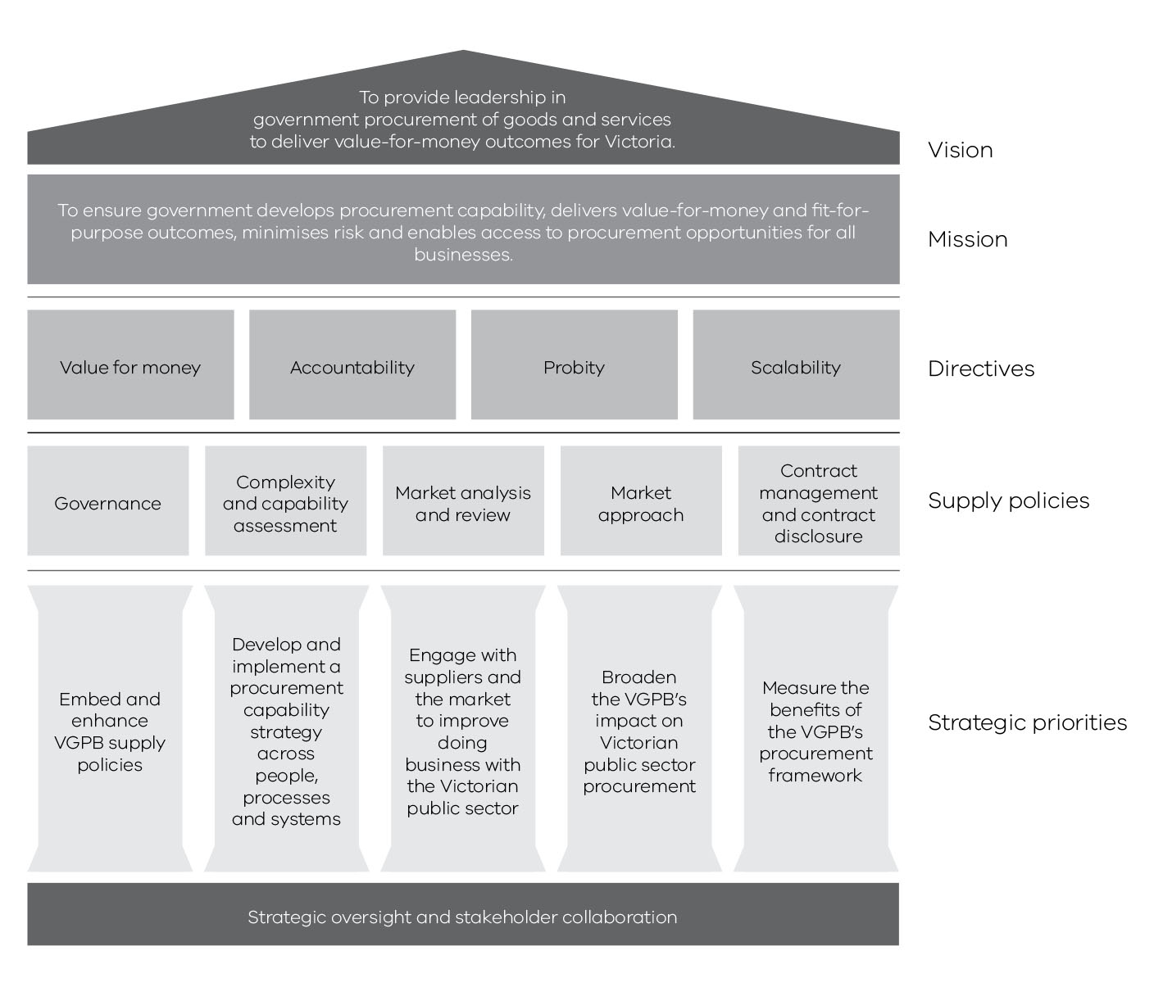

About the VGPB
The VGPB was established under the Financial Management Act 1994 (the FMA). The VGPB meets no less than six times a year to develop and approve policies, provide strategic oversight of major goods and services procurement and discuss procurement policy and practice.

Vision and mission
The VGPB’s vision is to provide leadership in government procurement of goods and services to deliver value-for-money outcomes for Victoria.
The VGPB’s mission is to ensure government:
- develops procurement capability;
- delivers value-for-money and fit-for-purpose outcomes;
- minimises risk; and
- enables access to procurement opportunities for all businesses.

Directives
The VGPB’s supply policies cover end-to-end procurement activity from identifying needs, planning and market research through to contract management. Each policy is supported by good practice guides, tools and templates to ensure consistency across government.
When applying the policies, organisations must ensure all procurement activity meets the following directives:
- Value for money: A balanced judgement of a range of financial and non-financial factors, taking into account the mix of quality, cost and resources; fitness for purpose; total cost of ownership; and risk.
- Accountability: The accountable officer has the flexibility to conduct procurement activities using appropriate capability to provide value-for-money outcomes.
- Probity: High standards of behaviour and actions in the conduct of procurement processes. Equity, confidentiality, avoiding conflicts of interest, and consumer/supplier confidence in the integrity of government procurement processes.
- Scalability: The relationship between the complexity of a procurement project and the capability of the organisation to conduct it to achieve a good procurement outcome.

Functions and powers
The VGPB has the following functions as defined by section 54B of the FMA:
- in relation to the supply of goods and services to departments and specified entities and the management and disposal of goods by departments and specified entities—
    - to develop, implement and review policies and practices; and
    - to provide advice, staff training and consultancy services;
- to monitor compliance by departments and specified entities with supply policies and Ministerial directions and to report irregularities to the relevant Minister and the Minister;
- to foster improvements in the use and application of purchasing systems and electronic trading;
- to establish and maintain a comprehensive data base of purchasing data of departments and specified entities and supply markets for access by departments and specified entities;
- any other functions conferred on the Board by this Part.
The VGPB has the following powers under section 54C of the FMA:
- The Board has all the powers necessary to perform its functions.
- Without limiting subsection (1), the Board may—
  - enter into contracts or arrangements on its own behalf, on behalf of the State or on behalf of departments or specified entities;
  - call and award tenders and advertise;
  - consider and approve requisitions for the purchase of goods and services by departments or specified entities;
  - require accountable officers to audit compliance by departments and specified entities with supply policies and Ministerial directions and provide audit reports to the Board;
  - require accountable officers to provide information and data relating to the supply of goods and services and the management and disposal of goods;
  - exercise any other powers conferred on the Board by this Act or the regulations.
An accountable officer must provide to the Board on request—
  - audit reports referred to in subsection (2)(d);
  - information and data referred to in subsection (2)(e).

For the purpose of this report departments and specified entities are referred to as organisations.

Reporting relationship
The VGPB reports to the Minister for Finance. The Department of Treasury and Finance (DTF) provides secretariat and other support to the VGPB and has a direct reporting line to the Minister for Finance on procurement and contracting issues. Figure 3 illustrates this relationship.
Figure 3: VGPB reporting relationship
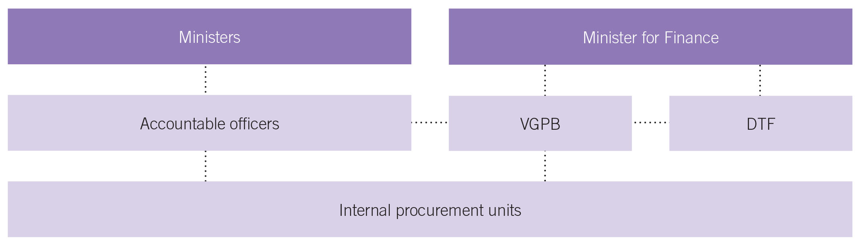
Under section 54M of the FMA, the VGPB must give the Minister for Finance a report of its work and activities for the year ending on 30 June that year. The Minister for Finance tables the VGPB’s annual report in Parliament.

Scope of VGPB policies
The VGPB’s policies apply to the following public service bodies:
- government departments and specified entities;
- the Victorian Public Sector Commission; and
- those offices or bodies specified in section 16(1) of the Public Administration Act 2004.
Under section 54AA of the FMA, the Governor in Council may declare by Order that VGPB policy also applies to an entity or a class of entities. VicRoads was granted VGPB accreditation effective 1 July 2015 and was declared by the Governor in Council as a specified entity under the scope of the VGPB on 1 October 2015. PTV is continuing its accreditation process with the VGPB.
Table 3 lists the public service bodies bound by VGPB policies as at 30 June 2016.
Administrative offices and the Victorian Public Sector Commission do not report directly to the VGPB, but operate through their portfolio departments. Victoria Police sits in the Department of Justice and Regulation portfolio but reports to the VGPB directly for purposes of oversight.

Table 3: Victorian Government public service bodies bound by VGPB policies as at 30 June 2016
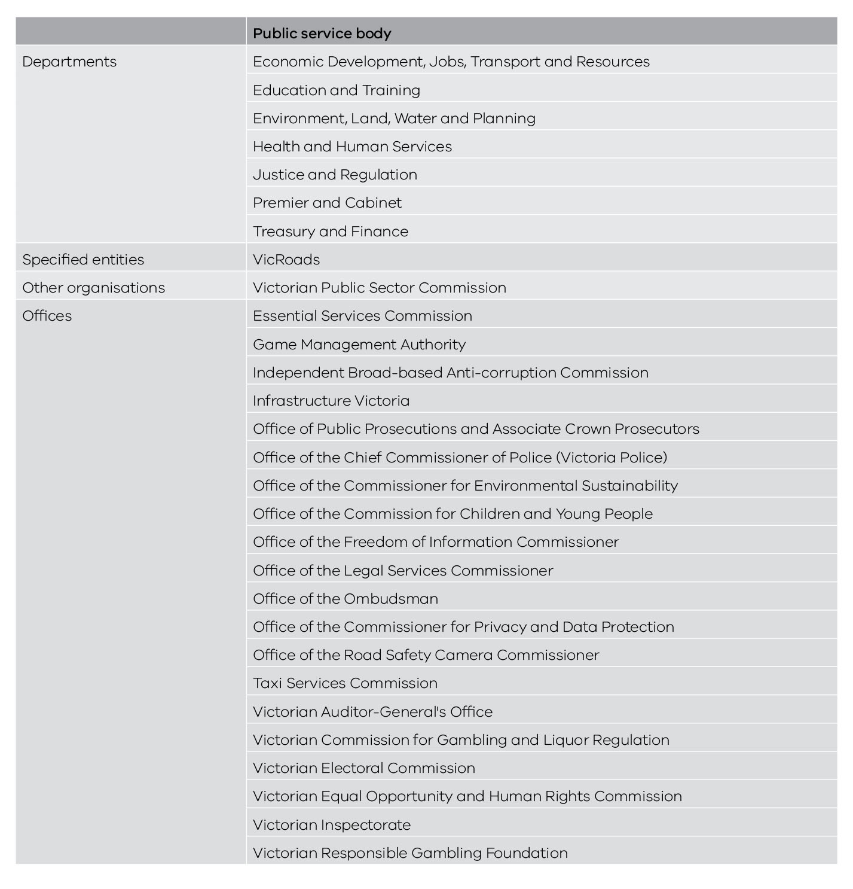

Compliance with VGPB policies
Section 54L of the FMA requires all accountable officers and other members of staff of departments and specified entities to comply with VGPB procurement policies when acquiring goods and services.
The VGPB has a comprehensive multi-year audit program, rolled out over a three-year period, to verify compliance with VGPB supply policies. The aim of the audit program is to minimise risks and improve processes to drive better procurement outcomes. The audit measures the extent to which organisations are achieving savings, efficiencies and better service delivery as a result of improved supplier engagement, increased market engagement and greater rigour in driving value from contracts.
Organisations submit their procurement activity plans every year for review. Organisations can nominate certain strategic procurements for VGPB oversight. In addition, the VGPB can identify specific procurements for ongoing oversight and opportunities for aggregation. All oversight projects are considered to be of strategic importance to the State and are subject to the VGPB’s ongoing review at key stages of the procurement process. The VGPB provides recommendations for organisations to action based on the outcomes of its review.
Organisations also complete an annual supply report at the end of each financial year for the VGPB. Each annual supply report summarises procurement activity during the year and is approved by the Chair of the internal procurement unit, who is responsible for governing the organisation’s procurement process.

VGPB members
The Board consists of a chairperson and not less than six other members. Board members are selected based on experience and expertise in procurement-related matters. They can be internal or external to government.
At 30 June 2016 the VGPB had eight members including the Chair. Six members were external appointees and two appointees were from the Victorian Government (see Table 4).
The VGPB meets every two months. The VGPB also met for an additional day in March 2016 to develop its five-year strategic plan.
The VGPB had two member appointments that concluded during the year:
- Neil Lucas on 9 October 2015; and
- Julie Freeman on 30 June 2016.
Table 4: VGPB members as at 30 June 2016
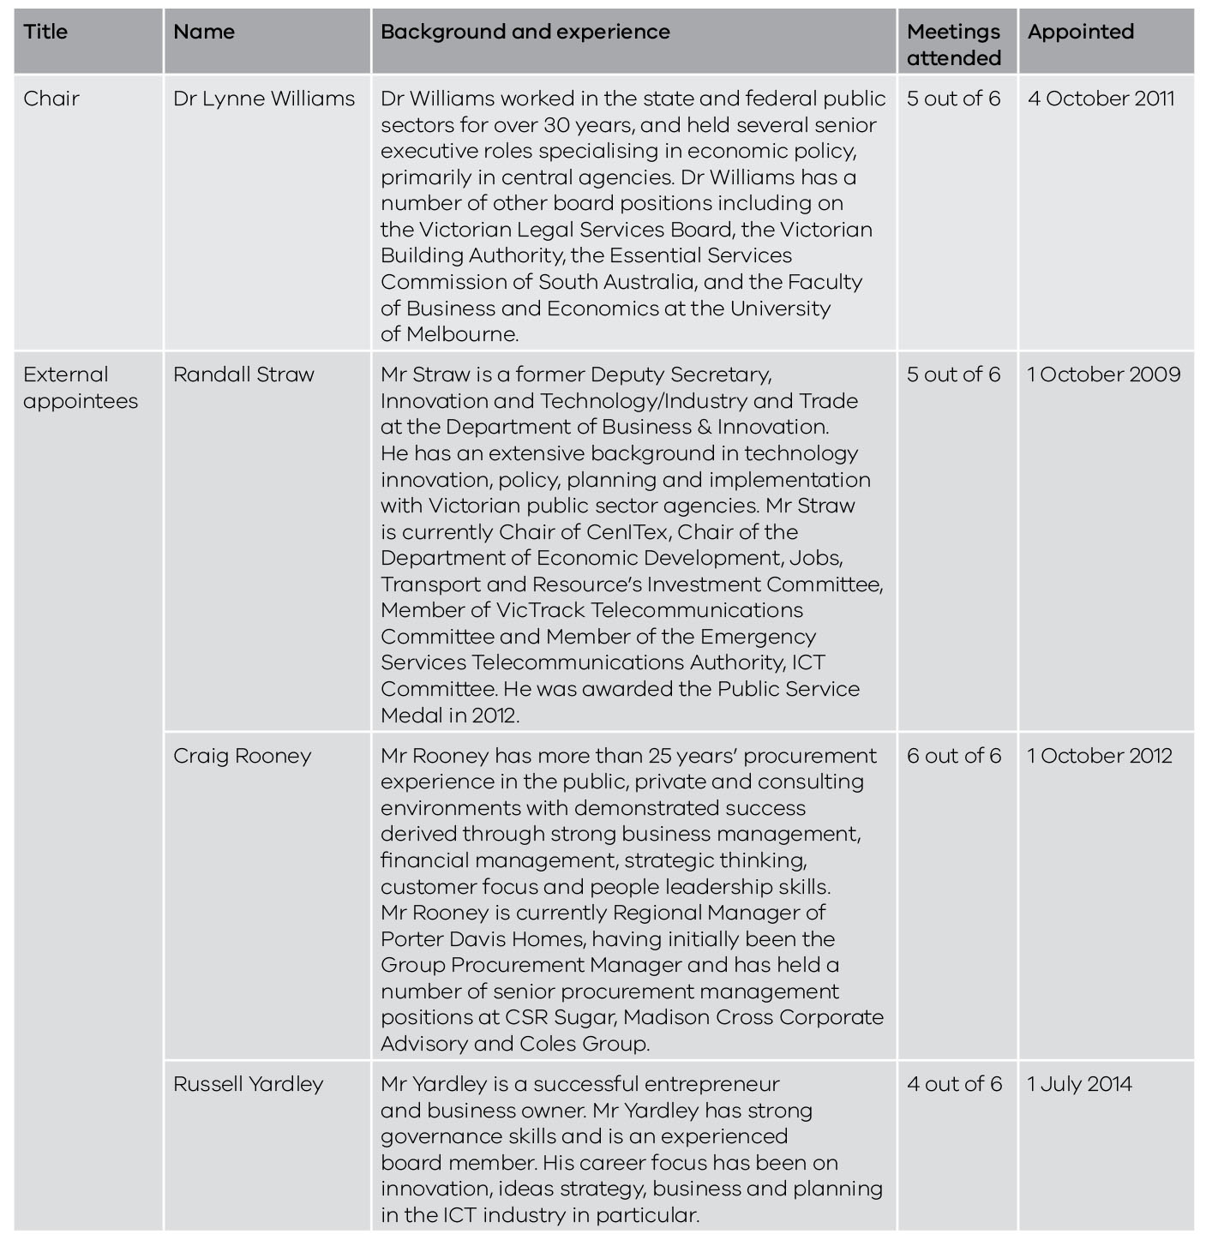
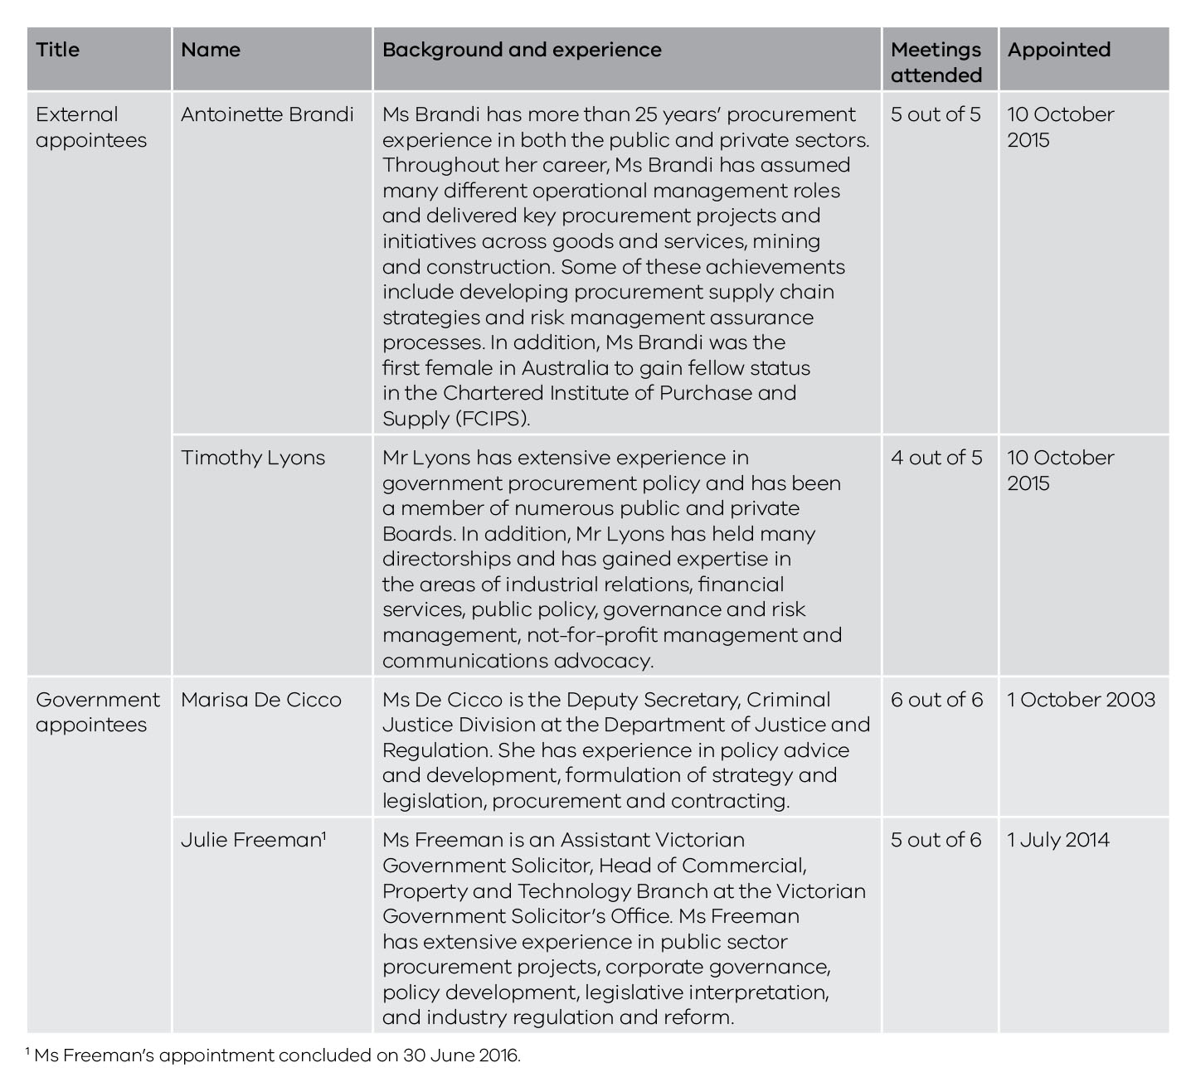
VGPB annual assessment
As part of its commitment to continuous improvement, the VGPB assesses its performance over the previous year.
The assessment in 2015–16 showed that the VGPB continues to fulfil its legislative functions. The VGPB focused on embedding the new supply policies and broadening its scope through its accreditation program. Implementing the supply policy review was a significant piece of work. The revised policies were gazetted on 30 June 2016 and became effective from 1 July 2016 and several initiatives were identified and planned for delivery.
During the year the VGPB set aside one day to develop its five-year strategic plan. The day was informed by stakeholder engagement with CPOs to build on a more collaborative approach to the planning process, which is a key element to the role of the VGPB. The VGPB recognises the need to engage more with senior stakeholders across government and looks forward to building these relationships.
Members agreed that the role of the VGPB has continued to change and recognised the Minister’s and DTF's support in providing further resourcing for the Secretariat to deliver its legislative functions, the implementation of the policy review and its strategic plan. The Board enjoyed open and respectful debate to deliver effective outcomes.

Procurement spend

This section provides an overview of procurement approvals valued at greater than $100 000 in the 2015–16 financial year for:
- one-off supply; and
- aggregated purchasing arrangements including:
  - sole entity purchase contracts (SEPCs); and
  - state purchase contracts (SPCs).
This section also includes purchases made under the critical incident procurement policy.
One-off supply and SEPC approvals relate to approval of the procurement; that is, to enter into a contractual arrangement with the selected supplier or suppliers. SPC approvals relate to approval of the business case.
Actual expenditure occurs later and may occur over a number of financial years depending on the nature of the contract.
All figures in the tables and text in the annual report have been rounded. Discrepancies in tables between totals and sums of components reflect this rounding.

Overview of procurement spend
In 2015–16, organisations reported 790 procurement approvals valued at $2 414.9 million as shown in Table 5. Overall, 15 per cent of procurement approvals were for goods and 85 per cent for services.
Table 5: Total number and value of one-off supply, SEPC and SPC approvals in 2015–16 by goods and services
 | One-off supplies |  | SEPCs |  | SPCs |  | Totals
 | Number | Value | Number | Value | Number | Value | Number | Value
Goods | 88 | $304.1M | 23 | $115.1M | 4 | $172.6M | 115 | $591.8M
Services | 655 | $611.4M | 14 | $663.7M | 6 | $548.0M | 675 | $1 823.1M
Totals | 743 | $915.5M | 37 | $778.8M | 10 | $720.6M | 790 | $2 414.9M

Trends in procurement spend
The number and value of procurement approvals increased in 2015–16 compared to the two previous years, as shown in Table 6.
Part of this increase can be attributed to the additional procurement approvals reported by VicRoads following their successful accreditation to VGPB supply polices from 1 July 2015.
The biggest increase was in the number and value of one-off supply approvals; an increase of 18 per cent and 32 per cent respectively.
The number of SEPCs remained the same, but the value increased substantially by $507.9 million compared to last year. This increase can be attributed to one high value procurement ($495.0 million) in the Department of Education and Training for ICT technical support for the Victorian schools program eduSTAR.TSS.
The number of SPCs increased by four with a corresponding increase in value of $62.0 million.
Table 6: Total number and value of one-off supply, SEPC and SPC approvals from 2013–14 to 2015–16
 | 2013–14 |  | 2014–15 |  | 2015–16
 | Number | Value | Number | Value | Number | Value
One-off supplies | 573 | $735.5M | 630 | $692.3M | 743 | $915.5M
SEPCs | 29 | $93.2M | 37 | $270.9M | 37 | $778.8M
SPCs | 5 | $114.8M | 6 | $658.6M | 10 | $720.6M
Totals | 607 | $943.5M | 673 | $1 621.9M | 790 | $2 414.9M
Note: The increase in one-off supply approvals in 2015–6 compared to previous years can be partly attributed to the additional procurement approvals reported by VicRoads following their successful accreditation to VGPB supply policies from 1 July 2015. VicRoads reported 77 one-off supply approvals valued at $55.0 million. VicRoads did not report any SEPCs or SPCs.

One-off supply contracts
One-off supply refers to a single purchase of a specific quantity of goods or services which has been subject to a discrete quotation or tender process.
In 2015–16, organisations reported 743 one-off supply procurement approvals valued at $915.5 million. Twelve per cent of one-off supply approvals were for procurement of goods and 88 per cent for services.
This compares to 630 one-off supply approvals in 2014–15 valued at $692.3 million.
Table 7 and Figures 4 and 5 show the number and value of one-off supply approvals by organisation and by goods and services.
Table 7: Number and value of one-off supply approvals by organisation and by goods and services in 2015–16
Organisation | Goods |  | Services
Organisation | Number | Value | Number | Value
Economic Development, Jobs, Transport and Resources | 8 | $14.2M | 66 | $19.8M
Education and Training | 18 | $163.0M | 233 | $139.0M
Environment, Land, Water and Planning | 8 | $3.4M | 97 | $166.8M
Health and Human Services | 3 | $7.6M | 89 | $63.6M
Justice and Regulation | 22 | $104.2M | 41 | $140.6M
Premier and Cabinet | 5 | $1.1M | 24 | $12.5M
Treasury and Finance | .. | .. | 23 | $11.1M
VicRoads | 8 | $1.2M | 69 | $53.8M
Victoria Police | 16 | $9.3M | 13 | $4.4M
Totals | 88 | $304.1M | 655 | $611.4M
Note: Discrepancies between totals and sums of components reflect rounding.

Figure 4: Number of one-off supply approvals by organisation and by goods and services in 2015–16

Figure 5: Value of one-off supply approvals by organisation and by goods and services in 2015–16

Aggregated purchasing arrangements
Aggregated purchasing arrangements (also known as standing offer agreements) are established when a sole or multiple organisations have a specific requirement for frequently purchased goods and services. By grouping together demand (aggregating demand) for commonly purchased goods and services, organisations can harness greater economies of scale when negotiating with potential suppliers.
These arrangements take the form of SPCs or SEPCs. SPCs incorporate a number of organisations, whereas SEPCs usually apply to a single organisation.
Aggregated purchasing arrangements can be established and managed in a number of ways – sole or multiple suppliers, open or closed panels, register, prequalification or a more formal contractual arrangement. They can involve arrangements with one or more suppliers for a set period (usually three to five years), incorporate a schedule of rates and performance levels, and usually require no obligation on the state to purchase a particular quantity of the goods or services.
All government organisations and agencies can access SPCs provided they commit to the rules of use. SEPCs are mandatory for the organisation establishing the procurement arrangement.
These long term agreements have benefits to government such as:
- using the aggregated purchasing power of organisations to negotiate lower prices and better service; and
- reducing the administrative burden for end users in preparing specifications, requesting quotations and tenders and evaluating offers for similar purchases.
The values in the tables are estimates. Expenditure occurs later and over a number of years as detailed in the contract term and options columns. Total estimated value includes the initial contract term as well as any options.

Sole entity purchase contracts
In 2015–16, organisations reported 37 SEPC approvals valued at $778.8 million. Only four organisations reported SEPCs during the year (see Table 8).
Of these, 62 per cent were for goods and 38 per cent for services although the overall value of goods was much lower (15 per cent of total SEPC approval value) than the value of services (85 per cent of total SEPC approval value). This compares to 37 SEPCs approvals in 2014–15 valued at $270.9 million of which 49 per cent were for goods and 51 per cent for services.
The increase in value from 2014–15 to 2015–16 and also the increase in the value of services as compared to goods can be attributed to one high value procurement in the Department of Education and Training of $495.0 million for ICT technical support for the Victorian schools program eduSTAR.TSS.
Table 8: Number and estimated potential value of SEPC approvals by organisation and by goods and services in 2015–16
Organisation | Goods |  | Services
Organisation | Number | Value | Number | Value
Education and Training | .. | .. | 3 | $610.0M
Environment, Land, Water and Planning | 7 | $70.6M | 2 | $41.0M
Health and Human Services | 3 | $13.8M | 3 | $8.8M
Victoria Police | 13 | $30.7M | 6 | $3.9M
Totals | 23 | $115.1M | 14 | $663.7M
Figures 6 and 7 provide an overview of number and value of SEPCs by organisation and by goods and services.
Figure 6: Number of SEPC approvals by organisation and by goods and services in 2015–16
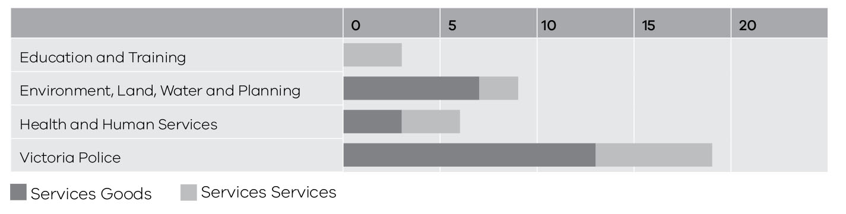

Figure 7: Value of SEPC approvals by organisation and by goods and services in 2015–16
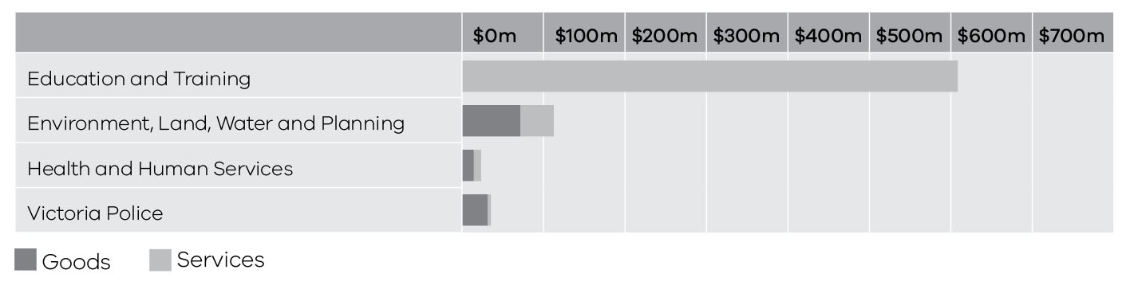

Table 9: Breakdown of SEPCs approved in 2015–16
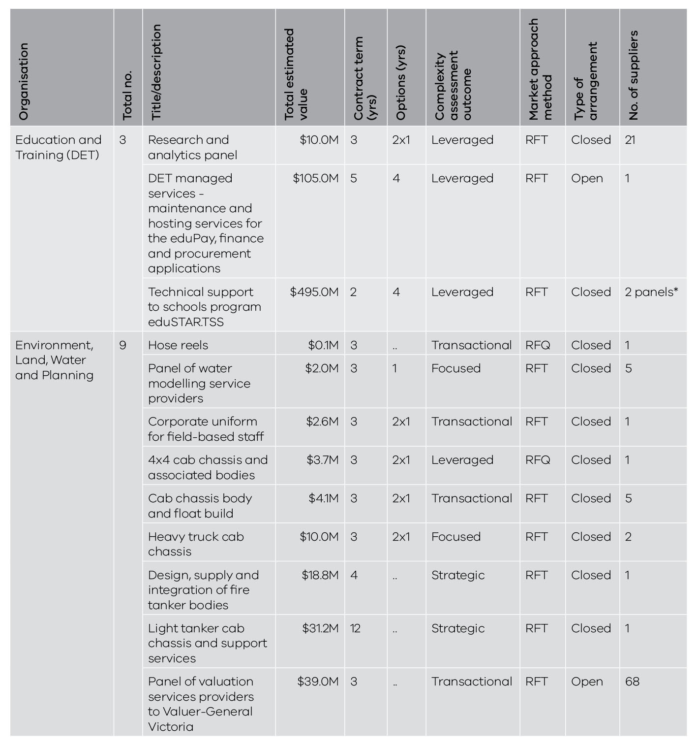
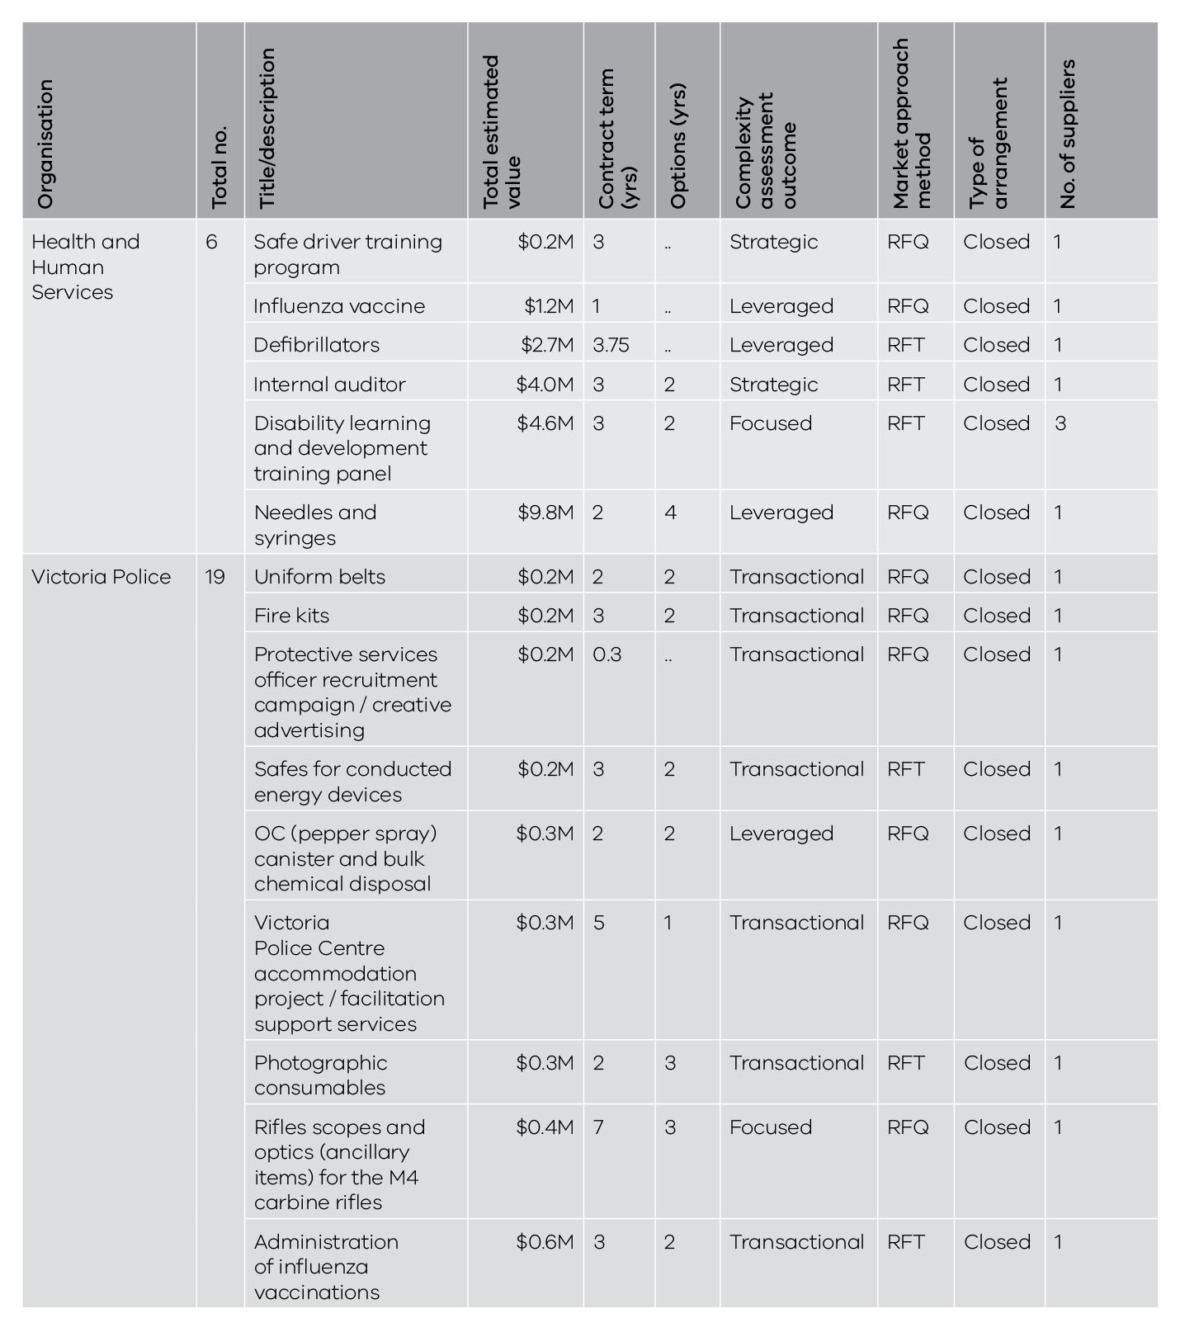
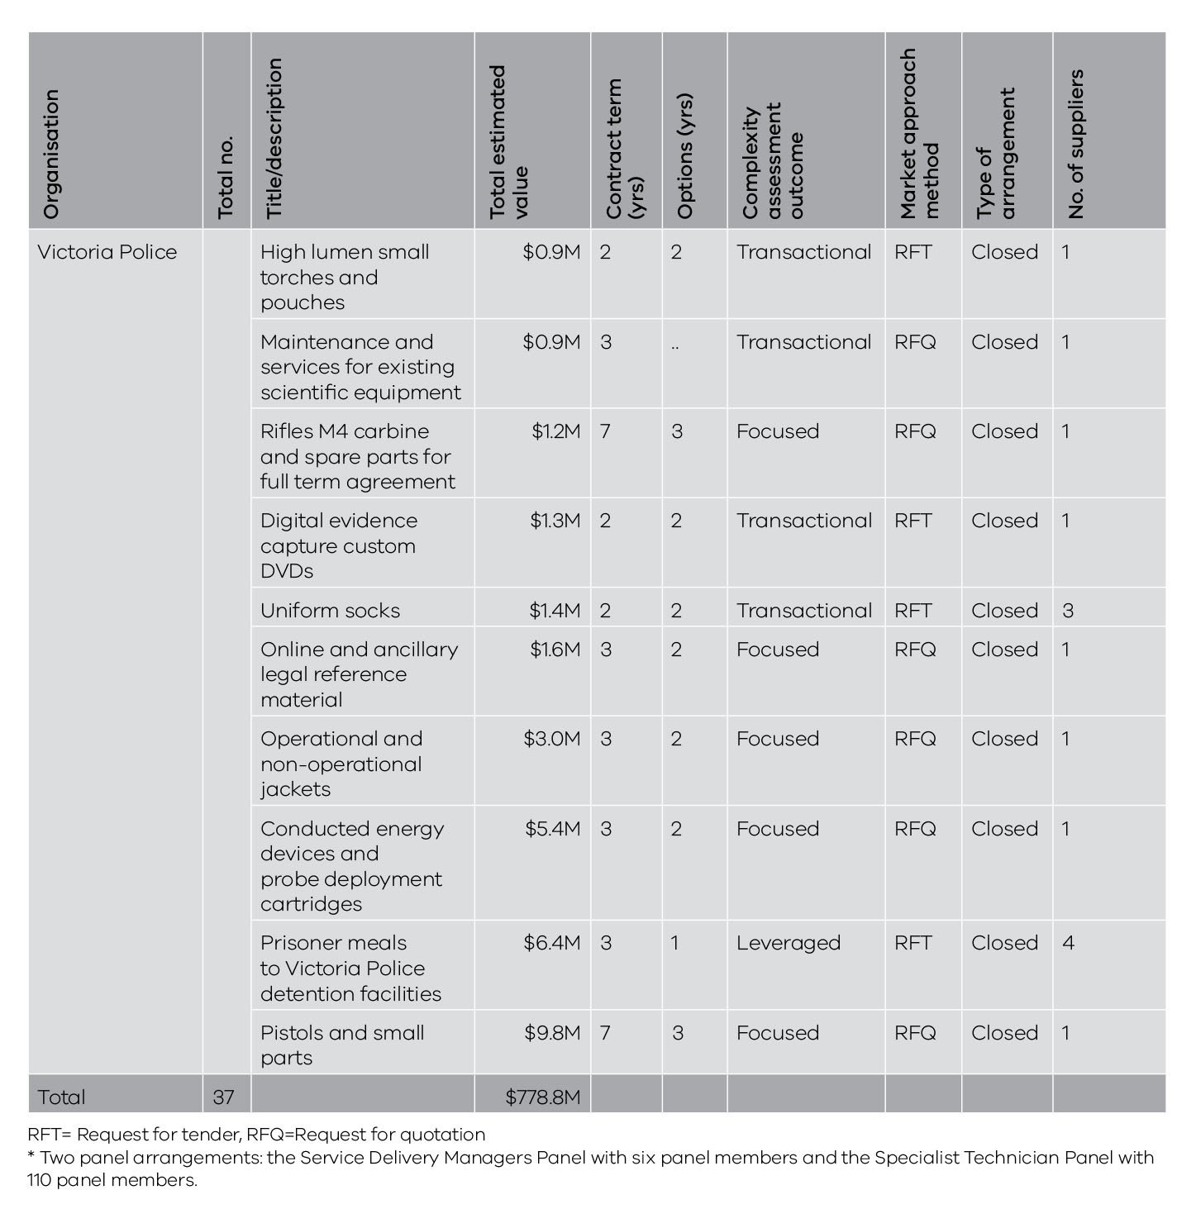

State purchase contracts
The Department of Treasury and Finance (DTF) primarily manages non-ICT goods and services SPCs and the Department of Premier and Cabinet is responsible for ICT SPCs.
Until 30 June 2016, DTF was responsible for overseeing SPCs and granting lead agency status to another organisation if certain criteria were met, as outlined in the relevant VGPB supply policy.
The VGPB’s policy review identified the need for the VGPB to take on a stronger role in establishing, reporting and oversight of SPCs. As a result, from 1 July 2016 DTF will no longer have an oversight role and the VGPB will play a stronger role in granting lead agency status. SPCs may also be nominated for VGPB oversight.
In 2015–16, organisations reported 10 SPCs with an estimated total value of $720.6 million. This compares with six SPCs with an estimated total value of $658.6 million reported in 2014–15.
Table 10 provides a breakdown of all SPCs approved in 2015–16.
Table 10: Breakdown of SPCs approved in 2015–16
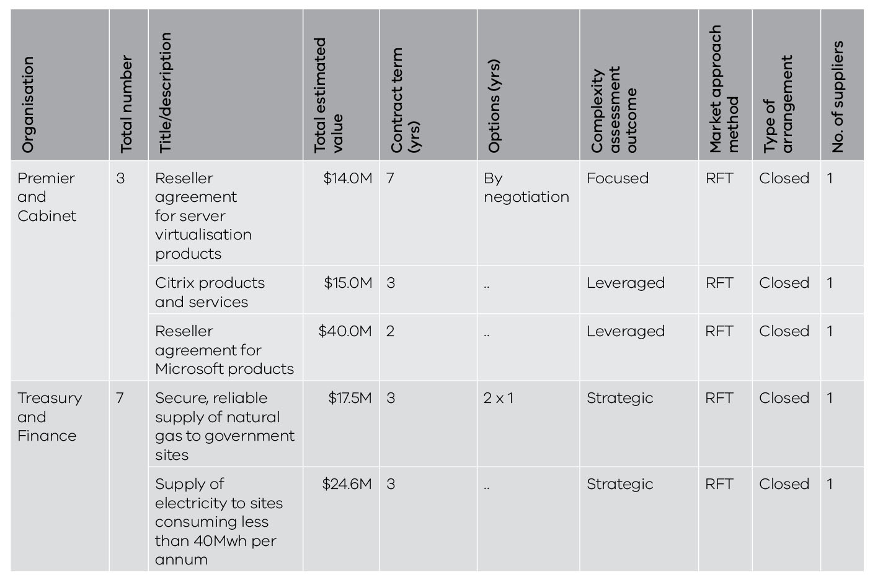

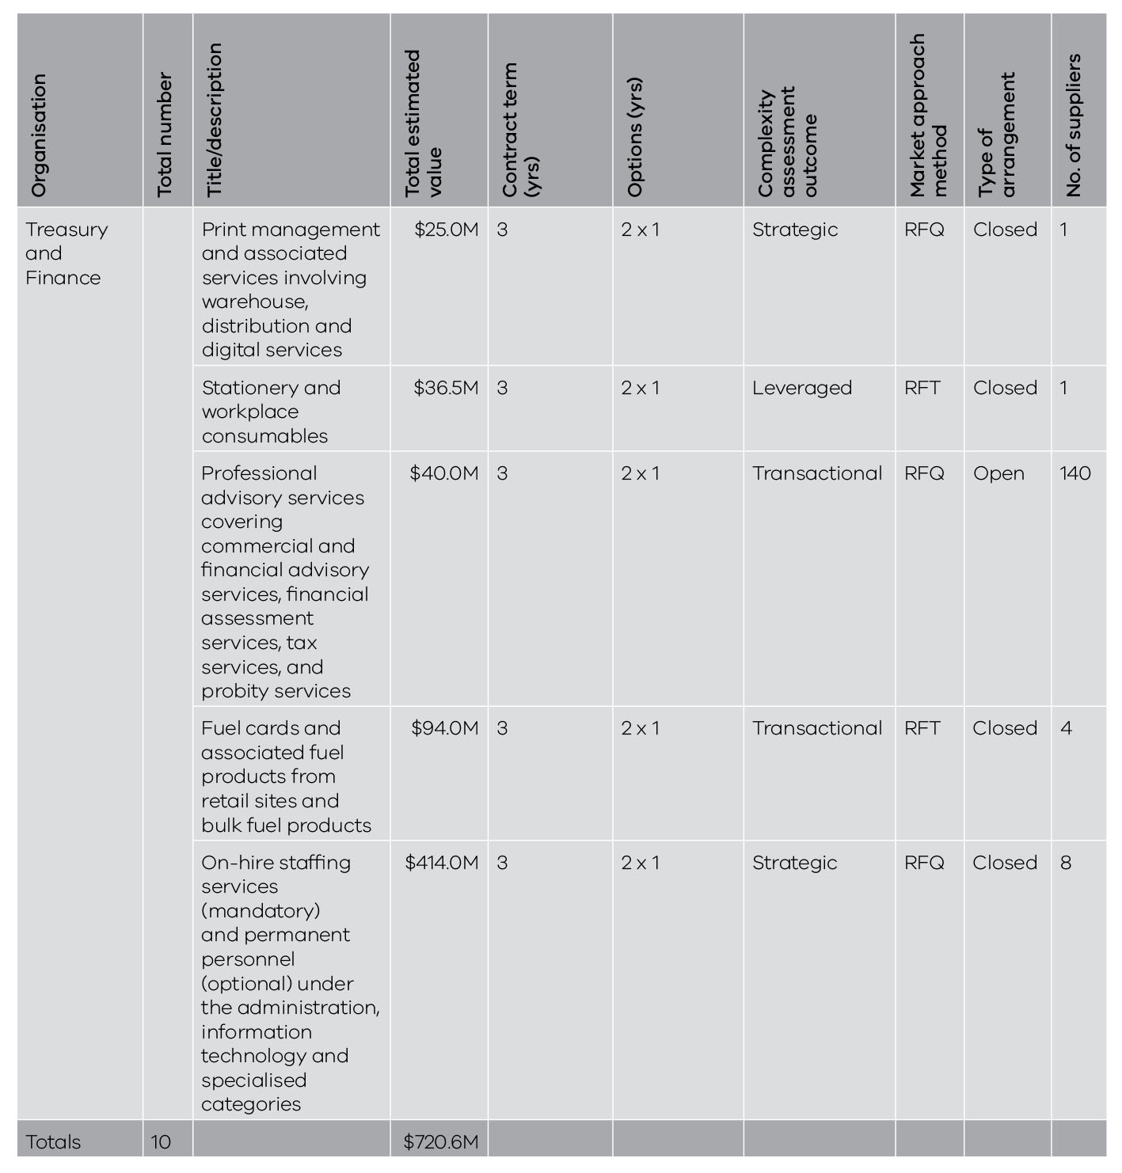

Critical incident procurement
The market approach policy establishes an alternative procurement process to operate during a critical incident and any subsequent relief effort. The processes under this policy aim to accommodate urgent procurement needs while ensuring that the procurement process adopted is reasonable and conducted with appropriate consideration of good practice procurement principles.
Four critical incident procurements were reported in 2015–16 as shown in Table 11. There were no critical incident procurements reported in 2014–15.
Table 11: Critical incident procurement in 2015–16
 | Number | Value
Goods | 1 | $0.14M
Service | 3 | $0.73M
Total | 4 | $0.88M
Note: Discrepancies between totals and sums of components reflect rounding.
All four procurements were reported by the Department of Environment, Land, Water and Planning and related to bushfire activity at Wye River and Tasmania.

Procurement complexity and VGPB oversight
Procurement complexity relates to the level of intricacy and scope of issues involved in procuring a good or service. It is measured by considering the internal and external influences on a procurement activity such as risk, total cost of ownership and market dynamics.
When buying goods and services, organisations complete a complexity assessment and use the results to guide the sourcing strategy and the management of risks and contractual arrangements.
During its regular review of organisations’ procurement activity plans, the VGPB identifies procurements for oversight that it considers to be of strategic importance to the state. Organisations can also nominate specific procurements for VGPB oversight.
The four complexity quadrants are described in Table 12.
Table 12: Description of complexity quadrants
 | Quadrant | Description
1 | Transactional | Low-value and low-risk transactions where approved suppliers (e.g. SPCs) are not available.
2 | Leveraged | Frequently used goods/services in a competitive marketplace that are procured by an individual organisation or whole of government, where the organisation has the ability to drive value.
3 | Focused | Procured goods/services where a limited number of suppliers are available or where novel commercial arrangements are in place. May include whole of government contracts.
4 | Strategic | Goods/services in a competitive market that are high value, where business criticality is high, and/or where the good/service is of state significance. May include whole of government contracts.

Procurement complexity
Table 13 shows the complexity assessment results for the one-off supply, SEPC and SPC approvals reported by organisations in 2015–16.
Table 13: Number of one-off supply, SEPC and SPC approvals by complexity quadrant in 2015–16
Type of complexity | Number | Value | Average value
Transactional | 241 | $275.2M | $1.1M
Leveraged | 312 | $1 164.9M | $3.7M
Focused | 135 | $126.8M | $0.9M
Strategic | 102 | $848.0M | $8.3M
Totals | 790 | $2 414.9M | $3.1M

Note: The leveraged quadrant includes two high value SEPCs valued at S495 million and $105 million. Without these SEPCs the average contract value would be closer to $1.8 million. The strategic quadrant includes one high-value SPC valued at $414 million. Without this SPC, the average contract value would be closer to $4.3 million.

The total average value reflects total value divided by total number and not the sum of the average value components.

Number of procurement approvals by complexity quadrant
Most procurement approvals were assessed as leveraged (39 per cent) followed by transactional (31 per cent). Focused was 17 per cent and strategic 13 per cent (see Figure 8).
This compares with 36 per cent leveraged, 26 per cent transactional, 19 per cent focused and 19 per cent strategic in 2014–15.
Figure 8: Number of procurement approvals by complexity quadrant in 2015–16
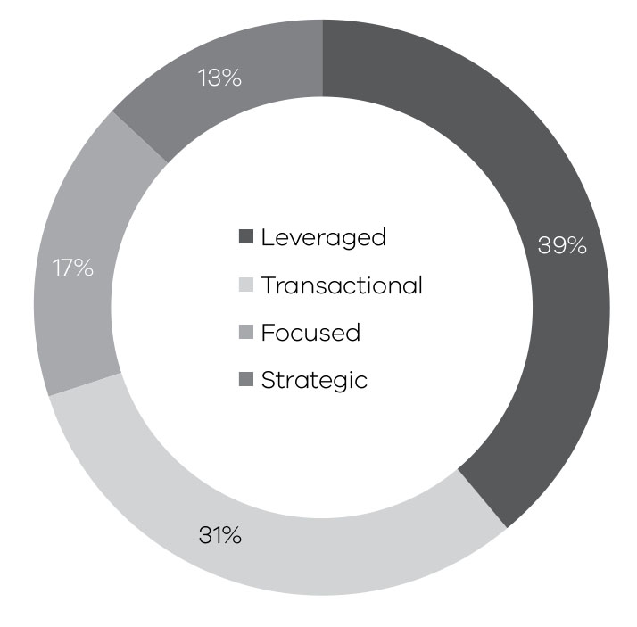

Number of complexity quadrants by organisation
Table 14 shows a breakdown of complexity quadrants by organisation giving an insight into the procurement profile of each organisation.
Table 14: Complexity quadrants (number) by organisation
Organisation | Transactional | Leveraged | Focused | Strategic | Totals
Economic Development, Jobs, Transport and Resources | 30 | 1 | 40 | 3 | 74
Education and Training | 7 | 217 | 30 | .. | 254
Environment, Land, Water and Planning | 75 | 5 | 28 | 6 | 114
Health and Human Services | 3 | 10 | 2 | 83 | 98
Justice and Regulation | 18 | 15 | 24 | 6 | 63
Premier and Cabinet | 27 | 4 | 1 | .. | 32
Treasury and Finance | 25 | 1 | .. | 4 | 30
VicRoads | 20 | 57 | .. | .. | 77
Victoria Police | 36 | 2 | 10 | .. | 48
Totals | 241 | 312 | 135 | 102 | 790

Value of procurement approvals by complexity quadrant
The leveraged quadrant had the highest total value with 48 per cent of the value of all procurement approvals, followed by strategic at 35 per cent (see Figure 9).
The focused quadrant had the lowest total value of procurement process approvals (5 per cent). This would be expected given that the focused quadrant is for procurements where a limited number of suppliers are available or where novel commercial arrangements are in place. The transactional quadrant had 12 per cent of the value of all procurement approvals.
These figures compare with 70 per cent strategic, 18 per cent leveraged, 8 per cent transactional and 5 per cent focused in 2014–15.
Both the high-value SEPCs ($495 and $105 million) reported by the Department of Education and Training were in the leveraged quadrant which explains the rise in value in this quadrant compared to the previous year.
Figure 9: Value of procurement approvals by complexity quadrant in 2015–16
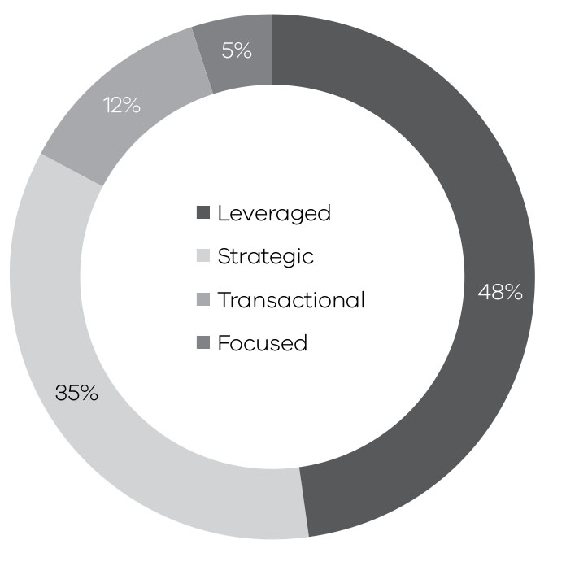

Trends in procurement complexity
As shown in Table 15, there has been an upward trend in the number and value of all complexity quadrants, except for strategic. This can be partly explained by the overall increase in the number and value of contracts approved in 2014–15.
The largest increase in value is in the leveraged quadrant. As mentioned previously, this can be partly explained by the two high value SEPCs for technical support services in schools ($495 million) and managed services contract ($105 million) reported by the Department of Education and Training.
It could also indicate that organisations are taking a more strategic approach to procurement. The VGPB’s supply policies require better upfront planning, category management and detailed market analysis. Organisations identify the best approach to market for any given category while also identifying opportunities to aggregate demand for frequently used goods and services procured from a competitive marketplace, giving them more buying power to drive value for money.
Table 15: Trends in procurement complexity
 | 2014–15 |  | 2015–16
Type of complexity | Number | Value | Number | Value
Transactional | 149 | $109.6M | 241 | $275.2M
Leveraged | 208 | $240.1M | 312 | $1 164.9M
Focused | 112 | $62.4M | 135 | $126.8M
Strategic | 107 | $954.3M | 102 | $848.0M
Totals | 576 | $1 366.5M | 790 | $2 414.9M
Table 16 shows how complexity quadrants have changed between 2014–15 and 2015-16 by organisation.
Table 16: Trends in complexity quadrants by organisation
Organisation | Transactional |  | Leveraged |  | Focused |  | Strategic
Organisation | 2014–15 | 2015–16 | 2014–15 | 2015–16 | 2014–15 | 2015–16 | 2014–15 | 2015–16
Economic Development, Jobs, Transport and Resources | 4 | 30 | 17 | 1 | 50 | 40 | 3 | 3
Education and Training | 3 | 7 | 170 | 217 | 21 | 30 | .. | ..
Environment, Land, Water and Planning | 11 | 75 | 2 | 5 | 3 | 28 | 2 | 6
Health and Human Services | 9 | 3 | 9 | 10 | .. | 2 | 97 | 83
Justice and Regulation | 25 | 18 | 3 | 15 | 25 | 24 | 3 | 6
Premier and Cabinet | 54 | 27 | 2 | 4 | .. | 1 | 1 | ..
Treasury and Finance | 18 | 25 | .. | 1 | 5 | .. | .. | 4
VicRoads | n/a | 20 | n/a | 57 | n/a | .. | n/a | ..
Victoria Police | 25 | 36 | 5 | 2 | 8 | 10 | 1 | ..
Totals | 149 | 241 | 208 | 312 | 112 | 135 | 107 | 102
Note: VicRoads began operating under the VGPB policies on 1 July 2015 so did not provide data in 2014–15.

Procurement activity subject to VGPB oversight
The VGPB reviews specific procurement activities for process and probity oversight. Procurement oversight projects typically run across multiple years. The VGPB actively managed 12 oversight projects during 2015–16 as listed in Table 17.
The oversight process can cover one or more of three different stages in the procurement process. Stage 1 relates to planning, Stage 2 is prior to contract execution and Stage 3 covers contract management. The oversight stage of the procurements reviewed by the VGPB in 2015–16 is listed in Table 17. This table does not reflect approval timing of contractual spend.
Table 17: Number and estimated value of procurement activities subject to VGPB oversight in 2015–16
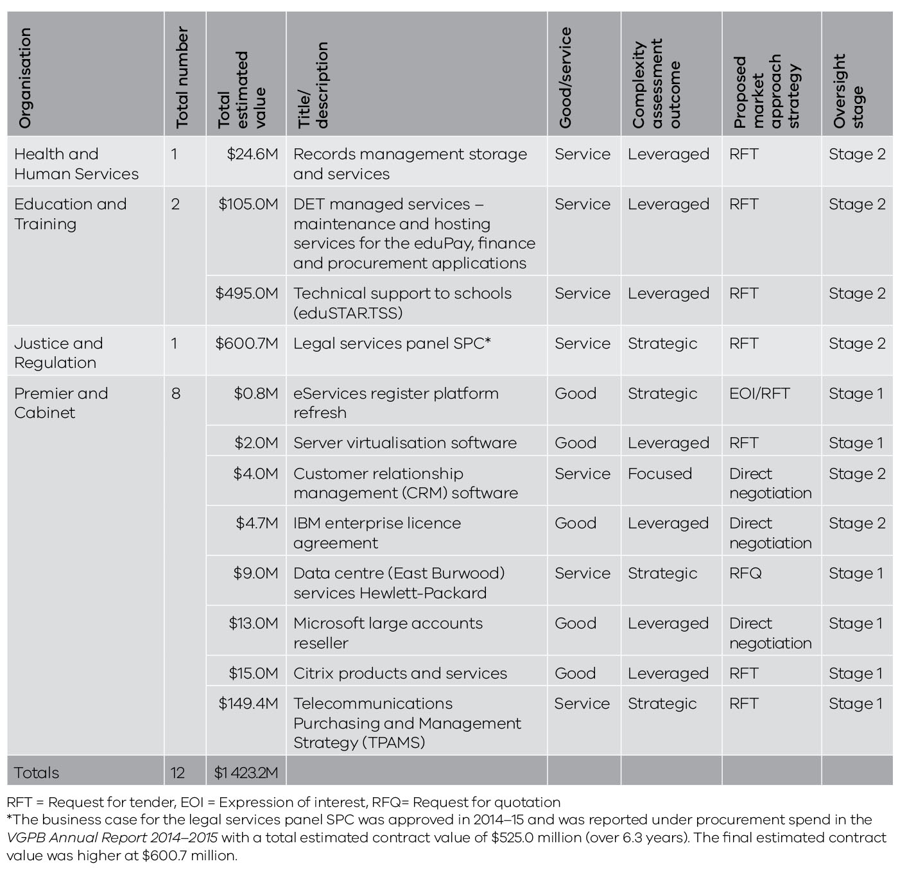

Compliance with VGPB procurement policies
Section 54L of the Financial Management Act 1994 requires all accountable officers and other members of staff of departments and specified entities to comply with VGPB procurement policies when acquiring goods and services.
The VGPB continues to fulfil its legislative role of monitoring compliance with the VGPB supply policies by requiring organisations to attest each year that they comply with these policies and provide evidence of compliance-related initiatives and activities.
This section reports on actions taken by organisations to demonstrate compliance with VGPB procurement policies in 2015–16.

Actions taken to ensure compliance
As part of the VGPB’s governance policy, each organisation must establish a CPO role and an internal procurement unit (IPU). The CPO and IPU work on numerous initiatives related to ensuring an effective governance framework and compliance with VGPB supply policies across their organisation.
The role of the CPO is to:
- provide expert advice and guidance to the accountable officer on matters related to the governance framework;
- oversee the development, application and ongoing assessment of the governance framework; and
- ensure that the complaints management process demonstrates due process and integrity.
The role of the IPU is to:
- ensure that all procurement activity applies strategies, policies, procedures, practices and probity that comply with VGPB supply policies and any other requirements in the FMA or imposed by the accountable officer;
- assess the procurement capability of the organisation on an annual basis;
- manage the preparation of a capability development plan;
- identify major procurement categories;
- review its own performance and capability at regular intervals; and
- report annually to the accountable officer on the organisation’s procurement activities.
Organisations sometimes choose a different name for their IPU, such as procurement governance committee, or procurement approval board.
At the end of each financial year, organisations complete an annual supply report (ASR) to provide the VGPB with procurement data, including actions taken to ensure compliance with VGPB policies. ASR data is signed off by the IPU chair.
Table 18 summarises the actions taken by organisations to comply with VGPB policies as provided in their ASR in 2015–16.
Table 18: Summary of actions taken by organisations to comply with VGPB supply policies in 2015–16
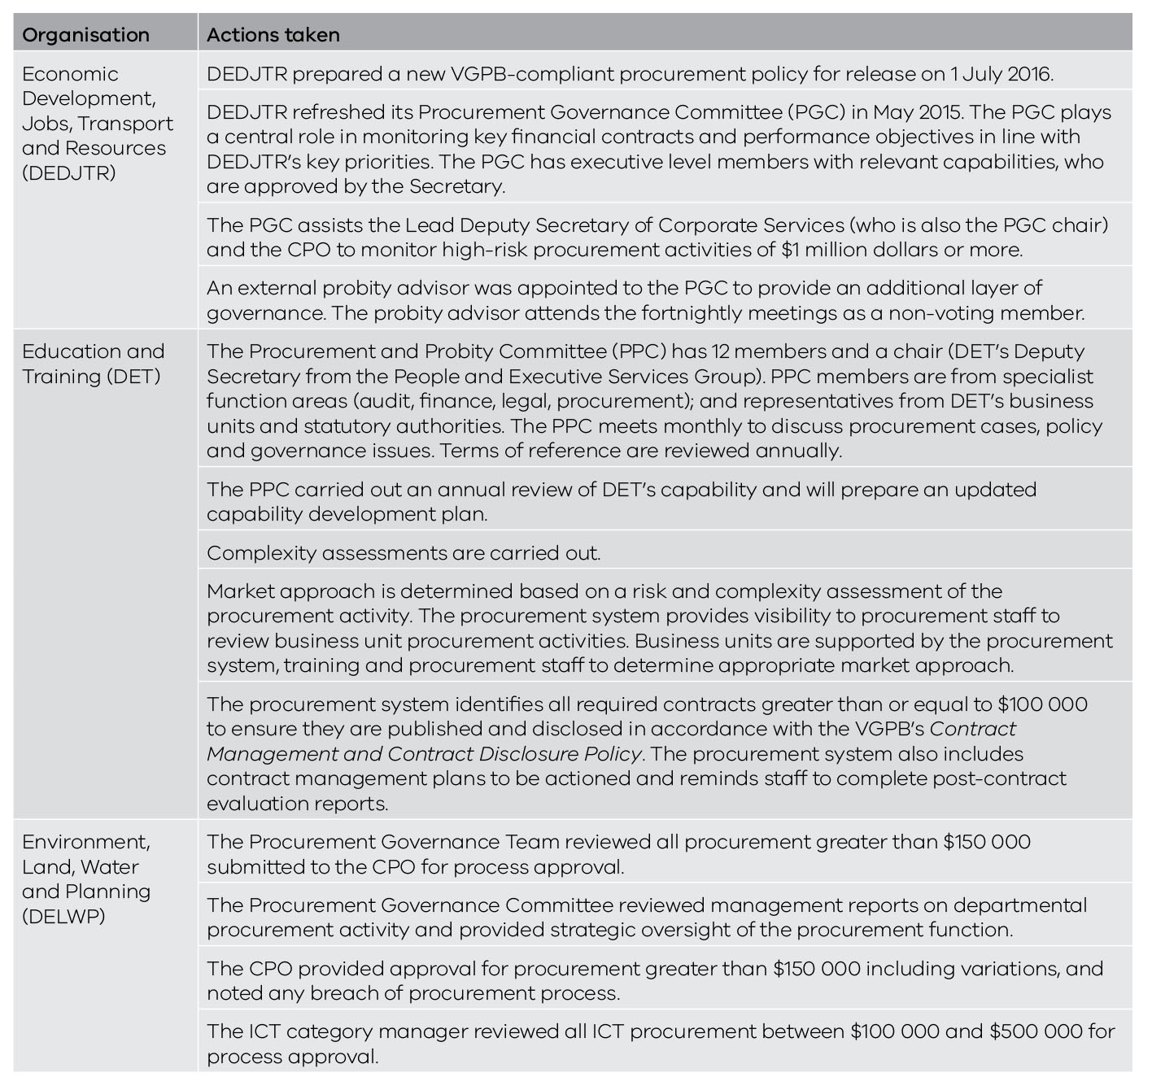
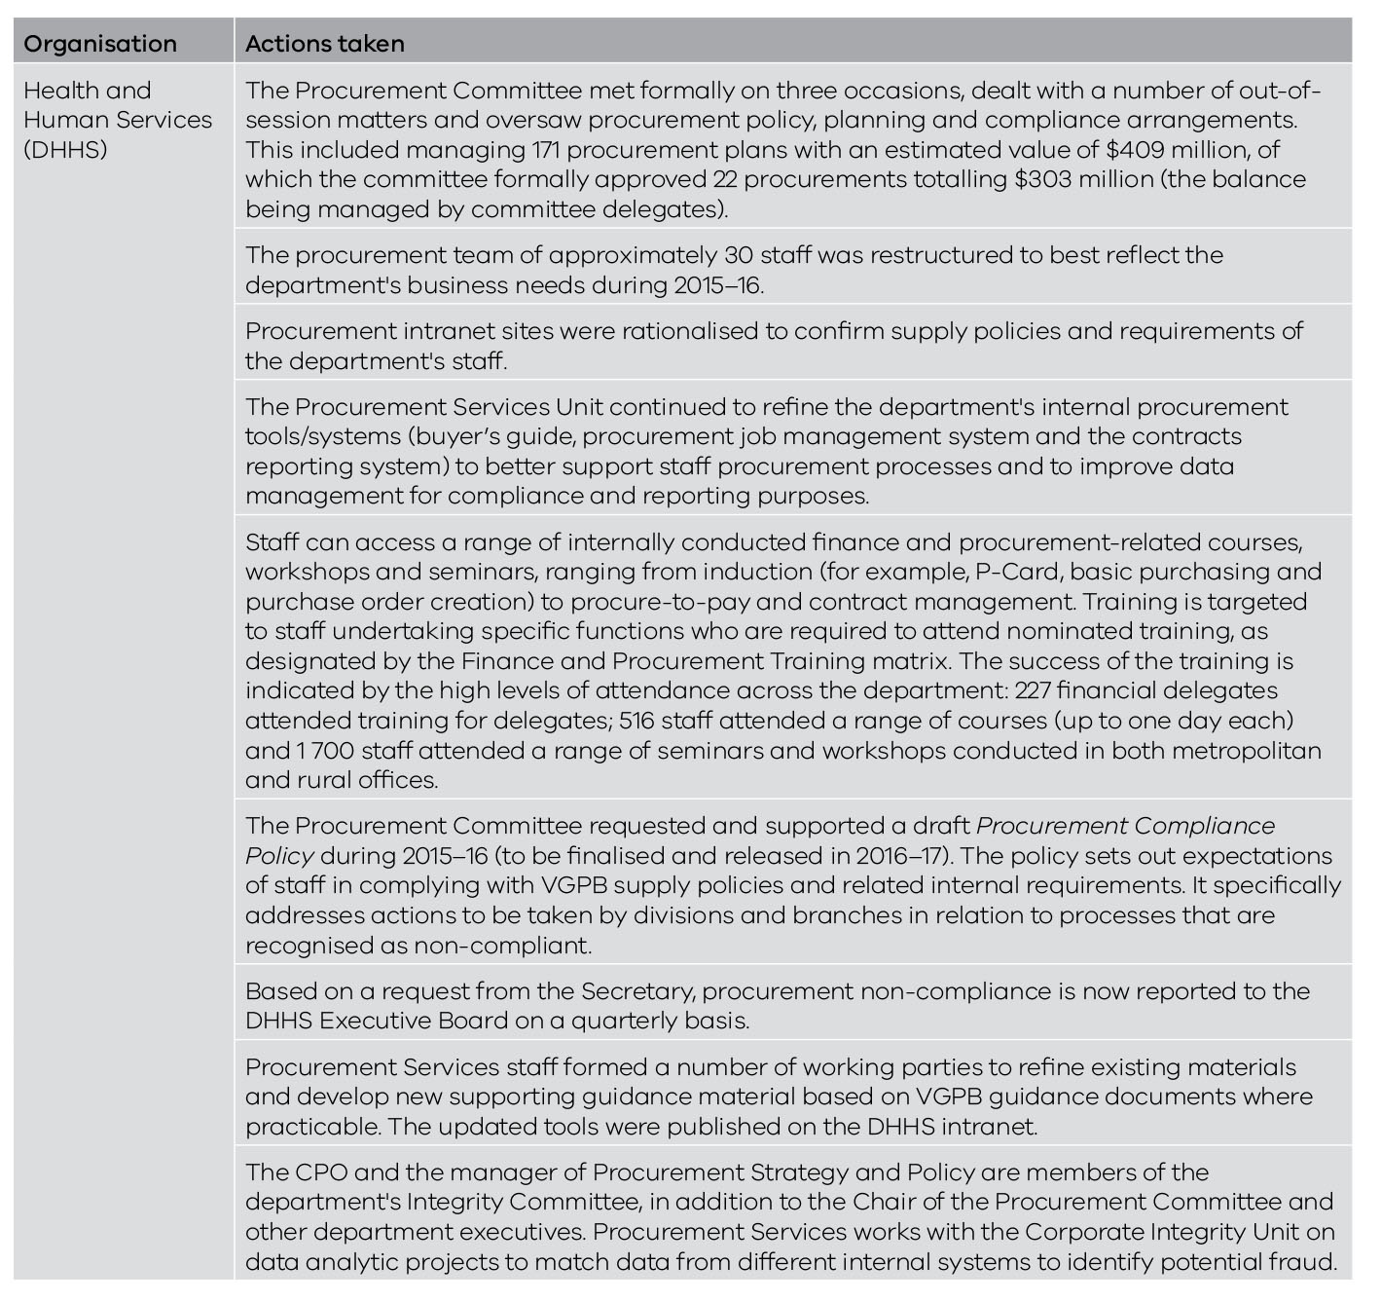
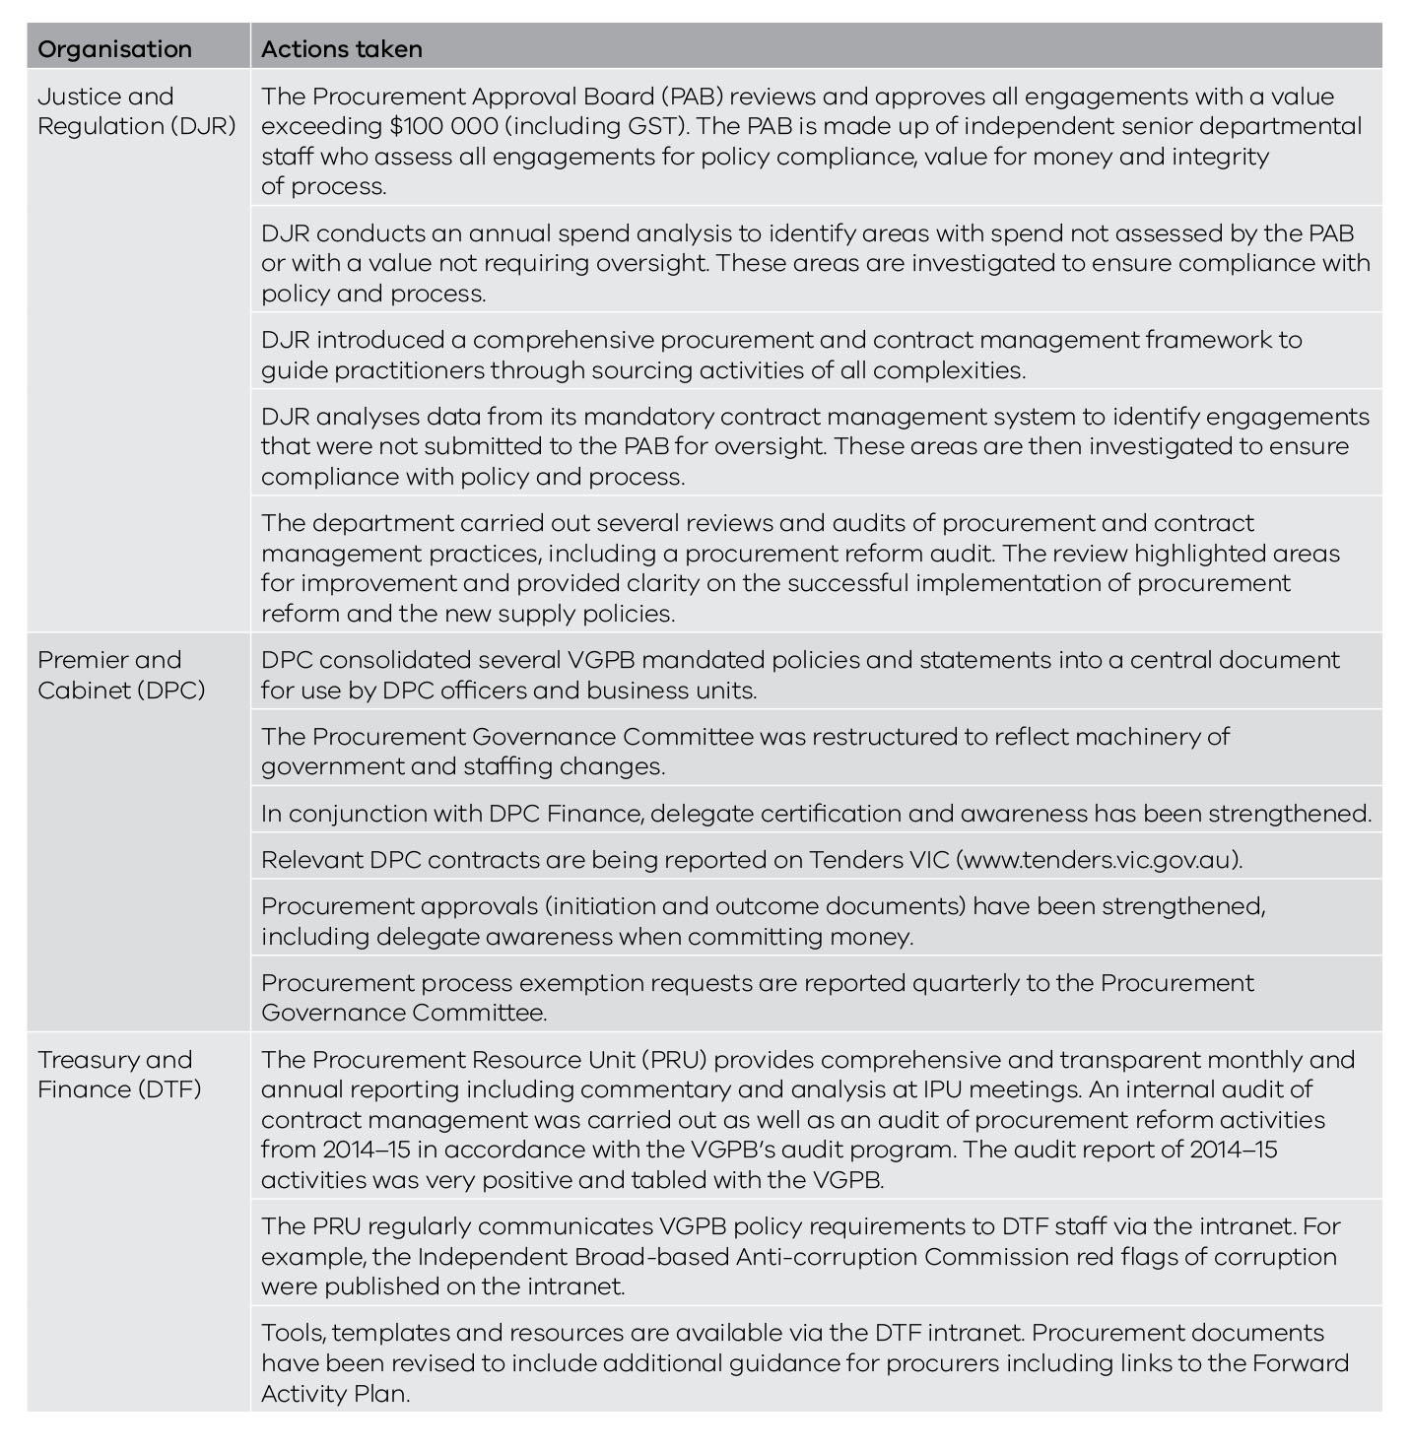
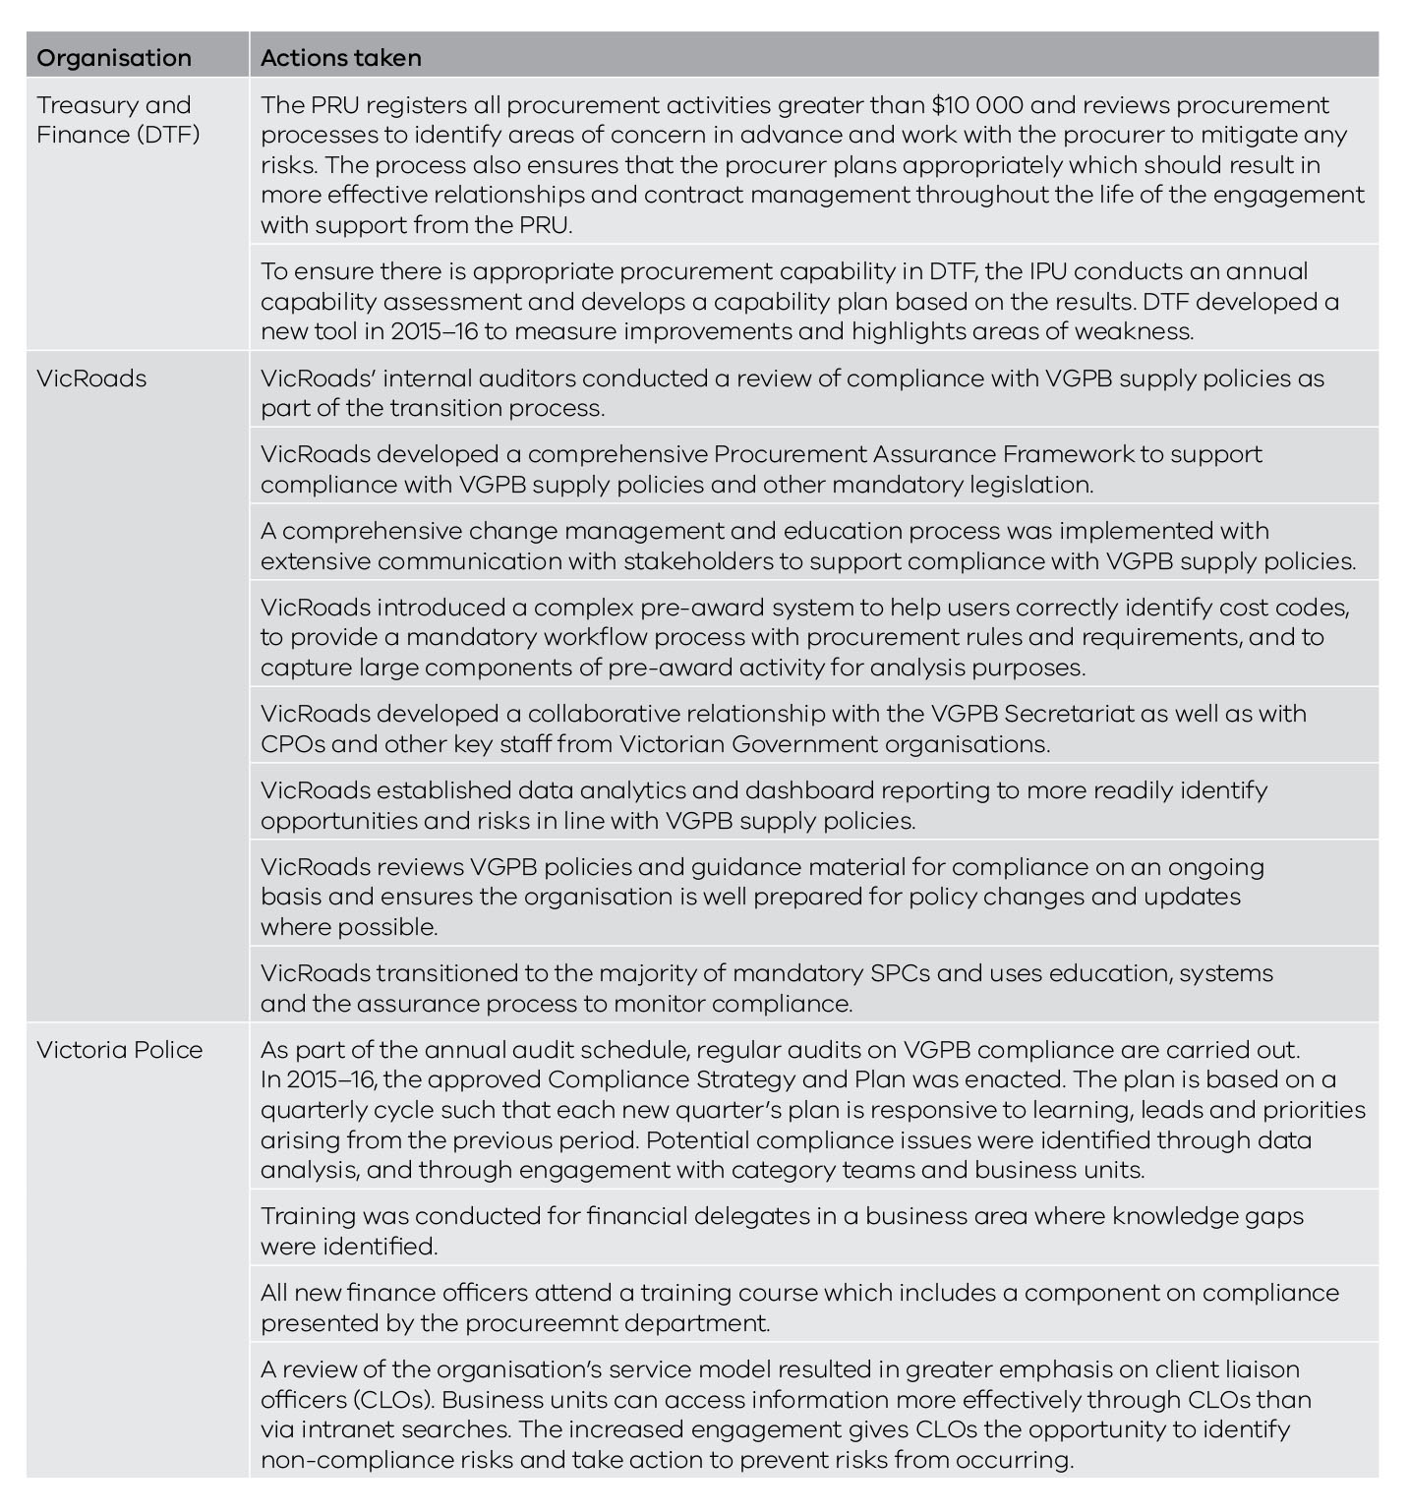

Audits
In 2015, the VGPB implemented a comprehensive three-year rolling audit program to verify compliance with VGPB supply policies.
The aim of the audit program is to minimise risks and improve processes to drive better procurement outcomes.
DTF was the first organisation to be audited in 2015–16. The VGPB concluded that the audit was thorough and overall findings were positive, with minimal recommendations for improvement.
The Victoria Police audit is currently under way and due for completion in the second half of 2016.
Table 19 lists the audit program schedule and results to date.
Table 19: Audit program schedule and results as at 30 June 2016
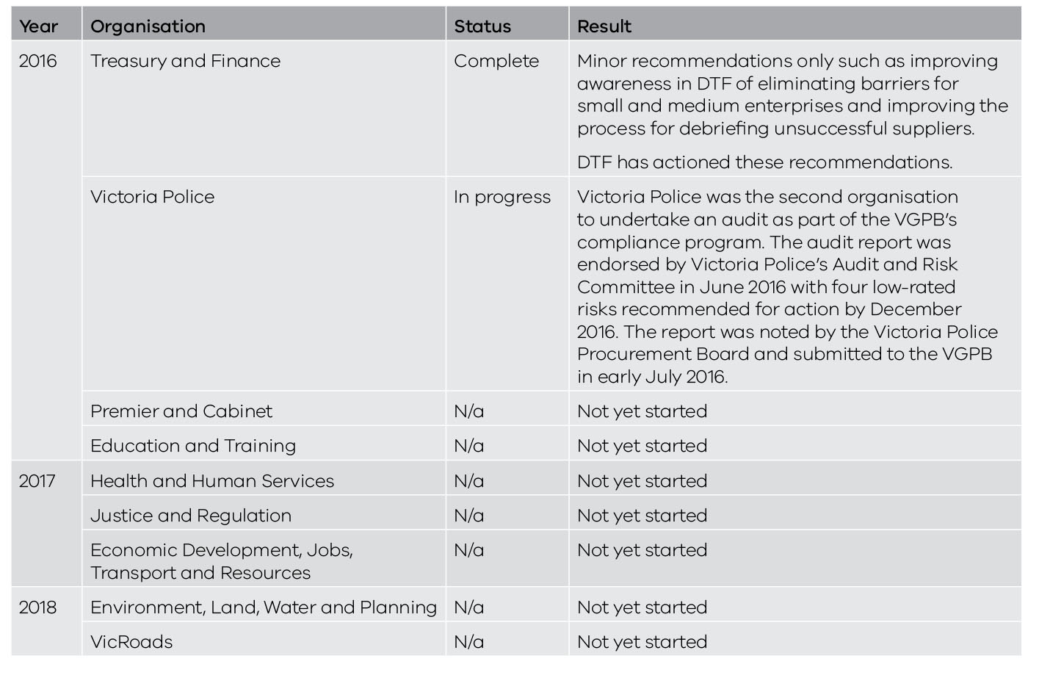

Complaints
Organisations are required to develop a complaints management system that sets out the process and procedures for addressing complaints by suppliers. CPOs are responsible for their organisation’s complaints management process.
The VGPB defines a complaint as an issue or concern expressed by a supplier in relation to the process and probity applied by an organisation when carrying out a procurement activity.
In 2015–16, organisations reported three complaints related to procurement activity as shown in Table 20. This compares to six complaints in 2014–15 and three complaints in 2013–14.
Table 20: Complaints related to procurement activity in 2015–16
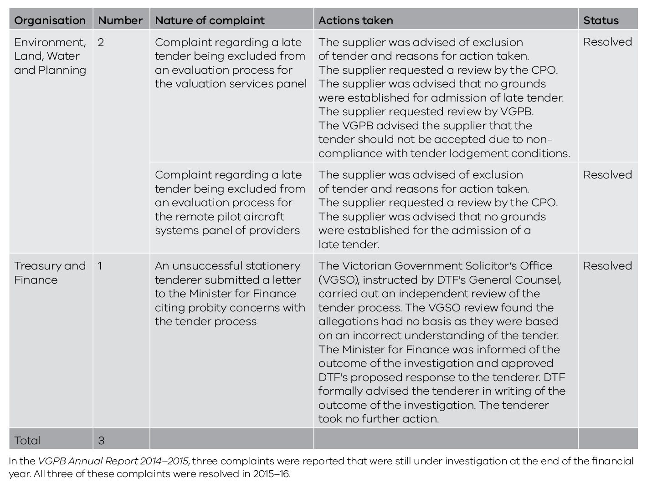

Procurement profiles and performance by organisation
This section provides an overview of each organisation’s procurement profile, performance and procurement-related activities in 2015–16.

Reporting on performance measures
In 2015–16, organisations began putting in place processes to capture the data needed to report on six new performance measures. Due to the significant amount of work involved in collecting this data for year one, the results reflect a ‘best endeavours’ approach. As far as possible, the 2015–16 outcomes will help form the baseline against which organisations will measure performance in future years.
The performance measures provide a consistent, quantifiable approach to measuring reform benefits. The VGPB will work with organisations in early 2016–17 to refine the measures before commencing the year two data collection.
Table 21 lists the six performance measures and summarises the methodology for its calculation. As mentioned above, the methodology may be adjusted in 2016–17 after reviewing year one results to ensure performance measures are relevant and improved where necessary.
Table 21: Key performance measures to assess the benefits of procurement reform
Performance measure |  | Definition
1 | Value created as a consequence of department procurement activity | Value of direct cost savings and potential costs avoided for department procurements of $100 000 and greater, conducted during the financial year as a percentage of the total value of department total contracted spend during the financial year.
2 | Proportion of the number of transactions at or below $2 000 through a P-Card or equivalent | Ratio of low-value transactions less than $2 000 through a P-card or equivalent card versus total number of low-value transactions less than $2 000 paid by any means.
3 | Increase in procurement capability | Annual assessment of the improvement in departmental procurement capability year on year, measured by the department score on the VGPB capability assessment tool and template.
4 | Cost of department’s procurement resources as a percentage of total contract spend | Percentage of the total salary and wages for all procurement resources allocating equal to, or greater than, 80% of time on procurement tasks against total department spend for the year.
5 | Supplier satisfaction assessment | Satisfaction with quality of service provided by the department procurement function as provided by an annual survey of supplier perception of experience over time.
6 | Planned procurement activity as a percentage of actual procurement activity | Number of planned procurements captured in a department’s internal forward activity plan against the number of procurement activities awarded to the market.

Procurement-related activities
In addition to the compliance-related activities listed in Table 18, the CPO and IPU work on numerous initiatives to improve procurement outcomes across the organisation. This includes (but is not limited to) activities such as:
- supporting SME or local business participation in government procurement opportunities;
- supplier engagement initiatives;
- developing and implementing procurement‑related systems; and
- capability development and procurement training.
This section lists procurement activities carried out in 2015–16 as well as activities planned for 2016–17.
The CPO and IPU Chair listed under each organisation is the person in the role at 30 June 2016.

Department of Economic Development, Jobs, Transport and Resources
IPU Chair | Sue Eddy, Lead Deputy Secretary, Corporate Services
CPO | Lisa Williams, Chief Procurement Officer, Corporate Services

Procurement profile
The role of the Department of Economic Development, Jobs, Transport and Resources (DEDJTR) is to increase jobs, investment, exports and opportunities; stimulate innovation, competitiveness, confidence, and support sustainability.
DEDJTR drives economic development and job creation across Victoria through areas such as transport and ports, investment attraction and facilitation, trade, innovation, regional development and small business, together with key services to sectors such as agriculture, the creative industries, resources and tourism.
DEDJTR has nine ministers across 13 portfolios: Public Transport; Major Projects; Employment; Agriculture; Regional Development; Industry; Resources; Roads and Road Safety; Ports; Tourism and Major Events; Creative Industries; Small Business, Innovation and Trade; Industrial Relations; and Training and Skills (international education).
The Procurement Governance and Support Division is a centre-led model with responsibility for supporting the effective procurement of goods and services across the department.
The division provides governance, advisory, strategic procurement, plus contract management system (CMS) administration. At any one time, the team will deal with on average 60 contracts, 15 of which typically would be strategic, 20 leveraged, 15 focused and 10 transactional.
As of June 2016, the division consisted of 14 resources, led by the CPO.

Procurement activities in 2015–16
Following its transition to the new supply policies in January 2015,DEDJTR continued to work on activities related to embedding the reform and consolidating systems from former departments.
In 2015–16, DEDJTR implemented the new procurement framework, developing a suite of departmental procurement policies, procedures, tool and templates and rolling out an extensive two-month procurement training program. Training ran from May to June across nine regional locations, four Melbourne metropolitan locations, plus three webinar sessions.
The department also began working on a system integration program to consolidate procurement-related systems and databases. Implementation will continue in 2016–17, with the first phase due for completion by the end of 2016.
DEDJTR is investigating long term options for a new enterprise resource planning platform. The platform will incorporate procurement functionality, including data analytics, contract reporting and workflow management.
Following the creation and publication of a forward procurement activity plan, the DEDJTR procurement team now has greater alignment with the needs of stakeholders, and better supports the profile of the department.

Performance in 2015–16
Table 22 lists DEDJTR’s data for the six performance measures. Data for 2015–16 reflects a ‘best endeavours’ approach given the significant amount of work involved in setting up processes to report against the performance measures. As far as possible, the 2015–16 outcomes will help form the baseline against which DEDJTR will measure performance in future years.
Table 22: DEDJTR performance in 2015–16
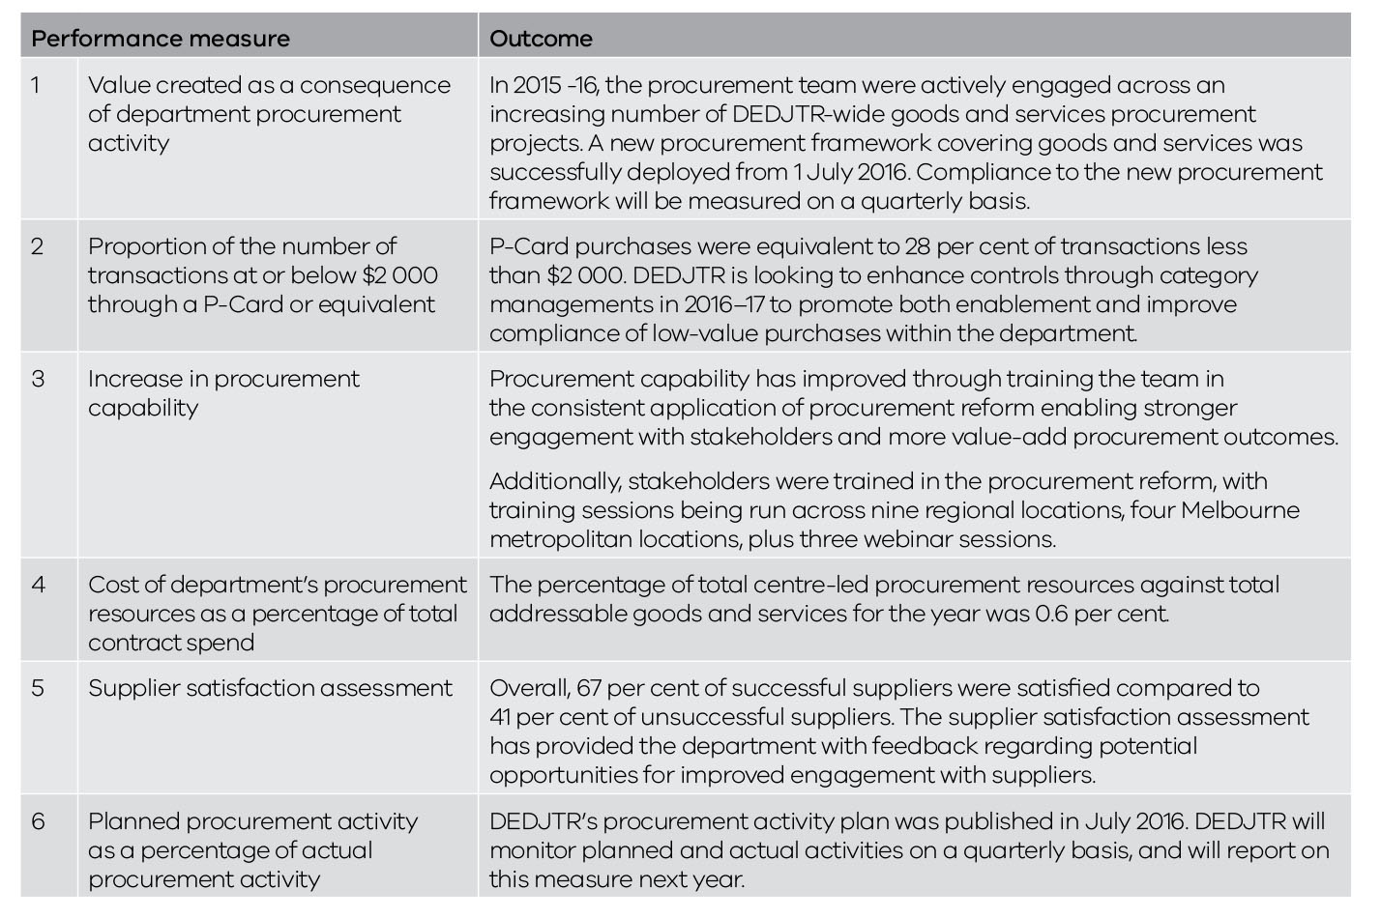

Procurement activities planned for 2016–17
In 2016–17, DEDJTR will:
- continue the procurement systems project, integrating contract management systems with both Oracle systems;
- review spend map and categories, based on post systems integration data;
- create stakeholder engagement plans (as part of category management implementation);
- publish DEDJTR’s procurement forward activity plan on its website; and
- continue to strengthen, expand and advance procurement capability.

Department of Education and Training
IPU Chair | Kate Rattigan, Deputy Secretary, People and Executive Services Group
CPO | Tarkan Koman, A/Executive Director, Procurement Division

Procurement profile
The Department of Education and Training (DET) offers learning and development support, services and resources for all Victorians, from birth through to adulthood.
In delivering these services, the department procures goods and services to the value of approximately $400 million annually.
The most significant procurement sourcing activity for DET in 2015–16 was the provision of ICT technical support for all Victorian Government schools ($495 million). Major areas of expenditure include IT, education, professional services and labour hire sectors. A significant portion of DET procurement activity is focused in the IT sector with procurement activities in the hardware, licensing and technical support areas.
At June 30 2016, there were more than 250 active contracts valued at greater than $100 000 with a total value of more than $900 million. Eighty-six per cent of contracts over $100 000 relate to procurements in the IT sector.
Most DET contracts over $100 000 are in the leveraged complexity quadrant (98 per cent). This is due to DET’s significant panel-related IT spend coupled with the frequent procurements in other typical leveraged sectors, including professional services and education services.

Procurement activities in 2015–16
In 2015–16, DET reviewed its procurement framework to ensure its ongoing alignment with VGPB supply policies. The framework and policy were considered to be robust and up-to-date.
DET updated its procurement capability development plan to improve procurement capability, risk monitoring and compliance. As part of its commitment to increasing standards of procurement capability and compliance, DET delivered a Certificate IV in Government (Procurement and Contracting) to procurement staff. The department also continued to deliver basic procurement training for all departmental staff.
The department completed its annual assessment of the Procurement and Probity Committee (DET’s IPU) against the terms of reference to identify areas that are working well and opportunities for improvement.

Performance in 2015–16
Table 23 lists DET’s data for the six performance measures. Data for 2015–16 reflects a ‘best endeavours’ approach given the significant amount of work involved in setting up processes to report against the performance measures. As far as possible, the 2015–16 outcomes will help form the baseline against which DET will measure performance in future years.
Table 23: DET performance in 2015–16
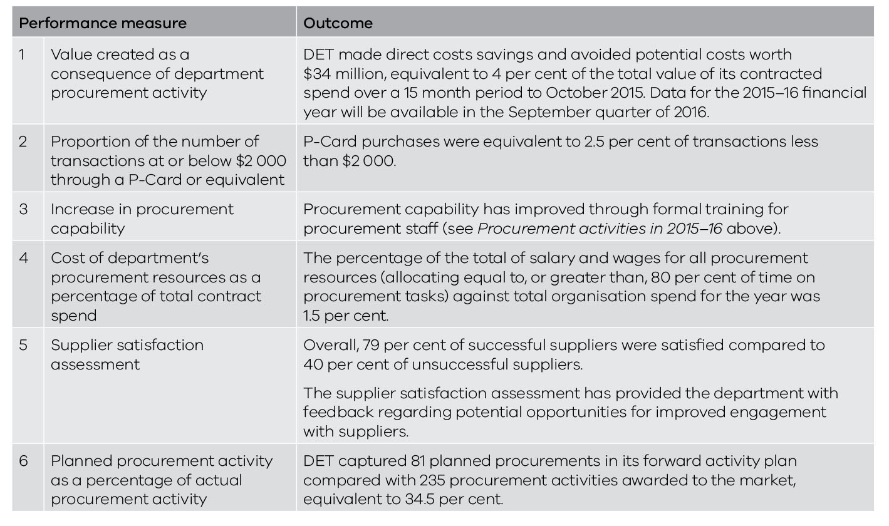

Procurement activities planned for 2016–17
In 2016–17, DET will:
- prepare a report on the audit of VGPB supply policies for review by the VGPB;
- implement three procurement projects under DET’s integrity program including:
  - reforming Victorian public schools by introducing a new Victorian schools procurement framework;
  - carrying out an independent review of procurement operations in DET; and
  - reviewing travel, fuel and fleet operations;
- develop a framework of core competencies for procurement-related positions in DET; and
- establish a new procurement leadership team to improve procurement leadership, knowledge and experience across DET.

Department of Environment, Land, Water and Planning
IPU Chair | Kathryn Anderson, Deputy Secretary, Corporate Services
CPO | Anthony Connelly, Executive Director, Business, Executive and Ministerial Services, Corporate Services

Procurement profile
The Department of Environment, Land, Water and Planning (DELWP) is tasked with creating liveable, inclusive and sustainable communities. DELWP focuses on caring for and protecting the environment and helping to respond to climate change through risk mitigation and adaptation strategies. DELWP assists local governments to support people, communities and growth at the local level. DELWP's individual and collective expertise across energy, environment, climate change, water, planning and local government is an essential part of its success.
DELWP is an organisationally diverse department with a broad and operationally extensive procurement profile. At any one time, there are more than 1 500 current contracts ranging from low value, low risk to highly complex, long term contracts that are significant for the department and the state and need high-level management.
A significant portion of DELWP’s procurement activity focuses on emergency management related to fire and flood recovery, including a chartered fleet of around 50 aircraft. In addition, DELWP’s IT area covers an expansive array of system applications that support the department and community to deliver government obligations and objectives in the areas of land management, environment, water and planning.
The more significant procurement sourcing activities in 2015–16 included a panel of property valuers for the Valuer-General, type 2 and type 3 helicopters, maintenance and IT support for the Victorian water register, supply of cab chassis and maintenance support for fire tankers, and design and manufacture of fire tanker bodies.

Procurement activities in 2015–16
In 2015–16, DELWP set up a new structure for the procurement team and strengthened procurement governance by restructuring the Procurement Governance Committee. New resources were added to the team to strengthen category management capability and to support increased reporting and compliance activity.
The department focused on social procurement objectives such as promoting Aboriginal businesses in Victoria as part of the DELWP Aboriginal Action Plan, and developing a socially responsible procurement policy to integrate gender equity, diversity, disability and environmental objectives into DELWP’s procurement practices.
To establish a baseline for capability, DELWP engaged an external organisation to provide a tool to help staff self-assess their procurement capability across seven stages of the procurement cycle. DELWP plans to repeat the assessment annually to measure improved confidence in conducting procurement.
DELWP reviewed training needs and implemented three new training courses and improved existing training and materials, encouraging more staff to attend formal training. DELWP holds a quarterly procurement forum attended by 50 to 60 staff.
The department strengthened compliance with procurements from the ICT eServices and staffing services SPC categories. This ensures better value for money including monitoring expenditure and contracts to ensure discounts and improved services are applied by service providers.

Performance in 2015–16
Table 24 lists DELWP’s data for the six performance measures. Data for 2015–16 reflects a ‘best endeavours’ approach given the significant amount of work involved in setting up processes to report against the performance measures. As far as possible, the 2015–16 outcomes will help form the baseline against which DELWP will measure performance in future years.
Table 24: DELWP performance in 2015–16
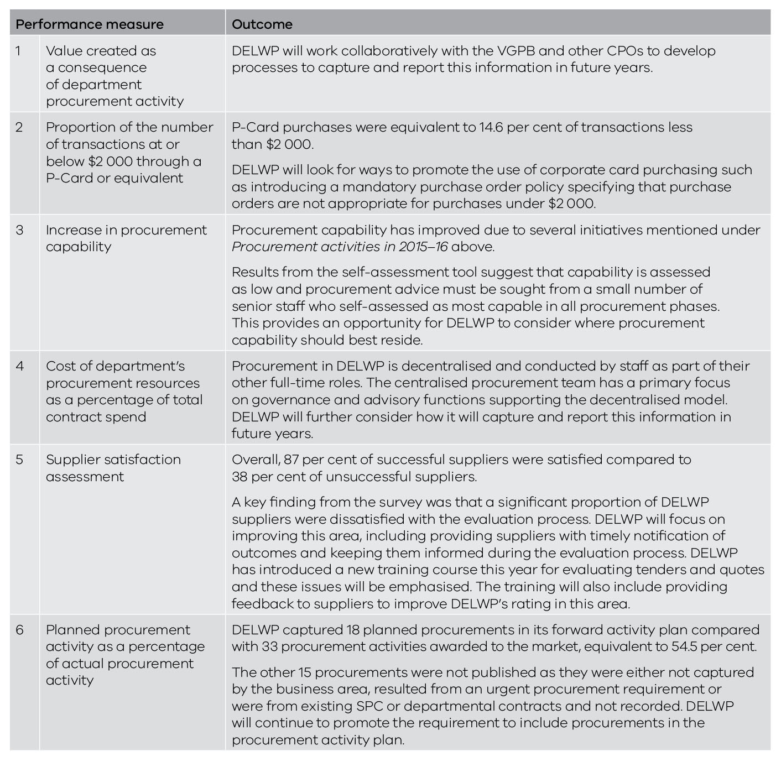

Procurement activities planned for 2016–17
In 2016–17, DELWP will:
- improve the contract register to allow for performance and milestone reporting;
- strengthen its commitment to socially responsible procurement by considering other areas for inclusion and educating staff where possible to promote government objectives in this area;
- continue to identify opportunities for savings and efficiencies, particularly in the areas of staffing services, professional services and ICT procurement; and
- carry out a full spend analysis to assess spending over the 2015–16 financial year following machinery of government changes in the previous year.

Department of Health and Human Services
IPU Chair | Lance Wallace, Deputy Secretary, Corporate Services
CPO | Genine Wallinga, Director, Procurement and Contract Management

Procurement profile
The Department of Health and Human Services (DHHS) develops and delivers policies, programs and services that support and enhance the wellbeing of all Victorians through the efforts of over 10 000 staff located throughout Victoria and the broad range of department-funded community sector and public health organisations.
In delivering these services, the department procures goods and services to the value of approximately $609 million annually across a broad range of categories, equivalent to 4 per cent of the department’s budget excluding employee-related expenses.
Procurement of goods and services in the department is overseen by the Procurement Committee. The CPO, who reports to the Chair of the Procurement Committee, directly manages the Procurement Services Unit which is responsible for supporting staff throughout the department when buying goods and services.
In terms of the department's business activities, goods and services’ spend related mostly to business support (73 per cent) which covers agency staff, utilities, ICT, security, cleaning, equipment, training, etc. Professional support (18 per cent) comprises mainly consultants, and client support (9 per cent) includes food and medical supplies.
The more significant procurement sourcing activities in 2015–16 included records storage and services, multifunction devices, super pharmacies and nurses, and pathology services. Major areas of expenditure include medical services and supplies, IT, training, professional services and labour hire.
The department operates a centre-led goods and services procurement model via the Procurement Services Unit. During 2015–16, the unit helped staff with some 970 procurement jobs with an estimated future value of approximately $559 million. Of these, 171 resulted in procurement plans being developed (estimated value $409 million) for referral to the Procurement Committee or its delegates in accordance with the department's governance framework.

Procurement activities in 2015–16
DHHS began preparing for the VGPB audit of compliance with supply policies scheduled for early 2017.
DHHS worked on developing procurement capability by addressing gaps identified in metrics and reporting and benchmarking. The department analysed data to improve its understanding of procurement and links with related (financial and personnel) data, particularly after detailed analysis based on audit and fraud test recommendations. Some 1 200 department vendors were also examined at beneficiary owner level. This has helped the department understand where, if any, potential fraud issues may lie.
DHHS also continued to implement training programs under the department’s Finance and Procurement Training matrix.
Several large-scale SPCs were due for re-tendering in 2015–16 including stationery, travel, financial and commercial services, and staffing services. DHHS made resources available to support the transition to these new SPCs as it involved considerable administrative work and affected a wide cross-section of staff.

Performance in 2015–16
Table 25 lists DHHS’s data for the six performance measures. Data for 2015–16 reflects a ‘best endeavours’ approach given the significant amount of work involved in setting up processes to report against the performance measures. As far as possible, the 2015–16 outcomes will help form the baseline against which DHHS will measure performance in future years.
Table 25: DHHS performance in 2015–16
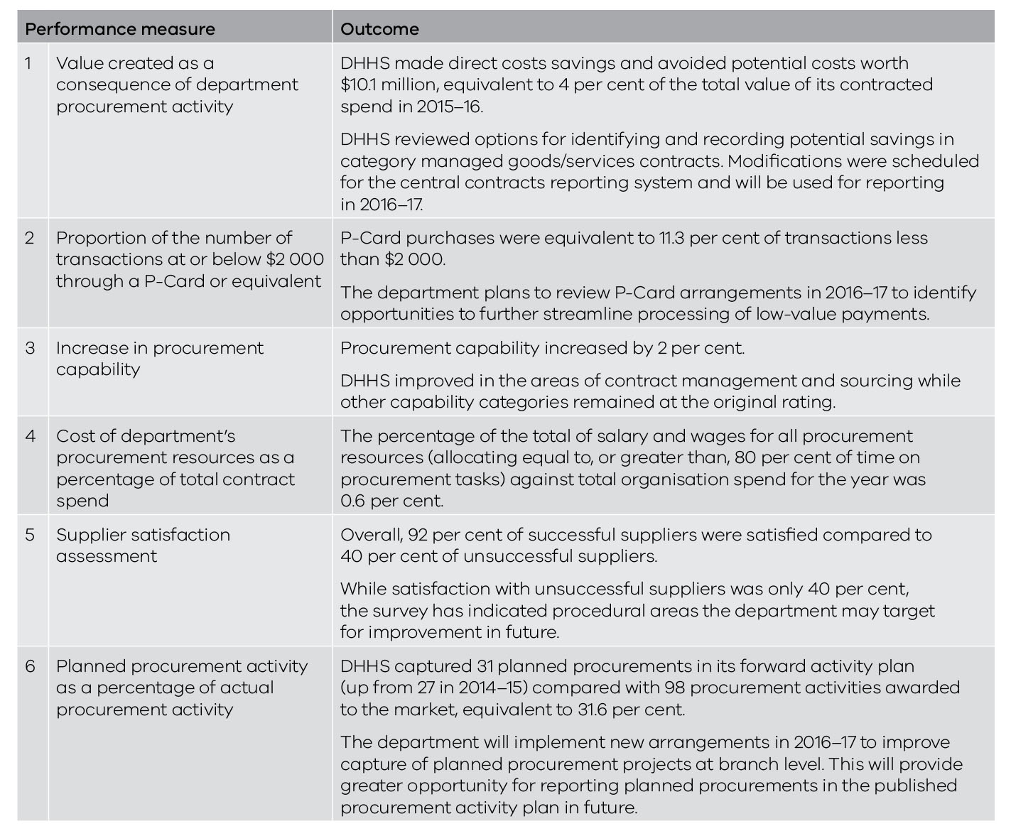

Procurement activities planned for 2016–17
In 2016–17, DHHS will:
- prepare a report on the audit of the VGPB supply policies for review by the VGPB;
- consolidate learning from category management arrangements to maximise buying and/or payment efficiencies by establishing at least two SEPCs or improving administrative arrangements;
- review finance and procurement training arrangements to confirm the best model of delivery based on the department's procurement capability risk profile;
- improve data analytics and data management with better coordination between audit, integrity and finance functions to reduce duplication, target appropriate risk areas and communicate results;
- implement a procurement compliance policy to minimise fraud and corruption in procurement and contract management practices;
- improve the coordination of procurement and finance-related functions by contributing to procurement systems initiatives at the whole of government level (e.g. vendor management, tender management) and departmental levels (e.g. financial system upgrade project); and
- implement a relationship management model throughout DHHS to ensure adequate and appropriate advice is always readily available for departmental staff when planning or undertaking procurement activities, and forward procurement planning is better supported.

Department of Justice and Regulation
IPU Chair | Gail Moody, Deputy Secretary, Corporate Governance and Infrastructure
CPO | Philip Chalkley, Chief Procurement Officer, Office of the Chief Procurement Officer

Procurement profile
The Department of Justice and Regulation (DJR) has a devolved procurement model, incorporating a mix of business units with a central procurement area combined with business units with a broad range of procurement practitioners and capability. Many procurements are carried out by individuals with part-time responsibility for procurement. There are an estimated 156 full-time procurement professionals and 144 part-time procurement professionals, with contractors supporting large procurement projects.
The predominant categories of spend across DJR are private prisons, construction and property, ICT, road safety and contractors/consultants equating to approximately 67 per cent of spend, with the full spectrum of procurement complexity and risk rating. The top 100 suppliers for the financial year 2015–16 account for more than 70 per cent of the addressable spend.
The Office of the Chief Procurement Officer (OCPO) was established in 2014 and comprises a governance and compliance team, a business engagement team, a reporting and analysis team and a grants management team. The business engagement team has implemented a business partnering model for the major procurement areas as a way of distributing targeted information to key procurement contacts within the business.
Corrections Victoria, Regional Services Network and Emergency Management Victoria continue to increase their focus and skills in the area of procurement.
In 2015–16, the Procurement Approval Board registered 228 new procurement activities. The total departmental contracted spend for the year was $3.66 billion.

Procurement activities in 2015–16
DJR continues to support and encourage an increase in practitioner capability through its comprehensive internal procurement and contract management training program, training more than 700 staff over two years. Along with the DJR procurement governance training module, this training program has recently been mandated to all practitioners.
The department has introduced a suite of new training programs including evaluation, market assessment and contract management. The department will engage a specialist resource to review and deliver the contract management training with the intent to migrate this to an internal training program.
DJR is in the process of accessing an appropriate certification course provided by a respected training institute in order to award an industry recognised certification for its procurement training course. The department also began preparing a procurement capability improvement survey.
The department introduced an eCatalogue capability in the Oracle iProcurement system to streamline departmental purchasing and contract management practice, increase compliance and price certainty for buyers, and reduce cost to deliver for market/suppliers. The first catalogue has had considerable uptake as it makes it easier for staff to buy items from the catalogue and streamlines the approval process. Purchasing from catalogues provides more detailed and accurate purchasing data which can be used for future leverage.
DJR upgraded its contract management system in 2014 and has further established mandatory reporting for contracts. The system provides more consistent reporting and the data can be used to identify efficiencies and opportunities for aggregation across the department.
The OCPO reviewed the procurement policy and refreshed the associated templates to assist the practitioners in their procurement initiatives and incorporate observations from recent audits or government reviews and enquiries. In addition, the DJR procurement toolbox was refreshed to provide a single, up‐to‐date source of procurement documents, policies and processes.

Performance in 2015–16
Table 26 lists DJR’s data for the six performance measures. Data for 2015–16 reflects a ‘best endeavours’ approach given the significant amount of work involved in setting up processes to report against the performance measures. As far as possible, the 2015–16 outcomes will help form the baseline against which DJR will measure performance in future years.
Table 26: DJR performance in 2015–16
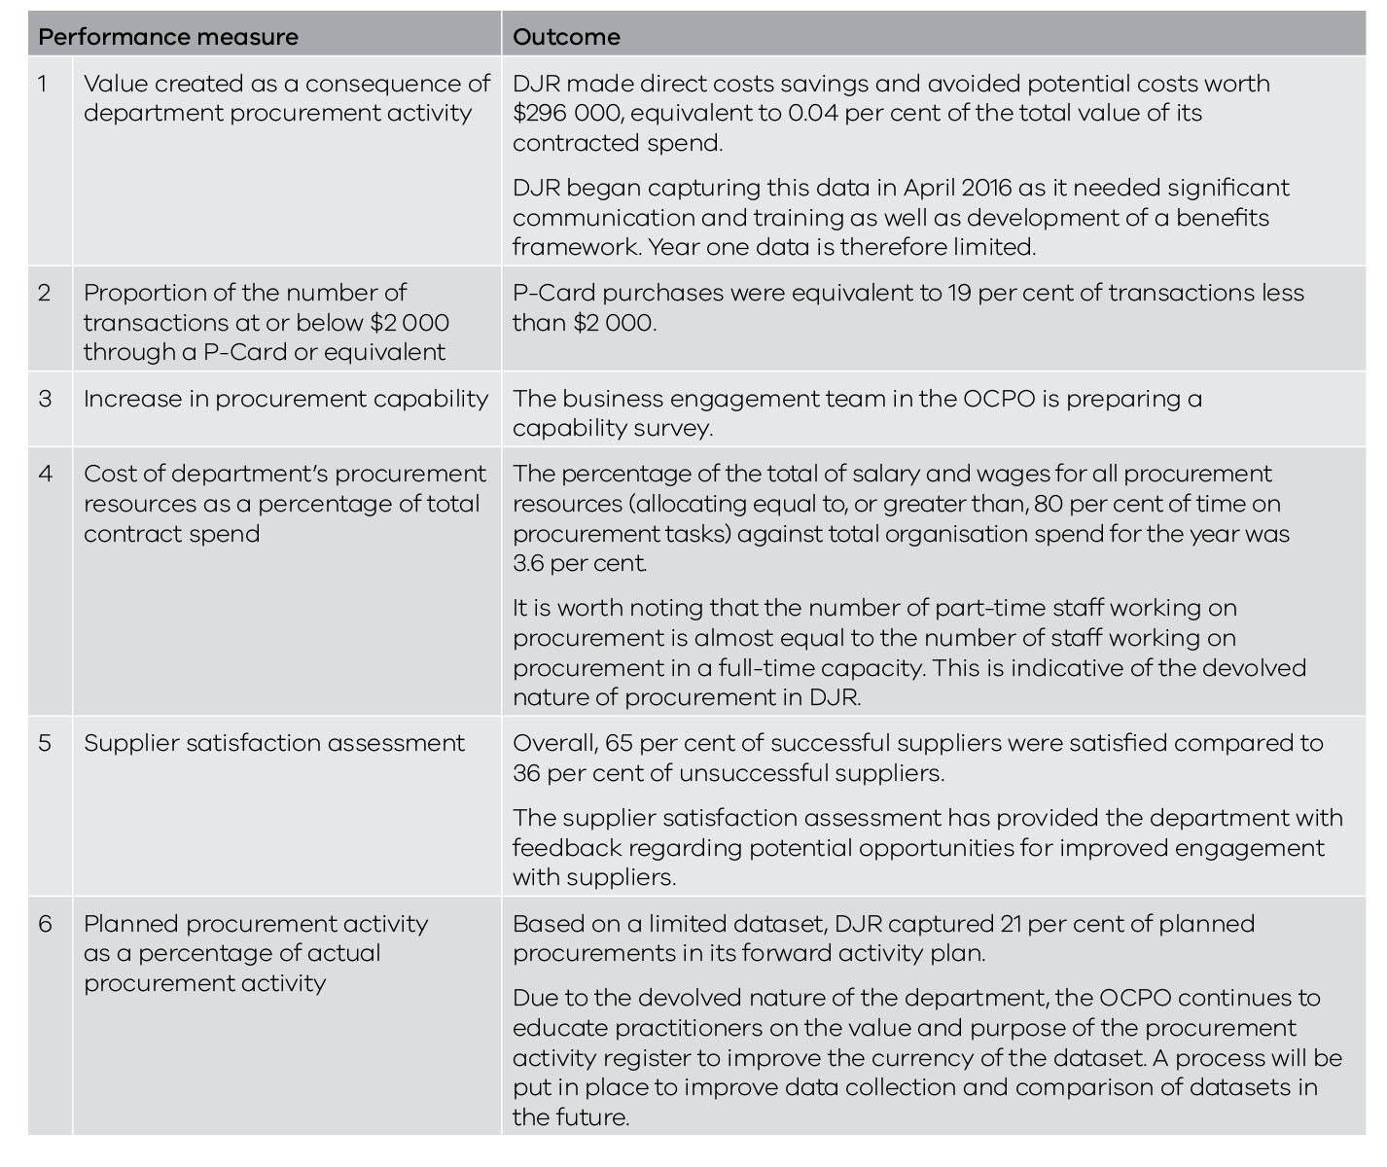

Procurement activities planned for 2016–17
In 2016–17, DJR will:
- purchase an eSourcing tool to automate the procurement process and provide greater consistency and transparency;
- carry out an in-depth spend analysis to identify saving and aggregation opportunities;
- expand the use of catalogues to make it easier for staff to buy products from certain categories;
- introduce an iSupplier capability to provide suppliers with a ‘self‐service’ capability to manage their corporate and invoice management data;
- introduce a supplier management framework to help staff and suppliers get the most from supplier relationships;
- introduce a benefits realisation framework to help staff identify and measure benefits of sourcing activities;
- introduce a contract management framework to guide contract managers through the contract management lifecycle;
- upgrade to Oracle R12 and adopt increased automated functionality offered by this version of iProcurement; and
- introduce Koori supplier training courses to lift the capability of Koori (Aboriginal) businesses when responding to government tenders.

Department of Premier and Cabinet
IPU Chair | Andrew Campbell, A/Executive Director, People, Culture and Operations
CPO | Ingrid Klein, Chief Financial and Procurement Officer, Finance and Procurement

Procurement profile
The Department of Premier and Cabinet (DPC) includes five supporting agencies:
- Office of the Governor;
- Public Record Office Victoria;
- Victorian Multicultural Commission;
- Office of the Freedom of Information Commissioner; and
- Office of the Victorian Government Architect.
There are several other agencies that sit under DPC but report separately from DPC.
DPC spends around $500 million a year; approximately 10 per cent of which relates to procurement spend. Of this, around 44 per cent relates to mandated spend on accommodation and ICT.
Of the 66 per cent of procurements which are not mandated, the majority are sourced via an open tender process or SPC.

Procurement initiatives in 2015–16
In 2015–16, DPC restructured its Procurement Governance Committee to reflect machinery of government changes and to improve engagement with DPC business areas and increase their understanding of the procurement framework.
DPC introduced weighted selection criteria for procurements over $25 000 to improve transparency, equity and accountability. Staff responded very positively to the criteria which have also established consistency and improved the understanding in business units of how to assess proposals.
Procurement information on the DPC intranet was reviewed and updated to help staff understand the procurement framework and access information and resources in a more user-friendly format. Information is now based on a five-step process and feedback has been very positive.
DPC provided procurement and contract management training sessions for staff to build capacity in DPC staff and business areas, improve value for money, improve compliance with legislative and regulatory requirements, and reduce risk.
DPC also reviewed its contract management practices to improve capability in this area and ensure compliance with DPC’s contract management policy.

Performance in 2015–16
Table 27 lists DPC’s data for the six performance measures. Data for 2015–16 reflects a ‘best endeavours’ approach given the significant amount of work involved in setting up processes to report against the performance measures. As far as possible, the 2015–16 outcomes will help form the baseline against which DPC will measure performance in future years.
Table 27: DPC performance in 2015–16
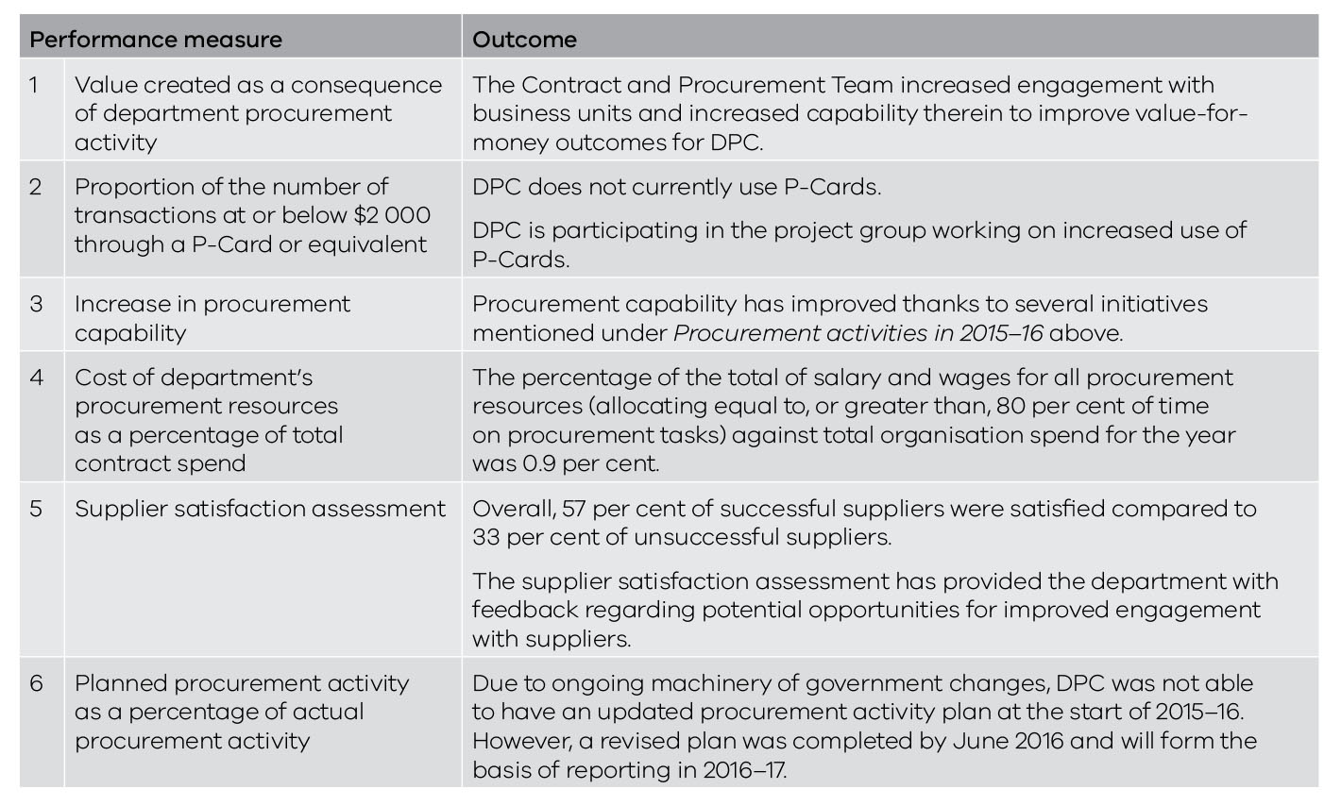

Procurement activities planned for 2016–17
In 2016–17 DPC will:
- prepare a report on the audit of the VGPB supply policies for review by the VGPB;
- provide training to promote the benefits of strategic procurement planning. This will help staff be more proactive in procurement planning which, in turn, will improve transparency for the market and identify opportunities for coordinated procurement;
- link procurement planning with broader departmental business planning and strategic initiatives by providing quarterly updates on DPC’s Annual Procurement Plan;
- develop and deliver basic contract management training sessions to improve public administration skills, increase opportunities to achieve value for money, and mitigate risk;
- improve procurement tools and templates based on feedback and experience; and
- improve monitoring of procurement and contract management to provide better oversight of DPC’s procurement practice and outcomes and support ongoing assessment and improvements to DPC’s procurement framework.

Department of Treasury and Finance
IPU Chair | Joe Bonnici, Chief Financial Officer, Corporate and Government Services Division
CPO | Iain Bramley, Assistant Director, Operational Services, Corporate Delivery Services (A/CPO)

Procurement profile
The Department of Treasury and Finance (DTF) provides government with economic, financial and resource management policy advice to help government deliver its policy outcomes. DTF’s innovative, expert advice balances economic, social and environmental goals within a framework of responsible financial management.
DTF is the lead agency for a number of SPCs through its Strategic Sourcing Group, however the procurement profile of DTF was primarily transactional for 2015–16. DTF procurements are primarily professional services.
DTF operates a decentralised procurement environment, supported by a centralised policy framework. The Procurement Resource Unit assisted approximately 90 procurers (20 per cent of DTF staff) with more than 200 procurements during 2015–16.

Procurement activities in 2015–16
DTF has benchmarked its governance performance against other departments with similar procurement profiles to find areas for improvement. As a result, DTF has:
- aligned IPU membership with the procurement profile of business units;
- improved the process for developing the forward procurement activity plan including quarterly reviews; and
- completed an IPU survey which showed many business areas have knowledge of the governance framework in the high and superior range. The survey is now focused on identifying improvement opportunities.
The department also benchmarked its processes to other government departments. This review identified some improvements and work needed to improve system capability.
DTF developed and implemented a new capability assessment tool which has already highlighted potential improvements. The tool measures capability in five areas: planning, compliance, contract management, stakeholder engagement and market approach. DTF will randomly select 25 procurements every quarter and apply performance measures from the tool.
The department was involved in an internal audit of contract management capability that resulted in recommendations for improvements –many of which were implemented during the year.
DTF reviewed its supplier engagement and analysed the 20 top suppliers as part of its spend mapping. This included having a better understanding of the supplier base of existing and potential suppliers and supporting it with effective supplier management techniques including regular strategic engagement and robust evaluation processes.
DTF completed a process flow of end-to-end procurement costs to increase understanding of these costs and how to decrease costs relative to business outcomes achieved. Related to this, DTF improved its data collection and analysis to allow for accurate and timely reporting and to efficiently measure end-to-end procurement costs.
The department began providing improved and automated monthly reporting to the IPU with analysis and graphs to promote decision making. DTF also benchmarked system capability against other departments with agreement from the IPU to review and improve systems going forward.

VGPB audit
DTF was the first organisation to undertake an audit as part of the VGPB’s compliance program. The VGPB was impressed with DTF’s audit report which outlined minor recommendations to improve awareness of eliminating barriers for small to medium enterprises and improve the process for debriefing unsuccessful suppliers. DTF has already actioned these recommendations.

Performance in 2015–16
Table 28 lists DTF’s data for the six performance measures. Data for 2015–16 reflects a ‘best endeavours’ approach given the significant amount of work involved in setting up processes to report against the performance measures. As far as possible, the 2015–16 outcomes will help form the baseline against which DTF will measure performance in future years.
Table 28: DTF performance in 2015–16
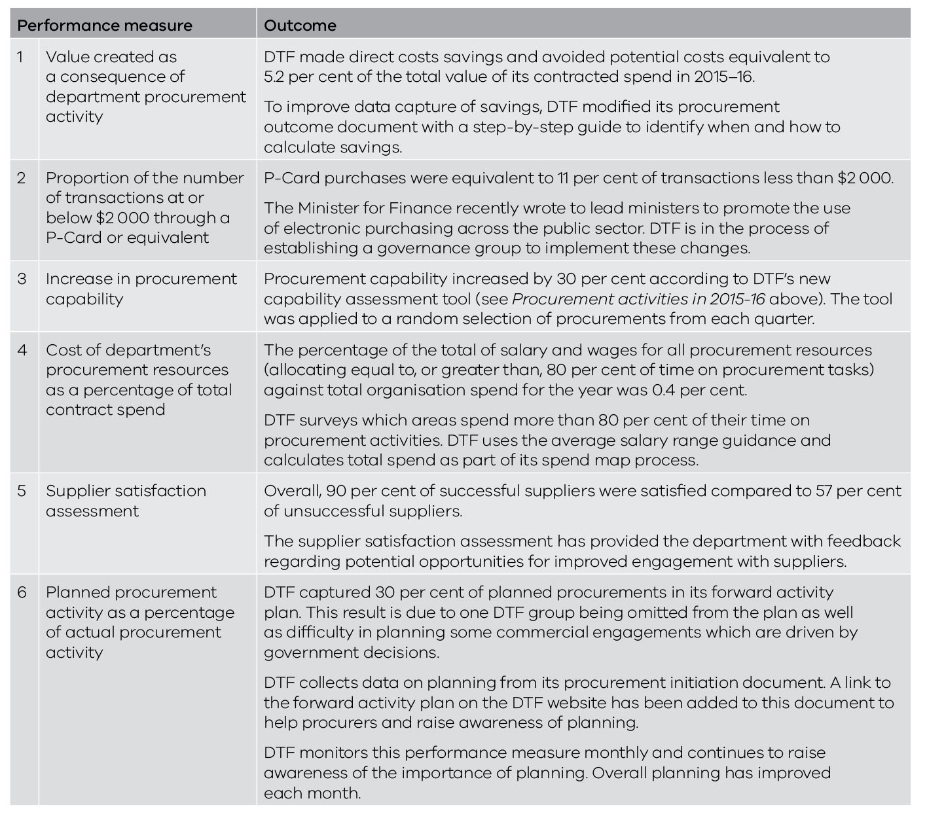

Procurement activities planned for 2016–17
In 2016–17, DTF will:
- continue to refine its governance framework based on the improvements made in 2015–16 as part of the benchmarking project;
- review data collected in 2015–16 and recommendations from the contract management capability audit to determine if the existing capability approach is appropriate;
- build on the metrics developed in 2015–16 to analyse spend data, value-for-money outcomes, and how effectively and efficiently DTF carries out procurement to identify opportunities for improvement and where appropriate action plans will be developed and implemented;
- apply information gathered from the supplier engagement framework to new procurement and contracting activities;
- review and further enhance supplier management plans based on liaison with other departments of a similar profile;
- continue evaluating full costs of conducting procurement activities (staffing costs, advertising, legal fees, etc.) and implement end-to-end cost plans to reduce procurement costs. Understanding procurement costs will continue to be a focus during 2016–17 and further analysis of costs/spend will lead to a more effective and efficient procurement process; and
- improve the reporting process to provide a suite of performance reports fully supported by the DTF dashboard.

VicRoads
IPU Chair | Judith Pettitt, Executive Director, Corporate Services
CPO | Chris McNally, Director, Procurement and Contract Management

Procurement profile
VicRoads plans, develops and manages the arterial road network and delivers road safety initiatives and customer focused registration and licensing services. The purpose of the organisation is to support economic prosperity and liveability by shaping the development and use of Victoria’s road system as an integral part of the overall transport system.
Procurement is considered a key function of the organisation and in delivering its services. VicRoads undertakes $2.8 billion of building and construction related procurement (93 per cent) and $214 million (7 per cent) of goods and services related procurement annually across a broad range of categories.
VicRoads has a centre-led procurement and contract management business area that provides policies, procedures, systems and advice to the broader organisation and also has some contract administration responsibilities. This decentralised process allows the majority of procurement activities to be carried out across the organisation by a wide range of individuals.
The Procurement and Contract Management business area, managed by the CPO, works in conjunction with the Procurement Governance Committee (PGC) to improve procurement practice capability and controls. A key focus is to maintain VicRoads’ high standing as a government procurement organisation by ensuring probity, timeliness and value for money through its procurement activities.
VicRoads has 11 category groups of goods and services spend with 87 individual categories. The majority of procurement spend uses SPCs. The largest areas of goods and services spend are in the categories of people services (41 per cent), registration and licensing (17 per cent) and ICT goods and services (11 per cent).
During 2015–16, VicRoads established 17 new goods and services formal contracts with a whole of life value of greater than $52 million, and created over 2 300 new purchase orders with an approximate total value of $143 million. The largest spend through purchase orders was to facilitate goods and services procurement arrangements through SPCs, where head contract arrangements and terms and conditions are already established. VicRoads established 30 procurement plans for higher complexity and risk procurements to provide assurance that appropriate strategies and the correct procurement approach have been applied. These plans were approved by the PGC or its delegate in accordance with the VicRoads governance framework.

Procurement activities in 2015–16
After being approved for accreditation to the VGPB supply policy framework on 1 July 2015, VicRoads implemented a comprehensive change management process to embed the reform across the organisation.
New governance arrangements were introduced in line with VGPB policies to achieve a better balance between risk management and process efficiencies. Procurement plans were implemented to ensure the details of the procurement approach and other key information is approved before any approach to market. The PGC was restructured with a new chair, committee members and an updated terms of reference.
VicRoads implemented a capability development plan, including capability assessments, system enhancements, workshops, online e-learning modules, self-service instructional documentation, specialist targeted training for key stakeholders, and adding procurement components to technical capability standards.
The organisation started using category management, developing key category group procurement strategies and revising the procurement category group structure.
A procurement assurance framework was developed and partially implemented. The framework will identify likely patterns for breaches of procurement processes and areas for improvement as well as very serious breaches of procurement processes or fraud to be escalated for further investigation.
VicRoads started a staged review of all procurement policies, procedures and authorisation limits in order to introduce a better balance between risk management and process efficiencies in line with the procurement governance approach.
Lastly, VicRoads began transitioning to meet the mandatory requirements of SPCs for greater processing efficiencies and improved value-for-money outcomes.

Performance in 2015–16
Table 29 lists VicRoads’ data for the six performance measures. Data for 2015–16 reflects a ‘best endeavours’ approach given the significant amount of work involved in setting up processes to report against the performance measures. As far as possible, the 2015–16 outcomes will help form the baseline against which VicRoads will measure performance in future years.
Table 29: VicRoads performance in 2015–16
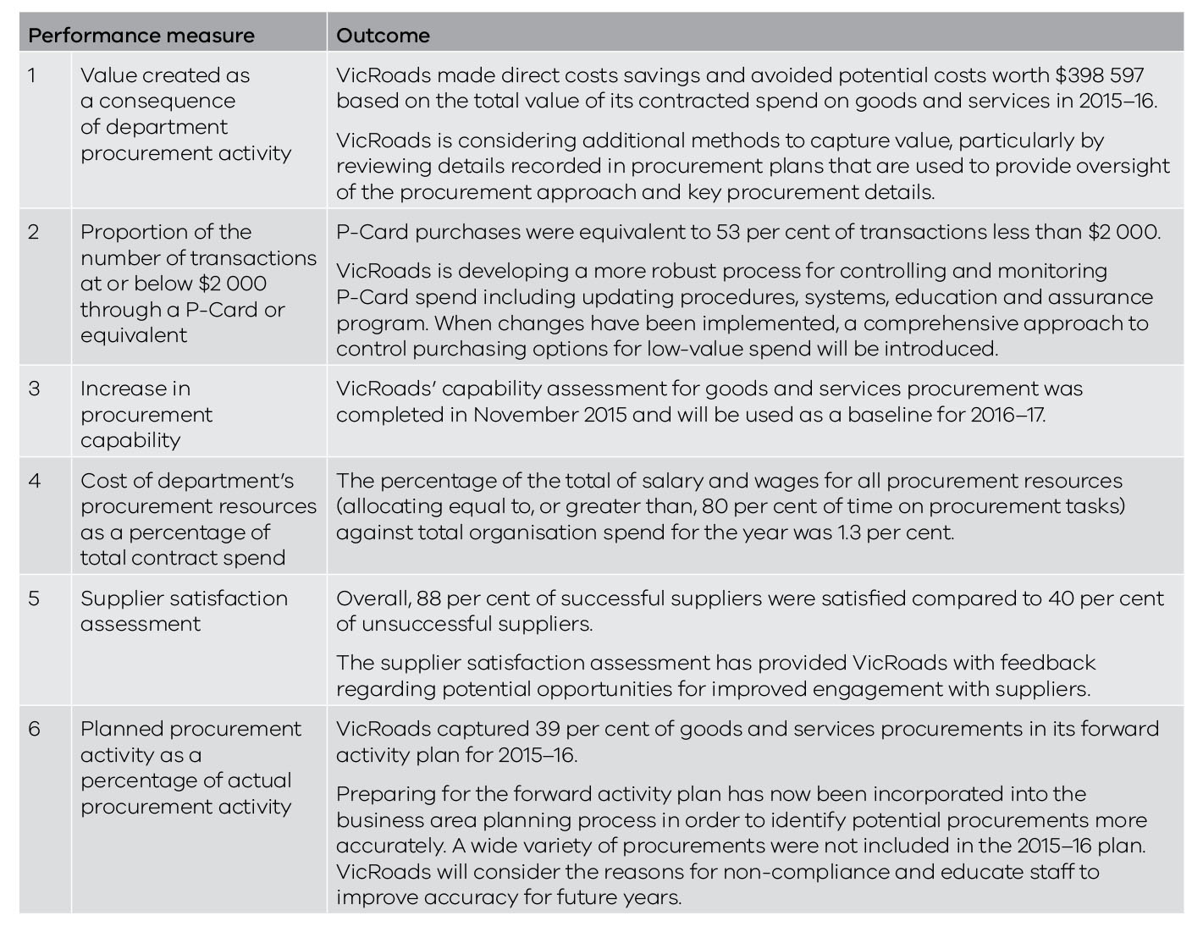

Procurement activities planned for 2016–17
In 2016–17, VicRoads will:
- continue to enhance and implement the procurement assurance framework;
- update and implement its capability development plan including capability assessments, system enhancements, refreshed and improved training, targeted category management training, improved self-service instructional documentation, specialist targeted training for key stakeholders and ability to evaluate procurement capability at an individual/business area level;
- introduce an e-Tendering system to deliver benefits such as process efficiencies, environmental benefits, cost savings, better probity and reduced procurement risks, improved data management, greater transparency and reduced effort for tenderers;
- review its contract management and administration approach and update contract management procedures;
- review the category management structure and continue to develop a greater understanding of the category groups, and an enhanced ongoing strategy for improvements and goals with the ability to deliver greater benefits in the future;
- continue the review of all procurement systems, tools, policies, procedures and authorisation limits to introduce a more effective and efficient approach to procurement that manages risks appropriately;
- undertake a critical assessment and transition process to facilitate the adoption of remaining mandatory SPCs, in particular fleet and printing;
- review the Independent Broad-based Anti-corruption Commission report on perceptions of corruption and develop a strategy to address concerns raised and evaluate areas of risk and opportunity;
- transition to delivering ethical procurement policies to deliver a fair and equitable procurement process aligned with the VGPB’s policy framework;
- develop data analytics and dashboards to provide a comprehensive view of procurement activities, risks and opportunities;
- refine the template and governance approach for procurement plans to deliver a more efficient and effective approach; and
- refine and implement the supplier engagement plan.

Victoria Police
IPU Chair | Andrew Loader, Chair of Police Procurement Board / Group Director, Human Resources Department
CPO | Kylie Callander, A/Director / Chief Procurement Officer, Procurement Department

Procurement profile
Victoria Police was established in 1853. It provides policing services to the Victorian community
24 hours a day, seven days a week, working to keep Victorians safe.
To deliver policing services, Victoria Police buys an extensive range of goods and services. Victoria Police procures under a category management framework comprising 11 categories (communications, information technology, properties, transportation, corporate support services, consultants and contractors, legal and evidentiary, uniform and equipment, office supplies, custodial, and operational support).
In 2015–16, Victoria Police spent $215 million procuring goods and services. At any one time, there were more than 400 active contracts, with contracts expiring and new contracts being entered into throughout the year. The organisation conducted 48 procurements to establish new contracts with estimated values of $100 000 or higher.
The more significant procurement sourcing activities in 2015–16 included patrol boats, booze and drug buses, custody services at Melbourne Custody Centre, and the policing information process and practices reform program. In contract management, the highlight was starting the IT services contract that resulted from a strategic procurement.

Procurement activities in 2015–16
In 2015–16, Victoria Police carried out several activities to improve procurement such as broadening commercial capability through recruitment, staff development, establishing a commercial risk appetite, expanding the suite of standard contract templates and enhancing the commercial skills of financial delegates.
Victoria Police carried out a capability assessment and identified nine key competencies that align with identified gaps from the VGPB capability assessment. The organisation delivered training in these competencies to 30 practitioners.
Victoria Police expanded the VGPB procurement governance model to cover a broader range of commercial transactions such as construction and contract establishment. This gives the organisation consistent governance arrangements across all spend and all stages of the procurement lifecycle.
Fraud prevention was improved by enhancing the conflict of interest policy, establishing a conflict of interest register, and establishing reporting requirements for when family members are employed or engaged through contracts.
The organisation began using more project management tools and techniques in sourcing activities to ensure procurement activities are completed in required timeframes and stakeholders are notified in advance of key tasks and timing. This improves resource planning and creates a more efficient procurement process.
Victoria Police also established a three-year sourcing pipeline to improve the alignment of sourcing and contract data sets and improve end-to-end planning. The pipeline will broaden the focus of the procurement planning cycle to provide a longer term view and more detail in annual plans.

VGPB audit
Victoria Police was the second organisation to undertake an audit as part of the VGPB’s compliance program. The audit report was endorsed by Victoria Police’s Audit and Risk Committee in June 2016 with four low-rated risks recommended for action by December 2016. The report was noted by the Victoria Police Procurement Board and submitted to the VGPB in early July 2016.

Performance in 2015–16
Table 30 lists Victoria Police’s data for the six performance measures. Data for 2015–16 reflects a ‘best endeavours’ approach given the significant amount of work involved in setting up processes to report against the performance measures. As far as possible, the 2015–16 outcomes will help form the baseline against which Victoria Police will measure performance in future years.
Table 30: Victoria Police performance in 2015–16
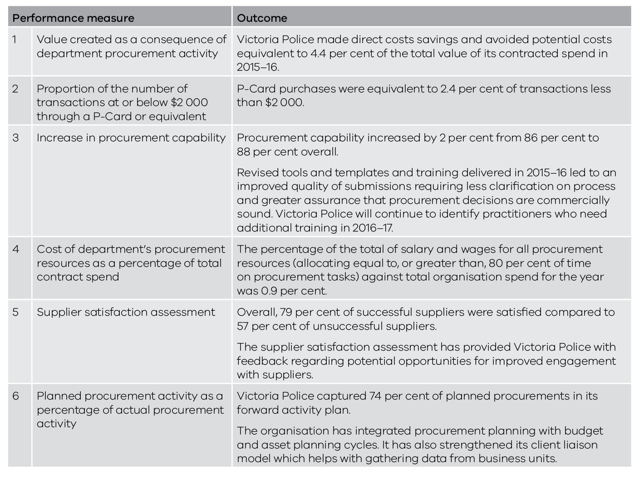

Procurement activities planned for 2016–17
In 2016–17, Victoria Police will:
- continue to strengthen procurement commercial expertise by increasing commercial knowledge, refining skills and improving capability for procurement leaders, practitioners and financial delegates;
- develop its engagement and communication model to improve client and organisational outcomes;
- improve the Police Procurement Board’s governance model by renewing the Board’s membership mix and enhancing the functions of the secretariat to improve the flow of information between the Board and the rest of the organisation; and
- improve data capture methods to increase procurement intelligence by working with key business areas to integrate databases and improve access to procurement and spend information.

Links and glossary

Procurement websites

Victorian Government Purchasing Board
The VGPB website provides advice on procurement of goods and services for government buyers and suppliers in Victoria. It contains VGPB policies, guidelines, tools and templates, and links to other procurement-related websites. Visit www.procurement.vic.gov.au

Tenders VIC
Tenders VIC lists all Victorian Government tenders and major contracts including listings of past tenders and contracts. Visit www.tenders.vic.gov.au

Australasian Procurement and Construction Council Inc (APCC)
The APCC is the peak council whose members are responsible for procurement,
construction, property and asset management policy for the Australian state and territory governments. Papua New Guinea is an associate member. The APCC comprises 11 member agencies. Visit www.apcc.gov.au

Training.gov.au
Training.gov.au is the National Register on Vocational Education and Training (VET) in Australia. Training.gov.au is the authoritative source of:
- nationally recognised training which consists of:
  - training packages;
  - qualifications;
  - units of competency;
  - accredited courses;
  - skill sets; and
- Registered Training Organisations who have the approved scope to deliver nationally recognised training, as required by national and jurisdictional legislation in Australia.
Visit www.training.gov.au

Glossary

Accountable officer: the head of any given department, or, for a public body, the chief executive officer (or comparable title) of that body.
Accreditation: the process carried out by a government entity to be assessed for compliance with the procurement reform framework and subsequently brought under VGPB scope. Government entities can either self nominate for accreditation or can be nominated by the Minister for Finance through legislative powers.
Administrative office: an office specified in section 16(1) of the Public Administration Act 2004.
Aggregated demand or aggregation: a generic term whereby demand for identical or similar categories is grouped together to leverage benefits from greater economies of scale when negotiating with potential suppliers.
Annual supply report (ASR): a report to the VGPB from in-scope organisations providing information and data relating to the purchase of goods and services during one financial year.
Audit: typically part of a control process to validate that key activities are being or have been carried out and to identify weaknesses or opportunities for improvement.
Best practice: seeking to identify and apply the best processes to achieve better value-for-money outcomes.
Better off overall test (BOOT): this test is based on the relevant modern award that covers any employees covered by the proposed enterprise agreement. Under the BOOT, each ‘award covered’ employee and each prospective award covered employee must be better off under the agreement than they would be if the relevant modern award applied to them.
Business case (procurement): the information needed to decide whether to support a proposed project before significant resources are committed to its development. The core of the business case is an assessment of the costs and benefits of proceeding with a project.
Capability: competence, capability and capacity are often used interchangeably to describe an individual’s or organisation’s ability to perform tasks or activities effectively. VGPB policy defines procurement capability as matching the person(s), resources, systems and processes to the requirements of a procurement activity.
Capability assessment: an assessment of the level of procurement capability in an organisation.
Capability development plan: a summary of the organisation’s capability assessment and plans to increase capability where required.
Category: a grouping of related goods or services based on similar characteristics. For example, packaging as a category may include a variety of different goods and materials, all of which share a common purpose. A category may be further divided into subcategories based on physical characteristics such as plastic packaging or cardboard packaging.
Category management: at the organisational level, category management covers better management of areas of spend that include similar goods and services, and involves analysis of and interaction with the appropriate market sectors. It also forms the basis for organising the procurement team to manage the end-to-end procurement process for a specific range of goods or services.
Chartered Institute of Purchasing and Supply (CIPS): promotes and develops high standards of professional skill, ability and integrity among all those engaged in purchasing and supply chain management. CIPS assists individuals, organisations and the profession as a whole.
Chief procurement officer (CPO): provides strategic expert advice and oversight of the procurement function to drive and ensure value-for-money outcomes in the organisation. The CPO is responsible for developing and monitoring a number of strategic procurement activities. The CPO can be a role or a position as defined in the VGPB’s governance policy.
Complexity: the level of intricacy and scope of issues involved in procuring a good or service, as defined in the VGPB’s complexity and capability assessment policy.
Complexity assessment: an assessment of the level of intricacy and scope of issues involved in procuring a good or service which considers a broad range of factors including risk, total cost of ownership and market dynamics.
Conflict of interest: a conflict between public duties and private interests. Conflicts of interest can be actual, perceived or potential. The Victorian Public Sector Commission provides resources to help public sector officials, organisations and directors of public entities protect the public interest by identifying and managing conflicts of interest appropriately. For more information, visit www.vpsc.vic.gov.au
(Source: definition taken from the Victorian Public Sector Commission website)
Contract: an agreement between two or more authorised persons on behalf of their organisations to perform or not perform a specific act that is enforceable in law. A contract may be verbal, written or inferred by conduct.
Contract management: all activities at the start, during and after the contract period to ensure all contractual obligations are fulfilled.
Critical incident: an emergency, crisis or disaster under which an organisation may adopt streamlined and flexible procurement processes to facilitate an immediate response.
Debrief: the process of advising unsuccessful respondents, on a no-commitment basis, of where improvements in their bid would make them more competitive in the future.
Department: a body existing by virtue of an order made under the Public Administration Act 2004.
Entity: any government or semi-government organisation not defined under the Public Administration Act 2004, i.e. not a department or administrative body. Also referred to as non-Crown bodies, public bodies and outer budget agencies.
e-procurement: involves the online conduct of business-to-business procurement processes using web-based applications.
Expression of interest (EOI): used to identify suppliers interested in, and capable of, delivering the required goods or services. Potential suppliers are asked to provide information on their capability and capacity to do the work. It is usually the first stage of a multistage tender process.
Financial delegate: a person authorised by the Minister to make general or specified decisions constrained only by the instrument of financial delegation. Specifically, financial delegates commit and incur expenditure, and sign contracts.
Financial delegation: a power handed down to a second party to act on their own behalf, but not including power to further delegate. The second party is responsible for actions arising from their use of such power.
Internal procurement unit (IPU): a body in each organisation responsible for ensuring that procurement activity complies with VGPB policy. The IPU assesses the procurement capability of the organisation and prepares a capability development plan on an annual basis. It also identifies major procurement categories and reports annually to the accountable officer on the organisation’s procurement activities.
Organisations sometimes choose a different name for their IPU, such as procurement governance committee, or procurement approval board.
Machinery of government: the allocation of functions and responsibilities between departments and ministers. In Victoria, these matters are the sole responsibility of the Premier.
One-off supply: a purchase of a specific quantity of goods or services which has been subject to a discrete quotation or tender process.
Open tender: the process of publicly inviting tenders usually through the release of a request for tender to the open market.
Prequalification: assessing a business’ eligibility to supply based on specific criteria for a particular category of goods or services.
Probity: uprightness, honesty, proper and ethical conduct and propriety in dealings. It is often also used in government in a general sense to mean good process.
Procurement: all the business processes associated with purchasing, spanning the whole cycle from identifying needs to the end of a service contract or the end of the useful life and subsequent disposal of an asset. It also includes the organisational and governance frameworks that underpin the procurement function. Procurement does not include store management and logistics that are part of the wider subject of supply chain management.
Procurement activity plan: details planned procurement activity for at least the next 12 to 18 month period and must be reviewed at least annually to keep the market informed of changes or developments. A high-level summary plan must be published on the organisation’s website to improve transparency for suppliers.
Procurement process: the step-by-step process for the planning, establishment and contract management of small and large acquisitions.
Procurement strategy: an overview of an organisation’s procurement profile. It includes a procurement activity plan, a contract management planning strategy, a supplier engagement plan and a capability development plan.
Purchasing card (P-Card): any type of purchasing card used in the Victorian public sector, such as general government purchasing cards, corporate cards, credit cards, purchasing card facilities. It is a payment mechanism that can provide benefits in the form of efficient procurement and reduced administration costs.
Quotation/quote: an offer to supply goods and/or services, usually in response to a request for quotation. Often used interchangeably with proposal, tender, bid and offer.
Request for quotation (RFQ): a written process of inviting offers to supply goods and/or services involving simple documentation and a limited number of potential suppliers.
Request for tender (RFT): a request for offer against a set of clearly defined and specified requirements. Tenderers are advised of all requirements involved including the conditions of tendering and proposed contract conditions.
Risk management: risks can occur at various stages in the procurement process and should be focused on both the operational consequences of non-performance and the risks to business delivery if a procurement activity does not achieve the desired value-for-money outcomes. Risks to the procurement activity should be continually monitored and managed, and new risks identified throughout the procurement cycle.
Scalability: adapting the procurement function to the needs of the organisation ensuring that sufficient capability (people, systems and processes) is in place in the organisation to handle the complexity level of all procurement activity. Scalability is also about simplifying procurement processes and not running an overly onerous process for low-value, low-risk purchases.
Select tender: a two-stage approach to the open market involving a registration/expression of interest, followed by a request for tender to a shortlist of registrants who satisfy an assessment of their capability and capacity.
Small to medium enterprises (SMEs): firms with less than 200 full-time equivalent employees and/or less than $10 million turnover (Australian Bureau of Statistics). Note that the Victorian Government uses the employment numbers to define small, medium and large enterprises. Less than 20 is defined as small, 20–199 is defined as medium and 200 plus is defined as large.
Sole entity purchase contract (SEPC): a procurement arrangement established when a sole organisation has a specific requirement for frequently purchased goods and services. SEPCs are mandatory contracts for the organisation establishing the procurement arrangement.
Sole supplier: sole supplier contract arrangements are established following a specific requirement for frequently purchased goods and or services, and where value for money can best be achieved by engaging with one party. The arrangement also works as they are seen as market leaders and guarantee strong services levels complemented with competitive pricing.
Standing offer agreement: an agreement for commonly used goods and services that provides more effective and efficient procurement. It covers a set period of time and usually requires no obligation on the state to purchase a particular quantity of the goods or services from the supplier. It includes SPCs and SEPCs.
State purchase contract (SPC): a mandatory standing offer agreement for the purchase of goods and services. The purpose of SPCs is to pursue whole of government contracts to achieve the best value-for-money outcomes, and make best use of the state’s aggregated purchasing power.
Supply policies: policies created by the VGPB to govern procurement of goods and services by all Victorian Government departments and specified entities.
Tender: a document in the form of an offer to supply goods and/or services, usually submitted in response to a public or selective invitation such as an RFT.
Tenderer: a party submitting a tender in response to an RFT.
Tenders VIC: the website provided by the Department of Treasury and Finance for advertising all government tenders.
Value for money: involves a balanced judgement of financial and non-financial factors. Typical factors include fitness for purpose, quality, whole of life costs, risk, environmental and sustainability issues, as well as price.
Victorian Government Purchasing Board (VGPB): the independent government entity that develops, implements and reviews procurement policies and practices; monitors compliance and reports irregularities; and fosters improvements in the use and application of purchasing systems. The VGPB provides leadership in government procurement of goods and services to deliver value-for-money outcomes for Victoria.
Victorian Public Sector Commission: responsible for strengthening the efficiency, effectiveness and capability of the public sector in order to meet existing and emerging needs and deliver high quality services; and maintaining and advocating for public sector professionalism and integrity.
Victorian Secretaries Board (VSB): comprises the Secretaries of each department, the Chief Commissioner of Police and the Victorian Public Sector Commissioner. The aim of the VSB is to coordinate policy initiatives across the public sector. It is also responsible for promoting leadership and information exchange in the public service. The VSB does not have a legal status.

Acronyms and abbreviations

APCC Australian Procurement Construction and Council Inc
ASR Annual supply report
BOOT Better off overall test
CMS Contract management system
CPO Chief procurement officer
DEDJTR Department of Economic Development, Jobs, Transport and Resources
DELWP Department of Environment, Land, Water and Planning
DET Department of Education and Training
DHHS Department of Health and Human Services
DJR Department of Justice and Regulation
DPC Department of Premier and Cabinet
DTF Department of Treasury and Finance
EOI Expression of interest
FMA Financial Management Act 1994
GST Goods and services tax
ICT Information and communications technology
IPU Internal procurement unit
PTV Public Transport Victoria
RFQ Request for quotation
RFT Request for tender
SEPC Sole entity purchase contract
SPC State purchase contract
SME Small to medium enterprises
VGPB Victorian Government Purchasing Board
VSB Victorian Secretaries Board

This annual report is printed on Ecostar. Ecostar is made Carbon Neutral and is 100 per cent recycled and FSC® Recycled Certified.
Ecostar is manufactured in a process chlorine free environment by an ISO 14001 certified mill.

Total percentage equals 101 due to rounding.

