VGPB Annual Report

2016–17

Victorian Government Purchasing Board
Achieving excellence in government procurement

Victorian Government Purchasing Board Annual Report 2016–17
Authorised by the Victorian Government
1 Treasury Place
Melbourne Victoria 3002
Australia

Victorian Government Purchasing Board
Telephone: +61 3 9651 1699
Email: vgpb@dtf.vic.gov.au
Website: procurement.vic.gov.au
Printed by Waratah Group – Digital, Port Melbourne
Designed by Cordial Creative
Printed on 100 per cent recycled paper
ISSN 1444-4097
Published September 2017
This document is available in PDF and Word format at www.procurement.vic.gov.au.

© State of Victoria (Victorian Government Purchasing Board) 2017
You are free to re-use this work under a Creative Commons Attribution 4.0 licence, provided you credit the State of Victoria (Victorian Government Purchasing Board) as author, indicate if changes were made and comply with the other licence terms. The licence does not apply to any images, photographs or branding, including government logos.
Copyright queries may be directed to IPpolicy@dtf.vic.gov.au.
Contents
Better procurement practice 1
Message from the Chair 2
Year in review 3
Strategic priorities in 2016–17 3
Changes to the annual report in 2016–17 8
About the VGPB 9
Vision, mission and directives 9
Reporting relationship 10
Scope of VGPB policies 10
VGPB members 10
Procuring goods and services 14
About the data in this report 15
Overview of contract approvals 15
One-off supply contracts 16
Procurement complexity 17
Critical incident procurement 21
Harnessing the buying power of government 22
State purchase contracts 25
Sole entity purchase contracts 25
Providing expert oversight and monitoring compliance 27
Performance measures 28
Audits 29
Procurement activity subject to VGPB oversight 30
Non-compliance 31
Complaints 32
Organisational procurement profiles 33
Performance measures methodology 33
Department of Economic Development, Jobs, Transport and Resources 34
Department of Education and Training 37
Department of Environment, Land, Water and Planning 39
Department of Health and Human Services 42
Department of Justice and Regulation 45
Department of Premier and Cabinet 48
Department of Treasury and Finance 51
Public Transport Victoria 54
VicRoads 56
Victoria Police 59
Appendix 62
Appendix 1: SEPC data breakdown 62
Acronyms 64

Tables
Table 1: VGPB members at 30 June 2017 11
Table 2: Contract types reported in the VGPB Annual Report 15
Table 3: Total number and value ($ million) of one-off supply, SEPC and SPC approvals in 2016–17 by goods and services 15
Table 4: Total number and value ($ million) of one-off supply, SEPC and SPC approvals from 2013–14 to 2016–17 16
Table 5: One-off supply approvals by organisation and by goods and services in 2016–17 16
Table 6: Description of complexity quadrants 17
Table 7: One-off supply, SEPC and SPC approvals by complexity quadrant in 2016–17 17
Table 8: Complexity quadrants (number) by organisation 18
Table 9: Trends in procurement complexity 20
Table 10: Number of transactional procurements by organisation from 2014–15 to 2016–17 20
Table 11: Number of leveraged procurements by organisation from 2014–15 to 2016–17 20
Table 12: Number of focused procurements by organisation from 2014–15 to 2016–17 21
Table 13: Number of strategic procurements by organisation from 2014–15 to 2016–17 21
Table 14: Critical incident procurement in 2016–17 21
Table 15: SPCs approved in 2016–17 25
Table 16: SEPCs approved in 2016–17 25
Table 17: Mechanisms for monitoring compliance with VGPB procurement policies 27
Table 18: Performance measure results in 2016–17 by organisation 28
Table 19: Audit program schedule and results as at 30 June 2017 29
Table 20: Procurement activities subject to VGPB oversight in 2016–17 30
Table 21: Non-compliance in 2016–17 31
Table 22: Complaints related to procurement activity in 2016–17 32
Table 23: Performance measure methodology 33
Table 24: DEDJTR’s compliance activities in 2016–17 35
Table 25: DEDJTR’s performance in 2016–17 36
Table 26: DET’s compliance activities in 2016–17 38
Table 27: DET’s performance in 2016–17 38
Table 28: DELWP’s compliance activities in 2016–17 40
Table 29: DELWP’s performance in 2016–17 41
Table 30: DHHS compliance activities in 2016-17 43
Table 31: DHHS performance in 2016–17 44
Table 32: DJR’s compliance activities in 2016-17 46
Table 33: DJR’s performance in 2016–17 47
Table 34: DPC’s compliance activities in 2016-17 49
Table 35: DPC’s performance in 2016–17 50
Table 36: DTF’s compliance activities in 2016–17 52
Table 37: DTF’s performance in 2016–17 53
Table 38: PTV’s compliance activities in 2016–17 55
Table 39: VicRoads’ compliance activities in 2016–17 57
Table 40: VicRoads’ performance in 2016–17 58
Table 41: Victoria Police’s compliance activities in 2016–17 60
Table 42: Victoria Police’s performance in 2016–17 61
Table 43: Breakdown of SEPCs approved in 2016–17 62

Figures
Figure 1: VGPB 2016–21 strategy overview 3
Figure 2: VGPB procurement directives 10
Figure 3: End-to-end procurement process 14
Figure 4: Number of contract approvals by complexity quadrant in 2016–17 18
Figure 5: Value of contract approvals by complexity quadrant in 2016–17 19
Figure 6: Victorian Government SPC categories 23

Better procurement practice

The Victorian Government buys many goods and services throughout the year. Following best practice procurement processes ensures government buys the most suitable product or service for the best value for money. It also saves time and money, and supports a well-functioning government and a thriving Victorian community.
The Victorian Government Purchasing Board (VGPB) sets the policies that govern procurement of non-construction goods and services across all Victorian Government departments and some public bodies. VGPB policies cover end-to-end procurement activities and are underpinned by the key principles of value for money, accountability, probity and scalability.
The VGPB’s activities in 2016–17 focused on progressing the five priorities in its strategic plan for the period 2016 to 2021:
- embed and enhance VGPB supply policies;
- develop and implement a procurement capability strategy across people, processes and systems;
- engage with suppliers and the market to improve doing business with the Victorian public sector;
- broaden the VGPB’s impact on Victorian public sector procurement; and
- measure the benefits of the VGPB’s procurement framework.
The VGPB recognises the many stakeholders affected by Victorian Government procurement and strives to work collaboratively with stakeholders to improve procurement outcomes for government and businesses across Victoria.

About this report
The VGPB Annual Report 2016–17 describes our work and activities between 1 July 2016 and 30 June 2017, as required by section 54M of the Financial Management Act 1994.
It summarises work carried out to meet our regulatory obligations and achieve our vision to provide leadership in government procurement of goods and services to deliver value-for-money outcomes for Victoria.
We report on the purchasing activity and procurement performance of the 10 mandated organisations: seven Victorian Government departments, Public Transport Victoria, VicRoads and Victoria Police.
The VGPB is a Victorian Government-owned body corporate.
As part of our commitment to sustainability, we print a limited number of copies of this report. An online version and accessible text format of this report is available from procurement.vic.gov.au.

Message from the Chair
Procurement is a key function of the Victorian Government. Smart and efficient procurement saves money, leaving more to spend on core services such as roads, hospitals and schools for all Victorians. In 2016–17, the VGPB remained focused on our key objective to ensure value for money using best practice procurement methods.
Our framework focuses on procurement as a core business function. Organisations need appropriate governance and planning to minimise risk and engage with the market to understand the best possible approach to drive greater value for money. Every business, irrespective of size or location, is given an equal opportunity to bid for government work.
Our aim is to make it easier for both procurers and suppliers to conduct business by having a consistent and transparent approach. To support this, we have enhanced our good practice guides and templates and developed new guides to broaden the VGPB’s influence across wider government.
In 2016–17, the VGPB implemented a Supplier Code of Conduct across government, supporting the Victorian Government’s 2014 election commitment to ensure ethical, sustainable and socially responsible procurement. The Supplier Code was a key initiative identified in the VGPB 2016 policy review.
The VGPB continues to broaden its scope across government, with Public Transport Victoria gaining accreditation on 1 January 2017.
On behalf of the VGPB, I would like to express my appreciation to the Minister for Finance, Robin Scott MP, for his continued support of the VGPB’s supply policies. The VGPB has enjoyed working collaboratively with in-scope organisations to deliver the Government’s priorities for procurement and embed procurement reform, thus providing better procurement outcomes across government.
I would also like to thank all VGPB members for their ongoing support through what has been a challenging and busy year.
The VGPB’s work this year has again been assisted by the dedication and committed work of the VGPB Secretariat in the Department of Treasury and Finance. Thank you also to all organisations’ chief procurement officers (CPOs) for their commitment and support throughout the year in assisting the VGPB with embedding the supply policies and implementing the strategic priority initiatives.
Our major achievements in 2016–17 were further consolidating the new supply policies across
in- scope organisations, continued simplification of the VGPB's procurement guides and implementing a Supplier Code of Conduct. A significant challenge for the future will be moving towards end-to-end procurement models.

(Dr) Lynne Williams AM
Chair, Victorian Government Purchasing Board

Year in review

Strategic priorities in 2016–17
In 2016–17, the VGPB began working on five strategic priorities as set out in its strategic plan for 2016 to 2021. Each priority includes initiatives to be implemented progressively over a five-year period. These priorities are underpinned by a CPO partnership model which recognises the importance of leveraging expertise and collaboration to deliver improved procurement outcomes for government.
Figure 1 provides an overview of the VGPB’s strategy for the 2016 to 2021 period.
Figure 1: VGPB 2016–21 strategy overview

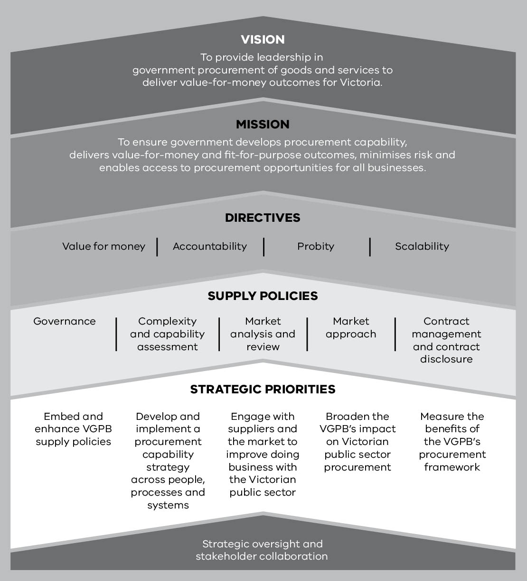
In 2016–17, the VGPB focused on developing strategies to meet the longer-term objectives of the VGPB and implementing government priorities. Working with stakeholders, the VGPB continued to embed the procurement reform supply policies, broaden its impact on Victorian public sector procurement and initiate actions to build capability in procurement. The activities carried out under each strategic priority are summarised in the following pages.

Strategic priority 1: Embed and enhance VGPB supply policies
The VGPB remains focused on embedding its supply policy framework. Over the past year, the VGPB has redeveloped much of its web content and enhanced guidance material based on stakeholder feedback. These updates clarify and communicate core goals, policies and the philosophy behind the VGPB’s supply policies.

Over the coming year, the VGPB will continue to implement its strategic stakeholder engagement program with an emphasis on building relationships with suppliers and CPOs. The program will allow the VGPB to continue to scan the broader operational environment to inform future policy refinements and build on relationships.

Implement the policy review communications and change management strategy
In 2014–15, the VGPB reviewed and revised its supply policies in line with the Government’s election commitments and operational feedback from departments and some public bodies to publicise policy changes and key initiatives broadly across the Victorian Government.
The strategy was centred around good governance, accountability and strategic planning to ensure implementation was seamless and that policies continued to drive procurement efficiencies for government.

Develop a Supplier Code of Conduct
The Supplier Code of Conduct (the Code) was a key initiative identified in the VGPB policy review. The VGPB led a working group to develop the Code with comprehensive representation from the Victorian public sector, including the Independent Broad-based Anti-corruption Commission (IBAC).
The Code describes the minimum standards in ethical, sustainable and socially responsible procurement that suppliers must aspire to meet, when conducting business with or on behalf of Government.

Procurement in action
Working together yields better results
In 2016, the Department of Economic Development, Jobs, Transport and Resources (DEDJTR), Public Transport Victoria and VicRoads ran a joint tender through the Professional Advisory Services State Purchase Contract to set up a panel for ad hoc financial advisory and accounting services.
The three organisations aggregated their needs and leveraged their expenditure, increasing the volume of scope by seven times compared to DEDJTR’s single requirements.
Working together led to significant financial savings for all three organisations, as well as saving time and resources by going to market once instead of three separate engagements. This also reduced the burden on suppliers in responding to the tender.
The Code also addresses three key IBAC recommendations from the IBAC report, Perceptions of Corruption – Survey of Victorian Government Suppliers (June 2016). The Code ensures suppliers are aware of how to report concerns with any part of the procurement process, understand the standards expected of public sector officials and explains why it is neither necessary nor appropriate to offer incentives to public sector officials.
The Code was launched in June 2017 and implementation is well underway. See procurement.vic.gov.au for more information.

Improve access for minority groups
The VGPB continued engaging across government on initiatives to improve access for minority groups, including providing feedback on the Victorian Government Social Procurement Policy framework currently under development.

Expand oversight to include state purchase contracts
The VGPB’s oversight role provides organisations with independent strategic procurement advice and guidance on high-risk, complex and high-value procurements. In 2016–17, the VGPB oversight program increased with the Board providing early engagement, input and oversight on the market engagement strategy for three state purchase contracts. This was in addition to the VGPB’s ongoing oversight program; reviewing a wide range of high-risk, complex procurement activities being undertaken by organisations across government.

Take a more active role in identifying opportunities for aggregation
The VGPB is working with Strategic Sourcing in the Department of Treasury and Finance to review organisations’ forward procurement activity plans to identify potential aggregation opportunities. The VGPB is uniquely positioned to carry out this review and advise government on aggregation opportunities that will drive greater procurement efficiencies and value for money.

Strategic priority 2: Develop and implement a procurement capability strategy across people, processes and systems
In 2016–17, the VGPB worked with organisations to increase their capability by understanding barriers affecting their procurement development. This involved working closely with organisations to identify common and significant capability gaps and prioritise opportunities to strengthen Victorian Government procurement capability. Some of the areas identified related to agility, technology (e-procurement) and using fit-for-purpose procurement approaches.
To strengthen and support these activities, the VGPB continued to enhance existing guides, tools and templates to comply with broader government legislative requirements. The VGPB also developed new material with feedback from stakeholders including other jurisdictions to align with industry best practice and minimise duplication of effort.
In addition, the results of one of the VGPB performance measures (increase in procurement capability) will help organisations baseline and measure the success of their capability improvement efforts.
In 2017–18, the VGPB will complete its capability research and continue to work with organisations to develop a capability strategy with initiatives to improve and support organisational capability.

Enhance existing guidance material and develop new material
In 2016–17, the VGPB developed a government buyer toolkit to help organisations implement the Supplier Code of Conduct. The tool kit included:
- the Supplier Code of Conduct;
- commitment letter;
- existing supplier letter;
- government buyer fact sheet;
- government buyer FAQs;
- schedule of contract changes;
- standard messaging;
- supplier fact sheet; and
- supplier FAQs.
The VGPB also updated numerous guides and contract tools to include reference to the Code.
The VGPB released guides to accreditation and alignment with the VGPB supply policy framework and worked on a guide to category management which will be released later in 2017–18.

Strategic priority 3: Engage with suppliers and the market to improve doing business with the Victorian public sector
One focus of VGPB supply policies is to make it easier for suppliers to do business with Government. The policies prioritise upfront strategic planning, with organisations conducting a complexity and risk assessment and thorough market analysis to guide the path to market. Organisations publish a procurement activity plan listing their main planned procurements, giving suppliers visibility of upcoming opportunities.

Develop a supplier engagement strategy
To help suppliers identify government procurement opportunities, the VGPB developed a supplier engagement strategy. The strategy is founded on engagement with key industry supplier bodies and interest groups to discuss future policy needs. The VGPB has strengthened relationships with its public-facing counterparts such as Business Victoria and the Industry Capability Network, giving more access to suppliers and the market to improve procurement practices.

Implement the Supplier Code of Conduct
As discussed, the VGPB rolled out the new Supplier Code of Conduct and developed support materials in a toolkit released to organisations in June 2017. The VGPB will work with the industry supply bodies identified in the supplier engagement strategy to ensure suppliers are aware of their obligations under the Code.

Develop a guide to supplier feedback
The supplier satisfaction survey in 2015–16 highlighted the need for government buyers to give better quality feedback on tender submissions. In response, the VGPB revised its Guide to supplier feedback in consultation with probity panel providers and CPOs to ensure good practice.
The VGPB will continue to track and assess the results of its performance measure on supplier satisfaction to assess the success of its actions. The 2016–17 survey results (Year two) showed an improvement in supplier satisfaction among unsuccessful suppliers with an increase from 40 per cent in 2015–16 to 44 per cent in 2016–17. During the same period, supplier satisfaction among successful suppliers remained consistent with a marginal increase from 79.8 to
80.3 per cent.
In 2017–18, the VGPB will continue to engage organisations to identify opportunities to pilot new innovative procurement approaches for specific projects.

Strategic priority 4: Broaden the VGPB’s impact on Victorian public sector procurement
The VGPB is committed to continuing to improve procurement practices not only for in-scope organisations but also for the broader Victorian public sector. The VGPB published information that is available to all Victorian entities, and works with those out-of-scope entities that want to bring their goods and services spend within VGPB scope.

Accredit entities to operate under VGPB supply policies
On 1 January 2017, Public Transport Victoria (PTV) gained accreditation to operate under the VGPB supply policy framework. Their accreditation marks the end of a considerable amount of preparatory procurement work and the VGPB is confident PTV will achieve considerable benefits from implementing the framework.
In March 2017, the VGPB released a guide to obtaining VGPB accreditation. This guide helps out-of-scope organisations prepare for the VGPB process and gives them a tool to assess their readiness to accredit.
The VGPB is currently working with multiple entities to gain accreditation to the VGPB supply policies. CenITex has completed a significant amount of work and is expected to gain accreditation on 1 July 2017. WorkSafe has started their accreditation journey and is expected to gain accreditation in early 2018. In addition, the VGPB has held discussions with the Transport Accident Commission about accreditation to the VGPB supply policy framework.

Develop a guide to aligning with the VGPB procurement framework
In March 2017, the VGPB released a guide for out-of-scope entities that want to align their procurement framework with VGPB supply policies, but without being accredited. This guide supports entities that do not have the resources or overall volume of expenditure to justify transitioning to an in-scope entity. It helps them develop an appropriately aligned procurement framework with many of the same benefits as an accredited organisation.
The guide was launched at the VGPB procurement community of practice forum. The forum was opened by VGPB member, Ms Antoinette Brandi and supported by VicRoads’ CPO, Mr Chris McNally and Manager of Procurement Practice and Assurance, Ms Felicity Roberts. The forum was well attended with broad representation from across the government sector.

Engage other stakeholders
The VGPB understands the importance of stakeholder engagement and continues to broaden its impact through ongoing consultation with other government procurement policymakers in Victoria and interstate. In particular, the VGPB forged a close working relationship with IBAC when developing the Supplier Code of Conduct: both parties believe this project can lift the standard of ethical, sustainable and socially responsible procurement across Victoria.

Finalise strategy to broaden the scope of the VGPB
Throughout 2017–18, the VGPB will finalise its strategy to broaden the scope of the VGPB. The strategy focuses on categorising entities into targeted groups to enable a strategic and systematic approach based on their procurement spend and complexity and risk profile. The strategy will enable the VGPB to continue to embed its supply policies across the Victorian public service.

Strategic priority 5: Measure the benefits of the VGPB’s procurement framework

Audit compliance
The VGPB continues to monitor compliance through its rolling audit program. Every three years, each in-scope organisation audits their compliance with VGPB supply policies and submits a report to the VGPB.
The VGPB completed three audits in 2016–17 and there are a further three audits in progress. The three completed audits resulted in predominantly low-risk findings and all organisations have accepted the recommendations made to improve compliance. All findings have been actioned and are either complete or in progress. More information on audit results can be found in Providing expert oversight and monitoring compliance.

Measure performance
The VGPB supply policies seek to improve the way organisations procure goods and services from the market. To understand these improvements, the VGPB continues to measure the benefits of the procurement reform.
In 2015–16, the VGPB launched a three-year performance measure implementation period. Performance measures provide a consistent reporting method across all in-scope organisations to measure the benefits of the reform over time.
Following the first reporting period, the VGPB worked with CPOs to refine the methodology for measuring and reporting on the benefits of the procurement reform framework. Minor amendments and clarifications were made to several of the measures for year two. Year two results have highlighted areas that are working well and others that still need refinement and clarification. Further refinements will be made in consultation with CPOs. More information on audit results can be found in Providing expert oversight and monitoring compliance.
In 2017–18, the VGPB will continue to measure the benefits of the reform as it moves into the third year of its rolling audit program and performance measures reporting.

Procurement in action
Fuel contract delivers benefits for VicRoads
After transitioning to the VGPB framework on 1 July 2015, VicRoads was keen to access the better pricing, terms and conditions negotiated through the various state purchase contracts (SPCs).
The SPC for fuel and associated products offers fuel cards to buy a range of fuels from petrol stations as well as bulk fuel. Using this SPC, VicRoads now distributes a single provider fuel card to all VicRoads fleet vehicles, instead of using multiple fuel cards. A secondary fuel card is only issued based on proof of demonstrated coverage requirements.
Some of the benefits of having a primary fuel card provider include simplified process for business areas (card reconciliation and usage reports), reduced administration costs and effort, increased efficiency through bulk ordering, reduced risk of card misuse and improved user experience through easy to use mobile apps to locate sites.

Changes to the annual report in 2016–17
In this annual report, the presentation of data has been streamlined under four sections:
- Procuring goods and services: Contract approvals and procurement complexity data in
2016–17.
- Harnessing the buying power of government: State purchase contract and sole entity purchase contract approvals in 2016–17.
- Providing expert oversight and monitoring compliance: Performance measures, audit results, procurement activity subject to VGPB oversight, instances of non-compliance with VGPB supply policies, and complaints. Organisations’ individual compliance activities are now listed under their organisational profile in the fourth section.
- Organisational procurement profiles: A procurement summary of each organisation, including procurement profile, a breakdown of performance measure results, activities carried out to ensure compliance with VGPB policies and activities planned for 2017–18.

About the VGPB
The VGPB sets the policies that govern procurement of non-construction goods and services across all Victorian Government departments and some public bodies. VGPB policies cover end-to-end procurement activities and are underpinned by value for money, accountability, probity and scalability.
The VGPB is a Victorian Government-owned body corporate established under the Financial Management Act 1994 (the FMA) to:
- develop, implement and review supply policies and practices;
- monitor compliance with supply policies;
- develop procurement capability;
- provide strategic oversight of major procurements; and
- engage with stakeholders to drive greater procurement efficiencies.

Vision, mission and directives

Vision
The VGPB’s vision is to provide leadership in government procurement of goods and services to deliver value-for-money outcomes for Victoria.

Mission
The VGPB’s mission is to ensure government:
- develops procurement capability;
- delivers value-for-money and fit-for-purpose outcomes;
- minimises risk; and
- enables access to procurement opportunities for all businesses.

Directives
The VGPB’s supply policies cover end-to-end procurement activity from identifying needs, planning and market research through to contract management. Each policy is supported by good practice guides, tools and templates to ensure consistency across government.
When applying supply policies, organisations must ensure all procurement activity meets the four directives in Figure 2.
Figure 2: VGPB procurement directives
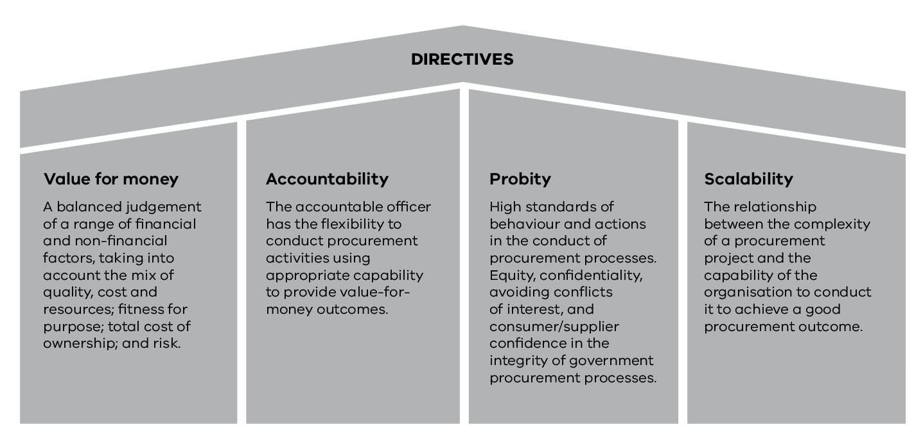

Reporting relationship
The VGPB reports to the Minister for Finance. The Department of Treasury and Finance provides secretariat and other support to the VGPB and has a direct reporting line to the Minister for Finance on procurement and contracting issues.
Under section 54M of the FMA, the VGPB must give the Minister for Finance a report of its work and activities for the year ending 30 June each year. The Minister for Finance tables the VGPB’s annual report in Parliament.

Scope of VGPB policies
VGPB supply policies apply to all Victorian Government departments and any entities specified by the Governor in Council (VicRoads and Public Transport Victoria). Public Transport Victoria was granted VGPB accreditation effective 1 January 2017.
VGPB policies also apply to the offices or bodies specified in section 16(1) of the Public Administration Act 2004. Offices listed in the Act report to the VGPB via their portfolio department, except for the Office of the Chief Commissioner of Police (Victoria Police), who reports directly to the VGPB.
The Victorian Public Sector Commission is also subject to VGPB policies but does not report directly to the VGPB.
For a full list of organisations bound by VGPB policy, refer to procurement.vic.gov.au/About-the-VGPB/Scope-of-Policies.

VGPB members
The VGPB consists of a chairperson and not less than six other members. Board members are selected based on experience and expertise in procurement-related matters. They can be internal or external to government.
At 30 June 2017, the VGPB had eight members including the Chair. Six members were external appointees and two appointees were from the Victorian Government (see Table 1).
The VGPB meets every two months and held six meetings over the reporting period.

Table 1: VGPB members at 30 June 2017
Title | Name | Background and experience | Meetings attended | Appointed
Chair | Dr Lynne Williams | Lynne worked in the state and federal public sectors for over 30 years, and held several senior executive roles specialising in economic policy, primarily in central agencies. Lynne has several other Board positions including the Victorian Legal Services Board, the Victorian Building Authority, the Essential Services Commission of South Australia, and the Commonwealth Grants Commission. Lynne was made a Member of the Order of Australia (AM) in January 2017. | 6 of 6 | 4 October 2011
External appointees | Randall Straw | Randall has more than 31 years’ experience in government ICT, formerly serving  as Deputy Secretary of Innovation and Technology at the former Department  of Business and Innovation. He has an extensive background in technology  innovation, policy, planning and implementation with Victorian public  sector agencies. Randall is currently Chair of CenITex, Independent Member of the  Department of Economic Development, Jobs, Transport and Resource's  Investment Committee, Member of VicTrack Telecommunications Committee and Member of the Emergency Services Telecommunications Authority, ICT Committee. He was awarded the Public Service Medal in 2012. | 5 of 6 | 1 October 2009
External appointees | Craig Rooney | Craig has more than 25 years of procurement experience in the public, private and consulting environments with demonstrated success derived through strong business management, financial management, strategic thinking, customer focus and people leadership skills. Craig is currently Regional Manager of Porter Davis Homes having initially been the Group Procurement Manager and has held several senior procurement management positions at CSR Sugar, Madison Cross Corporate Advisory and Coles Group. | 4 of 6 | 1 October 2012
External appointees | Russell Yardley | Russell is a successful entrepreneur and business owner. He has strong governance skills and is an experienced Board member. His career focus has been on innovation, ideas strategy, business and planning in the ICT industry in particular. | 6 of 6 | 1 July 2014
External appointees | Antoinette Brandi | Antoinette has more than 25 years’ procurement experience in both the public and private sectors. Throughout her career, Antoinette has assumed many different operational management roles and delivered key procurement projects and initiatives across goods and services, mining and construction. Some of these achievements include developing procurement supply chain strategies and risk management assurance processes. In addition, Antoinette was the first female in Australia to gain fellow status in the Chartered Institute of Purchase and Supply. | 4 of 6 | 10 October 2015
External appointees | Timothy Lyons | Timothy Lyons has extensive experience in government procurement policy and has been a member of numerous public and private boards. In addition, Timothy has held many directorships and has gained expertise in the areas of industrial relations, financial services, public policy, governance and risk management, not-for-profit management and communications advocacy. | 5 of 6 | 10 October 2015
Government appointees | Marisa De Cicco | Marisa is the Acting Deputy Secretary, Emergency Management at the Department of Justice and Regulation and Acting Chief Executive, Emergency Management Victoria. Marisa has experience in policy advice and development, formulation of strategy and legislation, procurement and contracting. | 6 of 6 | 1 October 2003
Government appointees | Leanne Price | Leanne brings more than 20 years of government procurement experience in the construction sector to the VGPB. During her 12-year career with the Department of Health and Human Services, Leanne has been responsible for the long-term planning, development and implementation of the health capital program, including oversight of the largest public hospital developments in Victoria's history. She also has significant public  transport experience, including developing Southern Cross Station. | 5 of 6 | 1 July 2016

VGPB annual assessment
As part of its commitment to continuous improvement, the VGPB assesses its performance over the previous financial year.
The assessment in 2016–17 has again shown the VGPB continues to fulfil its legislative functions, with a focus on greater engagement with senior stakeholders to build relationships and monitor compliance with its supply policies.
The VGPB is in the second year of its five-year strategic plan and its work in 2016–17 focused on the strategic priorities outlined in this plan.
In June 2017, the VGPB delivered on the Government’s 2014 election commitment to establish a Victorian Government Supplier Code of Conduct applicable to procurement of goods and services and construction works and services across the general government sector. The Code is designed to lift the standard of ethical, sustainable and socially responsible procurement across Victoria.
The VGPB acknowledged that 2016–17 was a productive year and the mix of skills, attitudes and experience on the Board allows for constructive and effective discussions at meetings.

Procuring goods and services
The VGPB recognises procurement as a core business function. VGPB supply policies cover the whole procurement lifecycle and are underpinned by high levels of probity, accountability and flexibility, with a strong focus on value for money, more interactive engagement with the market and productivity improvements.
Organisations operating under VGPB policy use a complexity and risk-based model. Organisations adopt a procurement governance framework scaled to match their procurement profile, while ensuring they have sufficient capability to conduct their procurements.
Good procurement ensures government uses public money responsibly; procuring the required goods and services at the right price to deliver value-for-money outcomes.
The VGPB’s five policies cover governance and end-to-end procurement activity from identifying needs, planning and market research through to contract management.
Each policy is supported by good practice guides, tools and templates to ensure consistency across government. Figure 3 illustrates the end-to-end procurement process.
Figure 3: End-to-end procurement process
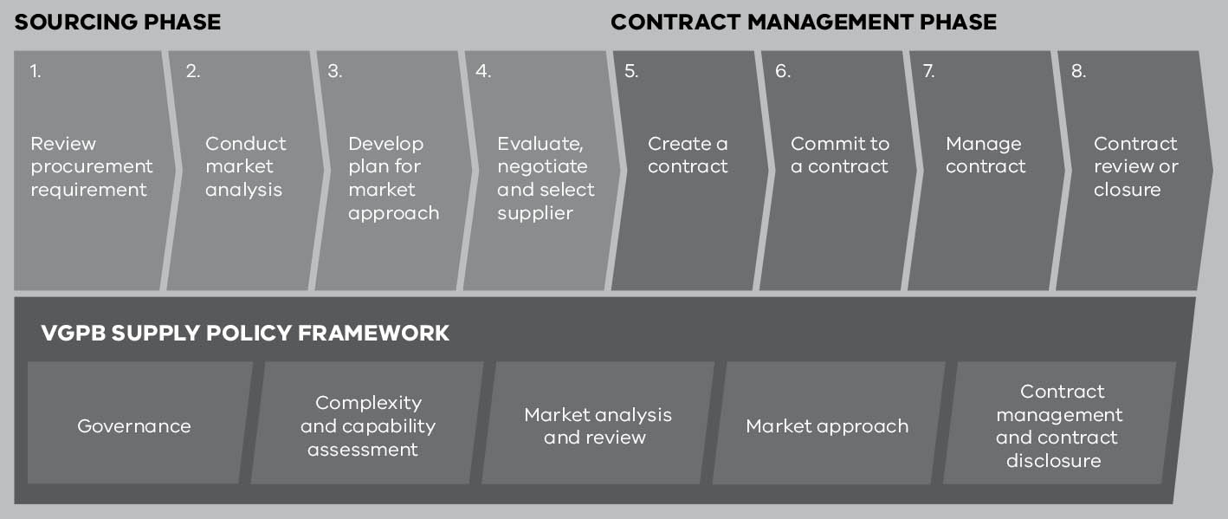

About the data in this report
The 10 mandated organisations (seven government departments, Public Transport Victoria, VicRoads and Victoria Police) provide data for the completed financial year as part of their annual supply reports.
Organisations report on contracts for goods and services (non-construction) valued over $100 000 (including goods and services tax) and approved in 2016–17. Reporting relates to approved contract values rather than actual contract spend. Contracts typically extend over several years and the total estimated contract value reflects the life of the contract, not the estimated annual spend. Total estimated contract spend also includes any options to extend the contract.
Contract types include one-off supply contracts and aggregated purchasing contracts (sole entity purchase contracts and state purchase contracts). Aggregated purchasing demand is grouping together demand for commonly purchased goods and services to harness greater economies of scale when procuring from the marketplace.
Table 2 lists the three contract types and their reporting requirements.
Table 2: Contract types reported in the VGPB Annual Report
Contract type | Contract description | Minimum reporting value | VGPB reporting stage
One-off supply | A single purchase of a specific quantity of goods or services which has been subject to a discrete quotation or tender process. | $100 000 (incl. GST) | Contract approval
Sole entity purchase contract (SEPC) | An aggregated arrangement established for one organisation or a business unit/group of business units within an organisation. SEPCs are mandatory for the organisation establishing the arrangement. | $100 000 (incl. GST) | Contract approval
State purchase contract (SPC) | An aggregated arrangement for the purchase of goods and services for use by mandated Victorian government departments and agencies. Other agencies can access the SPC if they agree to the rules of use. | $100 000 (incl. GST) | Business case approval
All figures in the tables and text in the annual report have been rounded. Discrepancies in tables between totals and sums of components reflect this rounding.

Overview of contract approvals
In 2016–17, organisations reported 1 005 procurement approvals valued at $2 084 million, as shown in Table 3.
Table 3: Total number and value ($ million) of one-off supply, SEPC and SPC approvals in
2016–17 by goods and services
 | One-off supplies |  | SEPCs |  | SPCs |  | Totals
 | Number | Value ($m) | Number | Value ($m) | Number | Value ($m) | Number | Value ($m)
Goods | 137 | 170.8 | 21 | 45.2 | 4 | 66.3 | 162 | 282.3
Services | 815 | 967.0 | 24 | 492.0 | 4 | 342.5 | 843 | 1 801.5
Totals | 952 | 1137.7 | 45 | 537.2 | 8 | 408.8 | 1 005 | 2 083.8
Most contract approvals were for one-off supplies (94.7 per cent), followed by SEPCs (4.5 per cent) and lastly, SPCs (0.8 per cent). In terms of value, one-off supplies were equivalent to 54.6 per cent of the total value of approved contracts, followed by SEPCs at 25.8 per cent and SPCs at 19.6 per cent. The difference in proportions between numbers and values is because SEPCs and SPCs generally have higher estimated contract values and usually span multiple years.
Most procurement contract approvals were for services (85.6 per cent).

Trends in contract approvals
Table 4 shows the number and value of contract approvals over the past four years.
The number and value of contract approvals has shown an upward trend over the past four years, although the total value in 2016–17 is 13 per cent lower than in 2015–16.
The increase over time can be partly attributed to bringing more organisations under the scope of the VGPB, with VicRoads reporting from 1 July 2015 and PTV from 1 January 2017 following their successful accreditation to VGPB supply policies.
In addition, the number and value of SEPC and SPC approvals will vary from year to year based on the specific procurement projects that need to be carried out in any given year, and/or the expiry and need for renewal of particular SEPCs and SPCs.
Table 4: Total number and value ($ million) of one-off supply, SEPC and SPC approvals from 2013–14 to 2016–17
 | 2013–14 |  | 2014–15 |  | 2015–16 |  | 2016–17
 | Number | Value ($m) | Number | Value ($m) | Number | Value ($m) | Number | Value ($m)
One-off supplies | 573 | 735.5 | 630 | 692.3 | 743 | 915.5 | 952 | 1 137.7
SEPCs | 29 | 93.2 | 37 | 270.9 | 37 | 778.8 | 45 | 537.2
SPCs | 5 | 114.8 | 6 | 658.6 | 10 | 720.6 | 8 | 408.8
Totals | 607 | 943.5 | 673 | 1 621.9 | 790 | 2 414.9 | 1 005 | 2 083.8
Note: The increase in one-off supply approvals in 2016–17 compared to previous years can be partly attributed to the increase in organisations reporting to the VGPB, better data capture and yearly variations in SEPC and SPC contract approvals.

One-off supply contracts
In 2016–17, organisations reported 952 one-off supply procurement approvals valued at
$1 138 million. Overall, 14 per cent of one-off supply approvals were for procurement of goods and 86 per cent for services.
This compares to 743 one-off supply approvals in 2015–16 valued at $916 million.
Table 5 shows the number and value of one-off supply approvals by organisation and by goods and services.
Table 5: One-off supply approvals by organisation and by goods and services in 2016–17
Organisation | Goods |  | Services
Organisation | Number | Value ($m) | Number | Value ($m)
Economic Development, Jobs, Transport and Resources | 81 | 93.3 | 153 | 148.9
Education and Training | 17 | 22.9 | 171 | 89.3
Environment, Land, Water and Planning | 4 | 0.8 | 104 | 48.4
Health and Human Services | 2 | 3.4 | 136 | 511.4
Justice and Regulation | 22 | 33.3 | 65 | 28.1
Premier and Cabinet | 3 | 1.3 | 80 | 36.1
Public Transport Victoria | .. | .. | 16 | 3.3
Treasury and Finance | .. | .. | 28 | 7.3
VicRoads | 1 | 0.2 | 53 | 88.4
Victoria Police | 7 | 15.7 | 9 | 5.7
Totals | 137 | 170.8 | 815 | 967.0
Note: Discrepancies between totals and sums of totals reflect rounding.

Procurement complexity
Procurement complexity refers to the level of difficulty involved in procuring a good or service. An assessment of complexity considers a broad range of factors including risk, total cost of ownership and market dynamics associated with the procurement activity.
When buying goods and services, organisations complete a complexity assessment and categorise procurements into one of four complexity quadrants (Table 6). The quadrant guides the sourcing strategy and how to manage risks and contractual arrangements.
Table 6: Description of complexity quadrants
Quadrant | Description
Transactional | Low-value and low-risk transactions where approved suppliers (e.g. SPCs) are not available.
Leveraged | Frequently used goods/services in a competitive marketplace that are procured by an individual organisation or whole of government, where the organisation has the ability to drive value.
Focused | Goods/services where a limited number of suppliers are available or where novel commercial arrangements are in place. May include whole of government contracts.
Strategic | Goods/services in a competitive market that are high value, where business criticality is high, and/or where the good/service is of state significance. May include whole of government contracts.

Overview of complexity
The VGPB’s supply policies require better upfront planning, category management and detailed market analysis. Organisations identify the best approach to market for any given category while also identifying opportunities to aggregate demand for frequently used goods and services procured from a competitive marketplace, giving them more buying power to drive value for money.
Table 7 shows the complexity assessment results for the one-off supply, SEPC and SPC approvals reported in 2016–17.
Table 7: One-off supply, SEPC and SPC approvals by complexity quadrant in 2016–17
Type of complexity | Number | Value ($m) | Average value per contract ($m)
Transactional | 463 | 246.2 | 0.5
Leveraged | 245 | 530.9 | 2.2
Focused | 125 | 119.8 | 1.0
Strategic | 172 | 1 186.8 | 6.9
Totals | 1 005 | 2 083.8 | 2.1

Note: The total average value reflects total value divided by total number and not the sum of the average value components. Strategic procurements are generally higher in value due to their risk and complexity profile.

Number of procurement approvals by complexity quadrant
Most procurement approvals were assessed as transactional (46 per cent) followed by leveraged (24 per cent). Strategic was 17 per cent and focused 12 per cent (see Figure 4).
This compares with 39 per cent leveraged, 31 per cent transactional, 17 per cent focused and 13 per cent strategic in 2015–16.
Figure 4: Number of contract approvals by complexity quadrant in 2016–17
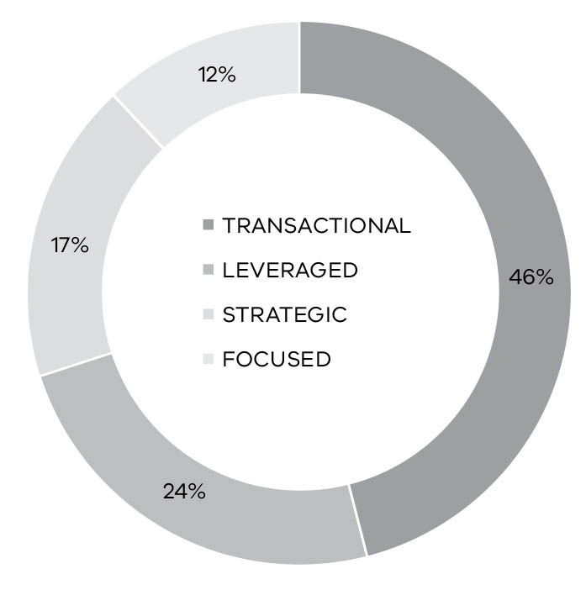

Number of complexity quadrants by organisation
Table 8 shows a breakdown of complexity quadrants by number and organisation giving an insight into the procurement profile of each organisation.
Table 8: Complexity quadrants (number) by organisation
Organisation | Transactional | Leveraged | Focused | Strategic | Totals
Economic Development, Jobs, Transport and Resources | 150 | 28 | 34 | 22 | 234
Education and Training | 50 | 118 | 14 | 7 | 189
Environment, Land, Water and Planning | 81 | .. | 24 | 14 | 119
Health and Human Services | 4 | 27 | 1 | 109 | 141
Justice and Regulation | 26 | 23 | 36 | 2 | 87
Premier and Cabinet | 80 | 3 | 2 | 5 | 90
Public Transport Victoria | 3 | 1 | 4 | 8 | 16
Treasury and Finance | 28 | 1 | .. | .. | 29
VicRoads | 12 | 42 | .. | .. | 54
Victoria Police | 29 | 2 | 10 | 5 | 46
Totals | 463 | 245 | 125 | 172 | 1 005

Value of procurement approvals by complexity quadrant
In 2016–17, the strategic quadrant had the highest total value of the four complexity quadrants at 57 per cent. This is an increase from 2015–16, where strategic was the second highest value quadrant at 35 per cent.
Leveraged was second highest at 25 per cent, compared to 48 per cent in 2015–16.
Transactional and focused remained consistent with 2015–16. Focused was the lowest with 6 per cent of the total value, compared to 5 per cent last year. This would be expected given that the focused quadrant is for procurements where a limited number of suppliers are available or where novel commercial arrangements are in place.
The transactional quadrant had 12 per cent of the value of all procurement approvals, which is the same as 2015–16.
Figure 5 shows the breakdown in complexity quadrants by value in 2016–17.
Figure 5: Value of contract approvals by complexity quadrant in 2016–17
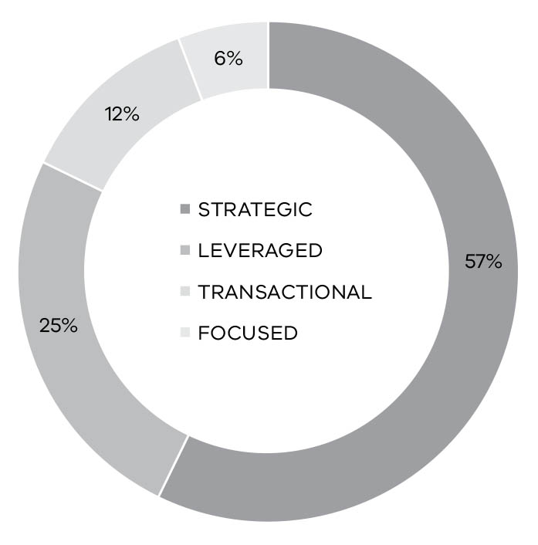

Trends in procurement complexity
Table 9 compares 2016–17 complexity quadrants with the two previous years. As noted, the number and value of procurements have generally increased over the past three years.
Strategic procurements increased in number and value in 2016–17, which could indicate that organisations are taking a more strategic approach to procurement.
Transactional activity has increased as procurement functions mature and their processes capture more activities.
Table 9: Trends in procurement complexity
 | 2014–15 |  | 2015–16 |  | 2016–17
Type of complexity | Number | Value ($m) | Number | Value ($m) | Number | Value ($m)
Transactional | 149 | 109.6 | 241 | 275.2 | 463 | 246.2
Leveraged | 208 | 240.1 | 312 | 1 164.9 | 245 | 530.9
Focused | 112 | 62.4 | 135 | 126.8 | 125 | 119.8
Strategic | 107 | 954.3 | 102 | 848.0 | 172 | 1 186.8
Totals | 576 | 1 366.5 | 790 | 2 414.9 | 1 005 | 2 083.8
Tables 10 to 13 show how the number of procurements in each complexity quadrant have changed for each organisation over the past three years. VicRoads began operating under the VGPB policies on 1 July 2015 and PTV on 1 January 2017 so neither provided data before these dates.
Table 10: Number of transactional procurements by organisation from 2014–15 to 2016–17
Organisation | 2014–15 | 2015–16 | 2016–17
Economic Development, Jobs, Transport and Resources | 4 | 30 | 150
Education and Training | 3 | 7 | 50
Environment, Land, Water and Planning | 11 | 75 | 81
Health and Human Services | 9 | 3 | 4
Justice and Regulation | 25 | 18 | 26
Premier and Cabinet | 54 | 27 | 80
Public Transport Victoria | n/a | n/a | 3
Treasury and Finance | 18 | 25 | 28
VicRoads | n/a | 20 | 12
Victoria Police | 25 | 36 | 29
Totals | 149 | 241 | 463
Table 11: Number of leveraged procurements by organisation from 2014–15 to 2016–17
Organisation | 2014–15 | 2015–16 | 2016–17
Economic Development, Jobs, Transport and Resources | 17 | 1 | 28
Education and Training | 170 | 217 | 118
Environment, Land, Water and Planning | 2 | 5 | ..
Health and Human Services | 9 | 10 | 27
Justice and Regulation | 3 | 15 | 23
Premier and Cabinet | 2 | 4 | 3
Public Transport Victoria | n/a | n/a | 1
Treasury and Finance | .. | 1 | 1
VicRoads | n/a | 57 | 42
Victoria Police | 5 | 2 | 2
Totals | 208 | 312 | 245
Table 12: Number of focused procurements by organisation from 2014–15 to 2016–17
Organisation | 2014–15 | 2015–16 | 2016–17
Economic Development, Jobs, Transport and Resources | 50 | 40 | 34
Education and Training | 21 | 30 | 14
Environment, Land, Water and Planning | 3 | 28 | 24
Health and Human Services | .. | 2 | 1
Justice and Regulation | 25 | 24 | 36
Premier and Cabinet | .. | 1 | 2
Public Transport Victoria | n/a | n/a | 4
Treasury and Finance | 5 | .. | ..
VicRoads | n/a | .. | ..
Victoria Police | 8 | 10 | 10
Totals | 112 | 135 | 125
Table 13: Number of strategic procurements by organisation from 2014–15 to 2016–17
Organisation | 2014–15 | 2015–16 | 2016–17
Economic Development, Jobs, Transport and Resources | 3 | 3 | 22
Education and Training | .. | .. | 7
Environment, Land, Water and Planning | 2 | 6 | 14
Health and Human Services | 97 | 83 | 109
Justice and Regulation | 3 | 6 | 2
Premier and Cabinet | 1 | .. | 5
Public Transport Victoria | n/a | n/a | 8
Treasury and Finance | 0 | 4 | ..
VicRoads | n/a | .. | ..
Victoria Police | 1 | .. | 5
Totals | 107 | 102 | 172

Critical incident procurement
The market approach policy establishes an alternative procurement process to operate during a critical incident and any subsequent relief effort. The process under this policy aims to accommodate urgent procurement needs while ensuring the procurement process adopted is reasonable and conducted with appropriate consideration of good practice procurement principles.
Three critical incident procurements were reported in 2016–17 as shown in Table 14. There were four critical incident procurements reported in 2015–16, valued at $0.9 million.
Table 14: Critical incident procurement in 2016–17
 | Number | Value
Goods | .. | ..
Service | 3 | $5.7M
Total | 3 | $5.7M
Two critical incidents were reported by the Department of Environment, Land, Water and Planning related to hiring a replacement fleet to respond to fire incidents.
The Department of Economic Development, Jobs, Transport and Resources reported one critical incident procurement related to provision of security.

Harnessing the buying power of government
By combining demand for common use goods and services, organisations can harness greater economies of scale when negotiating with potential suppliers.
Aggregating purchasing power allows organisations to negotiate lower prices and better terms and conditions and reduces the administrative burden on buyers and suppliers.
The Victorian Government has set up 46 SPCs for commonly purchased goods and services under 22 spend categories, as shown in Figure 6.
All government organisations and agencies can access SPCs provided they commit to the rules of use. For organisations bound by VGPB policies, SPCs are usually mandatory unless the lead department grants a written exemption.
More than 200 organisations benefit from the time and cost savings offered by SPCs. Organisations that can access SPCs include Victorian Government departments and agencies, local and federal government organisations and not-for-profit organisations.
Total annual spend under SPCs is estimated to be more than $1.3 billion.
The Department of Treasury and Finance (DTF) manages non-ICT goods and services SPCs, except for the legal services SPC, which is managed by the Department of Justice and Regulation. The Department of Premier and Cabinet (DPC) is responsible for ICT SPCs.
In 2017–18, the VGPB will continue to build on its role to help organisations identify new opportunities for aggregation. This will be done through quarterly SPC reporting and a review of organisations’ forward looking procurement activity plans, as well as data gathered from annual supply reports. These mechanisms will enable the VGPB to support both DTF and DPC in identifying additional opportunities for aggregation to drive greater value-for-money outcomes.
SPCs can be sole or multiple (panel) supplier arrangements or register arrangements. Panels can be open or closed. Open panels can accept new suppliers at set or other times during the contract period. Closed panels are restricted to the suppliers engaged at the start of the contract.
Registers consist of prequalified suppliers, compliant with the eligibility criteria to provide goods and services to Victorian Government.

About the data in this section
The contract values in the tables are estimates. Expenditure occurs as organisations order and consume goods and services under the SPC/SEPC. This takes place over the contract term. Total estimated value includes the initial contract term including any options to extend the contract.
Figure 6: Victorian Government SPC categories
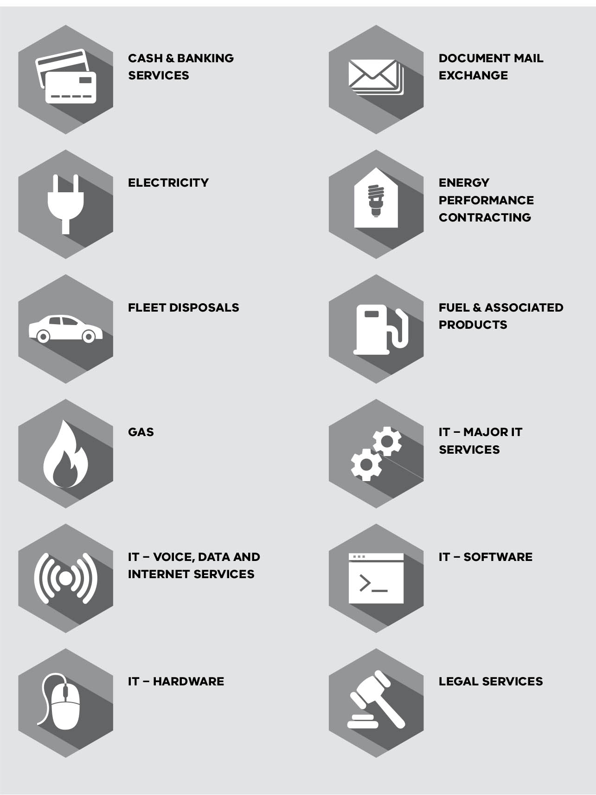

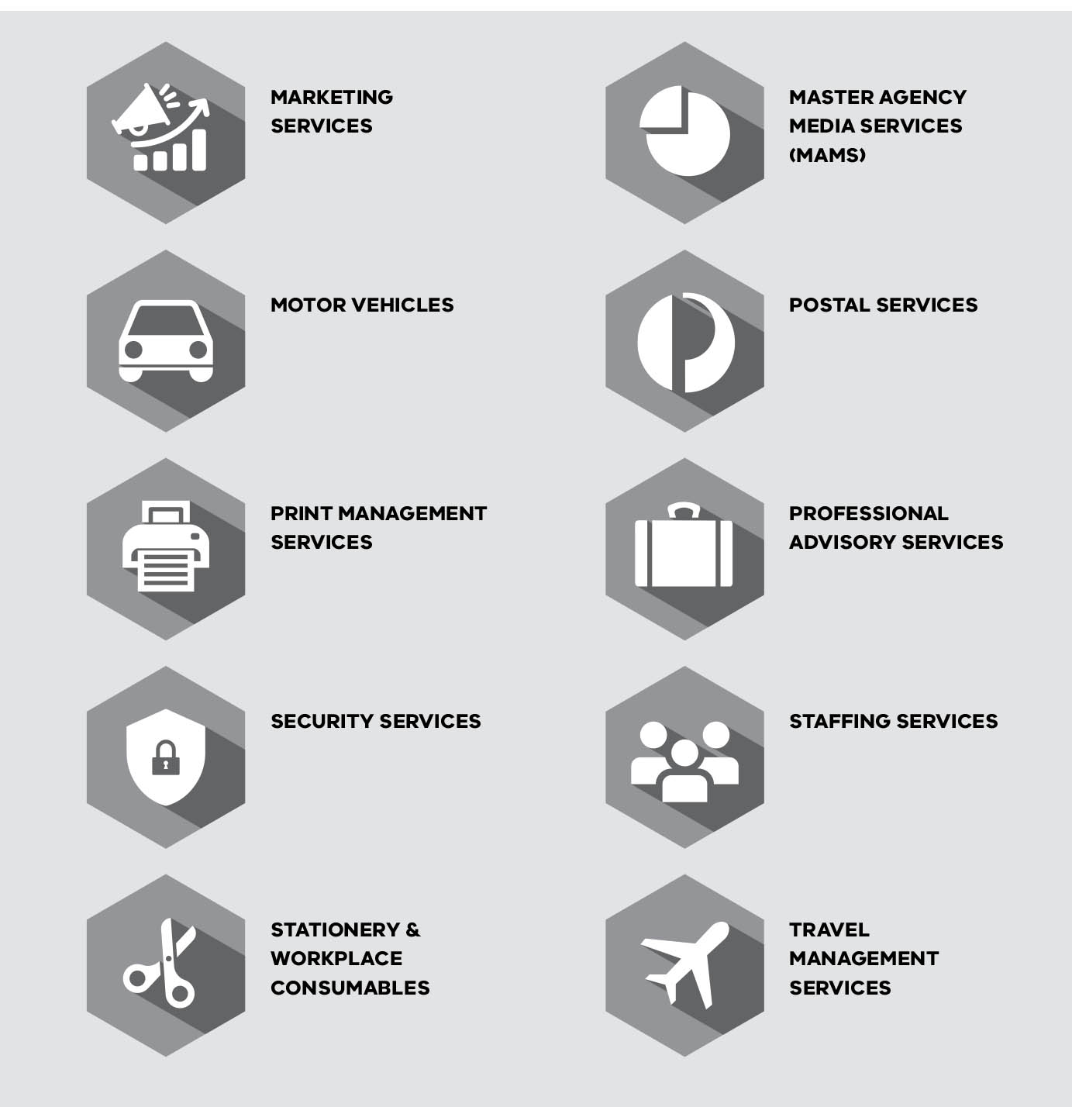

State purchase contracts
In 2016–17, eight SPCs were approved with an estimated total value of $409 million. This compares to 10 SPCs with an estimated total value of $721 million approved in 2015–16.
Table 15 provides a breakdown of all SPCs approved in 2016–17.
Table 15: SPCs approved in 2016–17
Organisation | Total number | Title/description | Total estimated value ($million) | Contract term (yrs.) | Options (yrs.) | Complexity assessment outcome | Market approach method | Type of arrangement | No. of suppliers
Premier and Cabinet | 7 | eServices Register Platform Refresh | 0.9 | 3 | Up to 2 years | Strategic | EOI | Open | 1
Premier and Cabinet | 7 | IBM Enterprise Licence Agreement | 2.7 | 1 | .. | Leveraged | RFQ | Closed | 1
Premier and Cabinet | 7 | VMware Reseller | 2.7 | 1 | .. | Leveraged | RFT | Closed | 1
Premier and Cabinet | 7 | Salesforce Customer Relationship Management | 15.0 | 3 | 3 | Focused | RFQ | Closed | 1
Premier and Cabinet | 7 | Data Centre (East Burwood) Services Hewlett-Packard | 47.5 | 5 | .. | Strategic | RFQ | Closed | 1
Premier and Cabinet | 7 | Microsoft Large Account Reseller | 60.0 | 3 | .. | Leveraged | RFQ | Closed | 1
Premier and Cabinet | 7 | TPAMS2025 | 200.0 | 3 | Ongoing | Strategic | RFT | Closed | 7
Treasury and Finance | 1 | Travel Management Services SPC | 80.0 | 3 | 2 x 1 year | Leveraged | RFT | Closed | 1
Total | 8 |  | 408.8
EOI = Expression of interest, RFQ = Request for Quotation, RFT = Request for tender

Sole entity purchase contracts
Sole entity purchase contracts (SEPCs) are similar to SPCs but apply to one organisation. In 2016–17, four organisations reported 45 SEPC approvals valued at $537 million, as listed in
Table 16.
Roughly half were for goods (47 per cent) and half for services (53 per cent), although the share of the total value of goods was much lower (8 per cent) than services (92 per cent).
This compares to 37 SEPCs approvals in 2015–16 valued at $779 million of which 62 per cent were for goods and 38 per cent for services, with goods accounting for 15 per cent and services for 85 per cent.
A breakdown of SEPC contracts approved in 2016–17 is provided in Table 43 in the Appendix.
Table 16: SEPCs approved in 2016–17
Organisation | Goods |  | Services
Organisation | Number | Value ($m) | Number | Value (Sm)
Education and Training | .. | .. | 1 | 75.0
Environment, Land, Water and Planning | 2 | 1.0 | 9 | 25.0
Health and Human Services | 2 | 10.0 | 1 | 0.3
Victoria Police | 17 | 34.2 | 13 | 391.7
Total | 21 | 45.2 | 24 | 492.0

PROCUREMENT IN ACTION

Negotiating more savings with ICT SPCs
DPC is responsible for managing ICT SPCs.
The department developed several new SPCs in 2016–17, delivering better value for money and meeting the VGPB’s procurement directives.
The TPAMS2025 program saw the establishment of five new telecommunications contracts in February 2017 resulting in significant pricing improvements and financial savings. This has led to considerable interest from local government and government-funded bodies in the not-for-profit sector, who are keen to access better pricing and terms and conditions under this SPC.
The Salesforce SPC is a cloud-based infrastructure platform with a much higher standardised discount structure. The State has already saved more than $400 000 (net) in the first three months of operation since 1 February 2017.
A new SPC was implemented with the company, Data#3 following a formal tender process to select the sole Microsoft-licensed solutions service provider on 1 October 2016. The scope also includes a fully managed Microsoft software asset management service.
The Microsoft enterprise agreement (EA) was renewed on 1 April 2017. The EA covers all Microsoft on-premise and cloud products as well as a secure productive environment, which gives users a higher level of security. The EA provides substantial discounts and other benefits, with estimated savings well above $13 million a year.
The VMware SPC and enterprise licence agreement was renewed in June 2017.
Aggregating the State’s server virtualisation assets into a single agreement allowed the negotiation of discounts, resulting in $3.6 million in savings in 2017.
The eServices Register established on 1 June 2017 gives ICT suppliers an effective mechanism to market their services by providing a marketplace through the VendorPanel platform sourced from the eProcurement SPC.
In its first weeks of operation, VendorPanel has already guided an estimated $20 million worth of ICT projects.

Providing expert oversight and monitoring compliance
Under the FMA, organisations must comply with VGPB supply policies when procuring goods and services. The VGPB monitors compliance through the mechanisms listed in Table 17.
Table 17: Mechanisms for monitoring compliance with VGPB procurement policies
Compliance mechanism | Details
Annual supply reports (ASRs) | Organisations submit an ASR to the VGPB at the end of each financial year summarising their procurement activity, performance measure results, actions taken to ensure compliance and instances of non-compliance.
Performance measures | Organisations monitor performance against six common performance measures and report results in their ASR.
Audit program | Organisations audit compliance with VGPB policies and submit an audit report to the VGPB once every three years.
Oversight of strategic procurements | Organisations can nominate certain strategic procurements for VGPB oversight. The VGPB can also identify specific procurements for oversight.
Complaints management | Organisations maintain a complaints management system for supplier complaints related to the process and probity applied during a procurement activity. Organisations provide details of complaints in their ASR.
Review of procurement activity plans | Organisations submit procurement activity plans every year for review by the VGPB.

Performance measures
Performance measures provide a consistent, quantifiable approach to measuring reform benefits. Performance measures are being implemented over a three-year period, starting in 2015–16. Year one results and data capture methods informed discussions with CPOs to refine the methodology for reporting in year two (2016–17). A summary of year two results are shown in Table 18. Some inconsistencies were identified related to applying performance measure one. This will be refined with CPOs before year three reporting.
As organisations progress with their data capture capability in year three (2017–18), full performance measure reporting with an established baseline to measure the benefits of the procurement reform will be possible. Refer to Table 23 in the next section for the methodology used to calculate results.
More information on organisational performance including a comparison with last year’s results can be found under each of the organisational profiles in the next section.
Table 18: Performance measure results in 2016–17 by organisation
Performance measure |  | DEDJTR | DET | DELWP | DHHS | DJR | DPC | PTV | DTF | VicRoads | Victoria Police
1 | Value created as a consequence of department procurement activity (%) | .. | 2.0 | .. | 0.2 | 0.4 | 39.2 | n/a | 21.5 | 17.0 | 18.9
2 | Proportion of the number of transactions at or below $2 000 through a P-Card or equivalent (%) | 29.9 | 4.3 | 19.7 | 12.3 | 10.4 | ..ª | n/a | 19.1 | 72.9 | 3.0
3 | Increase in procurement capability (%)^{b} | .. | 0.0 | 13^{c} | 6.6 | .. | .. | n/a | .. | 1.0 | (-11.4)^{d}
4 | Cost of department’s procurement resources as a percentage of total contract spend (%) | 0.2 | 0.8 | 0.03 | 0.7 | 3.8 | 1.2 | n/a | 0.3 | 1.7 | 2.4
5 | Supplier satisfaction assessment (% successful satisfied / % unsuccessful satisfied) | 90/46 | 78/50 | 82/37 | 82/53 | 70/50 | 73/36 | n/a | 67/50 | 88/25 | 86/0e
6 | Planned procurement activity as a percentage of actual procurement activity (%) | 29.3 | 31.7 | 63.2 | 5.7 | 10.6 | 50.0 | 25 | 60.5 | 42.5 | 85.2
Note: PTV gained accreditation on 1 January 2017 so could not provide performance results for the year.
ª DPC does not use P-Cards or equivalent.
^{b} All organisations measured procurement capability in 2016–17 but several did not in 2015–16, so could not measure the increase from the previous financial year. Figures will be available for 2017–18.
^{c} DELWP used its own internal capability tool for self-assessment by staff engaged in procurement.
^{d} Victoria Police measured a decrease in capability due to a broader organisational assessment in 2016–17. Victoria Police has identified several areas with opportunities to increase capability. For more information, refer to the Victoria Police procurement profile in the next section.
^{e} Victoria Police had a low sample size.

Audits
The VGPB has a three-year rolling audit program to:
- verify compliance with VGPB supply policies;
- minimise risks; and
- improve processes to drive better procurement outcomes.
The audit measures how well organisations are achieving savings, efficiencies and better service delivery as a result of improved supplier engagement, increased market engagement and greater rigour in driving value from contracts.
Victoria Police, the Department of Premier and Cabinet and the Department of Education and Training all completed their VGPB audits in 2016–17. The three completed audits resulted in mostly low-risk findings and all organisations have accepted the recommendations made to improve compliance. Implementation of recommendations is either complete or in progress.
Table 19 lists the audit program schedule and results to date. For more information on specific audit findings, refer to the relevant organisation’s procurement profile in the next section.
Table 19: Audit program schedule and results as at 30 June 2017
Audit year | Organisation | Status | Result | Year of completion (financial year)
2016 | Treasury and Finance | Complete | Two low-risk findings and two recommendations. The recommendations have been fully implemented. | 2015–16
2016 | Victoria Police | Complete | Four low-risk findings and eight recommendations. The recommendations have been fully implemented. | 2016–17
2016 | Premier and Cabinet | Complete | One low-risk finding, one moderate risk finding and four recommendations.  Implementation of recommendations is in progress. | 2016–17
2016 | Education and Training | Complete | Six low-risk findings and six recommendations. Four recommendations have been fully implemented and two are in progress. | 2016–17
2017 | Health and Human Services | In progress | Audit underway and due to be finalised late 2017.
2017 | Environment, Land, Water and Planning | In progress | Audit underway and due to be finalised late 2017. At the department’s request, the audit was brought forward from 2018 to 2017.
2017 | Economic Development, Jobs, Transport and Resources | In progress | Audit underway and due to be finalised late 2017.
2018 | Justice and Regulation | N/a | Audit has not yet started but has been rescheduled from 2017 to early 2018.
2018 | VicRoads | N/a | Not yet started.
2018 | Public Transport Victoria | N/a | Not yet started.
2018 | CenITex | N/a | Not yet started.

Procurement activity subject to VGPB oversight
The VGPB reviews specific procurement activities for process and probity oversight. Procurement oversight projects typically run across multiple years.
Organisations can nominate certain strategic procurements for VGPB oversight and the VGPB can also identify specific procurements for oversight. Oversight projects are considered to be of strategic importance to the State. The VGPB reviews these projects at key stages of the procurement process and gives recommendations for organisations to action.
The oversight process covers one or more of the following three stages of the procurement process:
- Stage 1: Planning;
- Stage 2: Before contract execution; and
- Stage 3: Contract management.
The VGPB actively managed 14 oversight projects during 2016–17 as listed in Table 20. This table does not reflect approval timing of contractual value and total estimated value is not disclosed for contracts in Stage 1 due to commercial sensitivity.
Table 20: Procurement activities subject to VGPB oversight in 2016–17
Organisation | Total number | Total estimated value ($m) | Title/description | Good/  Service | Complexity assessment outcome | Proposed market approach strategy | Oversight stage
Economic Development, Jobs, Transport and Resources | 1 | Not disclosed | CarbonNet - Offshore Appraisal Well | Service | Strategic | RFT | Stage 1
Health and Human Services | 2 | 24.5 | Records Management and Storage | Service | Leveraged | RFT | Stage 3
Health and Human Services | 2 | Not disclosed | Personal Alert Victoria | Service | Strategic | RFT | Stage 1
Justice and Regulation | 1 | Not disclosed | Facilities Maintenance Contract | Service | Focused | EOI/Select RFT | Stage 1
Premier and Cabinet | 2 | 200.0 | Telecommunications Purchasing and Management Strategy (TPAMS) | Service | Strategic | RFT | Stage 2
Premier and Cabinet | 2 | 0.8 | eServices Register Platform Refresh | Good | Strategic | EOI/RFQ | Stage 2
Treasury and Finance | 4 | Not disclosed | Cash and Banking SPC | Service | Strategic | RFT | Stage 1
Treasury and Finance | 4 | Not disclosed | Shared Service Provider Security Services SPC (WoVG) | Service | Focused | RFT | Stage 1
Treasury and Finance | 4 | 10.0 | Security Services for Treasury Reserve and WoVG | Service | Transactional | RFQ | Stage 3
Treasury and Finance | 4 | Not disclosed | Master Agency Media Services | Service | Strategic | RFT | Stage 1
Victoria Police | 4 | 72.9 | Custodial and Prisoner Escort Services | Service | Strategic | RFT | Stage 2
Victoria Police | 4 | 8.4 | Telecommunications Goods and Services | Goods | Leveraged | RFT | Stage 3
Victoria Police | 4 | 181.6 | Information Technology Services Contract | Service | Strategic | RFT | Stage 3
Victoria Police | 4 | Not disclosed | Integrated Operational Equipment Vests | Goods | Strategic | RFT | Stage 1
Total | 14
EOI = Expression of interest, RFT = Request for tender, RFQ = Request for quote

Non-compliance
This section reports on instances of non-compliance with applying VGPB supply policies in
2016–17. It relates to non-compliance with the VGPB supply policy framework, for example, failing to publish a procurement activity plan online, or not having the requisite components of the governance structure such as a CPO or internal procurement unit (IPU) Chair. It does not cover internal matters of non-compliance. Organisations also report on steps taken to resolve non-compliance in this instance and in future.
There were two instances of non-compliance reported in 2016–17, as listed in Table 21.
Table 21: Non-compliance in 2016–17
Department | Number | Instance of non-compliance | Actions taken to resolve instance of non-compliance | Actions taken to improve compliance in future
Premier and Cabinet | 2 | No IPU Chair at 30 June 2017 | As part of the Procurement Transformation Project, DPC is reviewing governance processes, including reporting lines. | When complete, the Procurement Transformation Project will recommend actions to improve compliance.  Procurement is being governed through the CPO office and as required, escalated to Executive Director, Corporate, DPC.  Machinery of government changes announced in April 2017 affected the IPU governance committee, with members being transferred to other entities across Government.
Premier and Cabinet | 2 | Complaints register not implemented | As part of the Procurement Transformation Project, DPC is finalising the register, policy and communication materials.  DPC engaged probity services to develop a protocol to ensure that suppliers have an alternate channel to discuss concerns or complaints. | DPC will communicate availability of the complaints register and the probity protocols to all DPC staff via staff induction and online resources.
Total | 2

Complaints
Organisations have a complaints management system that sets out the process and procedures for addressing complaints by suppliers. CPOs are responsible for their organisation’s complaints management process.
The VGPB defines a complaint as an issue or concern expressed by a supplier in relation to the process and probity applied by an organisation when carrying out a procurement activity.
In 2016–17, organisations reported five complaints related to procurement activity, as shown in Table 22. This compares to three complaints in 2015–16, six complaints in 2014–15 and three complaints in 2013–14.
Table 22: Complaints related to procurement activity in 2016–17
Organisation | Number | Nature of complaint | Actions taken | Status
Economic Development, Jobs, Transport and Resources | 1 | Supplier believed it did not receive full feedback on its unsuccessful tender submission | The CPO spoke to the supplier on two occasions to assess the complaint and give feedback. Situation resolved by providing detailed feedback on the lack of quality in the supplier’s submission. | Resolved
Environment, Land, Water and Planning | 2 | Late tender excluded from RFT process | Review of user activity log from Tenders Vic showed the tender was uploaded after 2pm closing time. Confirmed no operational issues with site on that day. Tenderer advised and tenderer responded accepting decision. | Resolved
Environment, Land, Water and Planning | 2 | Supplier not satisfied with tender process including timeframes, tender requirements and time taken to inform suppliers of the tender decision | Review of tender process in relation to issues subject to the complaint.  Review of probity adviser report advising satisfactory completion of the tender process.  Obtain relevant information from evaluation panel members. | Still under investigation
Health and Human Services | 1 | Appeal related to non-acceptance of a late bid | Independently (internally) reviewed the bidder’s appeal.  Bid was confirmed as being ineligible for consideration based on advertised offer terms. Bidder was advised accordingly in writing.  Bidder acknowledged the department’s interpretation and withdrew complaint. | Resolved
Victoria Police | 1 | Validity of contract | Victoria Police engaged a law firm to give advice on the complaint. | Still under investigation
Total | 5

Organisational procurement profiles
This section provides a summary of each organisation including its:
- procurement profile;
- performance in 2016–17;
- compliance with VGPB policies; and
- activities planned for 2017–18.
The CPO and IPU Chair listed under each organisation are the persons in those roles at 30 June 2017.

Performance measures methodology
Table 23 summarises the methodology for calculating the six common performance measures used to assess the benefits of procurement reform.
Table 23: Performance measure methodology
Performance measure |  | Definition
1 | Value created as a consequence of department procurement activity | Value of direct cost savings and potential costs avoided for department procurements of $100 000 and greater, conducted during the financial year as a percentage of the total value of department total contracted spend during the financial year.
2 | Proportion of the number of transactions at or below $2 000 through a P-Card or equivalent | Ratio of low-value transactions less than $2 000 through a P-card or equivalent card versus total number of low-value transactions less than $2 000 paid by any means.
3 | Increase in procurement capability | Annual assessment of the improvement in departmental procurement capability year on year, measured by the department score on the VGPB capability assessment tool and template.
4 | Cost of department’s procurement resources as a percentage of total contract spend | Percentage of the total salary and wages for all procurement resources allocating equal to, or greater than, 80 per cent of time on procurement tasks against total department spend for the year.
5 | Supplier satisfaction assessment | Satisfaction with quality of service provided by the department procurement function as provided by an annual survey of supplier perception of experience over time.
6 | Planned procurement activity as a percentage of actual procurement activity | Number of planned procurements captured in a department’s internal forward procurement activity plan against the number of procurement activities awarded to the market.

Department of Economic Development, Jobs, Transport and Resources
The Department of Economic Development, Jobs, Transport and Resources (DEDJTR) drives economic development and job creation across Victoria, incorporating transport and ports, investment attraction and facilitation, trade, agriculture, creative industries and resources. Recent times have seen the formation of Transport for Victoria, and the addition of another two administrative agencies under the Major Transport Infrastructure Projects umbrella.

Procurement profile
The current DEDJTR procurement approach is a centre-led model with responsibility for procurement strategy, policy and delivery of strategic sourcing for goods and services across DEDJTR.
AO: Richard Bolt, Secretary
CPO: Lisa Williams, CPO, Corporate Services
IPU Chair: Alex Jones, CIO, Corporate Services

As at June 2017, the DEDJTR procurement team consisted of 18 resources, led by the CPO.
The DEDJTR Strategic Procurement Division provides strategic procurement advice, manages compliance and governance, develops policy and strategy and is engaged in executing key procurement activities.
DEDJTR has a complex portfolio of services, and therefore a diverse range of spend categories.
Annual addressable goods and services spend is about $430 million on goods and services, categorised at a high level into the following categories: agriculture and marine, facilities management, general business services, human resources, IT and telecoms, marketing, meetings and events, professional services, scientific research, travel and utilities.
Procurement is of high importance to DEDJTR as large proportions of DEDJTR’s strategic goods and services procurements are 'multidisciplinary' and 'project based', where each activity often incorporates multiple categories of expenditure.

Compliance with VGPB policies
Table 24 lists DEDJTR’s activities to ensure and improve compliance with VGPB supply policies. Compliance activities are grouped against VGPB supply policies, though activities often overlap with multiple policies.
DEDJTR also undertook an audit as part of the VGPB’s compliance program with a completion date of 7 July 2017. Audit results will be covered in next year’s annual report.
DEDJTR’s IPU is called the Procurement Governance Committee (PGC). The PGC includes an external probity adviser and all members have relevant capabilities approved by the Secretary. The probity adviser attends the fortnightly meetings as a non-voting member.

Activities planned for 2017–18
In 2017–18, DEDJTR will:
- update and improve standard form contracts to streamline the contracting process;
- provide streamlined, modular procurement and contract management training to uplift procurement capability across the business; and
- develop a roadmap for implementing new procurement technology systems (source-to-contract and contract management) to simplify the procurement and approvals process and provide better data for analysis and identifying opportunities.
Table 24: DEDJTR’s compliance activities in 2016–17
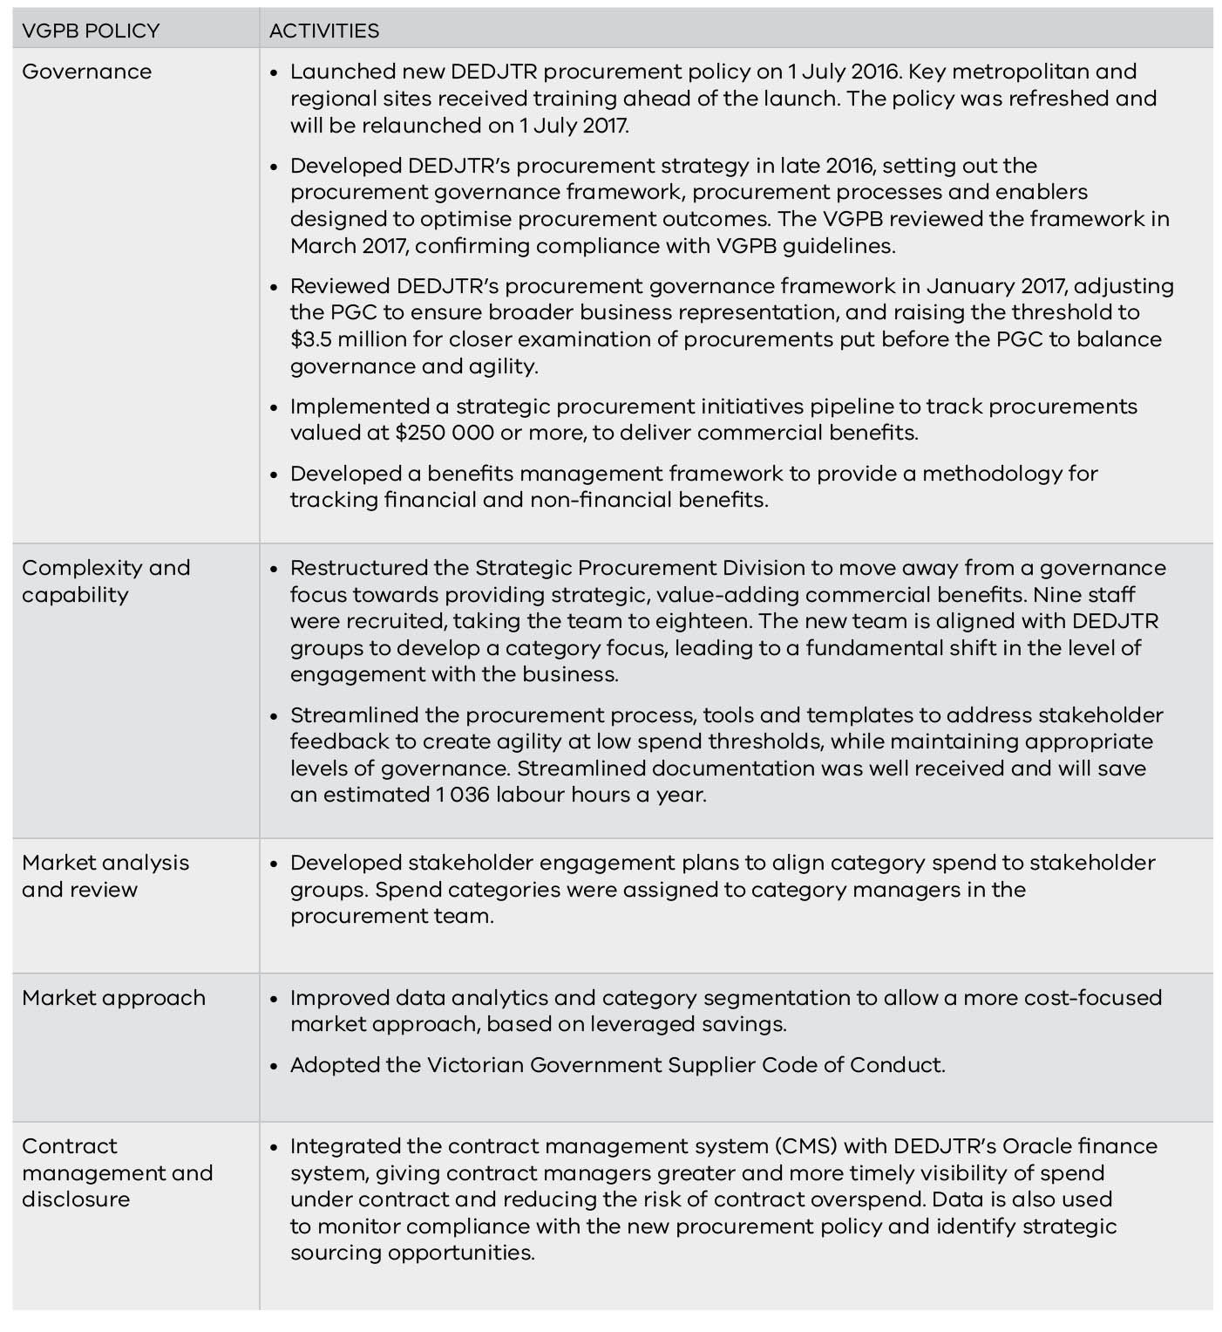

Performance
Table 25 sets out DEDJTR’s performance in 2016–17, and a comparison with 2015–16.
Table 25: DEDJTR’s performance in 2016–17
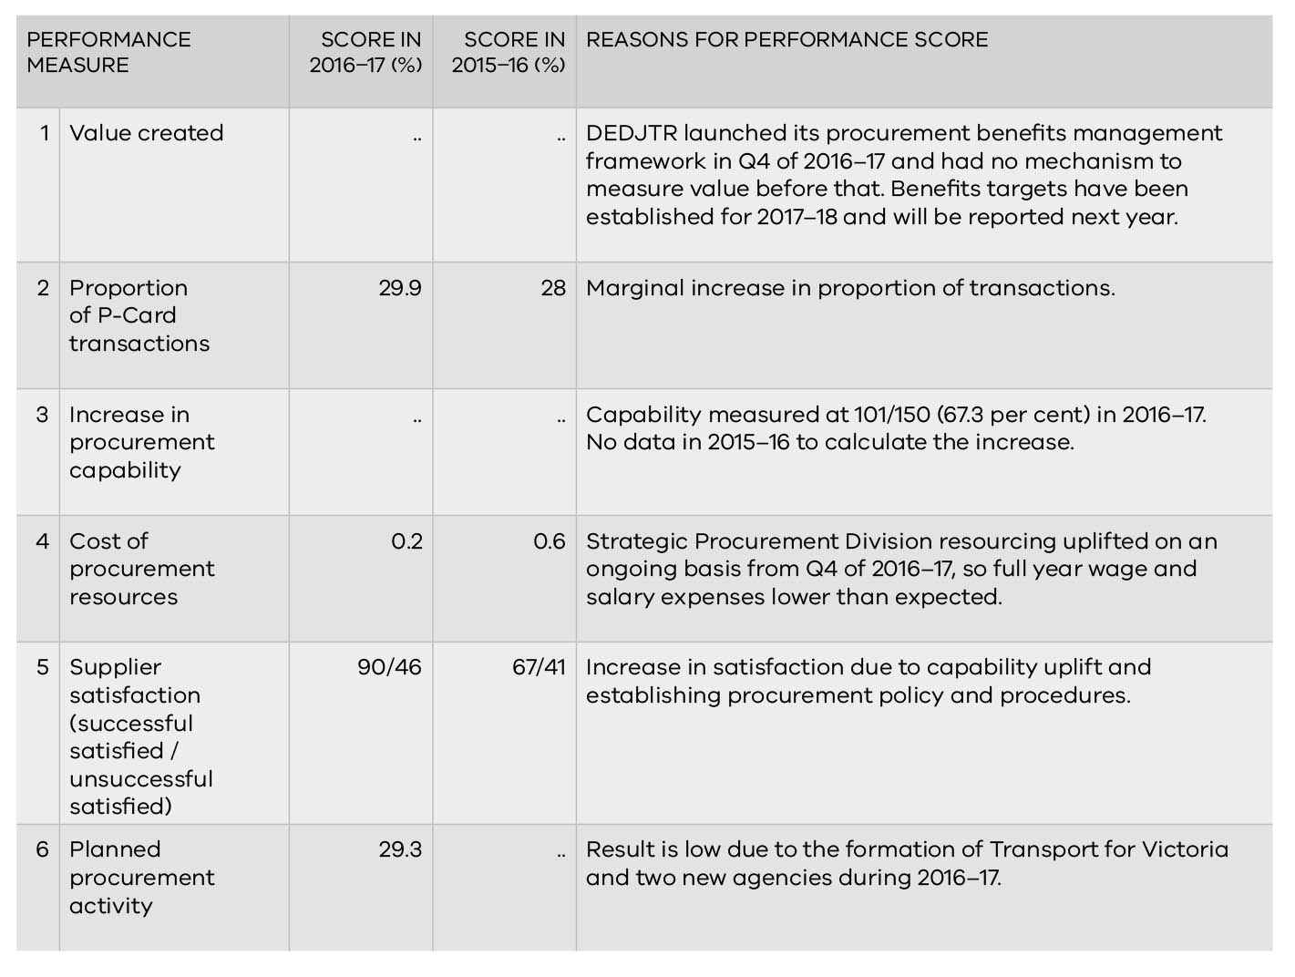

Department of Education and Training
The Department of Education and Training (DET) leads the delivery of education and development services to children, young people and adults both directly through government schools and indirectly through the regulation and funding of early childhood services, non-government schools and training programs.

Procurement profile
In delivering these services, the department procures goods and services to the value of approximately $400 million annually. Major areas of expenditure include IT, professional services and school buses. A significant portion of DET procurement activity is focused on the IT sector.
AO: Gill Callister, Secretary
CPO: Tarkan Koman, Executive Director, Procurement Division
IPU Chair: Kate Rattigan, Deputy Secretary, People and Executive Services Group

In 2016–17, DET approved 189 contracts valued at more than
$100 000 with a total value of $187 million. Just less than half (47 per cent) of contracts over $100 000 relate to procurements in the IT sector.
Most DET contracts over $100 000 are in the leveraged complexity quadrant (62 per cent). This is due to DET’s IT, professional services and learning and development spend.
The department operates a devolved model. Each business unit in DET (centrally and regionally) manages its own procurement processes with support provided by the Procurement Division. Each business unit delegate is responsible for ensuring staff are operating according to the department’s policies for all purchasing and payment activities.

Compliance with VGPB policies
Table 26 lists DET’s activities to ensure and improve compliance with VGPB supply policies. Compliance activities are grouped against VGPB supply policies, though activities often overlap with multiple policies.
DET was audited as part of the VGPB’s compliance program on 28 November 2016. The audit result was that DET’s procurement function needs improvement. DET had six audit actions and four of these have been completed. DET is addressing the remaining two actions for completion by 30 September 2017.
DET’s IPU is called the Procurement and Probity Committee.

Activities planned for 2017–18
In 2017–18, DET will:
- develop new e-learning procurement modules for DET staff;
- review and simplify the procurement system so it aligns with the new procurement procedures and allows for faster completion of procurement activities;
- review and update DET’s procurement strategy; and
- identify categories for school procurement suited to panel arrangements to achieve better value for money.

Table 26: DET’s compliance activities in 2016–17
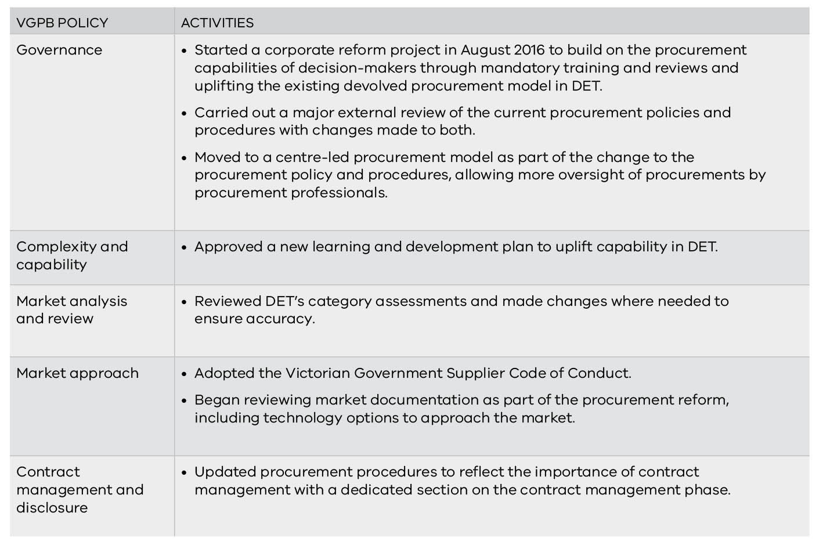

Performance in 2016–17
Table 27 sets out DET’s performance in 2016–17, and a comparison with 2015–16.
Table 27: DET’s performance in 2016–17
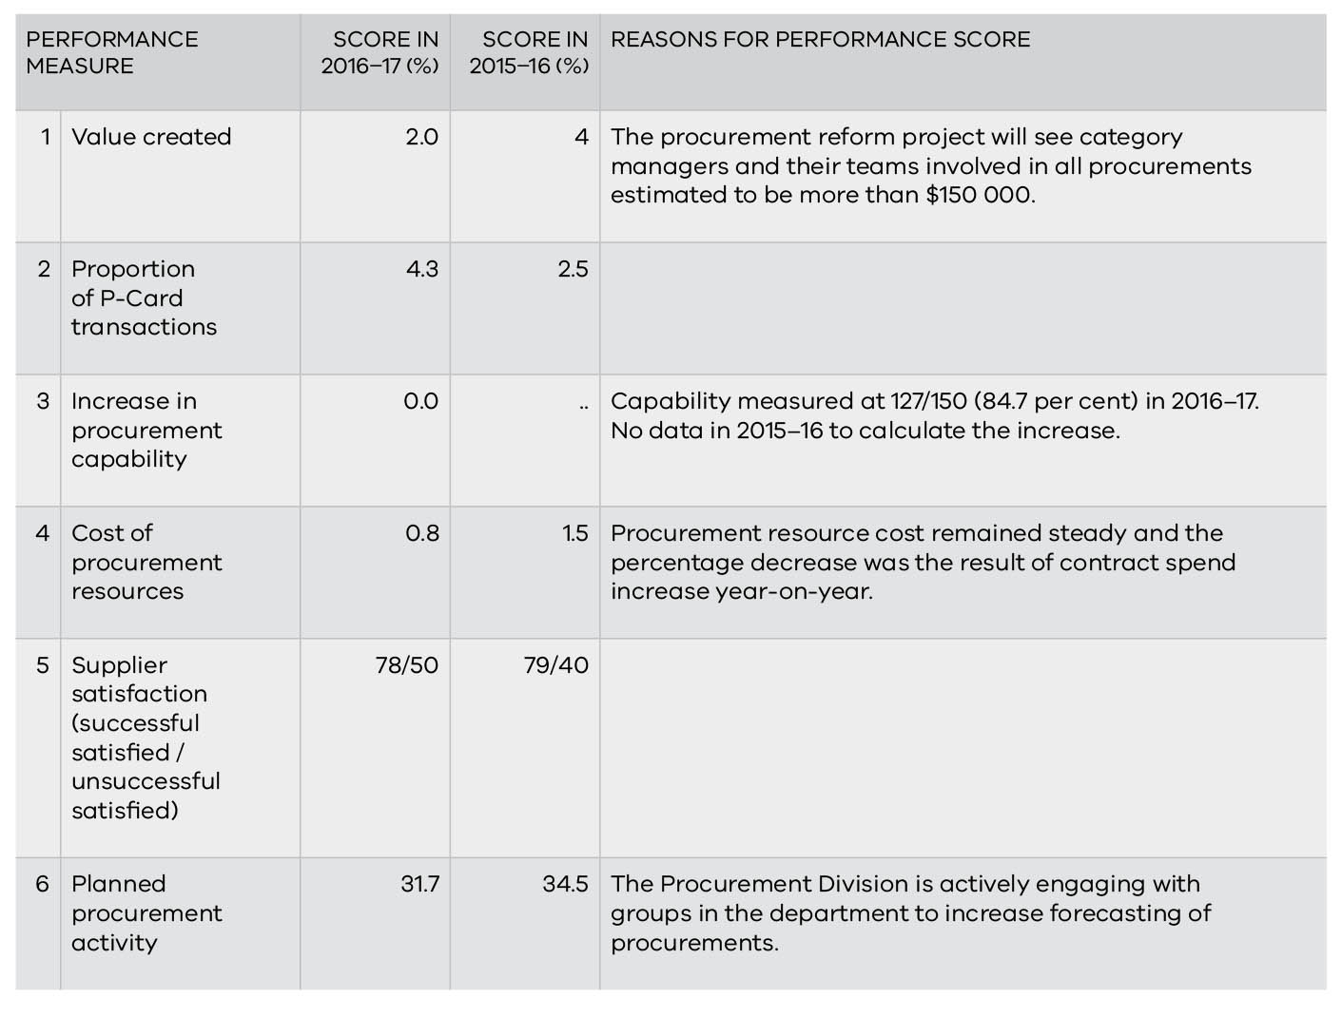

Department of Environment, Land, Water and Planning
The Department of Environment, Land, Water and Planning (DELWP) brings together Victoria’s planning, local government, environment, energy, suburban development, forests, emergency management, climate change and water functions into a single department to strengthen connections between the environment, community, industry and economy.

Procurement profile
DELWP is an organisationally diverse department with a broad and operationally extensive procurement profile. At any one time, there are more than 1 500 current contracts ranging from low-value and low-risk to highly complex, long-term contracts that are significant for the department and the State and need high-level management.
AO: Christine Wyatt, A/Secretary
CPO: A.J. Karliner, CPO, Corporate Services
IPU Chair: Kathryn Anderson, Deputy Secretary, Corporate Services

A significant portion of DELWP’s procurement activity focuses on emergency management related to fire and flood recovery, including a chartered fleet of around 50 aircraft. In addition, DELWP’s IT area covers an expansive and disparate array of systems applications that support the department and community to deliver government obligations and objectives in the areas of land management, energy, environment, water and planning.
The introduction of the energy portfolio into DELWP through machinery of government changes this year has increased the number of procurements carried out by more than 100.

Compliance with VGPB policies
Table 28 lists DELWP’s activities to ensure and improve compliance with VGPB supply policies. Compliance activities are grouped against VGPB supply policies, though activities often overlap with multiple policies.
DELWP’s IPU is called the Procurement Governance Committee (PGC). The PGC reviews management reports on departmental procurement activity and provides strategic oversight of the procurement function.

Activities planned for 2017–18
In 2017–18, DELWP will:
- review a potential source-to-contract tool to improve its ability to manage tenders and suppliers;
- improve procurement reporting capability for better visibility of spend and data capture;
- review procurement and contract management training to ensure training is geared towards staff needs and reflects capability assessment requirements;
- expand its category management strategy to include procurement of professional services; and
- embed reporting on savings into monthly procurement reports through the procurement approvals process to allow for performance measure reporting and improve the focus on creating savings.

Table 28: DELWP’s compliance activities in 2016–17
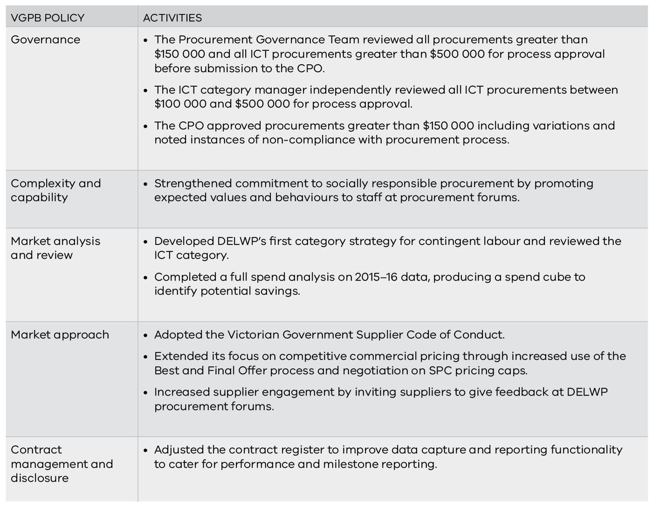

Performance
Table 29 sets out DELWP’s performance in 2016–17, and a comparison with 2015–16.
Table 29: DELWP’s performance in 2016–17
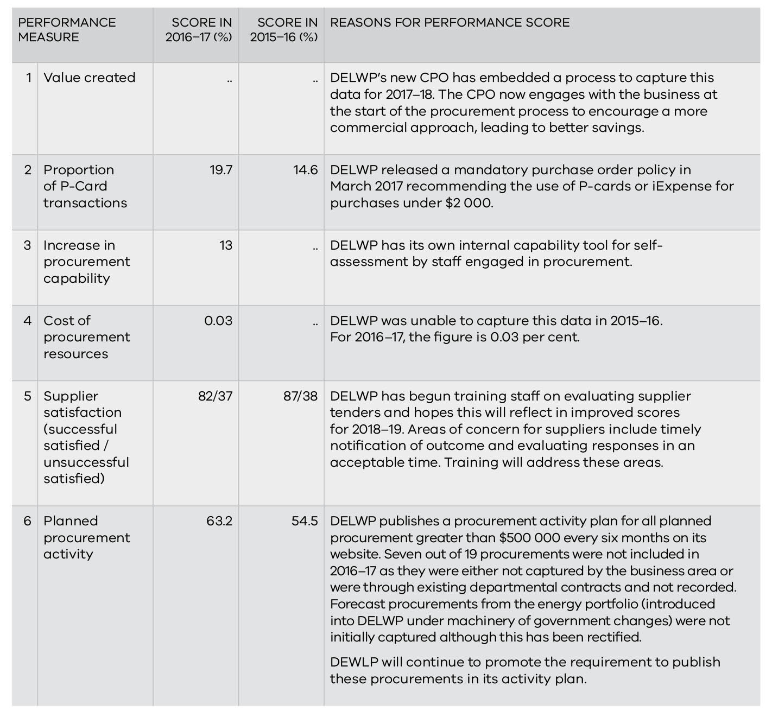

Department of Health and Human Services
The Department of Health and Human Services (DHHS) is responsible for developing and delivering policies, programs and services that support the health, wellbeing and safety of all Victorians.

Procurement profile
AO: Kym Peake, Secretary
CPO: Genine Wallinga, Director, Procurement and Contract Management Branch
IPU Chair: Carolyn De Gois, Deputy Secretary, Corporate Services

DHHS operates a centre-led goods and services (non-construction) procurement function that supports staff when undertaking various procurement actions.
The department’s main spend categories are:
- business support services–ICT (about 40 per cent of goods and services spend) comprising a range of information and communications technology subcategories;
- business support services–non-ICT (about 30 per cent) comprising subcategories such as security, training, utilities and equipment;
- professional services (about 20 per cent) comprising a range of consulting and advisory subcategories; and
- client support services (balance) comprising medical and support services for clients.

Compliance with VGPB policies and related activities
Table 30 lists DHHS activities to ensure and improve compliance with VGPB supply policies. Compliance activities are grouped against VGPB supply policies, though activities often overlap with multiple policies.
DHHS has started preparing for audit by the VGPB. The audit is expected to be finalised in September 2017.
DHHS IPU is called the Procurement Committee. It comprises 10 members at the executive level and is chaired by a deputy secretary. The committee oversaw procurement policy, planning and compliance arrangements, which included consideration of 216 procurement plans with an estimated value of $614 million, of which the committee formally approved 22 totalling $526 million (the balance being managed by committee delegates).
DHHS staff have access to a range of internally conducted, finance and procurement-related courses, workshops and seminars, ranging from induction (P-Card, basic purchasing, purchase order creation, etc.) to procure-to-pay and contract management. Training is targeted at staff undertaking specific functions who are required to attend nominated training, as designated by the Finance and Procurement Training matrix.

Activities planned for 2017–18
In 2017–18, DHHS will:
- continue to implement capability development projects from the capability assessment;
- streamline and improve procurement outcomes for staff by increasing the number of SEPCs and category analysis;
- make category data more readily available for staff, to support more timely analysis and investigation of procurement opportunities, through the department’s reporting tools;
- support opportunities for improvements in procurement and contract management systems, at both the whole of government and department level; and
- redesign procurement information on the department’s intranet to give staff immediate access to accurate advice.

Table 30: DHHS compliance activities in 2016-17
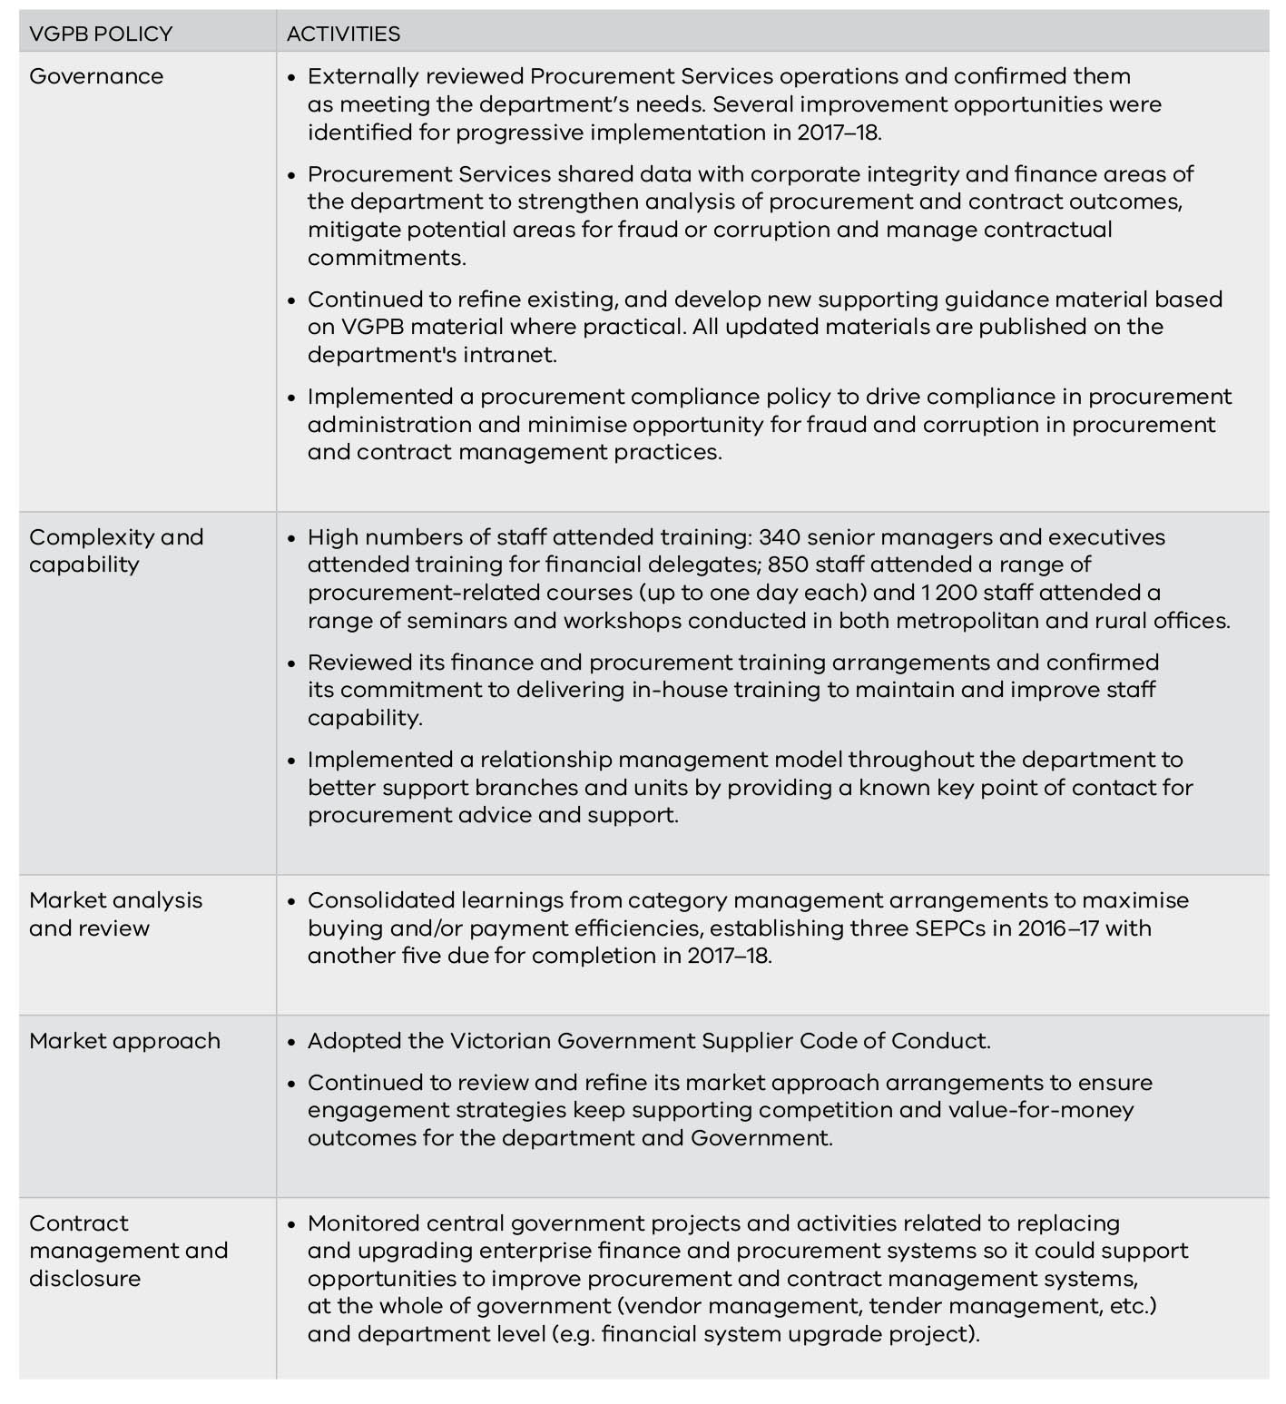

Performance in 2016–17
Table 31 sets out DHHS performance in 2016–17, and a comparison with 2015–16.
Table 31: DHHS performance in 2016–17
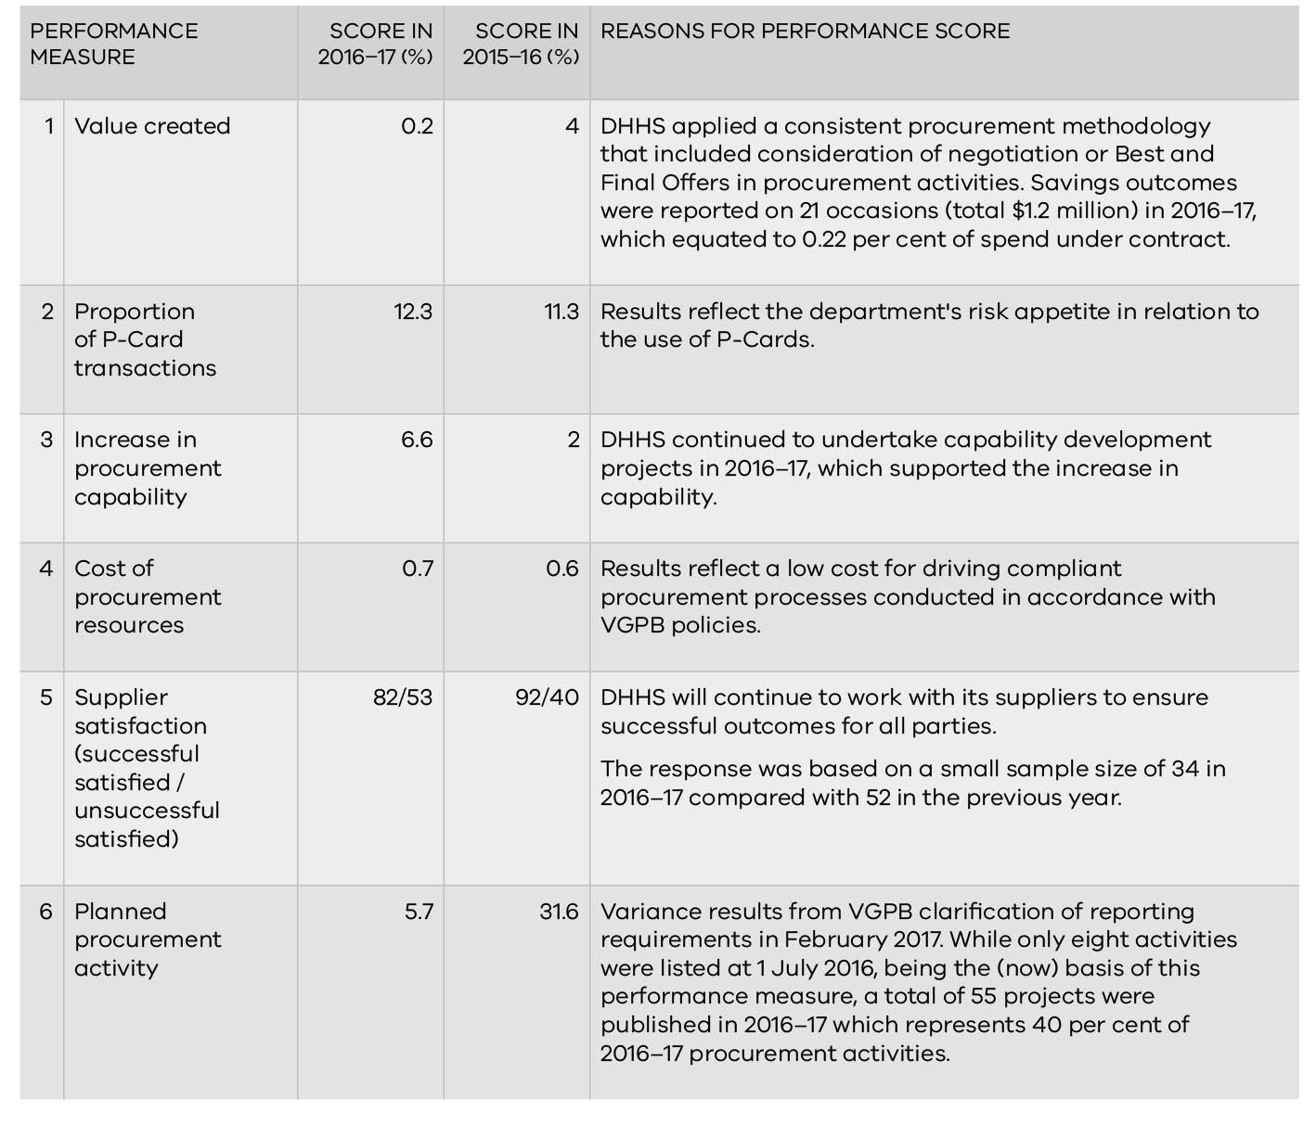

Department of Justice and Regulation
The Department of Justice and Regulation (DJR) delivers high-quality services to Victorians and supports a safe, just, innovative and thriving Victoria.

Procurement profile
DJR has a devolved procurement model, incorporating a mix of business units with a central procurement area combined with business units with a broad range of procurement practitioners and capability.
AO: Greg Wilson, Secretary
CPO: Philip Chalkley, CPO, Office of the CPO
IPU Chair: Shaun Condron, Deputy Secretary, Finance, Infrastructure and Governance

Many procurements are carried out by individuals with part-time responsibility for procurement. There are an estimated 156 full-time procurement professionals and 144 part-time procurement professionals, with contractors supporting large procurement projects.
The predominant categories of spend across DJR are private prisons, construction and property, ICT, road safety and contractors/consultants.

Compliance with VGPB policies and related activities
Table 32 lists activities completed by DJR to ensure and improve compliance with VGPB supply policies. Compliance activities are grouped against VGPB supply policies, though activities often overlap with multiple policies.
DJR’s IPU consists of a combined group of committees and boards including the Procurement Activity Board (PAB) and the Justice Procurement Committee (JPC).
The PAB independently review all sourcing activity and variations with a cumulative value exceeding $100 000 (including GST) for compliance with departmental procurement policies and processes. PAB members conduct two-stage reviews which include a sourcing plan before market approach, followed by a procurement process report before contract execution.
The JPC is the peak procurement committee with responsibility for the strategic direction of procurement in the department. It approves changes to policy and process that are aligned with the VGPB. The JPC meets quarterly, with its membership comprising senior executives across the department.

Activities planned for 2017–18
In 2017–18, DJR will:
- implement the new eSourcing tool;
- finalise the upgrade of P2P, eCatalogues and associated training;
- introduce an iSupplier capability to give suppliers a ‘self‐service’ capability to manage their corporate and invoice management data as part of the P2P (Peer-to-Peer) uplift project (delayed due to technology constraints with P2P);
- introduce a contract management framework to guide contract managers through the contract management lifecycle;
- introduce an enterprise contract management framework to help staff and suppliers get the most from enterprise supplier relationships; and
- embed the benefits realisation framework.

Table 32: DJR’s compliance activities in 2016-17
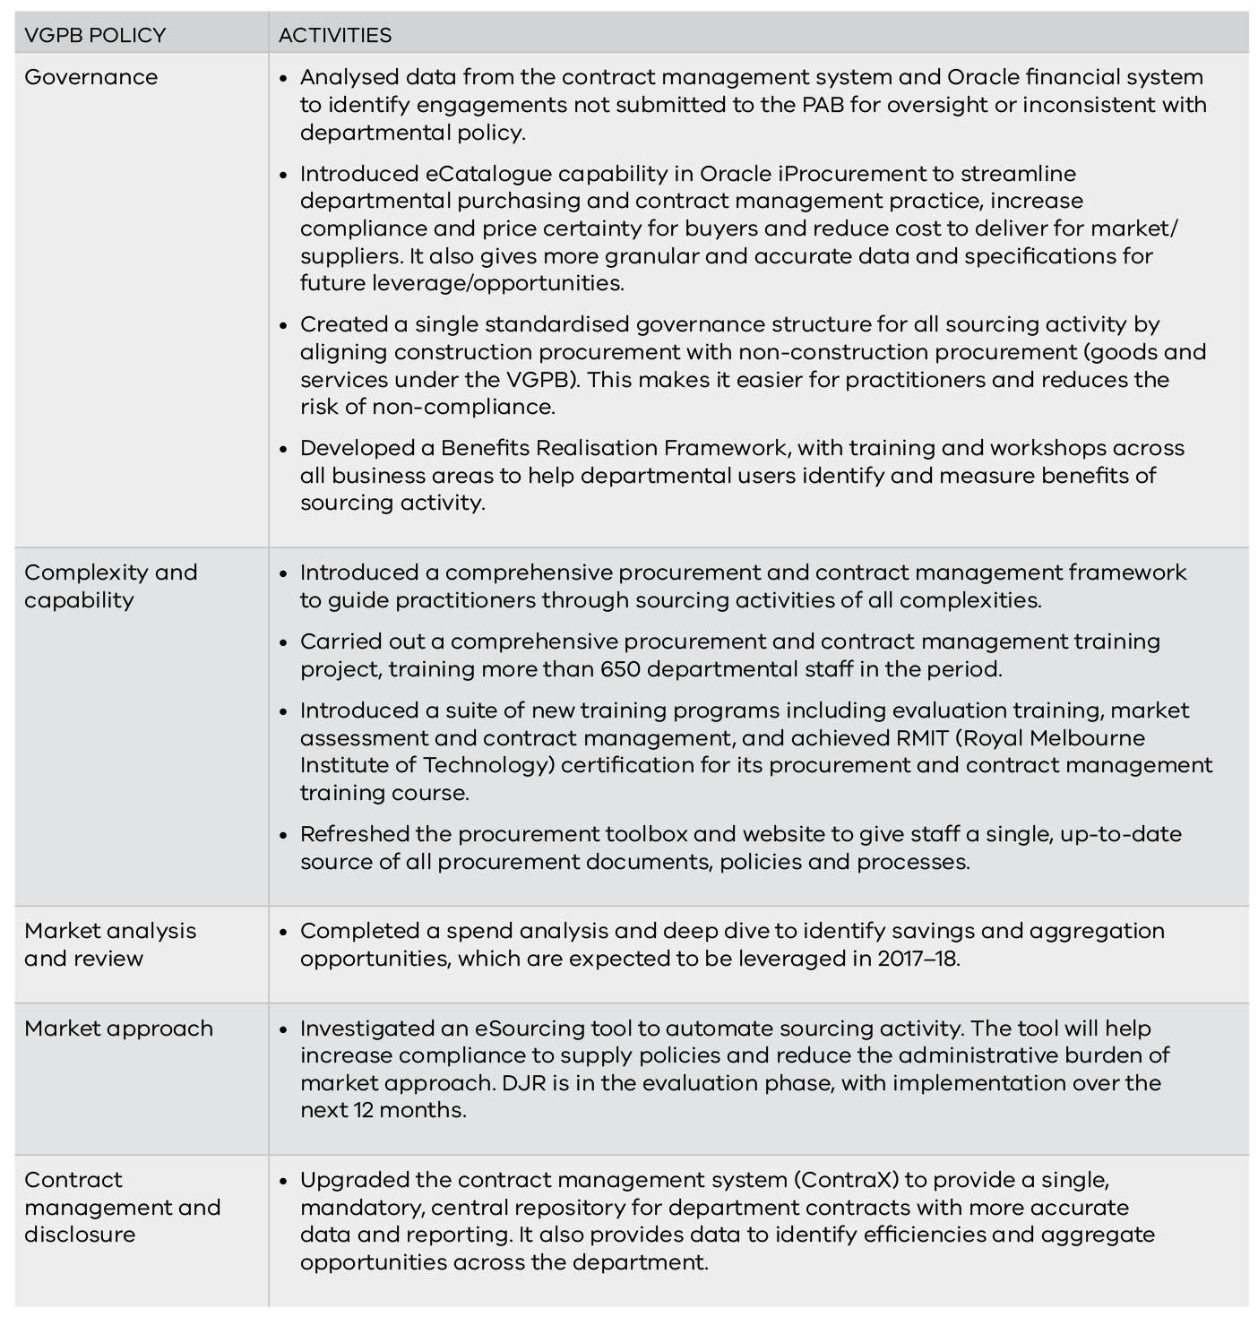

Performance in 2016–17
Table 33 sets out DJR’s performance in 2016–17, and a comparison with 2015–16.
Table 33: DJR’s performance in 2016–17
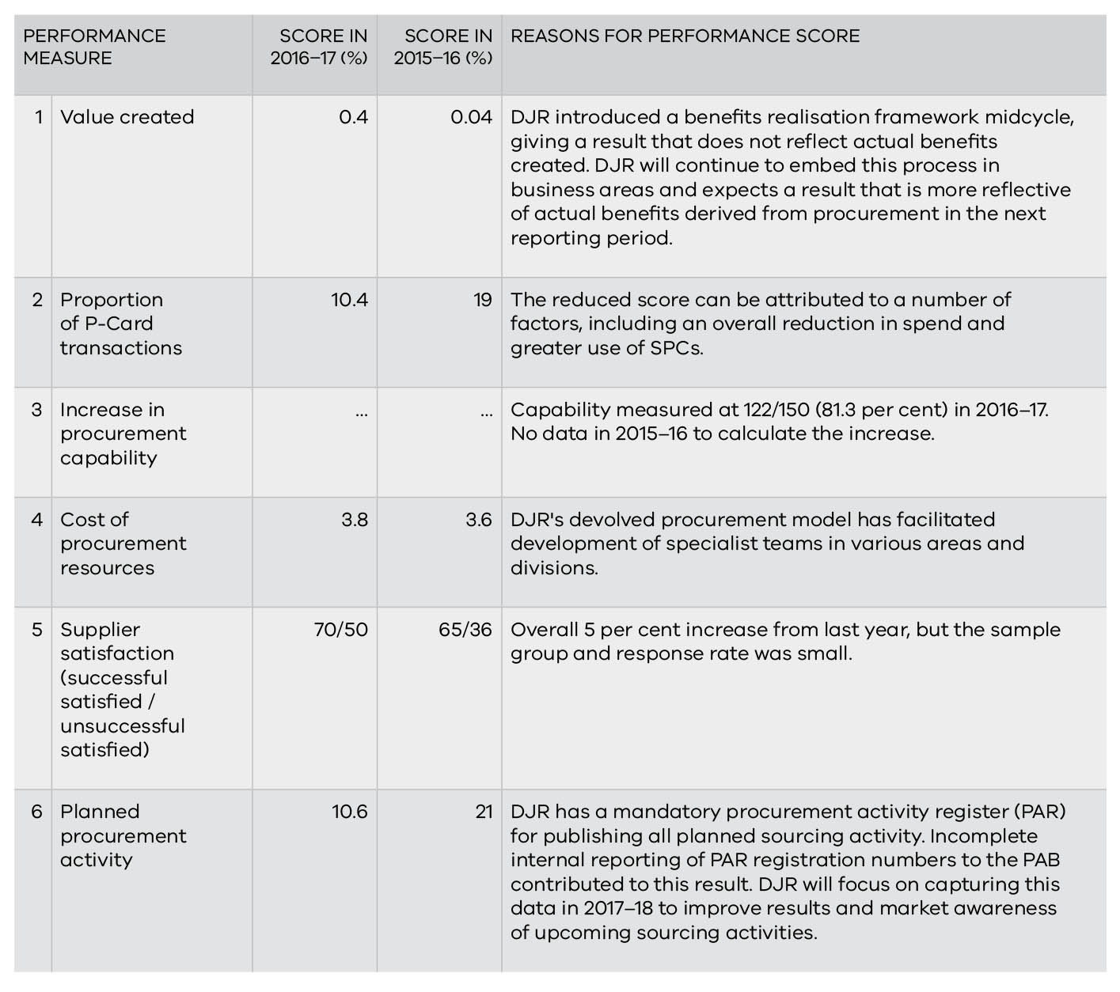

Department of Premier and Cabinet
The Department of Premier and Cabinet (DPC) leads the Victorian public service, advising government on emerging policy issues and reviewing the impact of government decisions that affect the government as a whole, in coordinating Victoria's response to major social, economic and environmental challenges, managing statewide emergencies such as terrorism, fire and flood, and ensuring the government's messages are consistent and effective.

Procurement profile
DPC is an organisationally diverse department and provides support to the Premier and eight Ministers across 16 portfolios. DPC’s procurement branch provides governance, strategic procurement and advisory services via two distinct functions.
AO: Chris Eccles, Secretary
CPO: Jag Rewal, Corporate Services & Procurement Branch
IPU Chair: Vacant

The Corporate Procurement Team (CPT) supports a centre-led system of procurement where staff (procurement and non-procurement practitioners) across DPC in various locations have the authority to tender, requisition and purchase goods and services within a set delegation.
Aside from SPCs, the procurement profile of DPC was primarily transactional for 2016–17. DPC procured mainly professional services and labour contractors. Through the WoVG Technology Procurement Team, DPC has lead agency responsibilities for the ICT SPCs.
DPC's procurement branch provides governance advice to the department for its procurement activities. For ICT SPCs, category managers provide advice to whole of government stakeholders on the use of their contracts.
DPC experienced significant changes during the year, including leading cross-agency system reform initiatives such as the National Disability Insurance Scheme and the family violence reform. The complexity and impact of these reforms required a significant transformation of DPC’s corporate services. The transformation program overseeing DPC’s primarily transactional procurements is already delivering projects across the department.
DPC’s current departmental governance structure is being reviewed under the Procurement Transformation Project with a revised governance structure to be presented to senior management in August 2017, including a new IPU Chair.

Compliance with VGPB policies and related activities
Table 34 lists activities completed by DPC to ensure and improve compliance with VGPB supply policies. Compliance activities are grouped against VGPB supply policies, though activities often overlap with multiple policies.
DPC underwent a VGPB audit in 2016–17. Five areas around governance (including reporting requirements) and market analysis were identified for improvement. Work is progressing to address the recommendations under the Procurement Transformation Project.
DPC’s IPU is called the Procurement Governance Committee (PGC).

Activities planned for 2017–18
In 2017–18, DPC will:
- review and streamline procurement processes to reduce duplication in documentation and improve process flow;
- develop a reporting calendar outlining key reporting requirements and dates to improve timeliness and quality reporting;
- continue to review and coordinate procurement/ contract management training for DPC under its continuous improvement plan; and
- plan a progressive roll-out of new procurement governance processes and training arrangements for DPC, aligned to the VGPB framework.
Table 34: DPC’s compliance activities in 2016-17
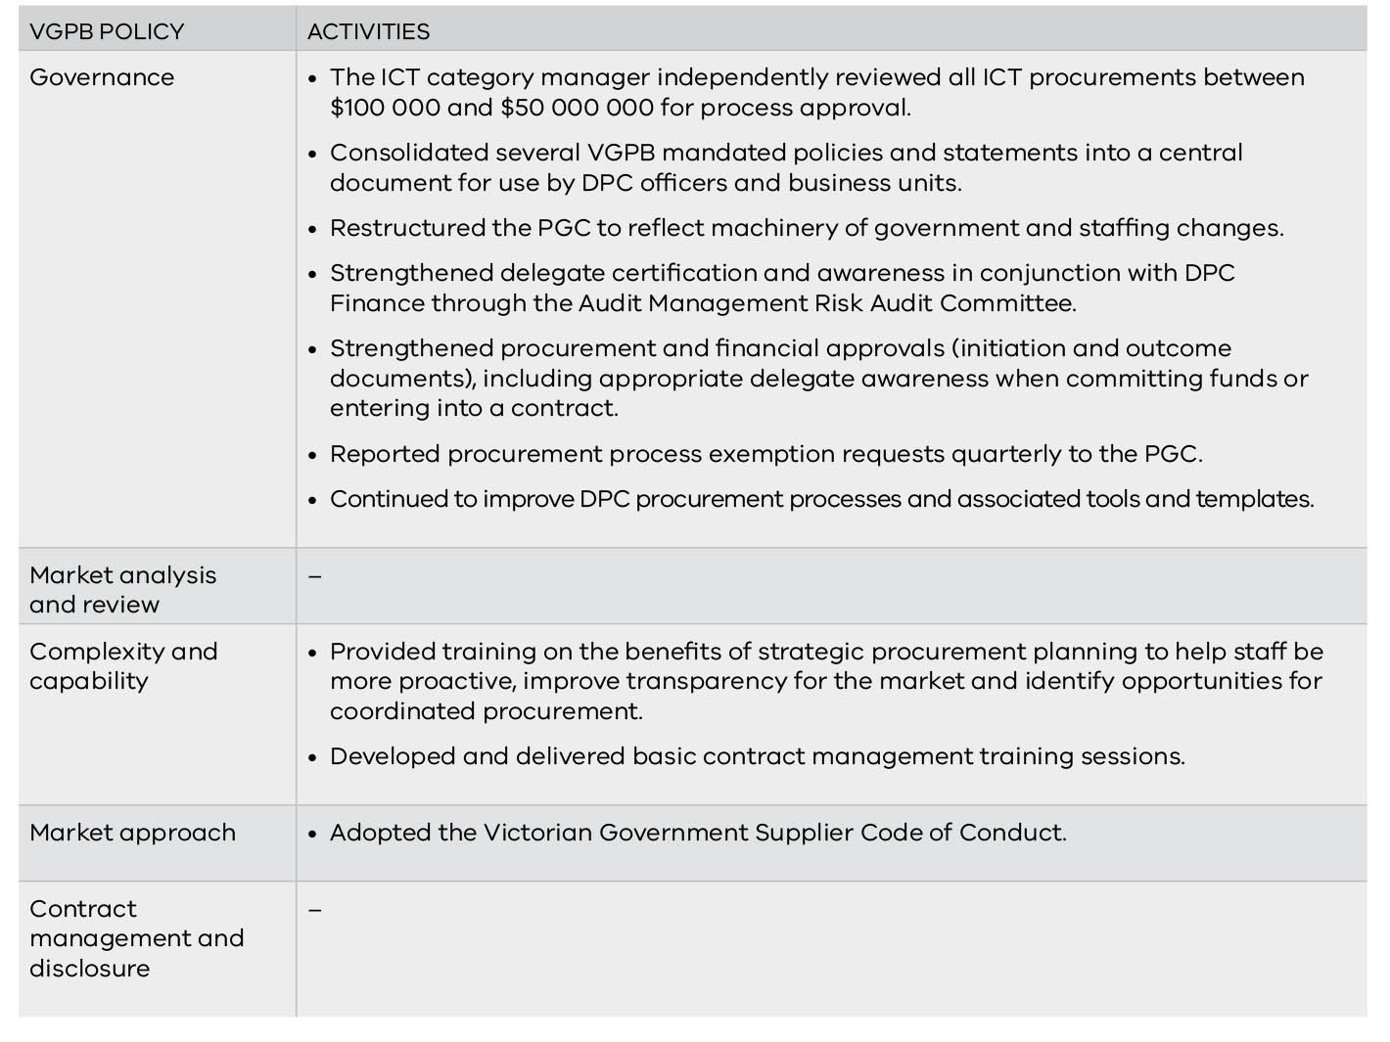

Performance in 2016–17
Table 35 sets out DPC’s performance in 2016–17, and a comparison with 2015–16.
Table 35: DPC’s performance in 2016–17
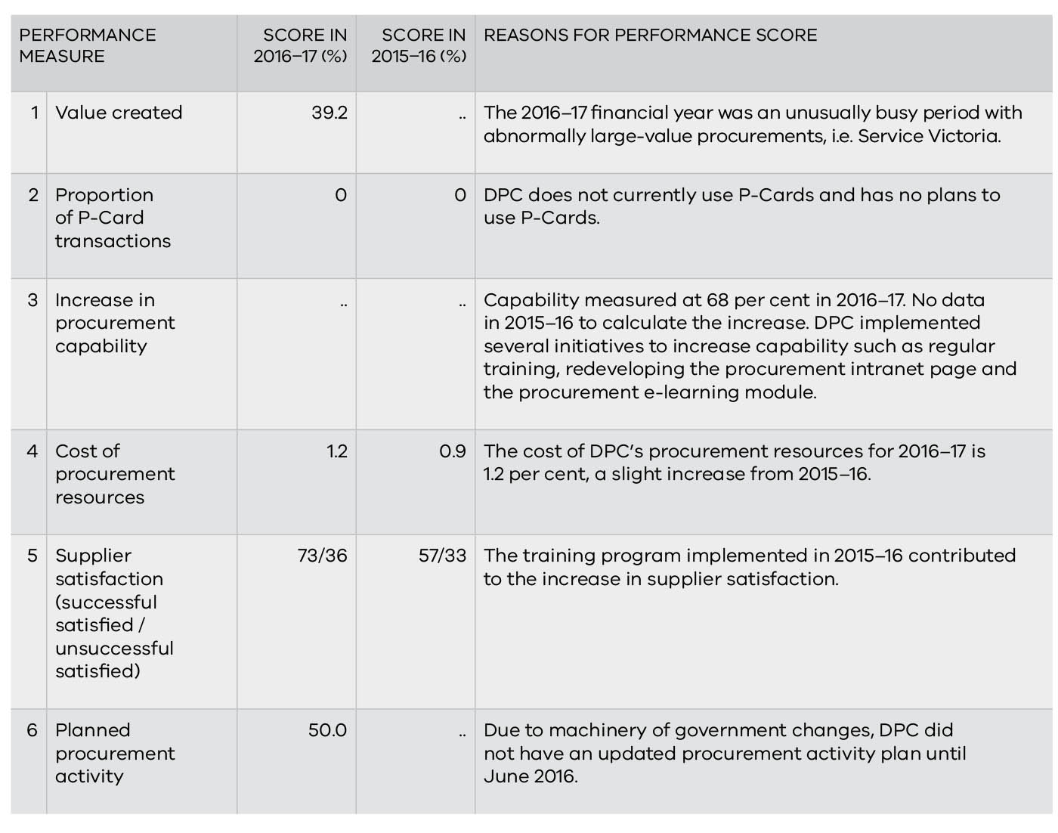

Department of Treasury and Finance
The Department of Treasury and Finance (DTF) provides economic, financial and resource management advice to support the Government to deliver its policies.

Procurement profile
DTF’s innovative, expert advice balances economic, social and environmental goals within a framework of responsible financial management.
AO: David Martine, Secretary
CPO: Steven Harris, Assistant Director, Performance and Integrity
IPU Chair: Joe Bonnici, CFO, Corporate Finance

DTF is the lead agency for most non-ICT SPCs through its Strategic Sourcing group. However, the procurement profile of DTF was primarily transactional for 2016–17.
DTF procurements are primarily professional services. DTF operates a decentralised procurement environment, supported by a centralised policy framework. The Procurement Resource Unit (PRU) assisted about 110 procurers (9 per cent of DTF staff) with more than 200 procurements during 2016–17.

Compliance with VGPB policies
Table 36 lists DTF’s activities to ensure and improve compliance with VGPB supply policies. Compliance activities are grouped against VGPB supply policies, though activities often overlap with multiple policies.
DTF’s IPU is supported by the PRU, which registers and reviews all procurement activities greater than $10 000, so it can identify areas of concern in advance and work with the procurer to mitigate risks. This ensures appropriate planning and results in effective contract management throughout the life of the engagement. The PRU provides comprehensive and transparent monthly and annual reporting including commentary and analysis at IPU meetings.
DTF’s internal auditors conduct an annual attestation audit of key procurement initiatives and programs. Audit findings are tabled at DTF’s Audit and Risk Committee.

Activities planned for 2017–18
In 2017–18, DTF will:
- explore data analytics, auditing, dashboards and automated reporting that satisfy legislative requirements and management reporting as part of the new system capability;
- develop training material (self-serve, fact sheets, classroom based) and deliver training for procure-to-pay system to improve contract management capability;
- embed and integrate procurement culture within People and Culture and integrity processes, such as in performance planning;
- implement Aboriginal procurement policy in DTF and agencies;
- implement the Supplier Code of Conduct; and
- integrate construction and legal procurement into the VGPB governance framework.

Table 36: DTF’s compliance activities in 2016–17
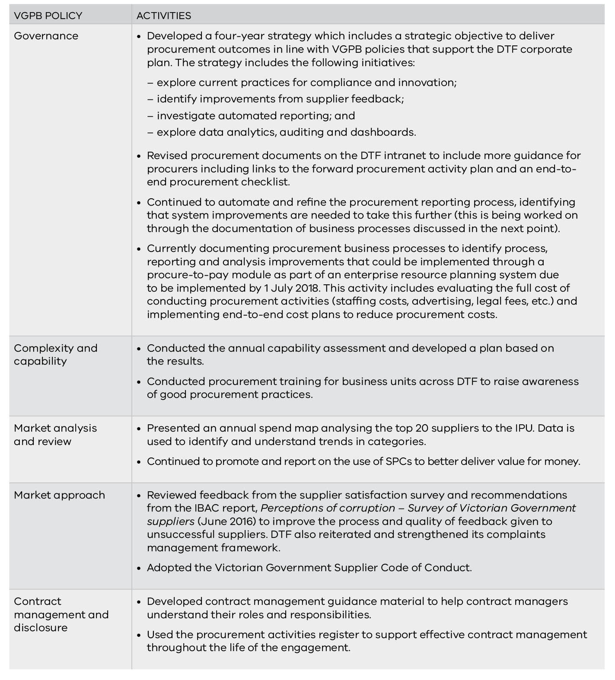

Performance
Table 37 sets out DTF’s performance in 2016–17, and a comparison with 2015–16.
Table 37: DTF’s performance in 2016–17
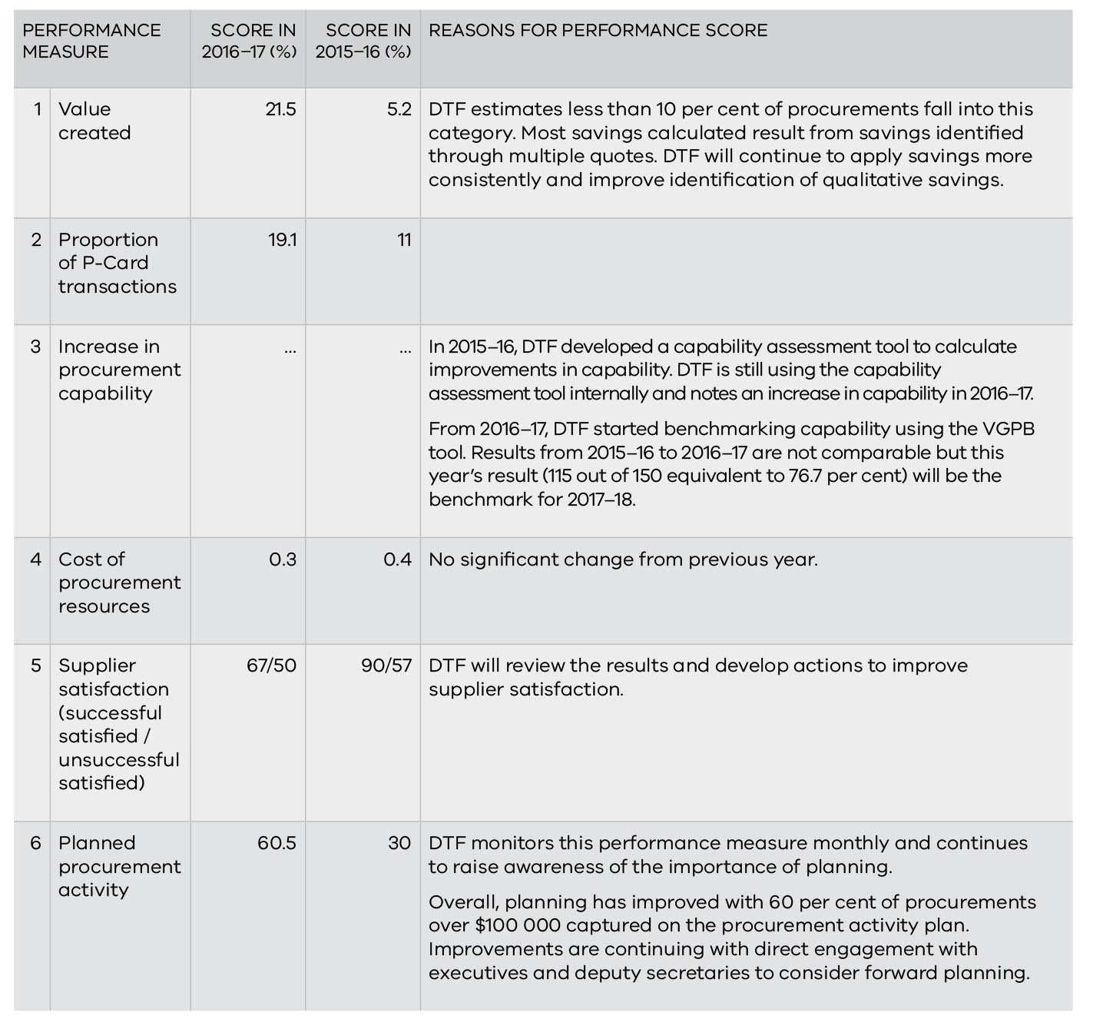

Public Transport Victoria
Public Transport Victoria (PTV) sits with VicRoads, VicTrack and V/Line under Transport for Victoria within DEDJTR. PTV works together with its partners to deliver a simpler, more coordinated transport system for Victoria. PTV’s vision is to deliver a safe and inclusive public transport network that all Victorians choose to use.

Procurement profile
PTV has influence over a range of different procurement activities including corporate, facilities, IT and professional services, franchise and construction expenditure.
AO: Jeroen Weimar, CEO
CPO: Ken Tuke, CPO, Corporate Services
IPU Chair: Dean Tillotson, Executive Director, Corporate Services

PTV procurement structure is covered by legislation, governance forums and ministerial directions as follows:
- corporate, facilities, IT and professional services expenditure including engaging professional services for construction-related activities are within scope of the FMA and fall under VGPB governance;
- franchise contracts are governed by DTF’s High Value High Risk Investment Framework process for which PTV has developed a bespoke investment management lifecycle process to ensure governance of projects delivered by franchisees; and
- construction expenditure is subject to prescribed principles and procedures under ministerial directions 1 and 2 (under Part 4 of the Project Development and Construction Management Act 1994).
PTV has introduced a new procurement framework with three stacks of expenditure to provide governance and procurement oversight for the above expenditure profiles. Three comprehensive guidelines direct PTV staff on how to appropriately manage procurement activities under each stack.

Compliance with VGPB policies
Table 38 lists PTV’s activities to ensure and improve compliance with VGPB supply policies. Compliance activities are grouped against VGPB supply policies, though activities often overlap with multiple policies.
PTV’s IPU is called the PTV Procurement Committee (PTV PC). The PTV PC will formally convene for the first time in August 2017. The Chair and Terms of Reference were agreed in 2016–17.
PTV has several mechanisms to monitor and manage performance:
- All procurement under $25 000 (GST inclusive) is subject to targeted audit checks using a range of analytical tools. Copies of all offers (e.g. quotes) and associated paperwork must be kept by the business unit responsible for the procurement.
- The Procurement Branch (PB) prepares monthly reports for PTV Directors with information on all expenditure that has exceeded approvals, upcoming contract expiry and recent contract awards. This allows PTV to specifically track instances of multiple contracts awarded under thresholds (order splitting). Additional internal reporting is conducted on use of financial delegations and compliance to policy, for example, ‘Frequency of Supplier Engagement over 12 months’.
- This reporting helps assess performance by highlighting instances to PTV Executive of upcoming contracts due to expire (for example), so they can be discussed with enough time to ensure procurement objectives can be met.
Purchases valued up to $25 000 (GST inclusive) are classed as local procurements and are managed directly by the business division at the local level. The PB has oversight of more complex, higher value procurements.

Activities planned for 2017–18
In 2017–18, PTV will:
- roll out category plans;
- roll out PEGA, a systems-based end-to-end approvals process for procurement projects; and
- establish three panels for goods and services.
Table 38: PTV’s compliance activities in 2016–17
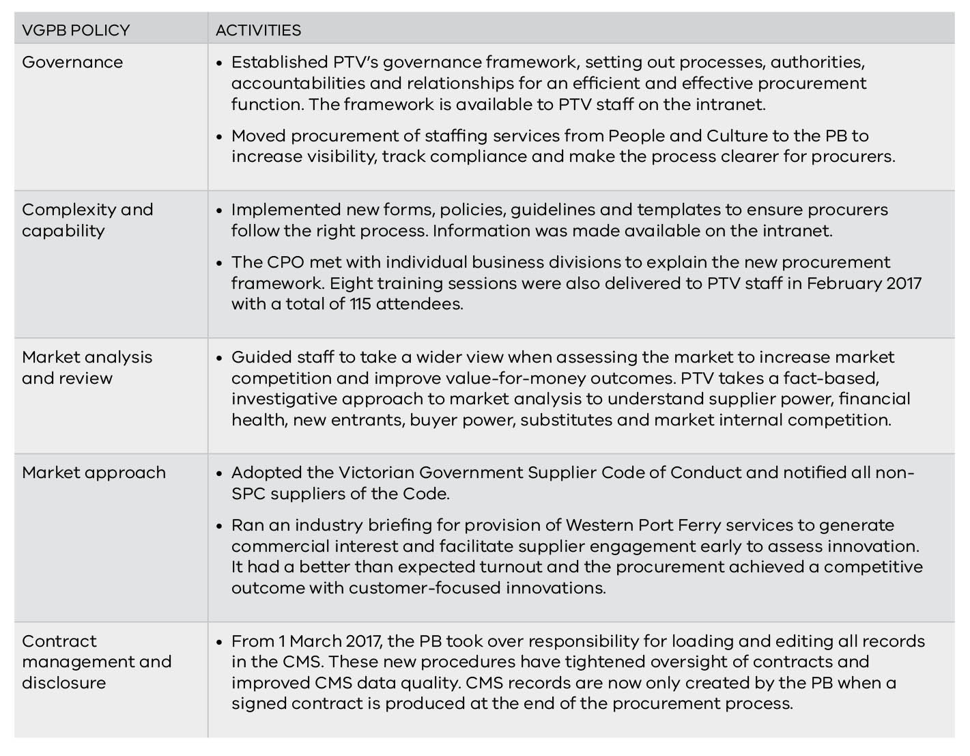

Performance
PTV gained accreditation to the VGPB supply policy framework on 1 January 2017 so will begin reporting fully on performance measures in 2017–18.
PTV published its forward procurement activity plan online and reported that 25 per cent of its procurement activity was added to this plan under performance measure 6.

VicRoads
VicRoads plans, develops and manages the arterial road network and delivers road safety initiatives and customer-focused registration and licensing services. The purpose of the organisation is to support economic prosperity and liveability by shaping the development and use of Victoria’s road system as an integral part of the overall transport system.
AO: John Merritt, Chief Executive
CPO: Chris McNally, Director Procurement Services, Finance and Risk
IPU Chair: Judith Pettitt, Executive Director Corporate Services

Procurement profile
Procurement is considered a key function of the organisation in delivering its services. Each year, VicRoads undertakes $1.8 billion of building and construction-related procurement (85 per cent) and $332 million (15 per cent) of goods and services related procurement across a broad range of categories. VicRoads has a centre-led procurement and contract management business area that provides policies, procedures, systems and advice to the broader organisation and also has some contract administration responsibilities. This decentralised process allows most procurement activities to be undertaken across the organisation by a wide range of individuals.
VicRoads has 11 category groups of goods and services spend with 55 individual categories. Most procurement spend uses SPCs. The largest areas of goods and services spend are in category groups of ICT (27 per cent), people services (27 per cent) and professional services (18 per cent).

Compliance with VGPB policies and related activities
Table 39 lists activities completed by VicRoads to ensure and improve compliance with VGPB supply policies. Compliance activities are grouped against VGPB supply policies, though activities often overlap with multiple policies.

Activities planned for 2017–18
In 2017–18, VicRoads will:
- continue to enhance and progress implementation of the Procurement Assurance Framework, reviewing IBAC reports and recommendations and working closely with other government departments to ensure it has appropriate policies, procedures and controls to manage the risk of inappropriate behaviour across the procurement process;
- continue the staged program to review and improve all procurement systems, tools, processes, policies and procedures;
- update and implement the supplier engagement plan;
- introduce an eTendering system;
- implement an updated capability development plan;
- develop and implement a social procurement framework;
- implement controls based on IBAC red flags of corruption and other IBAC information;
- review and update contract management procedures;
- continue to develop category management including developing data analytics and dashboards; and
- develop a preliminary business case to evaluate the potential adoption of a CMS and online supplier portal to be introduced in future years.
Table 39: VicRoads’ compliance activities in 2016–17
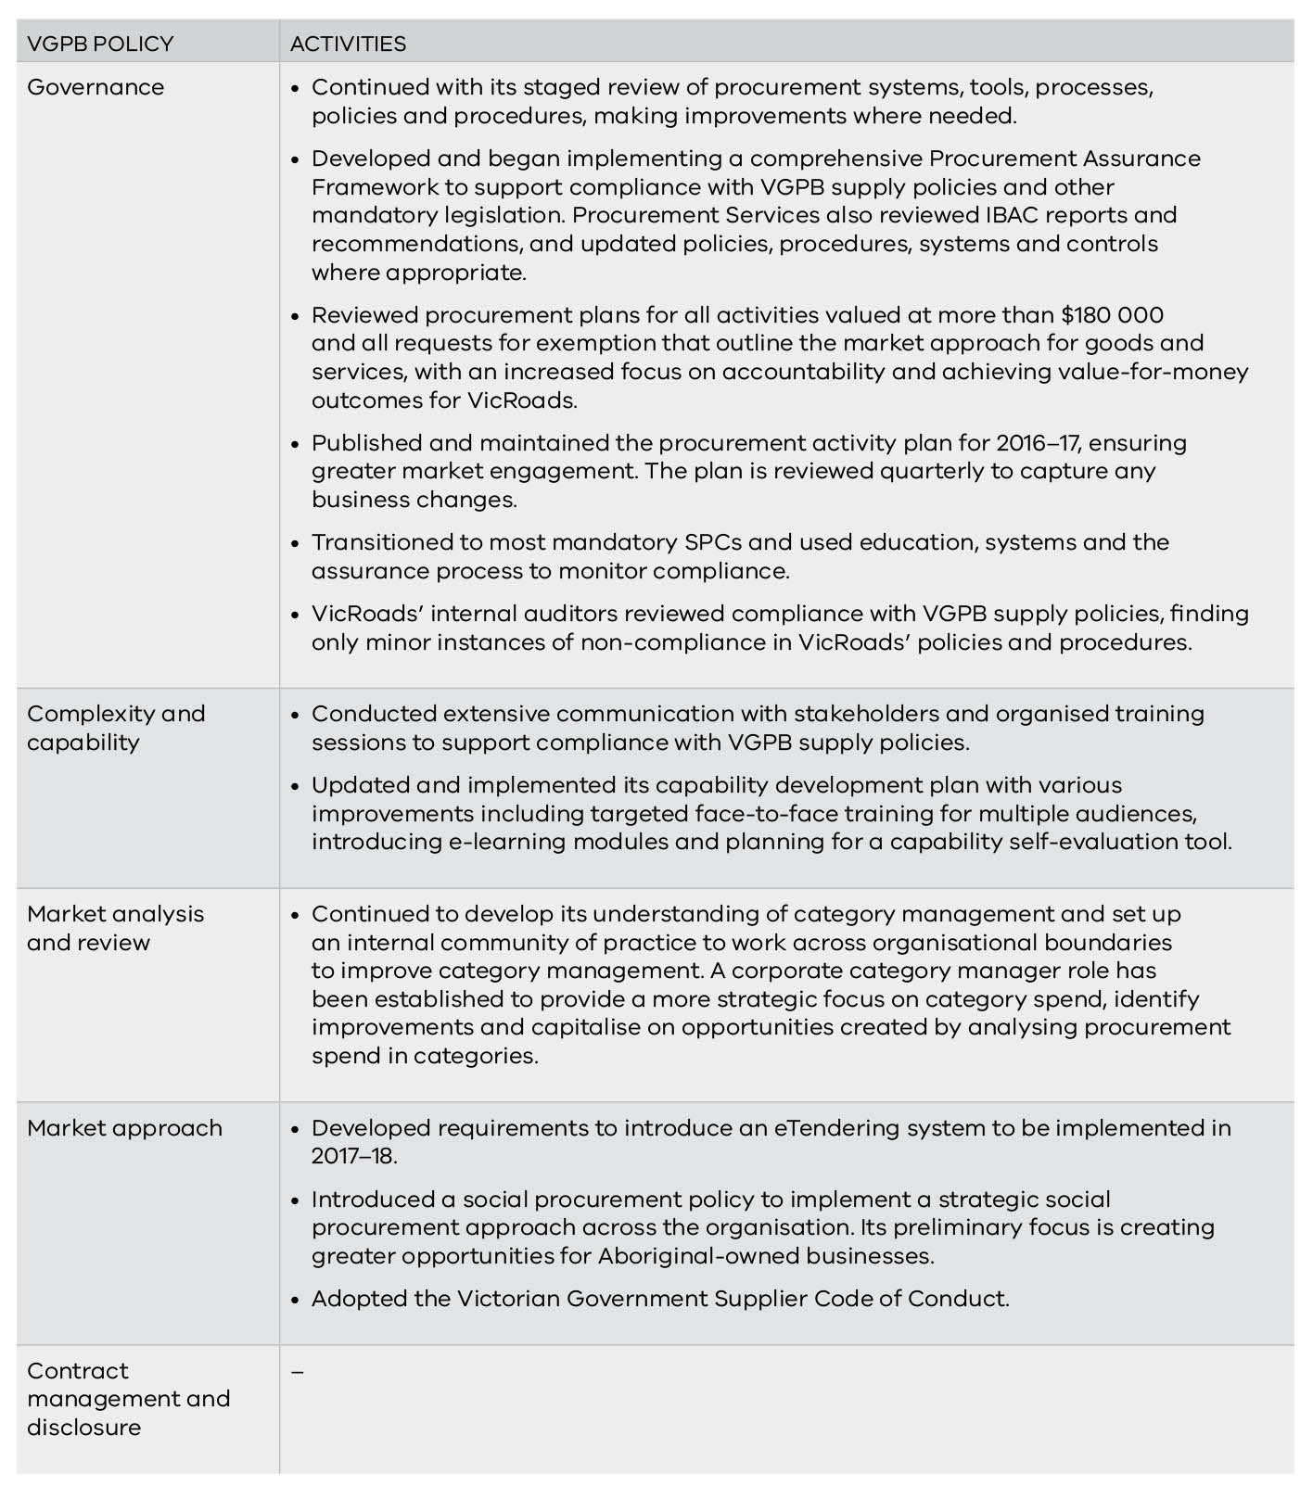

Performance
Table 40 sets out VicRoads’ performance in 2016–17 and a comparison with 2015–16.
Table 40: VicRoads’ performance in 2016–17
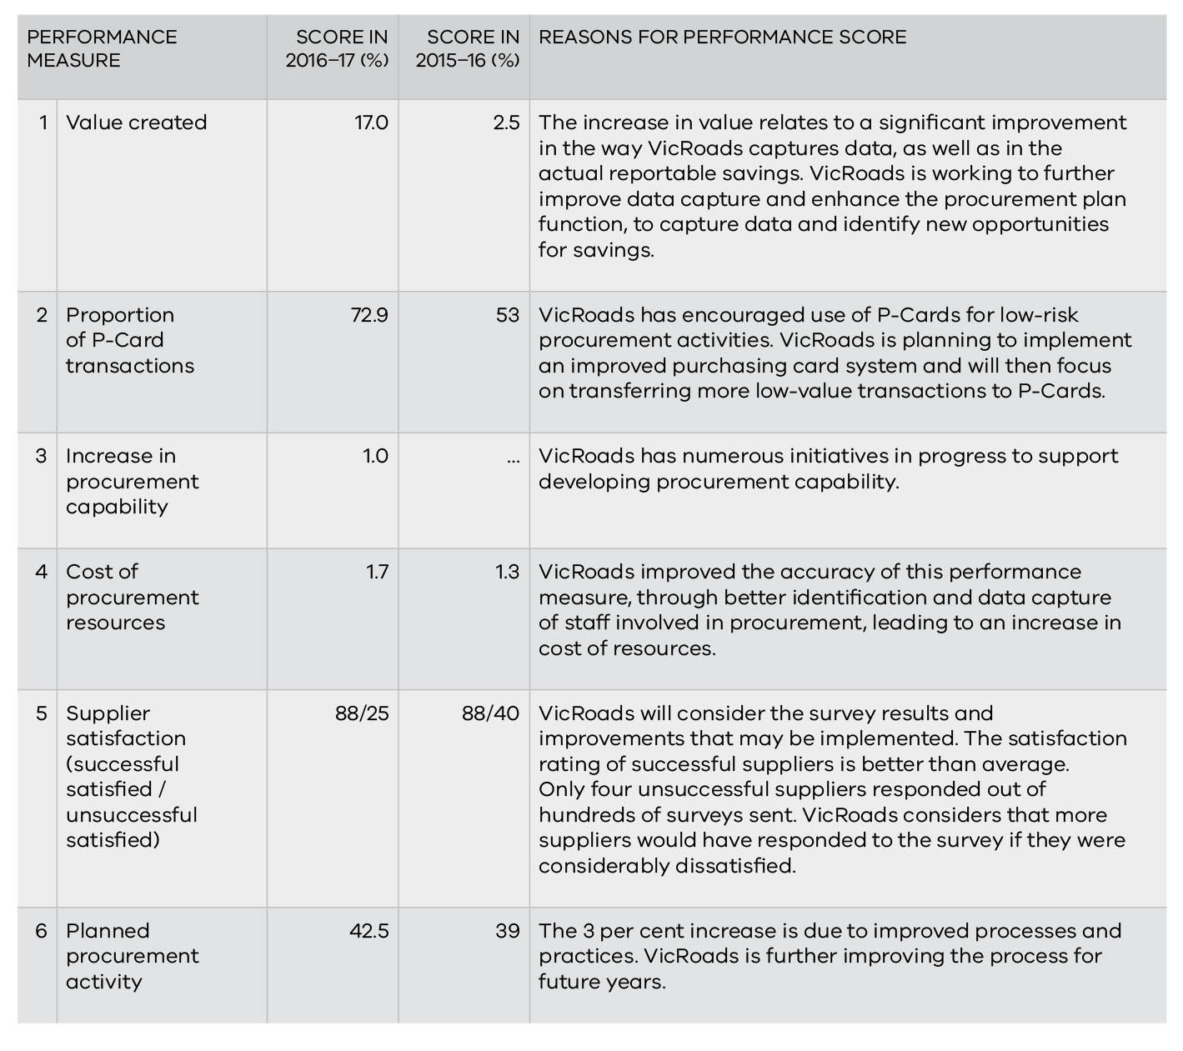

Victoria Police

Victoria Police is the primary law enforcement agency of Victoria, Australia. It was formed in 1853 and operates under the Victoria Police Act 2013. It provides policing services to the Victorian community 24 hours a day, seven days a week, working to keep over 5.9 million Victorians safe.

Procurement profile
To deliver policing services, Victoria Police buys an extensive range of goods and services. Victoria Police procures under a Category Management Framework made up of 11 categories (communications, information technology, properties, transportation, corporate support services, consultants and contractors, legal and evidentiary, uniform and equipment, office supplies, custodial and operational support).
AO: Graham Ashton, Chief Commissioner of Police
CPO: Kylie Callander, A/CPO/Director, Procurement Department
IPU Chair: Andrew Loader, Executive Director, Enterprise Project Management Office

In 2016–17, Victoria Police spent $447 million procuring goods and services. Forty-six procurements were conducted to establish new contracts with estimated values of $100 000 or higher.
Significant procurements and sourcing activities in 2016–17 included the booze bus replacement, custody and escort services and the supply of aviation fuel, the latter two resulting in significant savings. Additionally, procurements which include the API Gateway, Case Management Practice Model, Intelligence Management Application and Mobility Managed Services form part of the Blue Connect Program which focuses on transforming the way Victoria Police collect, manage and access information and connect with the community, and supporting an agile, responsive, modern police force positioned for the future.

Compliance with VGPB policies
Table 41 lists Victoria Police’s activities to ensure and improve compliance with VGPB supply policies. Compliance activities are grouped against VGPB supply policies, though activities often overlap with multiple policies.
Victoria Police submitted their audit results to the VGPB in July 2016. It had four low-rated risks for action which have all been completed.
Victoria Police’s IPU is called the Police Procurement Board (PPB). The PPB approves or notes all procurements valued at more than $100 000 to ensure compliance with VGPB supply policies. In 2016–17, the PPB was assessed by the Australian Institute of Company Directors to review capability and the membership mix, resulting in nine core PPB capability standards and recommendations.

Activities planned for 2017–18
In 2017–18, Victoria Police will:
- review procurement and contract management processes and approval matrix to streamline procurement timeframes;
- re-establish training across the organisation, especially in contract management, procurement approach, commercial uplift and governance requirements;
- develop its engagement and communication model to improve client and organisational outcomes;
- improve the PPB’s governance model by renewing the Board’s membership mix and enhancing the functions of the secretariat to improve the flow of information between the Board and the rest of the organisation; and
- improve data capture methods to increase procurement intelligence by working with key business areas to integrate databases and improve access to procurement and spend information.
Victoria Police will also undergo an interim audit to keep its CIPS (Chartered Institute of Procurement & Supply) Corporate Standard Certification successfully achieved in mid-2015 (valid for three years). CIPS certification is a globally recognised accreditation for achieving excellence in procurement and supply chain policies, strategies, procedures and processes.
Renewal of Victoria Police's Corporate Certification Standard 2018 will enable the organisation to undertake a CIPS Advanced Certification to demonstrate that the procurement function is a key influencer in corporate business strategy and change programs at executive level.
Table 41: Victoria Police’s compliance activities in 2016–17
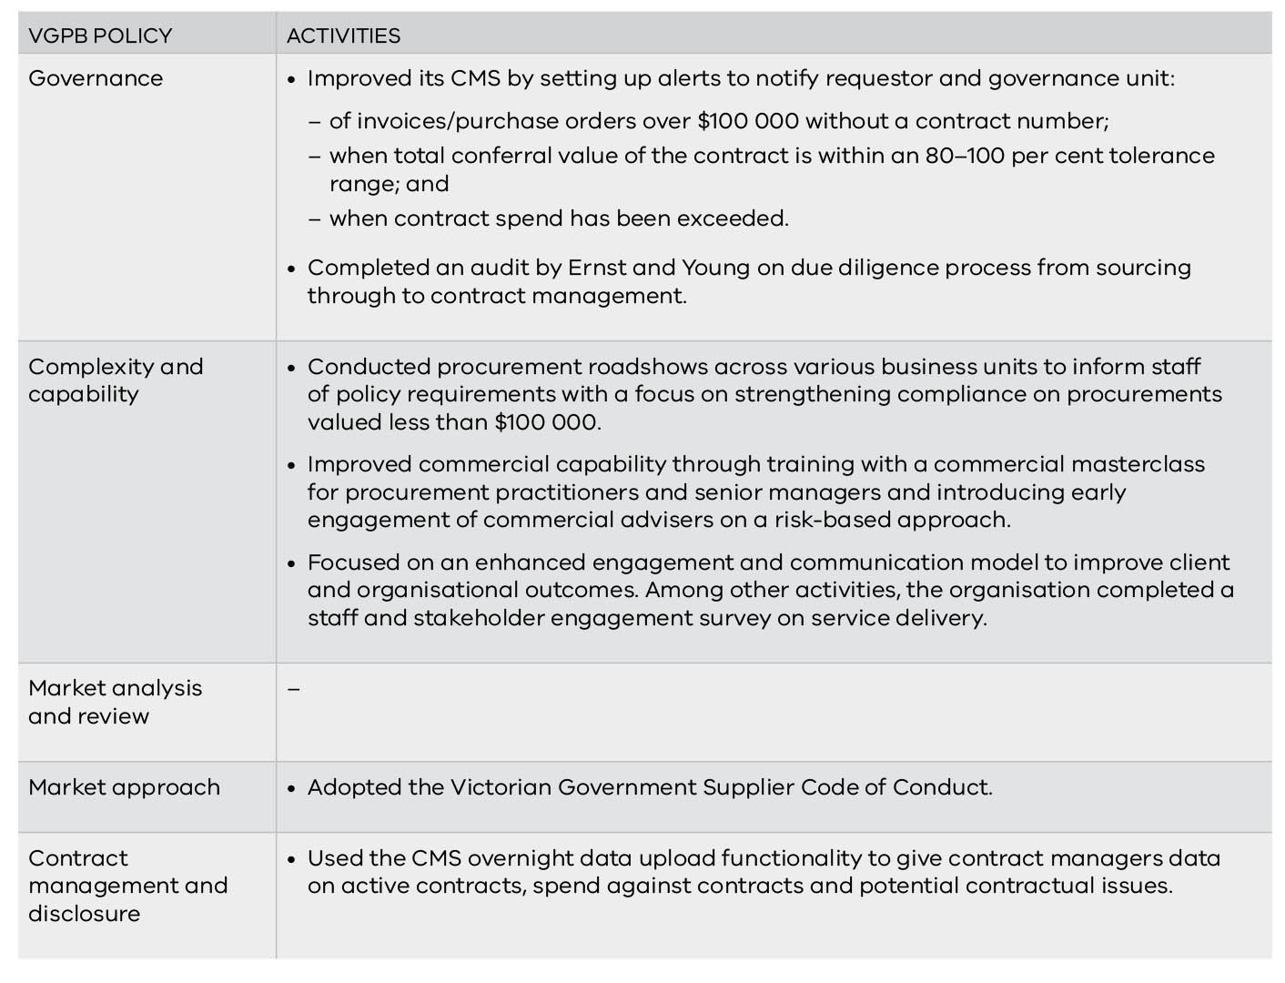

Performance in 2016–17
Table 42 sets out Victoria Police’s performance in 2016–17 and a comparison with 2015–16.
Table 42: Victoria Police’s performance in 2016–17
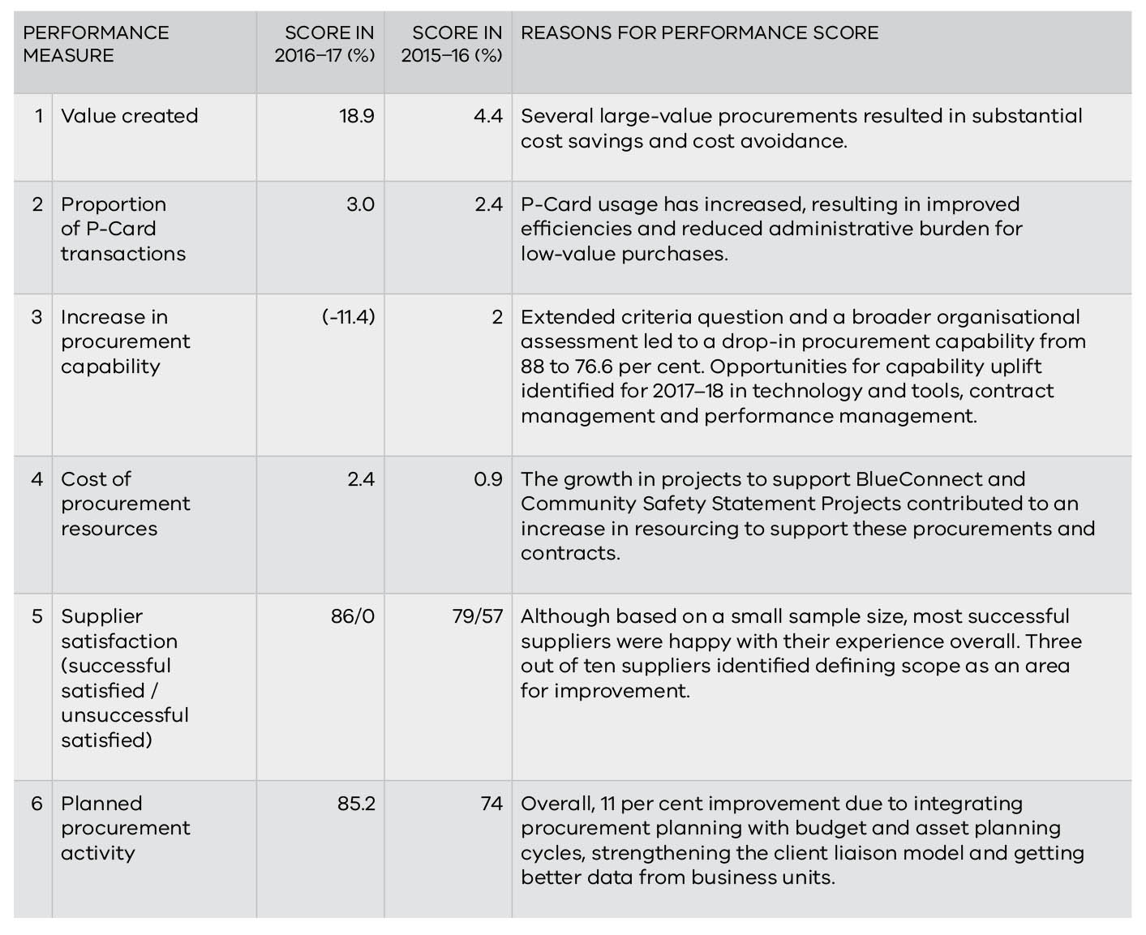

Appendix

Appendix 1: SEPC data breakdown
Table 43 details the 45 SEPC contracts approved in 2016–17.
Table 43: Breakdown of SEPCs approved in 2016–17
Organisation | Total number | Title/description | Total estimated value ($ million) | Contract term (yrs.) | Options (yrs.) | Complexity assessment outcome | Market approach method | Type of arrangement | No. of suppliers
Education and Training | 1 | Professional learning provider panel | 75.0 | 3 | 2x1 | Leveraged | RFQ | Closed | 25
Environment, Land, Water and Planning | 11 | Personnel for aerial suppressant mixing crews at Snowy District airbases | 0.1 | 1.6 |  | Focused | RFQ | Closed | 1
Environment, Land, Water and Planning | 11 | Smart Planning Program governance advisory services | 0.1 | 1.8 |  | Transactional | RFQ | Closed | 1
Environment, Land, Water and Planning | 11 | Smart Planning Program statutory drafting services | 0.1 | 0.8 |  | Transactional | RFQ | Closed | 1
Environment, Land, Water and Planning | 11 | Remotely piloted aircraft systems panel of providers | 0.5 | 1 | 1+1 | Transactional | RFT | Open | 4
Environment, Land, Water and Planning | 11 | Camping equipment for base camps | 0.5 | 4 |  | Transactional | RFT | Closed | 2
Environment, Land, Water and Planning | 11 | Hoses and hose accessories | 0.5 | 3 | 1+1 | Focused | RFT | Closed | 3
Environment, Land, Water and Planning | 11 | Planning Panels Victoria preferred supplier list | 0.8 | 2 |  | Transactional | RFQ | Closed | 10
Environment, Land, Water and Planning | 11 | First aid services at planned emergency events | 2.5 | 5 |  | Strategic | RFT | Closed | 3
Environment, Land, Water and Planning | 11 | Emergency and non-emergency transport services | 2.8 | 3 | 1+1 | Strategic | RFT | Closed | 3
Environment, Land, Water and Planning | 11 | Engineering and Professional services for asset damage assessment and preparation for insurance claims | 9.0 | 5 |  | Transactional | RFT | Closed | 2
Environment, Land, Water and Planning | 11 | Providers of organisational development services | 9.0 | 5 |  | Transactional | RFT | Open | 18
Health and Human Services | 3 | IT asset disposal | 0.3 | 3 | 2 | Strategic | RFQ | Closed | 1
Health and Human Services | 3 | Influenza vaccine for healthcare workers | 0.9 | 1 | … | Leveraged | RFQ | Closed | 2
Health and Human Services | 3 | Meningococcal vaccine for the Victorian Immunisation Program | 9.1 | 1 | … | Leveraged | RFQ | Closed | 1
Victoria Police | 30 | Youth cautioning pilot evaluation | 0.1 | 0.2 | … | Transactional | RFQ | Closed | 1
Victoria Police | 30 | Geelong Kokoda Youth Program (GYKP) Australian Kokoda Tours (AKT) | 0.2 | 1 | … | Transactional | RFQ | Closed | 2
Victoria Police | 30 | Industry consultant to booze/drug bus fleet replacement project | 0.2 | 1.5 | 0.6 | Transactional | RFQ | Closed | 1
Victoria Police | 30 | Mobile Technology Commercial Specialist Services | 0.2 | 0.5 | … | Transactional | RFQ | Closed | 1
Victoria Police | 30 | Conducted Energy Devices holsters | 0.3 | 3 | 2 | Focused | RFQ | Closed | 1
Victoria Police | 30 | Main cabin harness and headlight flasher units | 0.4 | 1 | 1 | Transactional | RFQ | Closed | 1
Victoria Police | 30 | Safety glasses | 0.4 | 3 | 2 | Transactional | RFT | Closed | 1
Victoria Police | 30 | Engage panel of external experts for the Workplace Harm Independent Advisory Board | 0.4 | 2 | 1 | Transactional | RFQ | Closed | 6
Victoria Police | 30 | Extendable batons | 0.4 | 3 | 2 | Transactional | RFT | Closed | 1
Victoria Police | 30 | Protective marking software for Outlook and Microsoft Office | 0.4 | 3 | … | Transactional | RFQ | Closed | 1
Victoria Police | 30 | Two laser 3D scanners and two desktop computers | 0.5 | 2 | 3 | Transactional | RFT | Closed | 1
Victoria Police | 30 | Handcuffs | 0.6 | 3 | 2 | Transactional | RFT | Closed | 1
Victoria Police | 30 | Helmets, respirators and filters | 0.7 | 3 | 2 | Focused | RFQ | Closed | 1
Victoria Police | 30 | Remote Positioning Vehicle (RPV) – small | 0.9 | 5 | … | Transactional | RFQ | Closed | 1
Victoria Police | 30 | Baseline ballistic testing of Integrated Operational Equipment Vests | 0.9 | 0.5 | … | Focused | RFQ | Closed | 1
Victoria Police | 30 | Digital In Car Video systems | 0.9 | 3 | 2 | Transactional | RFT | Closed | 1
Victoria Police | 30 | Armoured special purpose vehicles x 3 (and maintenance support) | 1.2 | 5 | … | Focused | RFQ | Closed | 1
Victoria Police | 30 | Disposable plastic mouthpieces to fit the Lion Alcolmeter SD- 400 touch preliminary breath test units | 1.6 | 3 | 2 | Transactional | RFQ | Closed | 1
Victoria Police | 30 | Remote Positioning Vehicle (RPV) – large and medium | 2.2 | 3 | … | Focused | RFQ | Closed | 1
Victoria Police | 30 | Panel for e-Crime digital forensic and investigation products | 2.5 | 3 | 2 | Transactional | RFQ | Closed | 6
Victoria Police | 30 | Veritas licensing, maintenance and technical support | 3.3 | 3 | … | Transactional | RFQ | Closed | 1
Victoria Police | 30 | Evidential drug testing kits | 3.3 | 3 | 2 | Transactional | RFQ | Closed | 1
Victoria Police | 30 | Aviation Fuel (BP) –Victoria Police Air Wing (VPAW) | 3.9 | 3.5 | … | Transactional | RFQ | Closed | 1
Victoria Police | 30 | Police patrol vessels | 7.2 | 2.5 | … | Focused | RFT | Closed | 4
Victoria Police | 30 | Preliminary drug testing cartridges | 8.0 | 3 | 2 | Focused | RFQ | Closed | 1
Victoria Police | 30 | Oracle database and replication licences including support maintenance | 8.7 | 5 | … | Transactional | RFQ | Closed | 1
Victoria Police | 30 | Metropolitan towing services | 9.6 | 3 | 2 | Leverage | RFT | Closed | 11
Victoria Police | 30 | Intelligence management application | 65.5 | 7 | 6 | Strategic | RFT | Closed | 1
Victoria Police | 30 | Custody and escort services | 72.9 | 3 | 4 | Strategic | RFT | Closed | 1
Victoria Police | 30 | Mobility managed service | 228.6 | 5 | 6 | Strategic | RFT | Closed | 1
Total | 45 |  | 537.2

RFQ = Request for quote, RFT = Request for tender

Acronyms
ASR Annual supply report
CIPS Chartered Institute of Procurement & Supply
CMS Contract management system
CPO Chief procurement officer
DEDJTR Department of Economic Development, Jobs, Transport and Resources
DELWP Department of Environment, Land, Water and Planning
DET Department of Education and Training
DHHS Department of Health and Human Services
DJR Department of Justice and Regulation
DPC Department of Premier and Cabinet
DTF Department of Treasury and Finance
EOI Expression of interest
FMA Financial Management Act 1994
GST Goods and services tax
IBAC Independent Broad-based Anti-corruption Commission
ICT Information and communications technology
IPU Internal procurement unit
IT Information technology
PTV Public Transport Victoria
RFQ Request for quotation
RFT Request for tender
SEPC Sole entity purchase contract
SPC State purchase contract
VGPB Victorian Government Purchasing Board
VPS Victorian public sector
WoVG Whole of Victorian Government

For a full glossary of terms, refer to procurement.vic.gov.au/About-the-VGPB/Glossary.

This annual report is printed on ecoStar. ecoStar is an environmentally responsible paper made Carbon Neutral. The greenhouse gas emissions of the manufacturing process including transportation of the finished product to BJ Bakk Papers Warehouse has been measured by the Edinburgh Centre for Carbon Neutral Company and the fibre source has been independently certified by the Forest Stewardship Council® (FSC®). ecoStar is manufactured from 100 per cent Post Consumer Recycled paper in a Process Chlorine Free environment under the ISO 14001 environmental management system.

