Medium Works Contract
End User Guidance

The Secretary
Department of Treasury and Finance
1 Treasury Place
Melbourne Victoria 3002
Australia
Telephone: +61 3 9651 5111
dtf.vic.gov.au

Authorised by the Victorian Government
1 Treasury Place, Melbourne, Victoria, 3002

© State of Victoria 2026

You are free to re-use this work under a Creative Commons Attribution 4.0 licence, provided you credit the State of Victoria (Department of Treasury and Finance) as author, indicate if changes were made and comply with the other licence terms. The licence does not apply to any branding, including Government logos.

Copyright queries may be directed to IPpolicy@dtf.vic.gov.au

ISBN 978-1-925551-91-4
Published September 2023

If you would like to receive this publication in an accessible format please email information@dtf.vic.gov.au

This document is also available in Word and PDF format at dtf.vic.gov.au

Disclaimer
The material contained in this End User Guidance is made available on the understanding that the State is not providing professional advice. Users must exercise their own skill and care with respect to this material and seek independent advice as necessary. The State gives no warranty and does not make any representation, express or implied, as to the contents or accuracy of the information contained in this publication. The State expressly disclaims any and all liability relating to or resulting from:
- the use of this End User Guidance by any person; or
- anything done, or omitted to be done, in reliance upon information contained in this End User Guidance.
This End User Guidance must not be used for the legal interpretation of the Department of Treasury and Finance Medium Works Contract. Nothing in this End User Guidance limits or affects the application, interpretation or enforcement of the terms and conditions of:
- any Expression of Interest or Request for Tender; or
- the Medium Works Contract or any Medium Works Contract entered into by the State.

Contents
1. Introduction 1
1.1 Context 1
1.1.1 Introduction to the Medium Works Contract 2
1.1.2 Compliance with Ministerial Directions and instructions 3
1.1.3 Key features 3
1.2 End User Guidance overview 4
1.2.1 When does this End User Guidance apply? 4
1.2.2 How to use this End User Guidance 4
1.3 Form and structure of the Medium Works Contract 5
1.3.1 Structure of the Medium Works Contract 5
1.3.2 How to complete the Medium Works Contract 7
1.4 Terminology 9
2. Medium Works Contract – General Conditions guidance 9
2.1 Definitions – clause 1.1 9
2.1.1 Adjustment Entitlement 9
2.1.2 Adjustment Event 10
2.1.3 Adjustment Event Table 10
2.1.4 Contract Documents 10
2.1.5 Contract Sum 11
2.1.6 Contractor 11
2.1.7 Contractor’s Activities 11
2.1.8 Contractor’s Representative 12
2.1.9 Contractor’s Margin 12
2.1.10 Delay Costs Cap 12
2.1.11 Delay Events 12
2.1.12 Design Schedule 12
2.1.13 Force Majeure Event 13
2.1.14 Key Personnel 13
2.1.15 Pricing Schedule 13
2.1.16 Principal Associate 14
2.1.17 Principal’s Representative 14
2.1.18 Schedule of Collateral Documents 14
2.2 Participants and roles – clause 3 14
2.2.1 Approval to Subcontract 14
2.2.2 Approved Subcontractors 15
2.2.3 Meetings 15
2.2.4 Reporting 15
2.3 Performance Security – clause 4 16
2.3.1 Form of security 16
2.3.2 Amount of security to be provided 16
2.3.3 Amount of Approved Security to be released after Notice of Practical Completion 16
2.4 Site access, management and conditions – clause 5 17
2.4.1 Dates by which the Principal must give the Contractor sufficient access to the Site 17
2.4.2 Responsibility for Site (Environment Protection Act 2017 (Vic)) 17
2.5 Works – clause 6 17
2.5.1 Approvals 17
2.6 Progress and Practical Completion – clause 7 18
2.6.1 Date for Practical Completion 18
2.6.2 Conditions precedent to Practical Completion 18
2.6.3 Directions to accelerate 18
2.6.4 Liquidated damages 19
2.7 Payment – clause 8 19
2.7.1 In general 19
2.7.2 Form of payment claims 20
2.7.3 Payment statements 21
2.7.4 Tax Invoice and payment 21
2.7.5 Set off 22
2.8 Adjustment Events – clause 9 22
2.8.1 In general 22
2.8.2 Variations 22
2.8.3 Latent Conditions and Excluded Site Conditions 25
2.8.4 Suspension 26
2.8.5 Force Majeure Events 27
2.8.6 Industrial Condition 27
2.8.7 Acts of Prevention 27
2.8.8 Delay Events 28
2.9 Adjustment Entitlements – clause 10 28
2.9.1 Adjustment Event Table 28
2.9.2 Adjustment principles 33
2.9.3 Adjustments to Contract Sum for direct costs 35
2.9.4 Adjustments to the Date for Practical Completion 36
2.9.5 Adjustments to the Contract Sum for Delay Costs 36
2.10 Dispute Resolution – clause 13 37
2.10.1 In general 37
2.10.2 Dispute Notice and negotiation 39
2.10.3 Mediation 39
2.10.4 Arbitration 39
2.11 Government requirements and collateral documents – clause 16 39
2.11.1 Mandatory Government Policy Requirements 39
2.11.2 Project Specific Government Policy Requirements 39
2.11.3 Schedule of Collateral Documents 40
3. Medium Works Contract – Government Policy Requirements guidance 40
3.1 In general 40
3.2 Government Policy Requirements 41
4. Medium Works Contract – Schedules guidance 41
4.1 In general 41
4.2 Schedule 1 – Contract Particulars 42
4.2.1 Attachment 1 to Schedule 1 – Separable Portion Particulars 42
4.3 Schedule 2 – Pricing Schedule 42
4.3.1 In general 42
4.3.2 Unit rates 43
4.3.3 Labour rates 43
4.3.4 Plant and Equipment rates 43
4.4 Schedule 3 – Provisional Sums 43
4.5 Schedule 4 – Insurance Schedule 44
4.5.1 In general 44
4.5.2 Public liability insurance 44
4.5.3 Works insurance 44
4.5.4 Professional indemnity insurance 44
4.5.5 Workers’ compensation insurance 45
4.6 Schedule 5 – Design Schedule 45
4.7 Schedule 6 – Project Specific Additional Conditions 45
4.8 Schedule 7 – Delivery Requirements 45
4.9 Schedule 8 – Adjustment Notice 46
4.10 Schedule 9 – Local Industry Development Plan 46
4.11 Schedule 10 – Social Procurement Commitment Schedule 46
4.12 Schedule 11 – Fair Jobs Code Plan Addendum 46
5. Collateral Documents guidance 46
5.1 Form of Statutory Declaration 47
5.1.1 Deed of Novation 47
5.1.2 Subcontract Deed of Novation 47
5.1.3 Consultant Deed of Novation 48
5.1.4 Unconditional Undertaking 48
5.1.5 Deed of Guarantee and Indemnity 48
5.1.6 Collateral Warranty 48
6. Execution 49
7. Template notices 49

    - Introduction
      - Context
The Department of Treasury and Finance (DTF) has prepared a whole-of-government infrastructure procurement framework (Framework). The Framework provides a consistent and transparent approach to infrastructure procurement across Victorian Government departments and delivery agencies (each an Agency).
The Framework covers three categories of procurement, including whole of life, lump sum and cost reimbursable. Each category contains a set of approved procurement models for use on Victorian Government infrastructure projects.
It consists of the following policy, guidance and standard form contacts:
- the Ministerial Directions and Instructions for Public Construction Procurement (Ministerial Directions), established under Part 4 of the Project Development and Construction Management Act 1994 (Vic)
- the Procurement - Investment Lifecycle Guideline, which outlines the three procurement categories and a set of approved procurement models
- a procurement requirements document for each of the three procurement categories
- standard form contracts and guidance for a subset of the approved procurement models.
Figure 1 provides an overview of the Framework and indicates where the Medium Works Contract – End User Guidance sits within it.
Figure 1 – DTF Infrastructure Procurement Framework
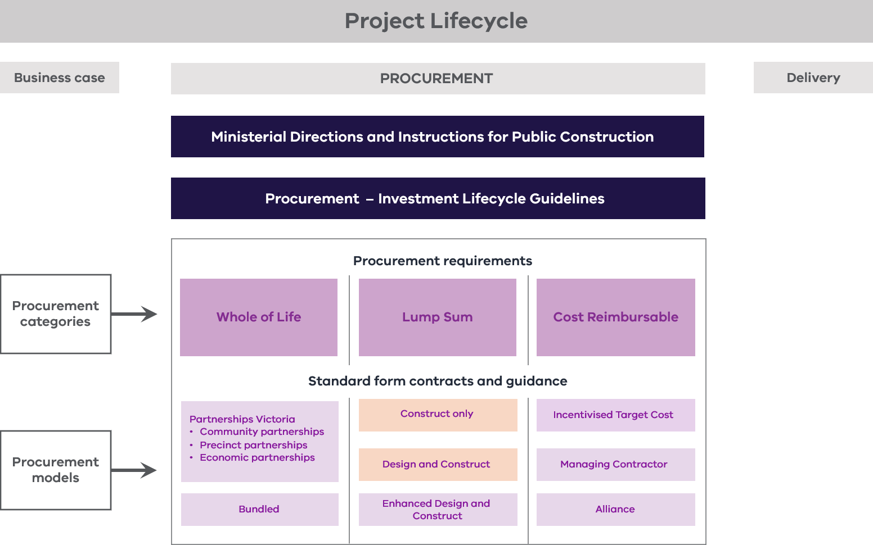
The Medium Works Contract is a new DTF owned and managed standard form contract developed as part of the Framework.
The Medium Works Contract is a fixed time, lump sum construction contract for use in the delivery of medium works projects involving construct only or design and construct delivery. As a basic works contract, it is aimed at projects between $1 million and $20 million (excl. GST) of low to moderate risk and complexity, on a single Site with the option of separable portions. It is not appropriate for the procurement of domestic building work (as defined in the Domestic Building Contracts Act 1995 (Vic)) without further amendment to comply with the requirements of that Act.
The Medium Works Contract is not intended for large or more complex procurements. For this reason, it does not include provisions addressing, for example, Change in Control, entitlements in respect of Changes in Legislative Requirements and Policy , artefacts or native title.
The Medium Works Contract is one of three contracts in a scalable family. These are listed below with the contract value ranges shown for their intended use:
    - Medium Works Contract: $1 million to $20 million (excl. GST)
    - Medium Works Contract – Short Form: $200,000 to $5,000,000 (excl. GST)
    - Minor Works Contract – Short Form: up to $200,000 (excl. GST).
        - Introduction to the Medium Works Contract
As part of the Victorian Government’s significant infrastructure reform program, DTF has refreshed and expanded the range and function of standard form contracts to generate time and cost savings during procurement and improve project outcomes.
These standard form contracts respond to industry and Agency feedback and reduce the variability across approved forms of contract. They are a focused range of contracts that are fit-for-purpose and responsive to the range of government project types and current procurement methodologies. They are adaptable and can be tailored to match project complexity.
These standard form contracts also provide a consistent contractual baseline for projects to minimise the need for bespoke legal and commercial drafting. Further drafting should only be required where necessary to address unique project risks and characteristics.
DTF has developed the Medium Works Contract with the aims of simplifying preparation of the contract for tender and execution, minimising the cost and time of legal review and fostering improved contract administration. The Medium Works Contract is user-friendly and uses terminology that is familiar to the market. It adopts concise clauses that are tailored to the size, complexity and nature of the Works, the contractor market and the range of procurements undertaken by delivery agencies. A key focus has been reducing the burden to industry when tendering.
The Medium Works Contract draws upon modern and widely accepted precedent contracts to create a template that is scalable for various forms of procurement.
        - Compliance with Ministerial Directions and instructions
The Medium Works Contract has been approved in accordance with Ministerial Directions for Public Construction Procurement, direction 7.1, as a Victorian Public Construction Contract (VPCC) for use in public construction.
Under direction 7, all public construction is required to be procured pursuant to an approved VPCC, except where other forms of contract are permitted under directions 7.1.2 or 7.1.6 (High Value High Risk Framework) or 7.1.7 (Partnerships and alliancing).
        - Key features
These are some of the key features of the Medium Works Contract.
    - It is a clear and concise contract with an easy-to-use Adjustment Events Table that provides an overview of all Contractor entitlements in one place.
    - It interfaces with a separate, consolidated document that addresses each of the relevant State procurement policies. Certain policies in the Schedule of Government Policy Requirements are always incorporated in the Medium Works Contract. Others are optional and can be incorporated if required. If an existing policy changes or a new policy is introduced, this schedule will be updated. This removes the need to update individual contracts within the new family of contracts.
    - It interfaces with a separate Schedule of Collateral Documents containing documents that are incorporated in the Medium Works Contract. These include approved forms of novation deed, a Deed of Guarantee and Indemnity and a statutory declaration to accompany payment claims.
    - It includes a standard form Request for Tender for use with the Medium Works Contract.
    - It provides assistance to Victorian Government agencies in the administration of the Medium Works Contract, including proforma notices. These can be found in sections 1.2 and 9.
      - End User Guidance overview
This End User Guidance contains key pieces of information, as set out below.
Relevant section(s) | Key information
Section 2 | An overview of, and practical guidance regarding, the structure and key principles of the Medium Works Contract
Section 3 | A summary of the policies included in the Schedule of Government Policy Requirements
Section 4 | A summary of the various Schedules incorporated in the Medium Works Contract
Section 5 | A summary of the documents included in the Schedule of Collateral Documents
Section 6 | An explanation as to the form of execution of the Medium Works Contract (by way of an agreement, not a deed)
Section 7 | Proforma notices
        - When does this End User Guidance apply?
This End User Guidance applies to all Victorian Government agencies that use the Medium Works Contract for public construction procurement.
        - How to use this End User Guidance
This End User Guidance should be read in conjunction with the Medium Works Contract.
Users should also consult the DTF Contracting Practice Notes for Public Construction Procurement. While that document provides guidance on the use of AS2124-1992 (with Victorian Public Sector Annexure Part B Special Conditions) and AS4300-1995 (with Victorian Public Sector Annexure Part B Special Conditions), it also provides a general overview of the key contracting principles that inform, and that should be considered when using, the Medium Works Contract.
      - Form and structure of the Medium Works Contract
        - Structure of the Medium Works Contract
The Medium Works Contract is made up of four sections.
Section | Contents
General Conditions | - Clauses 1 to 18.  - Mandatory Government Policy Requirements – these are set out in Part A of the Schedule of Government Policy Requirements, available at https://www.dtf.vic.gov.au/practitioners-toolkit/practitioners-toolkit-standard-form-contracts, and apply to all projects).  - Project Specific Government Policy Requirements – this refers to any Project Specific Government Policy Requirements that are incorporated in the Medium Works Contract (see clause 16.2 and Item 42 of the Contract Particulars (Schedule 1)). The Project Specific Government Policy Requirements are set out in Part B of the Schedule of Government Policy Requirements (available at https://www.dtf.vic.gov.au/practitioners-toolkit/practitioners-toolkit-standard-form-contracts). Guidance on when to incorporate Project Specific Government Policy Requirements is available at the Buying for Victoria website or the applicable policy websites (please refer to section 3).
Schedules | - Contract Particulars (Schedule 1) – the Contract Particulars set out the key project variables to be completed for a particular project. How this Schedule is completed depends on the particular project. Certain items must be completed by the relevant Agency prior to issue with a Request for Tender (RFT). Others need to be populated based on the successful bidder’s tender or tender negotiations.  - Separable Portion Particulars (Attachment 1 to Schedule 1) – Attachment 1 to Schedule 1 sets out the particulars for each Separable Portion (but are only used where the Works are divided into Separable Portions). The table in Attachment 1 should be replicated and completed for each Separable Portion.  - Pricing Schedule (Schedule 2) – Schedule 2 applies to all contracts as it sets outs rates and prices to be used for valuing Variations. Schedule 2 also acts as the basis for calculating the Contract Sum when it is not a fixed lump sum amount.  - Provisional Sums (Schedule 3) – Item 32 in the Contract Particulars (Schedule 1) provides for the (optional) inclusion of Provisional Sum Items in the Contract. If Provisional Sum Items are included in the Contractor’s Activities, clause 9.2 applies and Schedule 3 needs to be populated.  - Insurance Schedule (Schedule 4) – Schedule 4 applies to all contracts. Details of the Contractor’s insurance obligations are to be included here, as well as details of the Principal’s applicable insurance obligations.  - Design Schedule (Schedule 5) – Schedule 5 applies if it is so stated in Item 9 of the Contract Particulars (Schedule 1). It sets out additional terms and conditions applicable to the performance of any design work undertaken by the Contractor. It also provides for Design Consultants of the Principal (if any) to be novated to the Contractor.  - Project Specific Additional Conditions (Schedule 6) – Agency or project-specific requirements that are not otherwise addressed in the Contract can be included here (not including specifications, drawings and other technical documents that are to be included as Delivery Requirements in Schedule 7). Schedule 6 is not to be used to amend the General Conditions.  - Delivery Requirements (Schedule 7) – scoping and technical documents intended to be incorporated in the Contract are to be set out or identified here. If the Contractor is not responsible for the design of the Works, this Schedule should set out timing and cost objectives and attach or identify all the drawings and specifications for the Works (including revisions and dates). If the Contractor is required to perform design work, Schedule 7 should attach or identify documents that describe the Principal’s requirements for the Works, including its design, timing and cost objectives and the purposes for which the Works are required. These documents may comprise, for example, a project brief describing the Principal’s requirements for the project, drawings, specifications and a preliminary design (if any).  - Adjustment Notice (Schedule 8) – this is the form of Adjustment Notice required to be completed by the Contractor should it wish to make a Claim in respect of an Adjustment Event.  - Local Industry Development Plan (Schedule 9) – if Item 42 of the Contract Particulars (Schedule 1) specifies that the Local Jobs First Policy provisions apply, then the Contractor’s Local Industry Development Plan must be included in this Schedule.  - Social Procurement Commitment Schedule (Schedule 10) – if Item 42 of the Contract Particulars (Schedule 1) states that the Social Procurement Framework applies and either Alternative 1 (Social Procurement Framework without the Building Equality Policy) or Alternative 2 (Social Procurement Framework plus the Building Equality Policy) applies, then the Contractor’s Social Procurement Commitment Schedule must be included in this Schedule.  - Fair Jobs Code (FJC) Plan Addendum (Schedule 11) – if Item 42 of the Contract Particulars (Schedule 1) states that the FJC applies, then the Contractor’s FJC Plan Addendum must be included here.
Collateral Documents | - Those documents set out in the Schedule of Collateral Documents (which is available at https://www.dtf.vic.gov.au/practitioners-toolkit/practitioners-toolkit-standard-form-contracts) that are referred to in the Medium Works Contract are incorporated in the Medium Works Contract (see clause 16.3).
        - How to complete the Medium Works Contract
          - Step one: choose the appropriate procurement model
To prepare a Medium Works Contract, first determine which procurement model applies to the Works and select the appropriate model in Item 9 of the Contract Particulars (Schedule 1). This may be either:
    - construct only – if the Contractor will not be required to design any part of the Works, select ‘No’; or
    - Design and Construct (D&C) – if the Contractor will be required to design the Works or any part of the Works (in addition to constructing the Works), select ‘Yes’.
          - Step two: complete the Contract Particulars (Schedule 1)
The second step is to complete the Contract Particulars following the highlighting colour code in the template, as set out in the table below.
Colour | Instruction
Green | These items are to be completed by the Agency before going to tender and the highlighted text removed. Accompanying Guidance Notes may also be highlighted green.
Yellow | These items are to be completed by the Agency using information provided by the tenderer in response to the RFT. Accompanying Guidance Notes may also be highlighted yellow.

The Agency is not required (or able) to populate all of Schedule 1 (Contract Particulars). Some items in the Contract Particulars must be completed by the Agency on the basis of the successful tenderer's tender (or the position negotiated with the successful tenderer). Ensure it is indicated in the RFT what information tenderers are to bid back for this purpose.
          - Step three: complete the other Schedules
The Agency should complete the other Schedules according to the highlighting colour code described above as follows:
Schedule | How to complete
Pricing Schedule (Schedule 2) | The columns marked ‘Description’ and ‘Unit’ in the tables in the Pricing Schedule should be populated by the Agency prior to issuing the Contract as part of the RFT. The rates for the items specified by the Agency in the tables in Schedule 2 should be bid back by tenderers. Where the Contract Sum is not a fixed lump sum, tenderers should also bid back the quantity of those items.
Provisional Sums (Schedule 3) | Item 32 in the Contract Particulars (Schedule 1) provides for the inclusion of Provisional Sum Items in the Contract. If Provisional Sum Items are included in the Contractor’s Activities, Schedule 3 needs to be populated. Prior to issuing the RFT, agencies should typically populate the columns in Schedule 3 marked ‘Provisional Sum Item’ and ‘Description of Provisional Sum Item’. Tenderers will typically bid back the amounts for the columns marked ‘Direct Cost’, ‘Contractor’s Margin’ and ‘Provisional Sum (excl. GST)’. If there are no Provisional Sum Items, the Agency should insert the words ‘none stated’ in the table in Schedule 3. Provisional Sums should be included in the Contract Sum.
Insurance Schedule (Schedule 4) | Schedule 4 applies to all contracts. It sets out details of the Contractor’s insurance obligations, as well as details of the Principal’s applicable insurance obligations (if any). The Insurance Schedule should be populated by the Agency prior to issuing the RFT.
Design Schedule (Schedule 5) | This Schedule only applies when Item 9 in the Contract Particulars (Schedule 1) indicates the Contractor is required to discharge Design Obligations. The Schedule does not require any input from Agencies.
Project Specific Additional Conditions (Schedule 6) | Agency or project-specific requirements that are not otherwise addressed in the Contract should be included here (other than specifications, drawings and other technical documents, which should be included as Delivery Requirements in Schedule 7). Requirements in Schedule 6 should not amend the General Conditions. Schedule 6 should be populated prior to issuing the RFT.
Delivery Requirements (Schedule 7) | Scoping and technical documents intended to be incorporated in the Contract are to be set out or identified here. If the Contractor is not responsible for the design of the Works, this Schedule should set out timing and cost objectives and attach or identify all the drawings and specifications for the Works (including revisions and dates). If the Contractor is required to perform design work, Schedule 7 should attach or identify documents that describe the Principal’s requirements for the Works, including its design, timing and cost objectives and the purposes for which the Works are required. These documents may comprise, for example, a project brief describing the Principal’s requirements for the project, drawings, specifications and a preliminary design (if any). Schedule 7 should be populated by the Agency prior to issuing the RFT.
Local Industry Development Plan (Schedule 9) | If Item 42 of the Contract Particulars (Schedule 1) specifies that the Local Jobs First Policy provisions apply, then the Contractor’s Local Industry Development Plan must be included in the Contract as Schedule 9 prior to contract execution.
Social Procurement Commitment Schedule (Schedule 10) | If Item 42 of the Contract Particulars (Schedule 1) states that the Social Procurement Framework applies and either Alternative 1 (Social Procurement Framework without the Building Equality Policy) or Alternative 2 (Social Procurement Framework plus the Building Equality Policy) applies, then the Contractor’s Social Procurement Commitment Schedule must be included here prior to contract execution.
FJC Plan Addendum (Schedule 11) | If Item 42 of the Contract Particulars (Schedule 1) states that the FJC applies, then the Contractor’s FJC Plan Addendum must be included here prior to contract execution.
      - Terminology
Capitalised terms used in this End User Guidance have the meanings given to them in the Medium Works Contract unless otherwise defined in the End User Guidance. Any reference to a clause is a reference to a clause in the Medium Works Contract.
    - Medium Works Contract – General Conditions guidance
This section of the End User Guidance is intended to assist agencies in:
    - understanding certain clauses in the General Conditions; and
    - populating the Contract Particulars (Schedule 1).
Clauses 1–18 (both inclusive) of the General Conditions should not be amended.
      - Definitions – clause 1.1
This section of the End User Guidance provides a brief introduction to some key of the definitions in clause 1.1 of the Medium Works Contract.
This section does not deal with every definition in clause 1.1. It focuses on definitions that may be unfamiliar to users who are more accustomed to the language used in Australian Standards contracts, such as AS2124-1992.
        - Adjustment Entitlement
The Medium Works Contract identifies each of the Contractor’s entitlements to claim additional time, money or both in an Adjustment Event Table set out in clause 10.1(f).
Adjustment Events are the events or circumstances specified in the Adjustment Event Table that give rise to those entitlements (called Adjustment Entitlements).
As part of an Adjustment Event, the Contractor may be entitled to claim one or more of the following:
    - an increase to the Contract Sum for direct costs under clause 10.2;
    - an extension to the Date for Practical Completion under clause 10.3; and/or
    - an increase to the Contract Sum for delay costs under clause 10.4.
        - Adjustment Event
An Adjustment Event is an event or circumstance identified in the Adjustment Event Table. Examples include Force Majeure Events, Delay Events, Latent Conditions and Variations.
        - Adjustment Event Table
The Adjustment Event Table is set out in clause 10.1(f) of the Medium Works Contract. The table sets out each Adjustment Event and the Adjustment Entitlements that may be claimed in consequence of that Adjustment Event.
        - Contract Documents
          - Project Specific Additional Conditions
    - Project Specific Additional Conditions means the requirements (if any) set out in Schedule 6.
    - Any Project Specific Additional Conditions should be identified and completed by the Agency before going to tender.
    - There is a list of Contract Documents in Item 6 of the Contract Particulars (Schedule 1). In the template version of the Medium Works Contract, that list includes the Project Specific Additional Conditions. If no Project Specific Additional Conditions are included in Schedule 6, the Agency should insert ‘not used’ against the relevant entry in Item 6.
    - If Project Specific Additional Conditions are included in Schedule 6, Agencies need to consider whether those requirements should be listed first (in priority to the General Conditions) or elsewhere in the order of precedence in which they appear in Item 6.
    - Project Specific Additional Conditions should not be used as special conditions that amend the General Conditions. Rather, Schedule 6 is designed to provide a space for the inclusion of Agency or project-specific requirements that are not addressed by the more generic General Conditions. Note that the order of precedence in Item 6 applies to resolve a discrepancy between two or more of the Contract Documents. If the discrepancy is in one of the Contract Documents, it is resolved by applying the higher, greater or more onerous standard, quality, quantum, scope or requirement.
          - Delivery Requirements
    - Delivery Requirements means the documents set out at, identified or otherwise described in Schedule 7.
    - The Delivery Requirements are covered in section 1.3.1 above.
    - The Contract Documents identified in Item 6 of the Contract Particulars (Schedule 1) include the Delivery Requirements third in the order of precedence (with a provision to list the documents comprising the Delivery Requirements in order of their priority).
    - When completing Item 6 of Schedule 1 (Contract Particulars), Agencies should list the documents comprising the Delivery Requirements and in order of precedence for the purposes of resolving discrepancies in accordance with clause 1.3 (in the event the Principal’s Representative elects to apply the order of precedence but noting this process may not always be determinative). The General Conditions should always appear before the Delivery Requirements.
        - Contract Sum
    - The Contract Sum can be:
      - a fixed lump sum specified in Item 7 of the Contract Particulars (Schedule 1); or
      - (if no fixed lump sum is specified in Item 7) the amount calculated in accordance with the Pricing Schedule (Schedule 2).
    - The Contract Sum is bid back by tenderers in response to the RFT. The basis for payment should be consistent with that specified by the Principal in the RFT documents.
    - The Contract Sum should include any Provisional Sums.
    - For further guidance, please see section 4.3.
        - Contractor
The Contractor is the entity identified in Item 2 of the Contract Particulars (Schedule 1). The Contractor must be a legal entity (that is, it cannot be a trust).
        - Contractor’s Activities
The term Contractor’s Activities means all the things and tasks that the Contractor is or may be required to do to comply with its obligations under the Medium Works Contract. The term includes work that the Contractor subcontracts to others.
The Medium Works Contract also includes the defined term Works, which means all the physical things that the Contractor must design (if applicable) and construct.
By analogy, the distinction is comparable to the terms 'Works' and 'work under the contract', as used in certain Australian Standards contracts.
        - Contractor’s Representative
The Contractor’s Representative is the person specified in Item 4 of the Contract Particulars (Schedule 1).
The identity of the person who takes the role of Contractor’s Representative is usually bid back by tenderers in response to the RFT.
        - Contractor’s Margin
The amount of the Contractor’s Margin is specified in Item 34 of the Contract Particulars (Schedule 1). It includes preliminaries, overhead costs and profit (please see the definition in clause 1.1).
The Contractor’s Margin applies to any addition to or reduction in the Contract Sum for direct costs in accordance with clause 10.2. Where the Contract Sum is not a fixed lump sum but is calculated using the rates and prices in the Pricing Schedule, the Contractor’s Margin applies to the amount so calculated.
The amount of the Contractor’s Margin is usually bid back by tenderers in response to the RFT.
        - Delay Costs Cap
The Contractor is entitled to recover delay costs from the Principal in the case of certain Adjustment Events.
The Delay Costs Cap is the maximum amount that can be recovered by the Contractor on account of delay costs per Working Day. Please also see clause 10.4(a)(iii).
The amount of the Delay Costs Cap is specified by the parties in Item 38 of the Contract Particulars (Schedule 1). The amount of the Delay Costs Cap is usually bid back by tenderers in their response to the RFT.
        - Delay Events
The Medium Works Contract entitles the Contractor to claim time relief for the usual occurrences that give rise to extensions of time (such as Acts of Prevention, Variations and Latent Conditions). Whilst there is provision for the Agency to specify other specific events as Delay Events, this is not recommended and legal advice should be sought before doing so. See Item 35 of the Contract Particulars (Schedule 1).
        - Design Schedule
The Design Schedule is Schedule 5. It only applies if the Contractor is undertaking design work.
The General Conditions include a simple mechanism by which the Design Schedule can be ‘turned on’ if the Contractor is required to discharge Design Obligations - see clause 2.2 and Item 9 of the Contract Particulars (Schedule 1).
Item 9 also includes optionality for the Agency to specify whether any Design Consultants are to be novated by the Principal to the Contractor (and if so, to identify those Design Consultants). If any novation occurs, the approved form of Consultant Deed of Novation in the Schedule of Collateral Documents must be used.
If no Design Consultants are novated, the words ‘none stated’ should be inserted in the list of Design Consultants in Item 9.
Item 9 should be completed by the Agency before going to tender.
        - Force Majeure Event
The Medium Works Contract includes a Force Majeure Event regime.
In broad terms, a Force Majeure Event is specified category of event, the occurrence of which is beyond the reasonable control of the parties and prevents one or more of them from performing their obligations under the contract. Refer to clause 1.1 of the Medium Works Contract for the categories of event that may constitute Force Majeure Events. They do not include pandemics and epidemics.
The occurrence of a Force Majeure Event entitles the Contractor to claim an extension of time to the Date for Practical Completion. As specified in the Adjustment Event Table, Force Majeure Events do not entitle the Contractor to claim either direct or delay costs.
        - Key Personnel
The Key Personnel are specified in Item 5 of the Contract Particulars (Schedule 1).
The names and roles of the Key Personnel are usually bid back by tenderers in response to the RFT.
In preparing the RFT version of the Medium Works Contract, the Agency should specify any minimum roles required for the purposes of the project. This should be consistent with the information requested in the RFT.
If no minimum roles are specified by the Agency, proposed roles should be bid back by tenderers. Examples include Site Manager, Construction Manager, Commercial Manager, Occupational Health and Safety Manager, Environment Manager, Design Manager and Quality Manager.
        - Pricing Schedule
Please see section 4.3 regarding the Pricing Schedule (Schedule 2).
        - Principal Associate
Under clause 1.1, the term Principal Associate is defined as any agent or representative of the Principal. It includes the Principal’s Representative but excludes the Contractor and any Contractor Associates.
The term is used in a number of contexts, for example:
- Principal Associates are allowed to have access to the Site (clause 5.2(a)); and
- the Contractor's liability for loss of or damage to the Works is reduced to the extent such loss or damage is caused by any negligent act or omission of a Principal Associate (clause 11.1(a)).
        - Principal’s Representative
The Principal’s Representative is the person identified in Item 3 of the Contract Particulars (Schedule 1).
There is no Superintendent under the Medium Works Contract. The contract administration functions are all vested in the Principal and exercisable by the Principal’s Representative.
Under other forms of contract, such as AS2124-1992, functions exercised by the Superintendent are either performed in the capacity of an independent certifier or as an agent of the Principal. This division, in terms of capacity, is avoided in the Medium Works Contract because, first, all administrative functions are vested in the Principal. Secondly, the Principal’s Representative is expressly empowered to ‘give all directions, exercise all rights and perform all functions of the Principal under the Contract as agent for the Principal (and not as an independent certifier or valuer)’.
        - Schedule of Collateral Documents
The Schedule of Collateral Documents refers to the schedule of documents available at https://www.dtf.vic.gov.au/practitioners-toolkit/practitioners-toolkit-standard-form-contracts (or any alternative location notified by the Principal).
      - Participants and roles – clause 3
        - Approval to Subcontract
Clause 3.5(a) provides the Agency with the ability to specify any work that cannot be subcontracted without the prior written approval of the Principal’s Representative (except if it is subcontracted to the Subcontractors specified in Item 11 of the Contract Particulars (Schedule 1)).
The work for which approval is required is to be specified in Item 10 of the Contract Particulars (Schedule 1). This item should list those parts of the Contractor’s Activities over which the Principal requires visibility if they are to be subcontracted (other than to Subcontractors already approved under Item 11).
Item 10 should be completed prior to issuing the RFT.
        - Approved Subcontractors
Clause 3.5(a) provides the parties with the ability to pre-agree on Subcontractors to whom work specified in Item 10 may be subcontracted.
The relevant Subcontractors should be specified in Item 11 of the Contract Particulars (Schedule 1). These are usually the Subcontractors (if any) listed in a tenderer’s response to the RFT.
        - Meetings
The Medium Works Contract does not specify a schedule for meetings (frequency or project meeting type). It is a matter for the parties to specify the frequency and requirements for their project meetings, such as site meetings, commercial meetings and design meetings (if any).
Clause 3.7 requires the Contractor to attend meetings in accordance with Item 13 of the Contract Particulars (Schedule 1).
Item 13 of the Contract Particulars (Schedule 1) should be completed by the Agency prior to issuing the RFT.
Item 13 prescribes the requirements that the Contractor must meet in terms of attendance at meetings. On larger projects, this might provide for fortnightly or monthly meetings between the parties to discuss issues arising out of the monthly or fortnightly report.
        - Reporting
Clause 3.8 requires the Contractor to submit written reports regarding the Contractor’s performance under the Contract to the Principal’s Representative at the intervals specified in Item 14 of the Contract Particulars (Schedule 1).
Item 14 of the Contract Particulars (Schedule 1) allows for a description of the required reports, their frequency of submission and an outline of other requirements. Item 14 should usually be completed by the Agency prior to issuing the RFT.
On larger projects, Item 14 might require the submission of a fortnightly report on issues such as:
    - progress of the Works against the program;
    - details of work completed in the reporting period or scheduled to be completed in the next reporting period;
    - details of any delays to the Contractor’s Activities;
    - an updated program;
    - details of any outstanding claims or disputes; and
    - details of safety incidents.
      - Performance Security – clause 4
        - Form of security
Clause 4.1 requires that, within 10 Business Days after the Contract Date, the Contractor must provide security to the Principal in the form of the Approved Security.
The Approved Security is either:
    - an Unconditional Undertaking (defined as the form of bank guarantee set out in the Schedule of Collateral Documents or another form on such other terms as may be approved in writing by the Principal);
    - a bond issued by the government of the Commonwealth of Australia or by any Australian State or Territory government; or
    - another form of security approved in writing by the Principal.
There is no option for retention moneys to be used as performance security under the Medium Works Contract.
        - Amount of security to be provided
Clause 4.1 requires that the Approved Security be provided in the amount specified in Item 15 of the Contract Particulars (Schedule 1).
The amount of Approved Security will generally be a percentage of the Contract Sum (as at the Contract Date). The default specified in Item 15 is 5 per cent of the Contract Sum, however, it would not be unusual for the Principal to specify that the Contractor must provide performance security in an amount equal to 10 per cent of the Contract Sum. It would be unusual, though, to specify an amount of performance security that is less than 5 per cent of the Contract Sum.
        - Amount of Approved Security to be released after Notice of Practical Completion
Clause 4.2 requires that the Principal must release the amount of Approved Security specified in Item 16 of the Contract Particulars (Schedule 1) within 10 Business Days after the issue of a Notice of Practical Completion.
The default amount (if nothing is stated under Item 16) is 50 per cent of the Approved Security then held.
Rather than a dollar amount, this will generally be expressed as a percentage of the total of the Approved Security then held.
      - Site access, management and conditions – clause 5
        - Dates by which the Principal must give the Contractor sufficient access to the Site
Under clause 5.1, the Principal must give the Contractor access to the Site (or parts of the Site, if Item 19 of the Contract Particulars (Schedule 1) specifies that access will be staged) sufficient to allow the Contractor to perform the Contractor’s Activities, on the last to occur of:
    - the Contractor having provided:
      - evidence of insurance;
      - Approved Security; and
      - an Industrial Relations Management Plan; and
    - the date(s) specified in Item 19 of the Contract Particulars (Schedule 1).
Where the Principal is not the landowner of the Site, the date(s) in Item 19 of the Contract Particulars (Schedule 1) must link with any dates set out in the lease or licence that grants the Principal rights to perform the Works on the Site.
        - Responsibility for Site (Environment Protection Act 2017 (Vic))
Clause 5.4(c) and Item 22 of the Contract Particulars (Schedule 1) provide the option for the Contractor to be made responsible for the Site for the purposes of the Environment Protection Act 2017 (Vic) for the period during which the Contractor has access to the Site.
The Agency should select ‘yes’ in Item 22 unless it has engaged multiple contractors to undertake works on the Site.
      - Works – clause 6
        - Approvals
Clause 6.1(a) requires that the Contractor must apply for and obtain all Approvals other than any Approvals listed in Item 23 of the Contract Particulars (Schedule 1).
In Item 23 of the Contract Particulars (Schedule 1), the Agency should list any Approvals that the Principal is responsible for obtaining. These vary on a project-by-project basis. If the Principal is not responsible for obtaining any Approvals, insert the words ‘none stated’ in Item 23.
Item 23 should be completed prior to issuing the RFT.
      - Progress and Practical Completion – clause 7
        - Date for Practical Completion
Under clause 7.2, the Contractor is obliged to achieve Practical Completion by the Date for Practical Completion.
The Date for Practical Completion is the date or period of time identified in Item 25 of the Contract Particulars (Schedule 1), as adjusted under the Contract.
The Date for Practical Completion is typically bid back by tenderers in their response to the RFT. Agencies should avoid specifying a Date for Practical Completion unless there are very particular and compelling reasons for doing so. Agencies should instead consider including an indicative Date for Practical Completion or a time period for Practical Completion in the RFT.
        - Conditions precedent to Practical Completion
In clause 1.1, the term Practical Completion is defined as a point in time when certain requirements have been met and certain milestones have been achieved, including the Contractor having done the things specified in Item 26 of the Contract Particulars (Schedule 1).
Item 26 should be completed by the Agency prior to issuing the RFT. It should be used to identify any project-specific requirements to Practical Completion that are not otherwise addressed in the Delivery Requirements or elsewhere in the Contract.
        - Directions to accelerate
Under clause 7.2, if the Contractor is entitled to claim an extension of time for a delay in the performance of the Contractor’s Activities under clause 10, the Principal’s Representative may direct the Contractor to accelerate to overcome or minimise the delay to the extent that the Contractor can reasonably and practicably do so.
The Contractor must comply with a direction given under clause 7.2(b), and:
    - will no longer be entitled to an extension of time under clause 10 to the extent the delay can reasonably and practicably be overcome or minimised; and
    - subject to the preceding point, may submit an Adjustment Notice on account of its direct costs incurred in complying with the acceleration direction no later than the date for submission specified in the Adjustment Event Table.
If the Contractor chooses to unilaterally accelerate the performance of the Contractor’s Activities, it will do so at its own cost.
        - Liquidated damages
‘Liquidated damages’ refers to the pre-agreed amount of damages that will become payable by the Contractor to the Principal if the Contractor does not achieve Practical Completion by the Date for Practical Completion.
Under clause 7.4(a), if the Contractor does not achieve Practical Completion by the Date for Practical Completion, it must pay the Principal liquidated damages at the rate set out in Item 27 of the Contract Particulars (Schedule 1) for every day after the Date for Practical Completion until the Date of Practical Completion (or the date the Contract is terminated, or the Principal takes the relevant Contractor’s Activities out of the Contractor’s hands, whichever occurs first).
A rate per day for liquidated damages must be specified in Item 27 of the Contract Particulars (Schedule 1).
Alternatively, if Separable Portions apply, a rate must be specified in Attachment 1 – Separable Portions Particulars to the Contract Particulars.
Liquidated damages are a predetermined amount of money (specific to each project or each Separable Portion, as the case may be) that the parties agree will be paid by the Contractor to the Principal for each calendar day the Contractor is late in achieving Practical Completion beyond the Date for Practical Completion.
The amount specified by way of liquidated damages must be a pre-estimate, genuinely made at the time of contract award, of the loss the Principal will suffer if Practical Completion is not achieved by the Date for Practical Completion. The sorts of losses that should be considered for this purpose include the additional costs of:
    - project staff (retained over the extended construction period);
    - external project managers, advisers or consultants;
    - amounts payable to third parties with whom the Agency has agreed the project will be complete and ready for use by a certain date;
    - any loss of revenue;
    - any increases in the cost of maintaining existing infrastructure; and/or
    - any diversion of resources.
Liquidated damages cannot be excessive, punitive or used as a penalty for breach of Contract.
      - Payment – clause 8
        - In general
The payment process is set out in clause 8 of the Medium Works Contract, with Item 29 of the Contract Particulars (Schedule 1) specifying the times at which the Contractor is entitled to submit claims for payment.
Set out below is a flow chart of the steps entailed in the payment process.
Figure 2 – Payment process flow chart
At the times specified in Item 29, the Contractor submits a payment claim and statutory declaration (8.2).
Principal issues a payment statement within 10 Business Days of receiving a payment claim (8.3).
Contractor issues Tax Invoice to Principal within 5 Business Days of receiving a payment statement (8.4).
Principal pays Contractor within 10 Business Days of receiving a payment statement (8.4).

Time for payment claims
The times at which the Contractor is entitled to submit its payment claims under clause 8.2(a) are:
    - (until Practical Completion or termination of the Contract (whichever is earlier)) a day of each month specified in Item 29 of the Contract Particulars (Schedule 1), for the submission of periodic payment claims;
    - (after the date on which a Notice of Practical Completion is given) 20 Business Days (or such longer period as may be agreed in writing by the Principal's Representative); and
    - (after the expiry of the Defects Liability Period) 20 Business Days (or such longer period as may be agreed in writing by the Principal's Representative).
        - Form of payment claims
In accordance with clauses 8.2(b) and (c), payment claims must:
    - be in a form acceptable to the Principal’s Representative;
    - include supporting documentation;
    - set out:
      - particulars of the part of the Contract Sum claimed;
      - particulars of any other moneys claimed under the Contract; and
      - any other information the Principal’s Representative requires; and
    - include a statutory declaration regarding payment to employees and Subcontractors engaged by the Contractor that is in the form set out in the Schedule of Collateral Documents.
        - Payment statements
Within 10 Business Days after receipt of a Payment Claim, the Principal’s Representative must issue a payment statement (clause 8.3) setting out:
    - the amount then due and payable by the Principal to the Contractor on account of the Contract Sum and any other amounts payable under the Contract that the Principal proposes to pay to the Contractor (or vice versa); and
    - if the amount payable to the Contractor is less than the amount claimed in the Payment Claim, the reasons for this (including the reason for any retention, deduction, withholding or set off).
When setting out the reasons for proposing an amount payable that is less than the amount claimed, the Principal’s Representative should provide sufficient explanation for a neutral observer to understand the basis for the difference. The payment statement can include reports, photographs or other documents, if necessary, to support the reasons for the difference.
        - Tax Invoice and payment
Within 5 Business Days of receiving a payment statement, the Contractor must give the Principal’s Representative a Tax Invoice for the amount stated to be payable in the payment statement (clause 8.4).
Within 10 Business Days after receipt of a payment statement, the Principal must pay the Contractor the amount stated in the payment statement. Or, if a payment statement states that an amount is due from the Contractor to the Principal, the Contractor must pay that amount to the Principal within 10 Business Days after receipt.
Agencies should note that, regardless of whether a Tax Invoice is issued by the Contractor, if the Payment Claim satisfies the requirements for a valid Payment Claim under the SOP Act, the amount stated in the payment statement must be paid within 10 Business Days after receipt of a payment statement.
        - Set off
Under clause 8.8, the Principal is entitled to deduct from moneys otherwise due to the Contractor:
    - any debt or other moneys due from the Contractor to the Principal (including liquidated damages); and
    - any Claim to money that the Principal asserts in good faith against the Contractor, whether under the Contract or otherwise at Law or arising out of or in connection with the Contractor’s Activities or the Works.
        - Security of Payment Act
Clause 8.10 aligns the payment process set out in the Medium Works Contract with the requirements under the SOP Act.
Agencies should note that, as at time of writing in 2026, the Act is undergoing significant staged reform. Agencies should refer to the Building and Plumbing Commission website for the most up-to-date information on SOP Act obligations. These obligations will prevail over any inconsistent contractual terms in the event of a conflict.
      - Adjustment Events – clause 9
        - In general
The Medium Works Contract consolidates the Contractor’s entitlements to additional time and cost into one place. This simplifies the administration of the Contract, reduces uncertainty and makes the process of the Contractor applying for relief – and the Principal’s Representative determining the relief to which the Contractor is entitled – clear and easy to understand.
The Adjustment Event Table in clause 10.1(f) of the Medium Works Contract outlines each Adjustment Event that entitles the Contractor to claim time or cost relief or both.
In respect of an Adjustment Event, the Contractor may be entitled to claim one or more of the following (each an Adjustment Entitlement) according to the Adjustment Event Table:
    - an increase to the Contract Sum for direct costs calculated in accordance with clause 10.2;
    - an extension to the Date for Practical Completion determined in accordance with clause 10.3; and/or
    - an increase to the Contract Sum for delay costs calculated in accordance with clause 10.4.
        - Variations
The term ‘Variation’ is defined in clause 1.1 to mean any change to the Contractor’s Activities or the Works, including any increase, decrease, omission, addition or change in character or quality.
Under the Medium Works Contract, Variations can be:
    - proposed by the Principal in a Variation Request;
    - directed by the Principal in a Variation Order; or
    - requested by a Contractor for its own convenience.
If the Principal’s Representative issues a direction that the Contractor believes constitutes a Variation, it must give written notice of its opinion to the Principal’s Representative within 5 Business Days after receiving – and before complying with – the direction.
The Contractor is entitled to claim time and cost relief (both time-based costs and direct costs) on account of Variations.
The distinction between a Variation Request and a Variation Order is discussed further in sections 2.8.2.1 and 2.8.2.2.
          - Variation Request (by Principal’s Representative)
At any time before the Date of Practical Completion, the Principal may give the Contractor notice of a proposed Variation (a Variation Request) (clause 9.1(a)).
Within 5 Business Days after receiving a Variation Request, the Contractor must give the Principal’s Representative an Adjustment Notice stating the impact of the proposed Variation on the Contract Sum, the Contract Program and the Date for Practical Completion (clause 9.1(b)). The requirement to submit this Adjustment Notice is an Adjustment Event.
          - Variation Order

Where there is a Variation Request
Within 10 Business Days after receiving an Adjustment Notice under clause 9.1(b), the Principal’s Representative must make a determination (clause 9.1(c)) in accordance with clauses 10.1(c) and (d), then:
    - issue a Variation Order directing the Contractor to perform the Variation in accordance with the determination of the Principal's Representative; or
    - notify the Contractor that the Principal does not wish to proceed with the proposed Variation.

Where there is no Variation Request
The Principal’s Representative may issue a Variation Order any time before the Date of Practical Completion, whether or not a Variation Request and Adjustment Notice under clause 9.1(b) have been issued (clause 9.1(d)).
Receipt by the Contractor of a Variation Order issued under clause 9.1(d) is an Adjustment Event.
The Contractor must perform a Variation that is the subject of a Variation Order (clause 9.1(f)).
          - Variation requested by Contractor for its convenience
If the Contractor requests the Principal’s Representative to direct a Variation for the convenience of the Contractor (clause 9.1(h)), the Principal’s Representative:
    - may issue a Variation Order; and
    - will be deemed to have rejected the request if it is not expressly approved within 5 Business Days.
If a Variation Order is issued in response to a Contractor’s request, the Contractor will not be entitled to make any Claim in connection with that Variation unless the Variation Order expressly states that an Adjustment Notice may be submitted (clause 9.1(i)).
If a Variation Order issued under clause 9.1(h) expressly states that an Adjustment Notice may be submitted, an Adjustment Event occurs.
          - Directions giving rise to Variations
If the Contractor believes a direction by the Principal’s Representative is a direction to perform a Variation, the Contractor must give written notice of that opinion within 5 Business Days (clause 9.1(k)).
In response, the Principal’s Representative may:
    - request that an Adjustment Notice be submitted under clause 9.1(b), in which event clauses 9.1(b) and (c) will apply;
    - issue a Variation Order;
    - withdraw the direction; or
    - inform the Contractor that the direction does not require performance of a Variation, and the Contractor must comply with the direction.
Figure 3 – Variations under clause 9
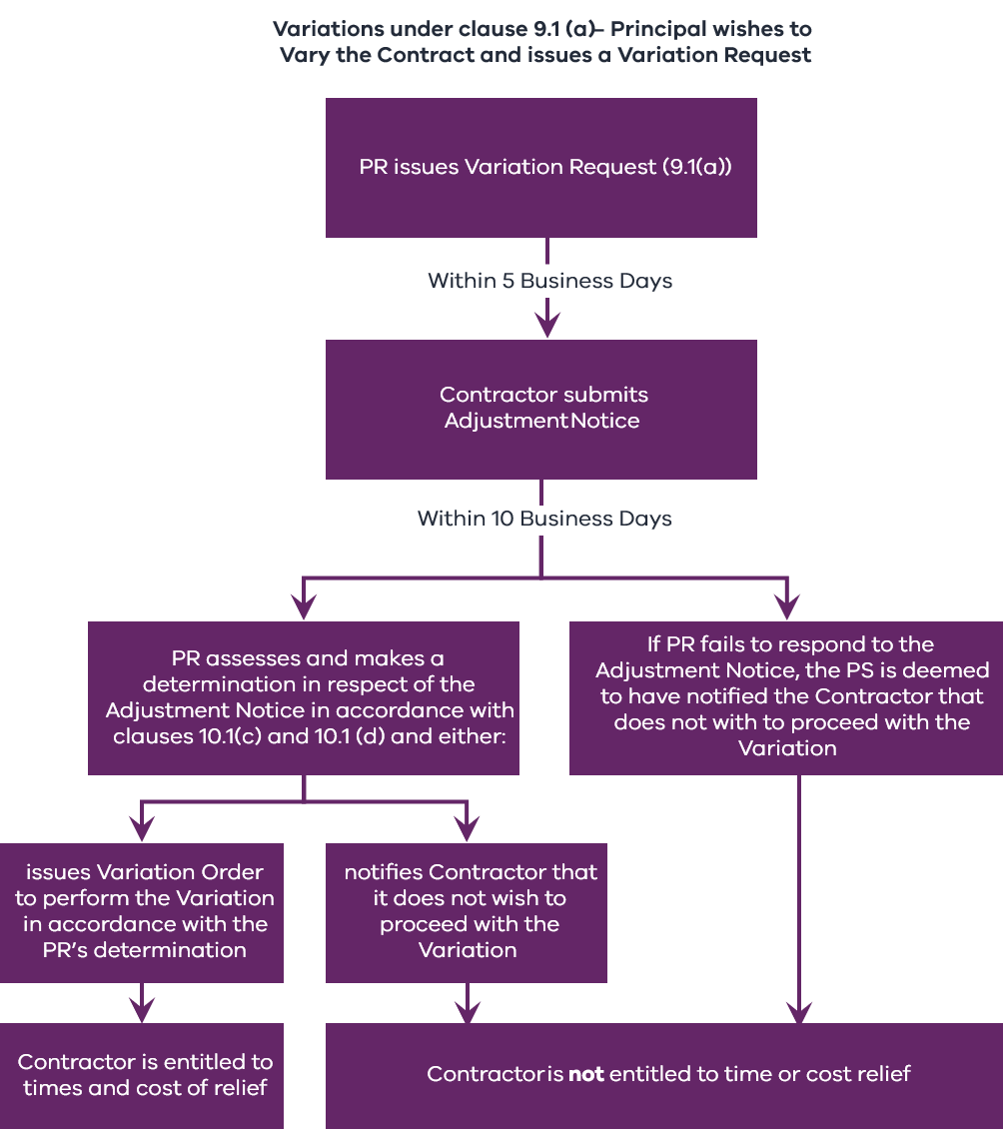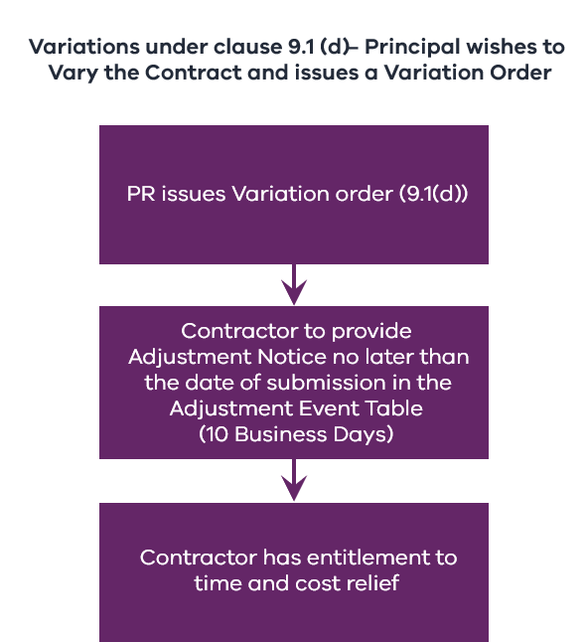
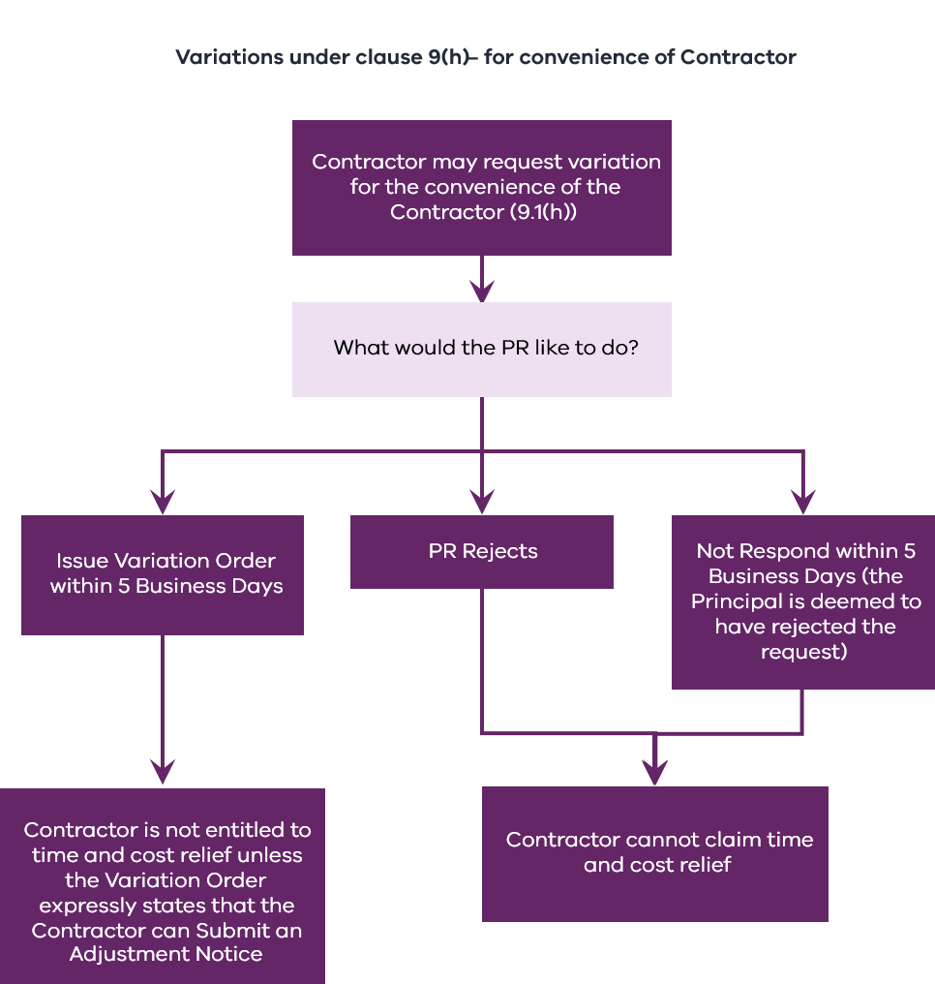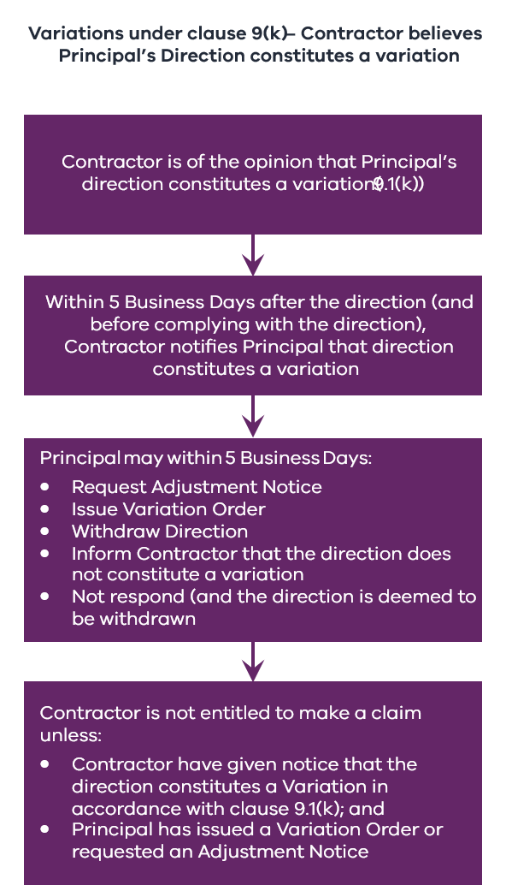

Provisional Sums
If the Contractor incurs costs in performing a Provisional Sum Item that exceed the relevant Provisional Sum, the Contractor is entitled to submit an Adjustment Notice in respect of that excess.
Provisional Sums are amounts payable for the performance of Provisional Sum Items (inclusive of Contractor’s Margin) as specified in Schedule 3.
Provisional Sum Items are the items of work specified in Schedule 3 (if any). Schedule 3 does not need to be completed for all projects. Item 32 in the Contract Particulars (Schedule 1) provides optionality to specify the inclusion of Provisional Sum Items in the Contract. If Provisional Sum Items are included in the Contractor’s Activities, clause 9.2 applies and Schedule 3 needs to be populated. Provisional Sums are required to be included in the Contract Sum.
Please see further discussion below regarding Schedule 3 (Provisional Sums).
        - Latent Conditions and Excluded Site Conditions
If a Latent Condition is encountered, this constitutes an Adjustment Event that entitles the Contractor to submit an Adjustment Notice claiming an extension of time to the Date for Practical Completion, time-based costs and direct costs.
Latent Conditions are defined in clause 1.1. In summary, Latent Conditions are Site Conditions that were not known to the Contractor at the Contract Date. These conditions differ materially from Site Conditions that could have been reasonably ascertained or anticipated by a Competent Contractor (as defined in clause 1.1) at the Contract Date if it had inspected certain information and the Site.
Latent Conditions do not include Excluded Site Conditions. Excluded Site Conditions are:
    - any climatic conditions, including any ground condition at the Site resulting from climatic conditions, wherever occurring; and
    - those Site Conditions (if any) specified in Item 33 of the Contract Particulars (Schedule 1).
Prior to issuing the RFT, the Agency should insert in Item 33 (Excluded Site Conditions) any Site Conditions the risk of which is to be borne by the Contractor – that is, Site Conditions that cannot give rise to Latent Conditions relief.
If the Contractor considers that it has encountered a Latent Condition, it must notify to the Principal’s Representative within 5 Business Days after the Latent Condition is encountered (clause 9.3(a)).
A notice under clause 9.3(a) must specify the Latent Condition encountered, the additional work and additional resources necessary to deal with it, the time anticipated to be required to deal with the Latent Condition and any expected delay in achieving Practical Completion (clause 9.3(b)).
Within 10 Business Days, the Principal’s Representative must (clause 9.3(c)):
    - notify the Contractor if it agrees that a Latent Condition has been encountered; and
    - (in any event) direct the Contractor as to the course it must adopt to address the relevant conditions.
If the Principal's Representative (clause 9.3(d)):
    - agrees that a Latent Condition has been encountered, then the Contractor may submit an Adjustment Notice in respect of the Latent Condition; or
    - does not agree that a Latent Condition has been encountered, then the Contractor must comply with any direction given by the Principal's Representative.
        - Suspension
Certain types of suspension of the Contractor’s Activities constitute an Adjustment Event.
The Contractor’s entitlements resulting from these Adjustment Events vary depending on the circumstances, as explained below.
          - Suspension by the Principal’s Representative
The Principal’s Representative may direct the Contractor to suspend (and recommence) part or all of the Contractor’s Activities (clause 9.4(a)).
Unless the suspension is a result of the Contractor’s failure to perform its obligations, the Contractor may submit an Adjustment Notice (clause 9.4(b)) claiming time relief and direct costs (but not time-based costs).
          - Suspension by the Contractor
The Contractor may suspend the Contractor’s Activities in accordance with the SOP Act and, in that event, the Contractor may submit an Adjustment Notice in respect of the suspension claiming time relief but neither direct nor time-based costs.
        - Force Majeure Events
A Force Majeure Event constitutes an Adjustment Event that entitles the Contractor to claim time relief but neither direct nor time-based costs.
Please see the definition of Force Majeure Event in clause 1.1.
If either party considers that a Force Majeure Event has occurred, that party must give notice of the Force Majeure Event to the other party no later than 5 Business Days after becoming aware of the Force Majeure Event (clause 9.5(a)).
If notice of Force Majeure Event (clause 9.5(b)) is given:
    - the Contractor must promptly take proper and reasonable steps (including expending money, rescheduling labour and resources and implementing appropriate temporary measures) to remedy, avoid or minimise the consequences of the Force Majeure Event;
    - the obligations of each party under the Contract that are prevented by the Force Majeure Event are suspended to the extent of such prevention; and
    - the failure of a party to perform the suspended obligations does not constitute a breach of the Contract by either party.
Once the Force Majeure Event (and its effects) no longer prevents the Principal or the Contractor (as the case may be) from performing the suspended obligations, the Principal’s Representative must give written notice to the Contractor lifting the suspension (clause 9.5(c)).
        - Industrial Condition
If an Industrial Condition occurs on or before the Date for Practical Completion, an Adjustment Event occurs that entitles the Contractor to an extension of time to the Date for Practical Completion but not time-based costs and direct costs.
        - Acts of Prevention
The term ‘Act of Prevention’ is defined in clause 1.1 as:
    - a breach of Contract by the Principal;
    - an act or omission of the Principal or a Principal Associate except for acts or omissions that are either:
      - permitted, authorised or required under the Contract; or
      - in response to or due to a breach of Contract by the Contractor; or
    - a Variation Order.
Acts of Prevention are Adjustment Events that entitle the Contractor to an extension of time to the Date for Practical Completion and time-based costs but not direct costs.
        - Delay Events
Delay Events are Adjustment Events that entitle the Contractor to claim an extension of time to the Date for Practical Completion. As defined, they are:
    - an Act of Prevention (defined in clause 1.1);
    - a suspension for which the Contractor is entitled to submit an Adjustment Notice under clause 9.4(b);
    - a suspension for which the Contractor is entitled to submit an Adjustment Notice under clause 9.4(d);
    - a Latent Condition;
    - each of the events in respect of which the Contractor may is entitled to claim an extension of time as set out in the Adjustment Event Table (delayed Site access, undertaking an additional inspection or test directed by the Principal’s Representative that does not disclose a Defect and Industrial Conditions occurring on or before the Date for Practical Completion); and
    - any other events that Item 35 specifies to be Delay Events.
Any Delay Events specified in Item 36 of the Contract Particulars (Schedule 1) as Compensable Delay Events also entitle the Contractor to claim time-based costs but not direct costs.
Additional events should not be included in Items 35 and 36 without legal advice. If no additional events are included, Items 35 and 36 can be marked ‘none stated’.
      - Adjustment Entitlements – clause 10
        - Adjustment Event Table
As noted earlier, the Medium Works Contract comprehensively identifies in one place – the Adjustment Event Table – the Contractor’s entitlements to claim additional time and cost relief. This is covered below.
No. | Adjustment Event | Time for submission of an Adjustment Notice | Adjustment Entitlement
No. | Adjustment Event | Time for submission of an Adjustment Notice | Adjustment to the Contract Sum for direct costs calculated in accordance with clause 10.2 | Extension of time determined in accordance with clause 10.3 | Adjustment to Contract Sum for delay costs calculated in accordance with clause 10.4
 | Site access: Principal fails to give access in accordance with clause 5.1(a). | Within 10 Business Days after the Access Date
 | Defects: Contractor conducts an additional inspection or test directed by the Principal’s Representative under clause 6.4(b)(ii)(B) that does not disclose a Defect. | Within 10 Business Days after the date on which the inspection or test is conducted
 | Acceleration: The Adjustment Notice is submitted in accordance with clause 7.2(c)(ii), accelerating the Contractor’s Activities under clause 7.2(b). | Within 10 Business Days after the date on which the Principal’s Representative’s request is given under clause 7.2(b)
 | Variation: Contractor is required under clause 9.1(b) to submit Adjustment Notice after issue of a Variation Request under clause 9.1(a). | Within 5 Business Days after receipt of a Variation Request under clause 9.1(a)
 | Variation: Contractor receives a Variation Order under clause 9.1(d) (including a Variation Order given in response to a request by the Contractor under clause 9.1(h) and that expressly states the Contractor may submit an Adjustment Notice). | Within 10 Business Days after the date on which the Variation Order is given
 | Provisional Sum: Contractor incurs costs exceeding the Provisional Sum. | Within 10 Business Days after the date on which notice is given under clause 9.2(c)(ii)
 | Latent Conditions: Principal’s Representative has given notice under clause 9.3(c)(i) agreeing that a Latent Condition has been encountered and is dealing with the Latent Condition pursuant to a direction given under clause 9.3(c)(ii). | Within 10 Business Days after the date on which the Principal’s Representative gives notice under clause 9.3(c)(i)
 | Suspension: Principal’s Representative directs a suspension under clause 9.4(a) and the Contractor is permitted to submit an Adjustment Notice under clause 9.4(b). | Within 10 Business Days after the date on which the Principal’s Representative gives the Contractor a direction under clause 9.4(a) to recommence performance of the suspended Contractor’s Activities
 | Suspension: Contractor suspends the Contractor’s Activities under clause 9.4(d). | Within 10 Business Days after the date on which the Contractor recommences performance of the suspended Contractor’s Activities
 | Force Majeure Event: A Force Majeure Event occurs. | Within 10 Business Days after the date on which notice is given by the Principal’s Representative under clause 9.5(c) lifting a suspension of obligations under clause 9.5(b)(ii)
 | Industrial Condition: An Industrial Condition occurs on or before the Date for Practical Completion. | Within 10 Business Days after the date on which the Contractor first became aware of the Industrial Condition (or the date on which a Competent Contractor could reasonably have first become aware of the Industrial Condition, whichever is earlier)
 | Acts of Prevention: An Act of Prevention occurs, other than Acts of Prevention that are the subject of another Item in the Adjustment Event Table. | Within 10 Business Days after the date on which the Contractor first became aware of the Act of Prevention (or the date on which a Competent Contractor could reasonably have first become aware of the Act of Prevention, whichever is earlier)
 | Delay Events: An event specified in Item 35 to constitute a Delay Event (excluding Compensable Delay Events) occurs. | Within 10 Business Days after the date on which the Contractor first became aware of the Delay Event (or the date on which a Competent Contractor could reasonably have first become aware of the Delay Event, whichever is earlier)
 | Delay Events: A Delay Event specified in Item 36 to constitute a Compensable Delay Event occurs. | Within 10 Business Days after the date on which the Contractor first became aware of the Delay Event (or the date on which a Competent Contractor could reasonably have first become aware of the Delay Event, whichever is earlier)

The Adjustment Events Table in clause 10.1(f) lists the Adjustment Events and identifies, in respect of each Adjustment Event:
    - whether the Adjustment Entitlement is one or more of:
      - an increase to the Contract Sum for direct costs calculated in accordance with clause 10.2;
      - an extension to the Date for Practical Completion determined in accordance with clause 10.3; and/or
      - an increase to the Contract Sum for delay costs calculated in accordance with clause 10.4; and
    - the time for submitting an Adjustment Notice.
        - Adjustment principles
          - Entitlement to claim – clause 10.1(a)
The Contractor is not entitled to make a Claim in respect of an Adjustment Event unless it has:
    - an express right to submit an Adjustment Notice under the Contract; and
    - submitted an Adjustment Notice in accordance with the Contract.
This Adjustment Notice must:
    - identify the clause giving rise to the entitlement;
    - be submitted no later than the date for submission in the Adjustment Event Table;
    - identify all Adjustment Entitlements that are claimed;
    - include documentary evidence substantiating:
      - the occurrence of the Adjustment Event; and
      - the Claim or Claims made by the Contractor in respect of the Adjustment Event;
    - supply information relating to clause 9.6 (Delay Events) that:
      - provides detailed particulars of the Delay Event;
      - states the number of days for which the Contractor claims an extension of time; and
      - demonstrates that the Delay Event affects activities that are on the critical path for achieving Practical Completion by the Date for Practical Completion in the then current Contract Program;
    - identify the steps that have been taken to minimise or mitigate:
      - the costs of the Adjustment Event; and
      - any delay arising from the Adjustment Event;
    - be completed in the form set out in Schedule 8; and
    - contain all information required by the Contract in respect of that Adjustment Event or that is reasonably required by the Principal’s Representative.
If these conditions are met, the Contractor’s only entitlements in respect of that Adjustment Event will be as set out in the Adjustment Event Table.
          - Assessment by Principal’s Representative – clauses 10.1(c) and (d)
The Principal’s Representative must assess the Contractor’s Claims, provide written notice to the Contractor as to whether it has a valid Adjustment Entitlement in accordance with the Contract and, if so, provide the Principal’s determination of that Adjustment Entitlement.
This must be completed:
    - within the time specified in the Contract; or
    - (if no time is specified) within 20 Business Days after submission of the Adjustment Notice.
In making this determination, the Principal’s Representative may:
    - make an assessment in respect of the Adjustment Entitlement that is different to the Contractor’s Claims;
    - take into account the extent to which the Contractor has or may have contributed to the Adjustment Event or its consequences; and
    - take into account any failure by the Contractor to take reasonable steps to minimise or mitigate:
      - the costs of the Adjustment Event; and
      - any delay arising from the Adjustment Event.
Figure 4 – Adjustment principles
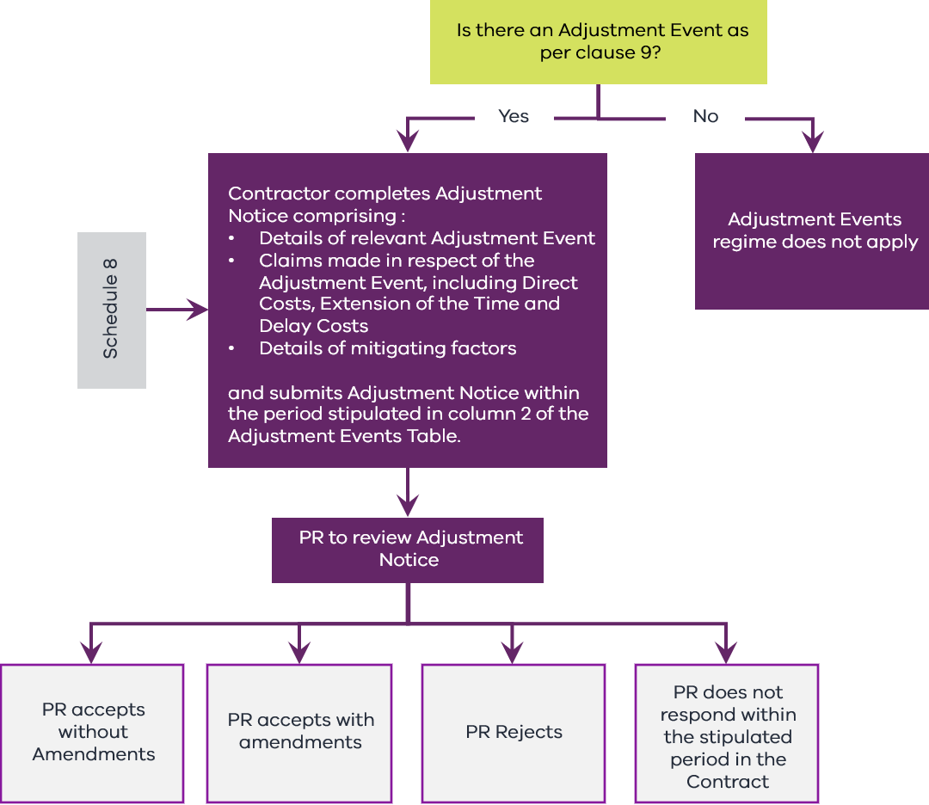

        - Adjustments to Contract Sum for direct costs
If the Adjustment Event Table provides that the Contractor is entitled to an adjustment to the Contract Sum for direct costs incurred due to the Adjustment Event, the Principal’s Representative adjusts the Contract Sum by the direct costs incurred or saved by the Contractor as a direct result of the Adjustment Event (clause 10.2).
Clause 10.2(a) sets out the approach that the Principal’s Representative must follow in determining the adjustment of the Contract Sum. This clause provides that the adjustment is to be determined as follows:
    - if applicable rates or prices are prescribed in the Contract, by using those rates and prices; or
    - if no rate or price is prescribed in the Contract, by the Principal’s Representative assessing the direct costs reasonably incurred or saved by the Contractor, including labour, plant, materials and preliminaries (but not including anything included in the definition of Contractor’s Margin).
Except in relation to any Provisional Sums:
    - where there is an increase to the Contract Sum, there must be added a further amount calculated by applying the Contractor’s Margin to the total of the direct costs determined by the Principal’s Representative; or
    - where there is a reduction to the Contract Sum, there must be added a further amount calculated by applying 50 per cent of the Contractor's Margin to the total of the direct costs determined by the Principal's Representative.
The direct costs calculated under clause 10.2 must exclude any costs incurred or likely to be incurred by the Contractor on account of any delay in achieving Practical Completion (clause 10.2(b)).
        - Adjustments to the Date for Practical Completion
If, in respect of any Delay Event, the Contractor is entitled to an extension of time to the Date for Practical Completion, the Principal’s Representative must:
    - determine the number of days by which the Delay Event has delayed or will delay the Contractor in reaching Practical Completion; and
    - extend the Date for Practical Completion by that period (clause 10.3(a)).
These must be done within the time specified in the Contract (or if no time is specified, within 20 Business Days) after receipt of the relevant Adjustment Notice for that Delay Event.
Whether or not the Contractor has given an Adjustment Notice or is otherwise entitled to make a Claim for an extension of time, the Principal has a discretion to, at any time – and from time to time – extend the Date for Practical Completion (clause 10.3(b)).
        - Adjustments to the Contract Sum for Delay Costs
          - Delay Events
In clause 1.1, Delay Events is defined as:
    - an Act of Prevention;
    - a suspension for which the Contractor is entitled to submit an Adjustment Notice;
    - a Latent Condition;
    - each of the events for which the Contractor is entitled to claim an extension of time as set out in the Adjustment Event Table; and
    - any other event specified in Item 35 as a Delay Event.
The definition of Delay Events in Item 35 should not be expanded without legal advice.
          - Compensable Delay Events
Some Delay Events also constitute Compensable Delay Events.
Compensable Delay Events are Delay Events for which delay costs are indicated to be payable in the Adjustment Event Table. In other words, these are events that entitle the Contractor to delay costs in circumstances where the Contractor has been granted an extension of time.
The list of Compensable Delay Events should not be expanded by an Agency by inserting additional Delay Events in Item 36 of the Contract Particulars (Schedule 1) without legal advice.
There is a Delay Costs Cap specified by the parties in Item 38 of the Contract Particulars (Schedule 1). The amount of the Delay Costs Cap is usually bid back by tenderers in their response to the RFT.
          - Assessing the quantum of delay costs
The Principal’s Representative must increase the Contract Sum if, in respect of any Compensable Delay Event, the Contractor (clause 10.4(a)) has:
    - been granted an extension of time; and
    - otherwise complied with the requirements of the Contract for relief in respect of the Compensable Delay Event.
The increase of the Contract Sum should be by the value of the extra direct costs reasonably and actually incurred by the Contractor on account of the delay for each Working Day by which the Date for Practical Completion is extended due to the Compensable Delay Event. These costs must not:
    - exceed the Delay Costs Cap per Working Day;
    - include any amount for profit or loss of profit or offsite overheads; or
    - include any direct costs other than those that are incurred due to the delay in achieving Practical Completion.
      - Dispute Resolution – clause 13
        - In general
The resolution procedure for disputes is set out in clause 13 of the Medium Works Contract. The following flow chart illustrates that procedure.
Figure 5 – Dispute Resolution
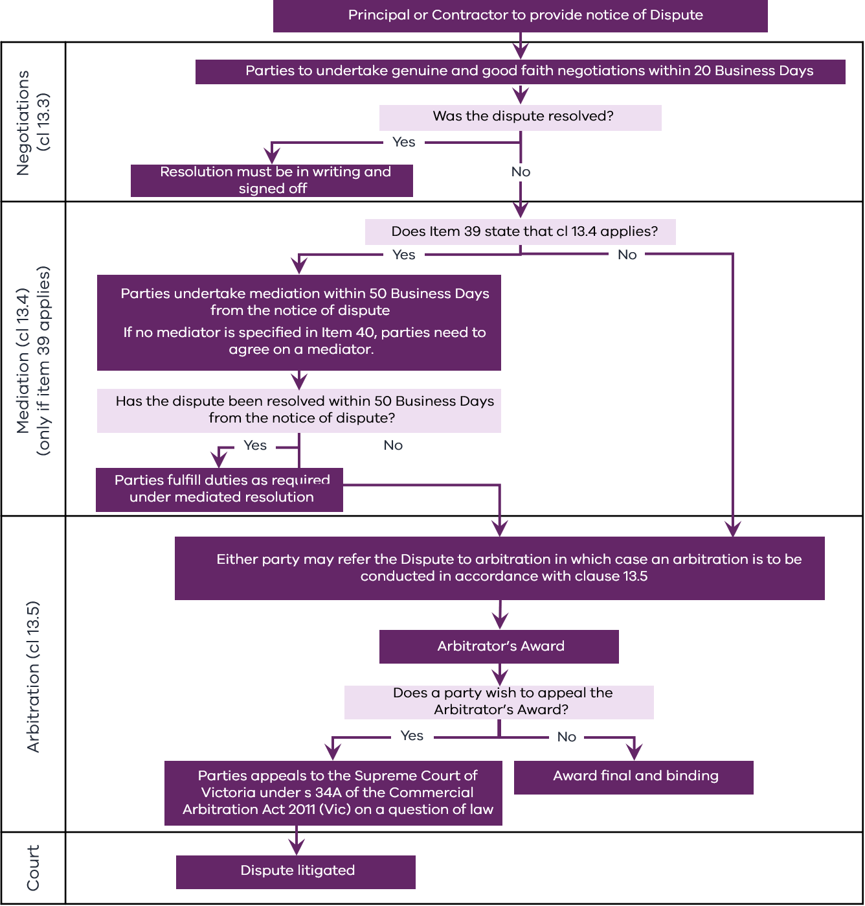
        - Dispute Notice and negotiation
If a Dispute arises, a party wishing to pursue the Dispute must give notice to the other party in writing. Within 20 Business Days after the date on which the Dispute Notice is given, the parties must undertake ‘genuine and good faith negotiations’ with a view to resolving the Dispute (clauses 13.2 and 13.3).
        - Mediation
If a Dispute is not resolved by negotiation, and Item 39 of the Contract Particulars (Schedule 1) specifies that clause 13.4 applies, the Dispute must be referred to mediation.
The procedure for mediation is set out in clause 13.4.
The Agency should make an election in Item 39 in the version of the Medium Works Contract issued with the RFT.
        - Arbitration
If a Dispute is not resolved by negotiation or (where clause 13.4 applies) mediation, either party may refer the Dispute to arbitration under clause 13.5.
      - Government requirements and collateral documents – clause 16
        - Mandatory Government Policy Requirements
Clause 16.1 incorporates into the Contract, by reference, the clauses set out in Part A of the Schedule of Government Policy Requirements as at the Contract Date. Agencies should familiarise themselves with these clauses. As these requirements may be adjusted over time, the most up-to-date Schedule of Government Policy Requirements will be made available on the DTF website, and agencies should check regularly. Any change of address will be updated in all impacted RFT and Contract Documents.
        - Project Specific Government Policy Requirements
Clause 16.2 incorporates into the Contract, by reference, those clauses set out in Part B of the Schedule of Government Policy Requirements, as at the Contract Date, if specified in Item 42 of the Contract Particulars (Schedule 1). Agencies should familiarise themselves with the Project Specific Government Policy Requirements and specify, in Item 42, those that apply to the Contract.
DTF ensures that the Schedule of Government Policy Requirements is available at all times via the DTF website (and any changes of address are updated in all impacted RFT and Contract Documents).
Agencies should refer to Buying for Victoria for guidance on how to apply the Social Procurement Framework. If Item 42 specifies that the Social Procurement Framework provisions apply, then the applicable alternative (Social Procurement Framework without the Building Equality Policy, Social Procurement Framework plus the Building Equality Policy or Building Equality Policy only) and the required reporting frequencies must be specified in Items 43 and 44. These should be specified by the Agency prior to issuing the RFT.
The Fair Jobs Code (FJC) applies when the value of the contract is $3 million or more (excl. GST). Alternative 2 in Item 45 only applies when the value of the contract is $20 million or more. If Item 42 states that the FJC applies, then the applicable alternative (FJC Pre-Assessment Certificate with related requirements or FJC Pre-Assessment Certificate with related requirements and FJC Plan with related requirements) and the required frequency of submission of FJC Plan Addendum Performance Reports must be specified in Item 46. These should be specified by the Agency prior to issuing the RFT.
If it is specified in Item 42 that the Tip Truck Policy provisions apply, adjustment details should be specified by the Agency in Item 47 prior to issuing the RFT.
        - Schedule of Collateral Documents
Clause 16.3 incorporates into the Contract, by reference, any documents set out in the Schedule of Collateral Documents that are referred to in the Contract.
DTF ensures that the Schedule of Collateral Documents is available via the DTF website at all times (and any changes of address are updated in all impacted RFT and Contract Documents).
    - Medium Works Contract – Government Policy Requirements guidance
      - In general
The General Conditions of the Medium Works Contract include:
    - the Mandatory Government Policy Requirements, which are set out in Part A of the Schedule of Government Policy Requirements (available at https://www.dtf.vic.gov.au/practitioners-toolkit/practitioners-toolkit-standard-form-contracts) and apply to all projects; and
    - those of the Project Specific Government Policy Requirements set out in Part B of the Schedule of Government Policy Requirements (available at https://www.dtf.vic.gov.au/practitioners-toolkit/practitioners-toolkit-standard-form-contracts) that are incorporated in the Contract under clause 16.2 and Item 42 of the Contract Particulars (Schedule 1).
      - Government Policy Requirements
The list of Project Specific Government Policy Requirements is set out in Part B of the Schedule of Government Policy Requirements, which is available at https://www.dtf.vic.gov.au/practitioners-toolkit/practitioners-toolkit-standard-form-contracts-clause-bank.
Guidance regarding Project Specific Government Policy Requirements is available at the Buying for Victoria website and the following specific policy websites:
    - Building Equality Policy: https://www.buyingfor.vic.gov.au/building-equality-policy-buyers
    - Victoria’s Social Procurement Framework: https://www.buyingfor.vic.gov.au/social-procurement-framework-and-guides
    - Protective Data Security Standards: https://ovic.vic.gov.au/information-security/standards/
    - Whole of Victorian Government Intellectual Property Policy Intent and Principles: https://www.dtf.vic.gov.au/funds-programs-and-policies/intellectual-property-policy
    - DataVic Access Policy: https://www.data.vic.gov.au/datavic-access-policy
    - Supplier Code of Conduct: https://www.buyingfor.vic.gov.au/supplier-code-conduct-buyers
    - Local Jobs First: https://localjobsfirst.vic.gov.au/
    - Fair Jobs Code Policy: https://www.buyingfor.vic.gov.au/fair-jobs-code-suppliers-and-businesses
Thresholds applying to public construction procurement are also explained in the fact sheet located at https://www.dtf.vic.gov.au/practitioners-toolkit/practitioners-toolkit-fact-sheets-public-construction-procurement.
    - Medium Works Contract – Schedules guidance
      - In general
There are 11 Schedules in the Medium Works Contract.
      - Schedule 1 – Contract Particulars
The Contract Particulars in Schedule 1 is the primary section of the Medium Works Contract to be populated by the Agency.
Numerous items in the Contract Particulars must be populated by the Agency in the form of the Contract issued as part of the RFT. Remaining items need to be completed on the basis of information bid back by or negotiated with the successful tenderer (for example, Items 5 (Key Personnel), 7 (Contract Sum), 25 (Date for Practical Completion) and 34 (Contractor’s Margin)).
The template Medium Works Contract uses a highlighting colour code.
Colour | Instruction
Green | These items are to be completed by the Agency before going to tender and the highlighted text removed. Accompanying Guidance Notes may also be highlighted green.
Yellow | These items are to be completed by the Agency using information provided by the tenderer in response to the RFT. Accompanying Guidance Notes may also be highlighted yellow.
The Date for Practical Completion should not be listed unless the Agency has very particular reasons for doing so. Agencies should instead consider including indicative dates or time periods for Practical Completion in the RFT.
Schedule 1 should be completed (to the extent possible and desirable) before issuing the RFT.
        - Attachment 1 to Schedule 1 – Separable Portion Particulars
Attachment 1 to Schedule 1 is only used where the Works are divided into Separable Portions. The table in Attachment 1 should be repeated for each Separable Portion.
The minimum number of Separable Portions is two – one being a portion of the Works, the balance of the Works being the second.
      - Schedule 2 – Pricing Schedule
        - In general
Schedule 2 applies to all contracts as it sets out rates and prices to be used for the purpose of valuing Variations. Schedule 2 also acts as the basis for calculating the Contract Sum when the Contract Sum is not a fixed lump sum amount.
The columns marked ‘Description’ and ‘Unit’ in the tables in the Pricing Schedule should be populated by the Agency before issuing the contract as part of the RFT.
The rates for the items specified by the Agency in the tables in Schedule 2 should be bid back by tenderers.
Where the Contract Sum is not a fixed lump sum, tenderers should also bid back the quantity of those items.
        - Unit rates
The column marked ‘Description’ in the Unit Rates Table is to be completed by Agencies to cover services such as earthworks, drainage, structural works, road, pavement and landscaping. This should also include a description of the relevant item; for example, supply and place crushed rock, disposal of rock offsite and soft landscaping.
The column marked ‘Unit’ in the Unit Rates Table is also to be completed by Agencies to specify the relevant unit of measurement, such as ‘Item’, ‘m²’ or ‘m³’.
        - Labour rates
The column marked ‘Description’ in the Labour Rates Table is to be completed by Agencies with a description of the relevant labour category, such as concrete worker or quality manager.
The column marked ‘Unit’ in the Labour Rates Table is also to be completed by Agencies to specify the relevant unit of measurement, such as hours or days.
        - Plant and Equipment rates
The column marked ‘Description’ in the Plant and Equipment Rates Table is to be completed by Agencies with a description of the relevant Plant and Equipment category, such as excavator, crane 150t, light vehicle 4x4 or bobcat.
The column marked ‘Unit’ in the Plant and Equipment Rates Table is also to be completed by Agencies to specify the relevant unit of measurement, such as hours or days.
      - Schedule 3 – Provisional Sums
Provisional Sums are amounts payable for the performance of Provisional Sum Items (inclusive of Contractor’s Margin) as specified in Schedule 3. Provisional Sum Items are the items of work specified in Schedule 3.
Schedule 3 does not need to be completed for all projects, only those for which Provisional Sum Items are required.
Item 32 in the Contract Particulars (Schedule 1) provides for the optional inclusion of Provisional Sum Items in the Contract. If Provisional Sum Items are included in the Contractor’s Activities, clause 9.2 applies and Schedule 3 needs to be populated. Prior to issuing the RFT, agencies should typically populate the columns in Schedule 3 marked ‘Provisional Sum Item’ and ‘Description of Provisional Sum Item’. Tenderers will typically bid back the amounts for the columns marked ‘Direct Cost’, ‘Contractor’s Margin’ and ‘Provisional Sum (excl. GST)’.
Agencies should clearly articulate what is covered by the Provisional Sum Item to ensure there is no duplication in costs. This may occur if the cost is included in both the Provisional Sum and the lump sum component of the Contract Sum.
If there are no Provisional Sum Items, insert the words ‘none stated’ in the table in Schedule 3.
For more information, see clause 9.2 and Item 32 of the Contract Particulars (Schedule 1).
      - Schedule 4 – Insurance Schedule
        - In general
The Insurance Schedule should be populated by the Agency prior to issuing the RFT.
        - Public liability insurance
Row 1 of the Contractor insurance obligations in Schedule 4 provides optionality for public liability insurance. The Agency should specify whether the Contractor is responsible for obtaining insurance covering public liability. If the Contractor is not responsible for obtaining public liability insurance, the Principal is responsible for ensuring that there is sufficient insurance in place. The details of the Principal insurance obligations are to be recorded in the second table to Schedule 4.
        - Works insurance
Row 2 of the Contractor insurance obligations in Schedule 4 provides optionality for Works insurance. The Agency should specify whether the Contractor is responsible for obtaining a policy for loss of or damage to the Works. If the Contractor is not responsible for obtaining Works insurance, the Principal is responsible for ensuring that there is sufficient insurance in place. The details of the Principal insurance obligations are to be recorded in the second table to Schedule 4.
The amount of Works insurance specified in Schedule 4 should be at least 100 per cent of the Contract Sum to allow for (among other things) demolition and additional design costs.
        - Professional indemnity insurance
Professional indemnity insurance (row 3 of the Contractor insurance obligations in Schedule 4) only needs to be specified as a requirement if the Contractor is responsible for designing part of the Works. In this case, the Contractor is responsible for obtaining insurance covering professional indemnity.
For more information, see Item 9 of the Contract Particulars (Schedule 1).
        - Workers’ compensation insurance
The Contractor is responsible for obtaining insurance for workers’ compensation. This includes liability under statute and common law as set out in row 4 of the Contractor insurance obligations in Schedule 4.
      - Schedule 5 – Design Schedule
The General Conditions include a mechanism by which the Design Schedule can be turned on if the Contractor is required to discharge Design Obligations. This mechanism is in clause 2.2 and Item 9 of the Contract Particulars (Schedule 1).
Item 9 of the Contract Particulars (Schedule 1) also includes optionality for the Agency to specify which Design Consultants are to be novated by the Principal to the Contractor (if any). If any novation occurs, the approved form of Consultant Deed of Novation in the Schedule of Collateral Documents must be used. If no Design Consultants are novated, the words ‘none stated’ should be inserted in the list of Design Consultants in Item 9 of the Contract Particulars (Schedule 1).
      - Schedule 6 – Project Specific Additional Conditions
Any Project Specific Additional Conditions are to be specified in Schedule 6.
While General Conditions are designed to apply across all projects, Project Specific Additional Conditions can address the unique nature of an individual project. These act as an addition to the General Conditions, not an amendment.
Contract Documents such as specifications, drawings or other technical documents should not be included as Project Specific Additional Conditions. Rather, those documents should be included as Delivery Requirements in Schedule 7.
DTF approval must be obtained for any Project Specific Additional Conditions proposed to be included in Schedule 6.
      - Schedule 7 – Delivery Requirements
If the Contractor is not responsible for undertaking any design of the Works, Schedule 7 should:
    - set out timing and cost objectives; and
    - attach or identify all specifications and drawings for the Works, including revisions and dates.
However, if the Contractor is required to undertake design work, this Schedule should attach or identify documents that describe the Principal’s requirements for the Works, including its design, timing and cost objectives. For example, these documents may comprise a brief describing the Principal’s requirements for the project, drawings, specifications and a preliminary design (if any).
      - Schedule 8 – Adjustment Notice
This is the form of Adjustment Notice required to be completed by the Contractor should it wish to make a Claim in respect of an Adjustment Event.
      - Schedule 9 – Local Industry Development Plan
If Item 42 of the Contract Particulars (Schedule 1) specifies that the Local Jobs First Policy provisions apply, the Contractor’s Local Industry Development Plan must be included in the execution version of the Contract as Schedule 9.
      - Schedule 10 – Social Procurement Commitment Schedule
Schedule 10 (Social Procurement Commitment Schedule) must be completed if:
    - Item 42 of the Contract Particulars (Schedule 1) states that the Social Procurement Framework provisions apply; and
    - Alternative 1 (Social Procurement Framework without the Building Equality Policy) or alternative 2 (Social Procurement Framework plus the Building Equality Policy) applies.
Item 43 of Schedule 1 should be populated by the Agency prior to issuing the RFT. The contents of Schedule 10 are prepared by the Contractor.
      - Schedule 11 – Fair Jobs Code Plan Addendum
If Item 42 of the Contract Particulars (Schedule 1) states that the FJC applies, Schedule 11 must be completed and included in the execution version of the Contract.
The required frequency of submission of FJC Plan Addendum Performance Reports is specified in Item 46 of the Contract Particulars (Schedule 1). This should be specified by the Agency prior to issuing the RFT.
    - Collateral Documents guidance
The Medium Works Contract incorporates by reference documents in the Schedule of Collateral Documents that are referred to in the Medium Works Contract.
The Schedule of Collateral Documents is available at https://www.dtf.vic.gov.au/practitioners-toolkit/practitioners-toolkit-standard-form-contracts.
The collateral documents are:
    - Form of Statutory Declaration;
    - Deed of Novation;
    - Subcontractor Deed of Novation;
    - Consultant Deed of Novation;
    - Unconditional Undertaking;
    - Deed of Guarantee and Indemnity; and
    - Collateral Warranty.
Clause 16.3 provides that any documents set out in the Schedule of Collateral Documents that are referred to in the Medium Works Contract are incorporated into and form part of the Medium Works Contract.
The Principal has some scope to approve an alternative form of some collateral documents, if this is necessary to incorporate any project-specific amendments. This is reflected in the relevant provisions of the Medium Works Contract. For example, clause 4.4 requires that the Contractor must provide a Deed of Guarantee and Indemnity ‘in the form set out in the Schedule of Collateral Documents (or such other form as may be approved in writing by the Principal)’. However, the Ministerial Direction requires that any ‘material change’ in a collateral document must be referred to the DTF for endorsement.
      - Form of Statutory Declaration
This is the form referred to in clause 8.2(c) that is submitted by the Contractor with each Payment Claim to confirm that its employees and Subcontractors have been paid their entitlements during the relevant payment period at the date of the Payment Claim.
        - Deed of Novation
This form of deed of novation is used when the Principal (Outgoing Party) wishes to effect a novation of the Contract to a new Principal, which must be a State Entity (Incoming Party) (see clause 18.6(b)).
The Deed of Novation will usually be used in circumstances where responsibility for a project is reassigned from the Principal that entered the Contract to a new State Entity.
It may also be used where the contracting Principal ceases to exist and the Contract must be novated to a new State Entity.
        - Subcontract Deed of Novation
This form of deed of novation is used when the Principal requires the Contractor to novate a Subcontract to the Principal. The Principal effectively takes the place of the Contractor under the Subcontract.
This form of novation is most commonly necessary where the Contract is terminated by the Principal (for example, as in clause 12.7 of the Medium Works Contract).
        - Consultant Deed of Novation
This form of deed of novation is used where optional Design Obligations apply, and the Principal has engaged a consultant to perform preliminary design work that the Principal wishes to novate to the Contractor under the Medium Works Contract.
This collateral document is relevant only where the optional Design Obligations apply, and the Principal has specified Design Consultants to be novated in Item 9 of the Contract Particulars (Schedule 1).
        - Unconditional Undertaking
This form of Unconditional Undertaking is the form referred to in the definition in clause 1.1.
It is one of the forms of Approved Security that a Contractor may provide under clause 4.
        - Deed of Guarantee and Indemnity
This form of Deed of Guarantee and Indemnity is referred to in clause 4.4.
This collateral document is only relevant if the Agency has decided that it is appropriate to require that such a deed be provided by a parent company of the Contractor (or other entity) and this requirement is specified in Item 17 of the Contract Particulars (Schedule 1).
        - Collateral Warranty
Where an Agency intends to have a third party take responsibility for elements of the Works, Item 12 of the Contract Particulars (Schedule 1) provides the option for the Principal to require a Collateral Warranty from the Subcontractor for the benefit of the Principal.
It is not mandatory to require the provision of any Collateral Warranty (or warranties). Agencies should seek legal advice if they are uncertain whether a Collateral Warranty is desirable in a particular circumstance.
The approved Collateral Warranty is one of the documents in the Schedule of Collateral Documents. It is a separate agreement between the Principal and the named Subcontractor by which the Subcontractor provides certain promises as to the quality of their work. This provides the Principal with a contractual link to the Subcontractor, which gives the Principal direct recourse to the Subcontractor for defects in the relevant Item of work.
Any Collateral Warranties must be provided by the Contractor to the Principal as a condition precedent to Practical Completion (clause 3.6(a)).
    - Execution
Execution of the Medium Works Contract is by way of an agreement (simple contract). The alternative is to execute it as a deed.
The statutory limitation period for bringing actions founded on simple contracts is six years from the date of the breach, as opposed to 15 years if executed as a deed. However, in Victoria, the statutory limitation period for commencing a ‘building action’ is prescribed in and extended by the Building Act 1993 (Vic) (Building Act). It provides that a ‘building action’ may be brought – whether in contract or tort – up to 10 years after the date of issue of an occupancy permit for the building work (or if an occupancy permit is not issued, the date of issue of a certificate of final inspection of the building work). The exception is for actions relating to combustible cladding, where the limitation period under the Building Act is 15 years.
    - Template notices
In this section are templates of various common notices that may be used by the parties to a Medium Works Contract. They are summarised in the following table.
While the Medium Works Contract prescribes that the Principal (rather than the Principal’s Representative) is the proper party to issue certain notices (for example, a notice of default under clause 12.1), users should note that:
    - the Principal’s Representative can give all directions, exercise all rights and perform all functions of the Principal as agent for the Principal (clause 3.1(b)(i)); and
    - the Principal can delegate the exercise of any rights of the Principal to a person other than the Principal’s Representative (clause 3.1(c)(ii)).

P = Principal (unless delegated under clause 3.1(c))
PR = Principal’s Representative
C = Contractor
Clause | Subject | Proforma available | Notice description | From | To | Timeframe for issue
1.3(a) | Discrepancies | N | If either party identifies any ambiguity, discrepancy or inconsistency (Discrepancy) in or between any one or more of the Contract Documents, it must promptly give written notice of the Discrepancy to the other party. | C or P | P or C | Promptly after Discrepancy is identified
3.1(b)(ii) | Delegation of Principal’s Representative's functions | Y | The Principal’s Representative may delegate its functions to another person by notice to the Contractor. | PR | C | At any time
3.1(c)(i) | Replacement of Principal’s Representative | Y | The Principal may replace the Principal’s Representative with another person by notice to the Contractor. | P | C | At any time
3.1(c)(ii) | Delegation of Principal's rights | Y | The Principal may delegate the exercise of any of its rights to a person other than the Principal’s Representative by notice to the Contractor. | P | C | At any time
3.1(c)(iii) | Variation or termination of delegation | Y | The Principal may vary or terminate any delegation of rights by notice to the Contractor. | P | C | At any time
3.2(c)(i) | Request to delegate Contractor's Representative's functions | Y | The Contractor’s Representative may delegate its functions to another person with the prior written approval of the Principal. | C | PR | At any time
3.3(b) | Request to replace Key Personnel | Y | The Contractor can replace Key Personnel with the prior written approval of the Principal’s Representative. | C | PR | At any time
3.3(c) | Request for approval of replacement of Key Personnel | Y | If any Key Personnel die, become seriously ill or resign, the Contractor must replace them with persons approved by the Principal's Representative who are of at least equivalent experience, ability and expertise. | C | PR | At any time in the event of the death, illness or resignation of Key Personnel
3.4 | Removal of persons | N | The Principal’s Representative may direct the Contractor to remove any person from the Site or the Contractor’s Activities. | PR | C | At any time
3.5(a) | Subcontractors | Y | The Contractor must not Subcontract work specified in Item 10 (except to a Subcontractor specified in Item 11) without the prior written approval of the Principal’s Representative. | C | PR | At any time
3.7(a) | Meetings | N | The Contractor must attend meetings at such times as the Principal’s Representative directs. | PR | C | At any time
3.8 | Reports | N | The Principal’s Representative may direct the Contractor as to the form of and details to be included in reports. | C | PR | At any time
5.2(a)(iii) | Site access | N | The Principal can give notice to the Contractor that it, a Principal Associate or other person authorised by the Principal will be accessing the Site. | PR | C | At any time on reasonable notice
6.4(b)(ii)B | Inspections and tests | N | The Principal’s Representative can direct the Contractor to carry out additional inspections and tests. | PR | C | At any time
6.5(d) | Principal Contractor | N | The Principal can ask the Contractor to accept an appointment as the Principal Contractor by the owner of the Site. | PR | C | At any time
6.6(c)(i) | Industrial Relations | N | The Principal can ask the Contractor to provide evidence of its compliance with Industrial Relations Laws. | PR | C | At any time
6.6(c)(ii) | Industrial Relations | N | The Principal can ask the Contractor to provide evidence of its compliance with the Industrial Relations Management Plan (where relevant). | C | PR | At any time
6.6(c)(iv) | Industrial Relations | N | The Principal can ask the Contractor to attend meetings to discuss employment or industrial relations matters. | P | C | At any time
6.6(c)(vi) | Industrial Relations | N | The Contractor must immediately advise the Principal of any act, fact or circumstance relevant to the Contractor’s ability to perform the Contractor’s Activities in a manner consistent with clause 6.6. | C | PR | Immediately
7.1(b) | Program | Y | The Principal’s Representative may (acting reasonably) review and comment on or reject a program submitted or resubmitted by the Contractor. | PR | C | Within 5 Business Days after receipt (if at all)
7.1(d)(iii) | Program | Y | The Principal’s Representative can direct the Contractor to update the Program. | PR | C | At any time
7.2(b) | Acceleration | Y | The Principal’s Representative may direct the Contractor to accelerate the performance of the Contractor’s Activities so as to overcome or minimise delay to the extent the Contractor can reasonably and practicably do so. | PR | C | Where the Contractor is entitled to claim an extension of time
7.3(a) | Practical Completion | N | The Contractor must promptly notify the Principal’s Representative in writing when it considers that Practical Completion has been achieved. | C | PR | Promptly
7.3(b)(ii)A | Practical Completion | Y | The Principal’s Representative must give the Contractor a Notice of Practical Completion if Practical Completion has been achieved. | PR | C | Within 10 Business Days after receipt of a notice under clause 7.3(a)
7.3(b)(ii)B | Practical Completion | Y | The Principal’s Representative must give the Contractor a written notice setting out the reasons why Practical Completion has not been achieved. | PR | C | Within 10 Business Days after receipt of a notice under clause 7.3(a)
7.3(c) | Practical Completion | Y | The Principal’s Representative can issue a Notice of Practical Completion (even if a notice under clause 7.3(a) has not been given). | PR | C | If Practical Completion has been achieved
7.5(b)(i) | Defects | Y | If the Principal’s Representative discovers or believes there is a Defect, it can give notice to the Contractor specifying the Defect and require the Contractor to rectify the Defect (or any part of it) within the time directed by the Principal’s Representative. | PR | C | At any time before the expiry of the Defects Liability Period
7.5(b)(ii) | Defects | Y | If the Principal’s Representative discovers or believes there is a Defect, it can give notice to the Contractor specifying the Defect and accepting the relevant work (or any part of it), despite the Defect. | PR | C | At any time before the expiry of the Defects Liability Period
7.7(a) | Use of partly completed Works | Y | The Principal may give written notice to the Contractor to use or occupy any part of the Works that the Principal’s Representative considers usable. | P | C | At any time where applicable
8.2(b)(iii) | Information to be included in Payment Claim | N | The Principal’s Representative can request information. | PR | C | At any time
9.1(a) | Variation Request | Y | The Principal’s Representative may give the Contractor written notice of a proposed Variation. | PR | C | At any time before the Date of Practical Completion
9.1(c)(i) | Variation Order | Y | The Principal’s Representative can issue a Variation Order directing the Contractor to perform a Variation in accordance with the Principal’s Representative’s determination in respect of the Contractor’s Adjustment Notice. | PR | C | Within 10 Business Days after receipt of an Adjustment Notice under clause 9.1(b)
9.1(c)(ii) | Variation | Y | The Principal’s Representative may notify the Contractor that the Principal does not wish to proceed with the proposed Variation. | PR | C | Within 10 Business Days after receipt of an Adjustment Notice under clause 9.1(b)
9.1(d) | Variation Order | Y | The Principal’s Representative can issue a Variation Order directing the Contractor to perform a Variation. | PR | C | At any time before the Date of Practical Completion
9.1(h)(i) | Variation Order | Y | The Principal’s Representative may issue a Variation Order for the convenience of the Contractor. | PR | C | If requested by the Contractor
9.1(l)(i) | Direction giving rise to a Variation | Y | After receipt of a notice under clause 9.1(k), the Principal’s Representative may request the Contractor to submit an Adjustment Notice under clause 9.1(b). | PR | C | Within 5 Business Days after receipt of a notice under clause 9.1(k)
9.1(l)(iii) | Direction giving rise to a Variation | Y | After receipt of a notice under clause 9.1(k), the Principal’s Representative may give notice withdrawing the direction. | PR | C | Within 5 Business Days after receipt of a notice under clause 9.1(k)
9.1(l)(iv) | Direction not giving rise to a Variation | Y | After receipt of a notice under clause 9.1(k), the Principal’s Representative may inform the Contractor that the Principal does not consider the direction requires the performance of a Variation. | PR | C | Within 5 Business Days after receipt of a notice under clause 9.1(k)
9.2(b)(iii) | Provisional Sums | Y | For each Provisional Sum Item, the Principal’s Representative will give the Contractor a direction to:  - perform the Provisional Sum Item;  - omit the Provisional Sum Item from the Contractor’s Activities; or  - perform only part of a Provisional Sum Item and omit the balance. | PR | C | By the Date for Practical Completion
9.3(a) & (b) | Latent Conditions | N | If the Contractor considers that it has encountered a Latent Condition, it must give written notice to the Principal’s Representative. | C | PR | No later than 5 Business Days after the Latent Condition is encountered
9.3(c) | Latent Conditions | Y | Notice from Principal’s Representative that it agrees a Latent Condition has been encountered and directing the Contractor as to the course it must adopt. | PR | C | Within 10 Business Days after receipt of a notice under clause 9.3(a)
9.3(c) | Latent Conditions | Y | Notice from Principal’s Representative that it does not agree a Latent Condition has been encountered and directing the Contractor as to the course it must adopt. | PR | C | Within 10 Business Days after receipt of a notice under clause 9.3(a)
9.4(a) | Suspension (notice to suspend) | Y | The Principal’s Representative may direct the Contractor to suspend all or a part of the Contractor’s Activities. | PR | C | At any time
9.4(a) | Suspension (notice to recommence) | Y | The Principal’s Representative may direct the Contractor to recommence performance of suspended Contractor’s Activities. | PR | C | At any time
9.5(a) | Force Majeure | N | If either party considers that a Force Majeure Event has occurred, that party must give written notice of the Force Majeure Event to the other party. | PR or C | PR or C | As soon as practicable and in any event no later than 5 Business Days after becoming aware of the Force Majeure Event
9.5(c) | Force Majeure | N | The Principal’s Representative must give written notice to the Contractor lifting a suspension under clause 9.5(b)(ii). | PR | C | Once the Force Majeure Event (and its effects) no longer prevents the Principal or the Contractor (as the case may be) from performing obligations suspended under clause 9.5(b)(ii)
10.1(c) | Adjustment Entitlements | Y | The Principal’s Representative must give written notice as to whether the Contractor has valid Adjustment Entitlements and, if so, set out the Principal’s determination of the Adjustment Entitlements. | PR | C | Within the time specified in the Contract for the relevant Adjustment Event  or  (if no time is specified) within 20 Business Days after submission of the Adjustment Notice
10.3(b) | Adjustments to the Date for Practical Completion | Y | The Principal may extend the Date for Practical Completion, regardless of whether the Contractor has given an Adjustment Notice or is otherwise entitled to claim an extension of time. | PR | C | At any time and from time to time
11.1(b) | Damage | N | If loss or damage arises from a Principal Risk, the Principal’s Representative can direct the Contractor to replace, make good or rectify the loss or damage. | PR | C | If loss or damage arises from a Principal Risk
11.3(b) | Evidence of insurance | N | The Principal’s Representative can request that the Contractor produce evidence of its compliance with clause 11.3. | PR | C | At any time
12.1 | Default and termination | N | The Principal can give the Contractor written notice of default. | P | C | In the event of Contractor default
12.2(a)(v) | Default and termination | N | The Principal can give the Contractor written notice taking work out of its hands. | P | C | Where clause 12.2(a) applies
12.2(a)(vi) | Default and termination | N | The Principal can give the Contractor written notice terminating the Contract. | P | C | Where clause 12.2(a) applies
12.5 | Default and termination | N | Termination for convenience. | P | C | At any time
13.2 | Dispute Notice | N | A party must give notice in writing to the other party if it wishes to pursue a Dispute. | P or C | C or P | If a Dispute arises
13.4(e) | Arbitration | N | Either party may refer the Dispute to arbitration. | P or C | C or P | In accordance with clause 13.4(e)
14(d) | Confidentiality | N | The Principal can direct the Contractor to return, delete or destroy any Confidential Information. | P | C | At any time
18.6(a) | Assignment | N | The Principal may novate the Contract or assign any payment or other right, benefit or interest under the Contract to any State Entity by written notice to the Contractor. | P | C | At any time

DELEGATION OF PRINCIPAL’S REPRESENTATIVE’S
FUNCTIONS
(clause 3.1(b)(ii))
Date:
To: | [insert details] (Contractor)
From: | [insert details] (Principal’s Representative)
Contract: | The Contract in respect of [insert description of Contract] entered into between [insert full name of Principal] (Principal) and the Contractor dated [insert date] (Contract)
Works: | [insert project name and address]

Unless the context requires otherwise, capitalised terms in this notice have the meanings given to them in the Contract.
This is a delegation under clause 3.1(b)(ii) of the Contract.
The Principal’s Representative gives notice that functions of the Principal’s Representative are delegated to another person as follows:
- Name of delegate: [##insert name of delegate]
- Delegated functions: [##insert description of the delegated contractual functions including clause references]
- Effective date: The delegation that is the subject of this notice takes effect on and from [##insert date].
Signed by the Principal’s Representative:
Name: [##insert name]
Position: [##insert name]
Date: [##insert date].

REPLACEMENT OF PRINCIPAL'S
REPRESENTATIVE
(clause 3.1(c)(i))
Date:
To: | [insert details] (Contractor)
From: | [insert details] (Principal)
Contract: | The Contract in respect of [insert description of Contract] entered into between the Principal and the Contractor, dated [insert date] (Contract)
Works: | [insert project name and address]

Unless the context requires otherwise, capitalised terms in this notice have the meanings given to them in the Contract.
This is a notice of replacement of the Principal’s Representative under clause 3.1(c)(i) of the Contract.
The Principal gives notice that the person currently appointed as the Principal’s Representative will be replaced by another person appointed by the Principal in that capacity with effect from [##insert date] (Effective Date) as follows:
Name of current Principal’s Representative: [##insert name of current Principal’s Representative]
Name of replacement Principal’s Representative: [##insert name of replacement Principal’s Representative].
In accordance with clause 17.1(b) of the Contract, on and from the Effective Date details for giving notices to the Principal’s Representative for the purposes of Item 48 of the Contract Particulars (Schedule 1) are as follows:
- Address (for hand delivery or delivery by courier or post, not a PO Box): [##insert address]
- Email address: [##insert email address].
Signed by the Principal
Name: [##insert name]
Position: [##insert name]
Date: [##insert date].

DELEGATION OF EXERCISE OF PRINCIPAL’S
RIGHTS
(clause 3.1(c)(ii))
Date:
To: | [insert details] (Contractor)
From: | [insert details] (Principal)
Contract: | The Contract in respect of [insert description of Contract] entered into between the Principal and the Contractor dated [insert date] (Contract)
Works: | [insert project name and address]

Unless the context requires otherwise, capitalised terms in this notice have the meanings given to them in the Contract.
This is a delegation under clause 3.1(c)(ii) of the Contract.
The Principal gives notice that the exercise of certain of the Principal’s rights under the Contract are, on and from [##insert date] (Effective Date), delegated to a person other than the Principal’s Representative as follows:
- Name of delegate: [##insert name of delegate]
- Delegated rights: [##insert description of the delegated contractual functions].
Signed by the Principal
Name: [##insert name]
Position: [##insert name]
Date: [##insert date].

VARIATION OR TERMINATION OF DELEGATION OF EXERCISE OF PRINCIPAL’S
RIGHTS
(clause 3.1(c)(iii))
Date:
To: | [insert details] (Contractor)
From: | [insert details] (Principal)
Contract: | The Contract in respect of [insert description of Contract] entered into between the Principal and the Contractor dated [insert date] (Contract)
Works: | [insert project name and address]

Unless the context requires otherwise, capitalised terms in this notice have the meanings given to them in the Contract.
By notice dated [##insert date] (Delegation Notice), the Principal delegated the exercise of certain rights of the Principal in accordance with clause 3.1(c)(ii) of the Contract.
[##delete one of the following]
The Principal gives notice under clause 3.1(c)(iii) of the Contract that the delegation the subject of the Delegation Notice is terminated with effect from [##insert date].
or
The Principal gives notice under clause 3.1(c)(iii) of the Contract that the delegation the subject of the Delegation Notice is varied with effect from [##insert date] as follows:
- [##insert details of Variation].
Signed by the Principal
Name: [##insert name]
Position: [##insert name]
Date: [##insert date].

REQUEST FOR APPROVAL TO DELEGATE FUNCTIONS
(clause 3.2(c)(i))
Date:
To: | [insert details] (Principal’s Representative)
From: | [insert details] (Contractor) or (Contractor’s Representative) [##delete whichever is NOT applicable]
Contract: | The Contract in respect of [insert description of Contract] entered into between [insert full name of Principal] (Principal) and [insert full name of Contractor] (Contractor) dated [insert date] (Contract)
Works: | [insert project name and address]

Unless the context requires otherwise, capitalised terms in this notice have the meanings given to them in the Contract.
In accordance with clause 3.2(c)(i) of the Contract, [##delete whichever is NOT applicable] <the Contractor> or <the Contractor’s Representative> requests the approval of the Principal’s Representative for the following delegation of functions:
- Name of delegate: [##insert name of delegate]
- Delegated functions: [##insert description of the delegated contractual functions, including clause references]
- Effective date: The delegation that is the subject of this notice is proposed to take effect on and from [##insert date].
Signed by [##delete whichever is NOT applicable] <the Contractor> or <the Contractor’s Representative>:
Name: [##insert name]
Position: [##insert name]
Date: [##insert date].

REQUEST FOR APPROVAL TO REPLACE KEY PERSONNEL
(clause 3.3(b))
Date:
To: | [insert details] (Principal’s Representative)
From: | [insert details] (Contractor)
Contract: | The Contract in respect of [insert description of Contract] entered into between [insert full name of Principal] (Principal) and the Contractor dated [insert date] (Contract)
Works: | [insert project name and address]

Unless the context requires otherwise, capitalised terms in this notice have the meanings given to them in the Contract.
This is a request for approval to replace Key Personnel under clause 3.3(b) of the Contract.
The Contractor requests the written approval of the Principal’s Representative to replace the following Key Personnel in Item 5 of the Contract Particulars (Schedule 1):
Existing Key Personnel | Role
[##insert name] | [##insert role]
[##insert name] | [##insert role]
The Contractor proposes to replace these persons with the following new Key Personnel:
Proposed replacement Key Personnel | Role
[##insert name] | [##insert role]
[##insert name] | [##insert role]
The Contractor requests the Principal’s Representative’s approval to effect the above replacement on and from [##insert date].
Signed by the Contractor’s Representative:
Name: [##insert name]
Position: [##insert name]
Date: [##insert date].

REQUEST FOR APPROVAL OF REPLACEMENT KEY PERSONNEL
(Clause 3.3(c))
Date:
To: | [insert details] (Principal’s Representative)
From: | [insert details] (Contractor)
Contract: | The Contract in respect of [insert description of Contract] entered into between [insert full name of Principal] (Principal) and the Contractor dated [insert date] (Contract)
Works: | [insert project name and address]
Unless the context requires otherwise, capitalised terms in this notice have the meanings given to them in the Contract.
This is a request for approval of replacement Key Personnel under clause 3.3(c) of the Contract.
The Contractor gives notice that the following Key Personnel specified in Item 5 of the Contract Particulars (Schedule 1) are unable to continue in their roles under the Contract for the following reasons:
Existing Key Personnel | Role | Reason for inability
[##insert name] | [##insert role] | [##insert relevant reason, for example, serious illness, resignation]
[##insert name] | [##insert role] | [##insert relevant reason, for example, serious illness, resignation]
The Contractor requests the written approval of the Principal’s Representative to replace the above Key Personnel with the following persons who have experience, ability and expertise equivalent to the outgoing Key Personnel:
Proposed replacement Key Personnel | Role | Experience, ability and expertise
[##insert name] | [##insert role] | [##insert details]
[##insert name] | [##insert role] | [##insert details]
The Contractor requests the Principal’s Representative’s approval to effect the above replacement on and from [##insert date].
Signed by the Contractor:
Name: [##insert name]
Position: [##insert name]
Date: [##insert date].

REQUEST FOR APPROVAL TO SUBCONTRACT WORK
(clause 3.5(a))
Date:
To: | [insert details] (Principal’s Representative)
From: | [insert details] (Contractor)
Contract: | The Contract in respect of [insert description of Contract] entered into between [insert full name of Principal] (Principal) and the Contractor dated [insert date] (Contract)
Works: | [insert project name and address]

Unless the context requires otherwise, capitalised terms in this notice have the meanings given to them in the Contract.
This is a request for approval under clause 3.5(a) of the Contract to Subcontract work.
The Contractor requests the written approval of the Principal’s Representative to Subcontract work specified in Item 10 of the Contract Particulars (Schedule 1) to a person other than a Subcontractor specified in Item 11 of the Contract Particulars (Schedule 1), as follows:
Contractor’s Activities specified in Item 10 | Proposed Subcontractor
[##insert name] | [##insert name, ACN and address]
[##insert name] | [##insert name, ACN and address]

Signed by the Contractor’s Representative:
Name: [##insert name]
Position: [##insert name]
Date: [##insert date].

COMMENT ON OR REJECTION OF CONTRACTOR’S PROGRAM
(clause 7.1(b))
Date:
To: | [insert details] (Contractor)
From: | [insert details] (Principal’s Representative)
Contract: | The Contract in respect of [insert description of Contract] entered into between [insert full name of Principal] (Principal) and the Contractor dated [insert date] (Contract)
Works: | [insert project name and address]

Unless the context requires otherwise, capitalised terms in this notice have the meanings given to them in the Contract.
I refer to the program [##insert the applicable option and delete the other] <submitted by the Contractor in accordance with clause 7.1(a)> OR <resubmitted by the Contractor in accordance with clause 7.1(d)> and dated [##insert date].
[##Delete one of the following]
Pursuant to clause 7.1(b) of the Contract, the Contractor is advised that its program is rejected for the following reasons:
- [##insert reasons].
In accordance with clause 7.1(d) of the Contract, the Contractor is required to amend and resubmit the program to the Principal’s Representative.
or
Pursuant to clause 7.1(b) of the Contract, the Contractor is advised that the Principal’s Representative has reviewed and makes the following comments regarding the Contractor’s program:
[##insert comments regarding program].
Signed by the Principal’s Representative:
Name: [##insert name]
Position: [##insert name]
Date: [##insert date].

DIRECTION TO UPDATE CONTRACTOR’S PROGRAM
(clause 7.1(d)(iii))
Date:
To: | [insert details] (Contractor)
From: | [insert details] (Principal’s Representative)
Contract: | The Contract in respect of [insert description of Contract] entered into between [insert full name of Principal] (Principal) and the Contractor dated [insert date] (Contract)
Works: | [insert project name and address]

Unless the context requires otherwise, capitalised terms in this notice have the meanings given to them in the Contract.
This is a direction under clause 7.1(d)(iii) of the Contract.
I refer to the current Contract Program dated [##insert date].
The Contractor is directed to update the Contract Program to take account of [##insert relevant changes, for example, delays] and to provide the updated Contract Program to me by no later than [##insert reasonable date].
Signed by the Principal’s Representative:
Name: [##insert name]
Position: [##insert name]
Date: [##insert date].

DIRECTION TO ACCELERATE
(clause 7.2(b))
Date:
To: | [insert details] (Contractor)
From: | [insert details] (Principal’s Representative)
Contract: | The Contract in respect of [insert description of Contract] entered into between [insert full name of Principal] (Principal) and the Contractor dated [insert date] (Contract)
Works: | [insert project name and address]

Unless the context requires otherwise, capitalised terms in this notice have the meanings given to them in the Contract.
This is a direction under clause 7.2(b) of the Contract.
The Contractor is entitled to Claim an entitlement to an extension of time under clause 10 of the Contract for a delay in the performance of the Contractor’s Activities, being [##insert description of cause(s) of delay].
In these circumstances, the Contractor is directed to accelerate the performance of the Contractor’s Activities so as to overcome or minimise the delay to the extent that it can reasonably and practicably do so.
The Contractor is required to comply with the direction the subject of this notice on the terms set out in clause 7.2(c) of the Contract.
Signed by the Principal’s Representative:
Name: [##insert name]
Position: [##insert name]
Date: [##insert date].

NOTICE OF PRACTICAL COMPLETION
(clause 7.3(b)(ii)A.)
To be used in response to Contractor’s notice under clause 7.3(a)
Date:
To: | [insert details] (Contractor)
From: | [insert details] (Principal’s Representative)
Contract: | The Contract in respect of [insert description of Contract] entered into between [insert full name of Principal] (Principal) and the Contractor dated [insert date] (Contract)
Works: | [insert project name and address]

Unless the context requires otherwise, capitalised terms in this notice have the meanings given to them in the Contract.
This is a Notice of Practical Completion under clause 7.3(b)(ii)A. of the Contract.
I refer to:
- the Contractor’s notice under clause 7.3(a) dated [##insert date]; and
- the joint inspection of the Works that occurred on [##insert date].
I hereby give notice that Practical Completion was achieved on [##insert date].
Signed by the Principal’s Representative:
Name: [##insert name]
Position: [##insert name]
Date: [##insert date].

NOTICE THAT PRACTICAL COMPLETION HAS NOT BEEN ACHIEVED
(clause 7.3(b)(ii)B.)
To be used in response to Contractor’s notice under clause 7.3(a)
Date:
To: | [insert details] (Contractor)
From: | [insert details] (Principal’s Representative)
Contract: | The Contract in respect of [insert description of Contract] entered into between [insert full name of Principal] (Principal) and the Contractor dated [insert date] (Contract)
Works: | [insert project name and address]

Unless the context requires otherwise, capitalised terms in this notice have the meanings given to them in the Contract.
This is a notice under clause 7.3(b)(ii)B of the Contract.
I refer to:
- the Contractor’s notice under clause 7.3(a) dated [##insert date]; and
- the joint inspection of the Works that occurred on [##insert date].
I hereby give notice that Practical Completion has not been achieved.
The reasons why Practical Completion has not been achieved are as follows:
- [##insert detailed reasons why Practical Completion has not been achieved].
Signed by the Principal’s Representative:
Name: [##insert name]
Position: [##insert name]
Date: [##insert date].

NOTICE THAT PRACTICAL COMPLETION HAS BEEN ACHIEVED
(clause 7.3(c))
To be used where Practical Completion has been achieved, but the Contractor has not given notice under clause 7.3(a)
Date:
To: | [insert details] (Contractor)
From: | [insert details] (Principal’s Representative)
Contract: | The Contract in respect of [insert description of Contract] entered into between [insert full name of Principal] (Principal) and the Contractor dated [insert date] (Contract)
Works: | [insert project name and address]

Unless the context requires otherwise, capitalised terms in this notice have the meanings given to them in the Contract.
This is a Notice of Practical Completion under clause 7.3(c) of the Contract.
Notwithstanding that the Contractor has not given a notice under clause 7.3(a) of the Contract, I hereby give notice that Practical Completion was achieved on [##insert date].
Signed by the Principal’s Representative:
Name: [##insert name]
Position: [##insert name]
Date: [##insert date].

DIRECTION TO CONTRACTOR TO RECTIFY DEFECT
(clause 7.5(b)(i))
Date:
To: | [insert details] (Contractor)
From: | [insert details] (Principal’s Representative)
Contract: | The Contract in respect of [insert description of Contract] entered into between [insert full name of Principal] (Principal) and the Contractor dated [insert date] (Contract)
Works: | [insert project name and address]

Unless the context requires otherwise, capitalised terms in this notice have the meanings given to them in the Contract.
Pursuant to clause 7.5(b)(i) of the Contract, the Principal’s Representative gives notice of the following Defect:
[##insert a reasonably detailed description of the Defect, including by attaching photographs or reports if necessary].
[##delete one of the following]
The Contractor is directed to rectify the Defect.
OR
The Contractor is directed to rectify the Defect in part. The part to be rectified by the Contractor is as follows:
[##insert a reasonably detailed description of the part of the Defect to be rectified].
The Contractor must undertake and complete the above rectification works by no later than [##insert date or period for completion of rectification].
The rectification work required by this direction will be subject to a separate Defects Liability Period determined in accordance with clause 7.5(c)(ii) of the Contract.
Signed by the Principal’s Representative:
Name: [##insert name]
Position: [##insert name]
Date: [##insert date].

DIRECTION TO CONTRACTOR ADVISING THAT A DEFECT IS ACCEPTED
(clause 7.5(b)(ii))
Date:
To: | [insert details] (Contractor)
From: | [insert details] (Principal’s Representative)
Contract: | The Contract in respect of [insert description of Contract] entered into between [insert full name of Principal] (Principal) and the Contractor dated [insert date] (Contract)
Works: | [insert project name and address]

Unless the context requires otherwise, capitalised terms in this notice have the meanings given to them in the Contract.
Pursuant to clause 7.5(b)(ii) of the Contract, the Principal’s Representative:
- gives notice of the following Defect:
[##insert a reasonably detailed description of Defect, including by attaching photographs or reports if necessary]
- hereby advises the Contractor that the Principal accepts the relevant work, despite the Defect.
In accordance with clause 7.5(e) of the Contract, the cost of rectifying the Defect as determined by the Principal’s Representative is $[##insert], calculated as follows:
- [##insert breakdown]
That amount is a debt due and payable by the Contractor to the Principal.
Signed by the Principal’s Representative:
Name: [##insert name]
Position: [##insert name]
Date: [##insert date].

NOTICE OF USE OR OCCUPATION OF WORKS
(clause 7.7(a))
Date:
To: | [insert details] (Contractor)
From: | [insert details] (Principal)
Contract: | The Contract in respect of [insert description of Contract] entered into between the Principal and the Contractor dated [insert date] (Contract)
Works: | [insert project name and address]

Unless the context requires otherwise, capitalised terms in this notice have the meanings given to them in the Contract.
This is a notice under clause 7.7(a) of the Contract.
The Principal hereby gives notice that:
- the Principal’s Representative considers the following part of the Works to be usable, notwithstanding that such part (or some other part) of the Works has not achieved Practical Completion:
[##insert description of part of the Works]
- the Principal intends to use or occupy (or arrange for Other Contractors to use or occupy) the part of the Works described in paragraph 1 of this notice on and from [##insert date of use or occupation].
Signed by the Principal:
Name: [##insert name]
Position: [##insert name]
Date: [##insert date].

VARIATION REQUEST
(clause 9.1(a))
Date:
To: | [insert details] (Contractor)
From: | [insert details] (Principal’s Representative)
Contract: | The Contract in respect of [insert description of Contract] entered into between [insert full name of Principal] (Principal) and the Contractor dated [insert date] (Contract)
Works: | [insert project name and address]

Unless the context requires otherwise, capitalised terms in this notice have the meanings given to them in the Contract.
This is a Variation Request under clause 9.1(a) of the Contract.
The Principal’s Representative proposes a Variation as follows:
[##insert detailed description of proposed Variation].
In accordance with clause 9.1(b) of the Contract, please proceed to provide an Adjustment Notice in respect of the above proposed Variation, stating its impacts (if any) on each of the matters specified in clause 9.1(b), within 5 Business Days of receipt of this Variation Request [##substitute a longer timeframe if one has been requested by the Contractor and agreed by the Principal’s Representative].
Signed by the Principal’s Representative:
Name: [##insert name]
Position: [##insert name]
Date: [##insert date].

VARIATION ORDER IN RESPONSE TO CONTRACTOR’S ADJUSTMENT NOTICE UNDER CLAUSE 9.1(b)
(clause 9.1(c)(i))
Date:
To: | [insert details] (Contractor)
From: | [insert details] (Principal’s Representative)
Contract: | The Contract in respect of [insert description of Contract] entered into between [insert full name of Principal] (Principal) and the Contractor dated [insert date] (Contract)
Works: | [insert project name and address]

Unless the context requires otherwise, capitalised terms in this notice have the meanings given to them in the Contract.
This is a Variation Order under clause 9.1(c)(i) of the Contract.
In circumstances whereby:
- the Contractor was given a Variation Request by the Principal’s Representative, dated [##insert date];
- in response to the Variation Request, the Contractor submitted an Adjustment Notice under clause 9.1(b) of the Contract, dated [##insert date]; and
- the Principal’s Representative assessed and made a Determination in respect of the Contractor’s Adjustment Notice in accordance with clauses 10.1(c) and 10.1(d) of the Contract, dated [##insert date] (Determination);
the Principal's Representative now issues this Variation Order directing the Contractor to perform the Variation that is the subject of the Variation Request in accordance with the Determination, a copy of which is attached.
Signed by the Principal’s Representative:
Name: [##insert name]
Position: [##insert name]
Date: [##insert date].

NOTICE NOT TO PROCEED WITH PROPOSED VARIATION
(clause 9.1(c)(ii))
Date:
To: | [insert details] (Contractor)
From: | [insert details] (Principal’s Representative)
Contract: | The Contract in respect of [insert description of Contract] entered into between [insert full name of Principal] (Principal) and the Contractor dated [insert date] (Contract)
Works: | [insert project name and address]

Unless the context requires otherwise, capitalised terms in this notice have the meanings given to them in the Contract.
This is a notice under clause 9.1(c)(ii) of the Contract.
In circumstances whereby:
- the Contractor was given a Variation Request by the Principal’s Representative, dated [##insert date]; and
- in response to the Variation Request, the Contractor submitted an Adjustment Notice under clause 9.1(b) of the Contract, dated [##insert date];
the Principal’s Representative hereby notifies the Contractor that the Principal does not wish to proceed with the proposed Variation the subject of the Variation Request.
Signed by the Principal’s Representative:
Name: [##insert name]
Position: [##insert name]
Date: [##insert date].

VARIATION ORDER
(clause 9.1(d))
Date:
To: | [insert details] (Contractor)
From: | [insert details] (Principal’s Representative)
Contract: | The Contract in respect of [insert description of Contract] entered into between [insert full name of Principal] (Principal) and the Contractor dated [insert date] (Contract)
Works: | [insert project name and address]

Unless the context requires otherwise, capitalised terms in this notice have the meanings given to them in the Contract.
This is a Variation Order under clause 9.1(d) of the Contract. The Contractor is hereby directed to perform the following Variation:
[##insert description of Variation].
Signed by the Principal’s Representative:
Name: [##insert name]
Position: [##insert name]
Date: [##insert date].

VARIATION ORDER FROM PRINCIPAL’S REPRESENTATIVE
FOR THE CONVENIENCE OF THE CONTRACTOR
(clause 9.1(h))
Date:
To: | [insert details] (Contractor)
From: | [insert details] (Principal’s Representative)
Contract: | The Contract in respect of [insert description of Contract] entered into between [insert full name of Principal] (Principal) and the Contractor dated [insert date] (Contract)
Works: | [insert project name and address]

Unless the context requires otherwise, capitalised terms in this notice have the meanings given to them in the Contract.
This is a Variation Order under clause 9.1(h) of the Contract.
I refer to the Contractor’s request to direct a Variation for its convenience dated [##insert date].
I hereby direct the Contractor to perform the Variation that is the subject of its request on the basis set out hereunder.
[##delete one of the following]
In accordance with clause 9.1(i) of the Contract, the Contractor is not entitled to submit an Adjustment Notice in respect of this Variation Order or otherwise to make any Claim arising out of or in connection with the Variation that is the subject of this Variation Order.
OR
In accordance with clause 9.1(i) of the Contract, the Contractor is entitled to submit an Adjustment Notice in respect of this Variation Order [##note: under clause 9.1(h), the Contractor is not entitled to submit an Adjustment Notice unless this Variation Order expressly permits it].
Signed by the Principal’s Representative:
Name: [##insert name]
Position: [##insert name]
Date: [##insert date].

RESPONSE TO CONTRACTOR NOTICE THAT DIRECTION GIVES RISE TO VARIATION – REQUEST TO SUBMIT AN ADJUSTMENT NOTICE
(clause 9.1(l)(i))
Date:
To: | [insert details] (Contractor)
From: | [insert details] (Principal’s Representative)
Contract: | The Contract in respect of [insert description of Contract] entered into between [insert full name of Principal] (Principal) and the Contractor dated [insert date] (Contract)
Works: | [insert project name and address]

Unless the context requires otherwise, capitalised terms in this notice have the meanings given to them in the Contract.
This is a request under clause 9.1(l)(i) of the Contract.
I refer to the Contractor’s notice under clause 9.1(k) dated [##insert date] in respect of my direction dated [##insert date] to [##insert particulars of relevant direction].
Pursuant to clause 9.1(l)(i) of the Contract, I hereby request that the Contractor submit an Adjustment Notice under clause 9.1(b) in respect of that direction.
Signed by the Principal’s Representative:
Name: [##insert name]
Position: [##insert name]
Date: [##insert date].

RESPONSE TO CONTRACTOR NOTICE THAT DIRECTION GIVES RISE TO VARIATION – NOTICE
WITHDRAWING DIRECTION
(clause 9.1(l)(iii))
Date:
To: | [insert details] (Contractor)
From: | [insert details] (Principal’s Representative)
Contract: | The Contract in respect of [insert description of Contract] entered into between [insert full name of Principal] (Principal) and the Contractor dated [insert date] (Contract)
Works: | [insert project name and address]

Unless the context requires otherwise, capitalised terms in this notice have the meanings given to them in the Contract.
This is a notice under clause 9.1(l)(iii) of the Contract.
I refer to the Contractor’s notice under clause 9.1(k) dated [##insert date] in respect of my direction dated [##insert date] to [##insert particulars of relevant direction].
Pursuant to clause 9.1(l)(iii) of the Contract, I hereby withdraw that direction.
Signed by the Principal’s Representative:
Name: [##insert name]
Position: [##insert name]
Date: [##insert date].

RESPONSE TO CONTRACTOR NOTICE THAT DIRECTION GIVES RISE TO VARIATION – NOTICE
THAT DIRECTION WAS NOT A VARIATION AND REQUIRING CONTRACTOR TO PROCEED
(clause 9.1(l)(iv))
Date:
To: | [insert details] (Contractor)
From: | [insert details] (Principal’s Representative)
Contract: | The Contract in respect of [insert description of Contract] entered into between [insert full name of Principal] (Principal) and the Contractor dated [insert date] (Contract)
Works: | [insert project name and address]

Unless the context requires otherwise, capitalised terms in this notice have the meanings given to them in the Contract.
This is a notice under clause 9.1(l)(iv) of the Contract.
I refer to the Contractor’s notice under clause 9.1(k) dated [##insert date] in respect of my direction dated [##insert date] to [##insert particulars of relevant direction].
Pursuant to clause 9.1(l)(iv) of the Contract, the Contractor is advised the Principal does not consider that the direction requires the performance of a Variation. The Contractor is therefore required to comply with the direction.
Signed by the Principal’s Representative:
Name: [##insert name]
Position: [##insert name]
Date: [##insert date].

DIRECTION WITH RESPECT TO PROVISIONAL SUM
(clause 9.2(b)(iii))
Date:
To: | [insert details] (Contractor)
From: | [insert details] (Principal’s Representative)
Contract: | The Contract in respect of [insert description of Contract] entered into between [insert full name of Principal] (Principal) and the Contractor dated [insert date] (Contract)
Works: | [insert project name and address]

Unless the context requires otherwise, capitalised terms in this notice have the meanings given to them in the Contract.
This is a direction under clause 9.2(b)(iii) of the Contract with respect to the following Provisional Sum Item:
[##insert description of Provisional Sum Item].
The Contractor is directed as follows with respect to the Provisional Sum Item:
Clause | The Contractor is directed to: | Tick which applies
9.2(b)(iii)A | Perform the Provisional Sum Item
9.2(b)(iii)B | Omit the Provisional Sum Item from the Contractor’s Activities
9.2(b)(iii)C | Perform only part of the Provisional Sum Item and omit the balance from the Contractor’s Activities, the part to be performed by the Contractor being as follows:  [##insert description of the part of the Provisional Sum Item to be performed]
Signed by the Principal’s Representative:
Name: [##insert name]
Position: [##insert name]
Date: [##insert date].

NOTICE FROM PRINCIPAL’S REPRESENTATIVE THAT IT AGREES A LATENT CONDITION HAS BEEN ENCOUNTERED AND DIRECTING CONTRACTOR HOW TO PROCEED
(clause 9.2(c))
Date:
To: | [insert details] (Contractor)
From: | [insert details] (Principal’s Representative)
Contract: | The Contract in respect of [insert description of Contract] entered into between [insert full name of Principal] (Principal) and the Contractor dated [insert date] (Contract)
Works: | [insert project name and address]

Unless the context requires otherwise, capitalised terms in this notice have the meanings given to them in the Contract.
This is a notice under clause 9.3(c) of the Contract.
I refer to the Contractor’s notice under clause 9.3(a) dated [##insert date], advising it considers that it has encountered a Latent Condition.
Pursuant to clause 9.3(c):
- I agree that a Latent Condition has been encountered; and
- insofar as the Contractor’s Activities are affected by the Latent Condition, I direct the Contractor to [##insert direction as to the course the Contractor must adopt to deal with the effects of the Latent Condition].
Signed by the Principal’s Representative:
Name: [##insert name]
Position: [##insert name]
Date: [##insert date].

NOTICE FROM PRINCIPAL’S REPRESENTATIVE THAT IT DOES NOT AGREE A LATENT CONDITION HAS BEEN ENCOUNTERED AND DIRECTING CONTRACTOR HOW TO PROCEED
(Clause 9.2(c))
Date:
To: | [insert details] (Contractor)
From: | [insert details] (Principal’s Representative)
Contract: | The Contract in respect of [insert description of Contract] entered into between [insert full name of Principal] (Principal) and the Contractor dated [insert date] (Contract)
Works: | [insert project name and address]

Unless the context requires otherwise, capitalised terms in this notice have the meanings given to them in the Contract.
This is a notice under clause 9.3(c) of the Contract.
I refer to the Contractor’s notice under clause 9.3(a) dated [##insert date], advising it considers that it has encountered a Latent Condition.
Pursuant to clause 9.3(c):
- I do not agree that a Latent Condition has been encountered; and
- insofar as the Contractor’s Activities are affected by the Site Condition that is the subject of the Contractor’s above notice under clause 9.3(a), I direct the Contractor to [##insert direction as to the course the Contractor must adopt to deal with the effects of the Site Condition].
Signed by the Principal’s Representative:
Name: [##insert name]
Position: [##insert name]
Date: [##insert date].

DIRECTION TO SUSPEND CONTRACTOR’S ACTIVITIES
(clause 9.4(a))
Date:
To: | [insert details] (Contractor)
From: | [insert details] (Principal’s Representative)
Contract: | The Contract in respect of [insert description of Contract] entered into between [insert full name of Principal] (Principal) and the Contractor dated [insert date] (Contract)
Works: | [insert project name and address]

Unless the context requires otherwise, capitalised terms in this notice have the meanings given to them in the Contract.
This is a notice under clause 9.4(a) of the Contract.
The Contractor is directed to suspend performance of the following part of the Contractor’s Activities:
- [##insert description of the part of the Contractor’s Activities that is to be suspended. If all Contractor’s Activities are to be suspended, insert ‘all of the Contractor’s Activities’].
[##insert the following ONLY if applicable – refer to clause 9.4(b)]
The suspension the subject of this direction has arisen as a result of the Contractor’s failure to perform its obligations under the Contract and in accordance with clause 9.4(b), the Contractor is not entitled to submit an Adjustment Notice in respect of the suspension.
Signed by the Principal’s Representative:
Name: [##insert name]
Position: [##insert name]
Date: [##insert date].

DIRECTION TO RECOMMENCE SUSPENDED CONTRACTOR’S ACTIVITIES
(clause 9.4(a))
Date:
To: | [insert details] (Contractor)
From: | [insert details] (Principal’s Representative)
Contract: | The Contract in respect of [insert description of Contract] entered into between [insert full name of Principal] (Principal) and the Contractor dated [insert date] (Contract)
Works: | [insert project name and address]

Unless the context requires otherwise, capitalised terms in this notice have the meanings given to them in the Contract.
This is a notice under clause 9.4(a) of the Contract.
I refer to the direction to suspend performance of the Contractor’s Activities given by notice from the Principal’s Representative under clause 9.4(a) dated [##insert date].
[##delete one of the following]
The Contractor is directed to recommence performance of all the Contractor’s Activities suspended pursuant to the above direction.
OR
The Contractor is directed to recommence performance of the following part of the Contractor’s Activities suspended pursuant to the above direction:
- [##insert description of the part of the Contractor’s Activities that is to be recommenced].
Signed by the Principal’s Representative:
Name: [##insert name]
Position: [##insert name]
Date: [##insert date].

DETERMINATION OF ADJUSTMENT NOTICE BY PRINCIPAL’S REPRESENTATIVE
(clause 10.1(c))
Date:
To: | [insert details] (Contractor)
From: | [insert details] (Principal’s Representative)
Contract: | The Contract in respect of [insert description of Contract] entered into between [insert full name of Principal] (Principal) and the Contractor dated [insert date] (Contract)
Works: | [insert project name and address]

Unless the context requires otherwise, capitalised terms in this notice have the meanings given to them in the Contract.
This is a notice under clause 10.1(c) of the Contract.
I refer to the Adjustment Notice submitted by the Contractor and dated [##insert date]. I have determined as follows in respect of the Claims that are the subject of the Adjustment Notice:
Adjustment Event Claimed by Contractor:
[##insert Adjustment Event]
Does the Contractor have a valid Adjustment Entitlement for: |  | If the Contractor DOES have a valid Adjustment Entitlement, the assessment of the Principal’s Representative is:
An adjustment to the Contract Sum for direct costs and Contractor’s Margin?  If "No", the reasons for the Principal's Representative's assessment are [##insert] | Yes ☐ No ☐ | Direct costs: $[##insert amount] excl. GST)  Plus Contractor's Margin: $[##insert amount] excl. GST)  Total: $[##insert amount] (excl. GST)
An extension of time to the Date for Practical Completion?  If "No", the reasons for the Principal's Representative's assessment are [##insert] | Yes ☐ No ☐ | The Date for Practical Completion is extended by [##insert number] days
Any delay costs?  If "No", the reasons for the Principal's Representative's assessment are [##insert] | Yes ☐ No ☐ | The Contract Sum is increased by the following amount: $[##insert amount or, if no delay costs are assessed to be payable, insert ‘nil’].
Signed by the Principal’s Representative:
Name: [##insert name]
Position: [##insert name]
Date: [##insert date].
NOTICE OF EXTENSION OF TIME WHERE NO ADJUSTMENT NOTICE HAS BEEN GIVEN
(clause 10.3(b))
Date:
To: | [insert details] (Contractor)
From: | [insert details] (Principal)
Contract: | The Contract in respect of [insert description of Contract] entered into between the Principal and the Contractor dated [insert date] (Contract)
Works: | [insert project name and address]

Unless the context requires otherwise, capitalised terms in this notice have the meanings given to them in the Contract.
This is a notice under clause 10.3(b) of the Contract.
I hereby extend the Date for Practical Completion [##add ‘for Separable Portion [insert number or description]’ if the extension is in respect of a Separable Portion] by [##insert number] days. The adjusted Date for Practical Completion is now [##insert new date].
Signed by the Principal:
Name: [##insert name]
Position: [##insert name]
Date: [##insert date].

